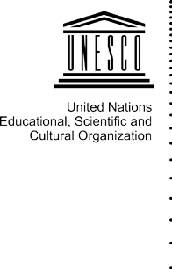







Open Access IndIcAtOrs
And schOlArly cOmmunIcAtIOns In lAtIn AmerIcA

Open Access Indicators and Scholarly Communications in Latin America / Juan Pablo Alperin ... [et.al.] ; edición literaria a cargo de Juan Pablo Alperin ; Dominique Babini ; Gustavo E. Fischman. - 1a ed. - Ciudad Autónoma de Buenos Aires : CLACSO; Buenos Aires: Unesco, 2014.
E-Book.

ISBN 978-987-722-027-8

1. Educación. 2. Comunicación. I. Alperin, Juan Pablo II. Alperin, Juan Pablo, ed. lit. III. Babini, Dominique, ed. lit. IV. Fischman, Gustavo E., ed. lit. CDD 302.23
Otros descriptores asignados por CLACSO:
Acceso abierto / América Latina / Comunicaciones académicas / Indicadores acceso abierto / Repositorios digitales / Evaluación de la investigación / SciELO / Redalyc / PKP / CLACSO
Other descriptors allocated by CLACSO:
Open Access / Latin America / Scholarly communications /
Open access indicators / Digital repositories / research evaluation / SciELO / Redalyc / PKP / CLACSO

Open Access IndIcAtOrs
And schOlArly cOmmunIcAtIOns In lAtIn AmerIcA

Juan Pablo Alperin, Dominique Babini and Gustavo Fischman
(Editors)

Juan Pablo Alperin Abel L. Packer
Eduardo Aguado-López Arianna Becerril-García Dominique Babini Gustavo Archuby Valeria Carrizo

Darío A. García Sebastián Higa Diego Spano

Deputy Executive Secretary Pablo Gentili
Academic Director Fernanda Saforcada
Editorial Production & Web Contents Area Chief Editor Lucas Sablich
Art Director Marcelo Giardino
Production Fluxus Estudio

First edition
Open access indicators and scholarly communications in Latin America (Buenos Aires: CLACSO, august de 2014)

ISBN 978-987-722-027-8
© Consejo Latinoamericano de Ciencias Sociales Queda hecho el depósito que establece la Ley 11.723.

This book is under the following Creative Commons licence


This book is available in full text on the Web Virtual Library of CLACSO <www.biblioteca.clacso.edu.ar>

CLACSO
Consejo Latinoamericano de Ciencias Sociales - Conselho Latino-americano de Ciências Sociais (Latin American Council of Social Sciences)
Estados Unidos 1168 | C1101AAX Ciudad de Buenos Aires, Argentina
Tel. [54 11] 4304 9145 | Fax [54 11] 4305 0875 | <clacsoinst@clacso.edu.ar> | <www.clacso.org>



Sponsored by the Swedish International Development Agency

The responsibility for opinions expressed in books, articles, studies and other contributions rests solely with the signing authors, and publication does not necessarily reflect the views of the Executive Secretariat of CLACSO.

TABLE oF ConTEnTS

Foreword 9

SEction i

Juan Pablo Alperin
open Access indicators. Assessing Growth and Use of open Access Resources from Developing Regions.
The case of Latin America 15

SEction ii

Abel L. Packer
The Metrics Used in the Development of the SciELo network Model 81

Eduardo Aguado-López and Arianna Becerril-García
Redalyc. A Platform of Visibility for the Scientific Production.
Published in open Access ibero-American journals 97

Dominique Babini, Gustavo Archuby, Valeria Carrizo, Darío A. García, Sebastián Higa and Diego Spano open Access indicators in Subject Digital Repositories.
The case of cLAcSo´s Latin America and the caribbean Social
Sciences Digital Repository indicators 143

SECTion ii

REDALYC

A PLATFoRm oF ViSiBiLiTY FoR THE
SCiEnTiFiC PRoDUCTion

Published in open Access ibero-American journals*

Eduardo Aguado-López** and Arianna Becerril-García***

inTRoDUCTion
Today, the use of technological platforms that modify scientific pro- duction, communication, and practices of knowledge legitimization have gained greater relevance, particularly since the development of diverse regional initiatives that have been consolidating their on-line digital archives and libraries. These initiatives have had the goal of increasing the visibility of, and access to, the knowledge contained in the papers generated by universities and research centers whose purpose is to contribute to scientific debate, and who wish to do so in accordance to the disciplinary and social particularities of their re- spective national and regional agendas.
This phenomenon has not only oriented scientific production to- wards more democratic and inclusive communication scopes, but it

* research assistants: Miguel leal arriola, salvador Chávez Ávila, rodrigo Perera ramos y Miguel Ángel aguirre Pitol.
editorial review: José luis Gómez Flores y Mauricio Pérez sánchez. Translation: Natalia lifshitz
** Professor at the autonomous University of the state of Mexico, Founder and General director of redalyc.org
*** Professor at the autonomous University of the state of Mexico, director of sys- tems and Information Technology in redalyc.org.

97

has also invigorated the institutions themselves and their academic communities to the extent that they interact in more open and com- plementary directions. Moreover, we see the creation and integration of spaces with more collaboration among researchers, universities, and countries from different regions of the world.
This process was preceded by an indexing regime of academic publications that attempted to promote this universal dialogue, but which proved irresistible for the evaluation of the academic perfor- mance of the researchers and institutions. The alliance between the bibliometric databases and specialized editorial boards resulted in a restricted group of journals that were considered to be prestigious. This group of journals, these with access to indicators of their impact, have been those considered to be part of the “mainstream” in the com- munication and evaluation of science.
Thus, the alliance between academic journals,big publishers, and companies in charge of the dissemination of science started to con- solidate.1 This alliance generated a vicious circle in which research- ers were looking for publications in venues higher in the hierarchies inside their disciplines in attempts to make themselves visible within this communication circuit—a circuit that placed emphasis on the need to increase the value of their citation indicators and, therefore, the measurable academic impact of their papers (bourdieu, 1999).
even though publishing in journals indexed in these databases may be seen as a source of credibility, a detailed analysis of the origin and topic of the papers according to the countries and the institu- tions of their authors can reveal little participation from countries in latin america and the Caribbean – especially in the fields of social sciences and humanities. This is a reality that goes deep into each country because of their strong centralization of the scientific produc- tion centered in a few universities and some research centers (russell & ainswort, 2011).
at the same time, the idiomatic and thematic particularities that determine the diverse ways of production, communication, and collabo-

1 IsI-Thomson reuters: Institute for scientific Information was created in 1960, and has offered bibliography services, particularly citation analysis, since 1980. They produce an annual report Journal Citation report (JCr) that uses the Impact Factor, that is, the mean number of citations of each paper in the journals it controls. The Ulrich index is a directory and database that provides information about periodical scientific publications. Its on-line counterpart, Ulrichsweb, has international coverage emphasizing publications in english. In turn, sciVerse-scopus is an abstract and scientific journals citation bibliographical database, handled by the dutch publisher elsevier, which also offers author profiles based on affiliations, number of publications, and bibliographical data, such as the number of citations each published document has received.

ration of the science generated in the global south2 often complicate the inclusion of the work of their researchers in the big databases, because they not only are linked with their communities’ different habits and with the specificities of each source institution or country – particularly in latin america and the Caribbean, regions strongly influenced by their deep social differences and inequalities – but they also account for a literary corpus differentially associated at international and local scales with the theoretical treatment and conceptual narratives of the theme- problems (hicks, 2004).
In this sense, Chapter 4 of UNesCo’s World Social Science Report (2010) shows how the number of social science articles generated be- tween 1988 and 2007 included in the social science Citation Index (ssCI) of IsI-Thomson reuters had its greatest increase in latin ameri- ca, despite the fact that the region is constantly underperforming europe, North america, and asia. This is why analyzing the latin american pro- duction from open access regional platforms3, such as scielo, latin- dex, ClaCso, or redalyc, is particularly relevant as the region is more strongly represented in those scientific information systems (beigel, s.f.). additionally, as mentioned by dominique babini (UNesCo, 2010), the main objectives of inter-institutional programs such as sci- elo, ClaCso, and redalyc are to increase the visibility and access of Ibero-american journals in order to develop regional indicators that allow for a more effective follow-up of scientific research, periodically providing diverse analysis on the progress and consolidation of re- gional networks. This is how they can function as a model for other
organizations to develop similar or broader initiatives.
In that regard, it is important to remember the origin of the Net- work of scientific Journals of latin america, the Caribbean, spain and Portugal (red de revistas Científicas de américa latina, el Caribe, españa y Portugal), redalyc.org, which was founded in 2003 as an inter-institutional project at the Universidad autónoma del estado

- This expression identifies what in other contexts and moments has also been referred to as “developing Country” or “Third world”. however, the idea of global south attempts to allude to the countries with medium and low income, generally located in the southern hemisphere, as opposed to europe and North america. The expression is problematic in the case of Mexico, Central america, and the Caribbean, because even though they are located in the Northern hemisphere, they share the same characteristics and similar problems as the countries located at the south of the globe, which is why we insist in using it as it allows us to refer to the countries that share problems related to low relative developmental levels, as well as particular organizational schemes which have allowed societies marked by injustice and economic inequality.
- To identify the meaning of open access and its implications for scientific publications see Melero (2005) and babini (2006).

de México (UaeMeX). Its objective is to create, design, and main- tain an online library capable of compiling the peer-reviewed open access journals, as well as their scientific content, and to provide services for scientific information and act as a meeting point for eve- ryone interested in consulting, debating. and validating the knowl- edge produced in Ibero-american nations. The mentioned, texts can be downloaded for free by students, academics, researchers, or any other interested person4.
In addition to the aforementioned, redalyc.org has joined the websites that implement open access with high technological stand- ards. Thus, interoperability mechanisms such as oaI-PMh (open ar- chives Initiative – Protocol for Metadata harvesting5) and exchange micro-formats encourage the linking and broadcasting of data from around the world. This situation allows for a greater dissemination of scientific information through a vast network that includes such highly relevant organizations as the directory of open access Jour- nals (doaJ) of the open society Institute (osI), JournalTocs, scienti- ficCommons.org, and Google scholar, among others, and maximizes the access and impact of science produced in latin america and the Caribbean at internationally competitive levels.
at the same time, the journals inside the redalyc.org project standout among the extensive scientific editorial production of Ibero america because they pass an evaluation process as a man- datory requirement. The criteria include international parameters of editorial quality, such as being ruled by peer review and the condition of publication, in their majority, original results from scientific research.
as a complement, the scientometrics lab redalyc-fractal (lab- Crf) was created in 2010 as a research group in charge of analyzing the information associated with the papers in the database, with the goal of identifying and characterizing the behavior patterns of the sci- ence published in Ibero-american journals indexed by redalyc.org. one of the first concrete proposals of the labCrf was the creation of

- From its beginning, redalyc.org strove to bring together journals of social and human disciplines exclusively because, back then, they realized that those areas of knowledge were less likely to be incorporated into international databases or consolidated in their publishing processes. however, since 2006, the project opened up to the inclusion of journals from all areas of knowledge (rogel-salazar y aguado- lópez, 2011).
- The oaI-PM protocol outlines the generation of inter-effectiveness tools that, independently of the application, allow for the exchange of information so combined searches of the metadata of all the associated reservoirs (data suppliers) come from centralized points (service suppliers).

an analysis model based in scientific production and communication entities. For this, a set of scientometric indicators are applied whose goal is to account for the state of the art acquired by science produced inside the areas of knowledge and their disciplines at a regional, na- tional, or institutional level – information of high utility for those who have to make decisions regarding scientific and technological develop- ment inside countries and institutions of the entities that participate in this database.
In that regard, initiatives such as redalyc.org gain great relevance because they efficiently increase the visibility and the interactivity around scientific papers throughout the internet, achieving a higher impact in the academic media and improving the communication among editors, readers, and authors. That is why in the Latin Ameri- can and Caribbean Consultation on Open Access to Scientific Informa- tion, led by UNesCo in Jamaica in early 2013, it was recognized that the need to keep encouraging the work developed by the technological platforms and open access regional databases (UNesCo, 2013), par- ticularly because all knowledge locked behind commercial barriers is sterile, as it remains confiscated by big publishing companies that take advantage of the research products generated with public funds (llorens, 2013).

mAin CHARACTERiSTiCS oF THE DATABASE
redalyc.org is an online library that allows reading, downloading, and sharing of full text scientific papers for free, which is why it functions as a meeting point for everyone interested in reconstructing the scien- tific knowledge of and about Ibero america. This website – the most visible segment of this effort – is part of an initiative led by a group of researchers and editors concerned for the lack of visibility of the research results generated in and about the region. That is why it has been established as a window that allows observing the most noted scientific production in the Ibero-american region.
For more than 10 years, redalyc.org has been establishing itself as a relevant actor in the Ibero-american context, not just because it has been welcomed by the academic communities and their com- munication and scientific collaboration networks, but because of the its bigger contribution of providing a free and open content database. This includes the appropriateness of the information derived from the application of the scientometric indicators. These indicators, de- signed by the labCrf with a novel and alternative focus, account for the behavior and the existing local and regional peculiarities around the process of generating scientific knowledge using public and trans- parent criteria.

In accordance with the latest technological and publishing devel- opments, the appropriate strategy for scientific communication media edited in emergent countries is to be positioned so that it is relevant to the region using a combination of strategies aimed to improve quality and convenience, while also capable of capturing the best contribu- tions of the researchers working on topics of interest to Ibero america and mainly to latin america. These efforts will be able to contain the biases inherent to international collections whose tendencies have systematically affected the journals that are not seen as “mainstream,” as mentioned by ana María Cetto (santillán, 2011). This is why we should move forward with actions that seek to reverse this import- export pattern of the science produced in countries from the global south, to be able to make an incursion in the validation and scientific debate from a more balanced position regarding First world countries (Guédon, 2011).
From this perspective, redalyc.org has functioned as a media- tor that allows for the communication and indexing of the scientific production published in journals from the Ibero-american region through an open access technological platform, while also overcom- ing many obstacles to maintain and adapt the global standards to the work ways of scientists from the global south (aguado-lópez et al., 2012). The Ibero-american contribution to the production of science was invisible because many of the communication spaces were absent in the databases that, from traditional models and standards, have certain access restrictions for countries, institutions, and researchers of the region. This is why the results presented next make what tradi- tionally has been invisible, visible; that science has no borders.
Therefore, when taking into consideration that information tech- nologies are in constant development and the process of science re- search and communication, it is relevant for knowledge, as a common good, to be available to whoever wants to access it. as such, redalyc. org is part of the recent movement of information exchange in open access technological platforms, which have experienced significant quantitative and qualitative growth in the last decade. This is why it contributes to the effort of strengthening the Ibero-american publica- tions from editorial quality criteria, which improve the prestige of the journals and leverage the visibility of science generated in the region, emphasizing the work done by latin american researchers in matters of humanistic and social interest.

inCLUSion AnD EVALUATion oF JoURnALS
Today, scientific journals are not organizations of diffusion, but they also work as spaces that regulate the access to information and aca-

demic knowledge (Guédon, 2011). This is why they can be conceived as books in continual construction as continue publishing the daily work of researchers, who, apart from promoting the visibility of their contributions to the scientific field, also guarantee the quality of their academic hypothesis from the prestige some of the journals can offer. In this context, redalyc.org builds its library in agreement with a series of policies and selection procedures of guaranteed quality jour- nals. The journal collection is the raw material for the access and con- tent retrieval services in the website and the data universe from where the metadata comes from, which informs the indicators applied by the labCrf. Thus, the journals in this important project gather the edito- rial and academic standards. This is guaranteed by using an exhaus- tive methodology for adding them to the database that internationally
accepted and validated parameters.
The evaluation methodology is made of 60 quantitative and quali- tative criteria organized in three units – admission, quality, and man- agement – with which the candidate journals are evaluated. These re- sults are ratified by an international advisory scientific Committee.6 In accordance with this, it is essential to favorably satisfy all the crite- ria from the first two areas (admission and quality) to continue with the evaluation, because they represent 39 criteria – and a subsequent score between 31% and 69%, from which a journal needs to achieve 82% to be included in the database. In turn, the third area foresees 21 points with qualitative value, which therefore does not influence the previous quantitative estimation.7
It is important to emphasize that a substantial part of the evalu- ation process is centered on the compliance of generally accepted standards of importance used to determine the scientific nature of a journal regarding editorial and content quality. These are the peer review double blind, the integration of an editorial committee, the originality of most of the published research results, and a regular publication schedule. This is stated by the basic admission criteria, as following:

- Composed of academics with recognized international prestige as experts in the fields of natural sciences, social sciences, and the humanities, and with broad editorial experience. This referee organization is meant to support the evaluation guidelines to which journals will be subject to and to give their academic guarantee in the incorporation or rejection of any journal to the redalyc.org database. For a detailed review of the methodology, see: http://www.redalyc.org/info_pe.oa?page=/ politica-editorial/metodologiaevalua.html
- The total of criteria and the detailed evaluation methodology can be consulted in http://www.redalyc.org/info_pe.oa?page=/politica-editorial/metodologiaevalua.html

  - seniority and periodicity: the journals must have published constantly the year previous to their nomination, in order to prove seriousness and capacity to gather and publish their written materials.
  - originality: to prevent the science dialogue from becoming a monologue, it is recommended for papers to be submitted to only one journal, and to make original contributions to the theoretical and applied debate of the disciplines.
  - scientific content: the content of the journal must refer at least 50% to 75% to material from results of an academic research.
  - IssN: each publication must have a numeric code referring to the existence of a printed or electronic publication.
  - editorial committee: the journal must have a committee of experts on the subjects associated to the publication, whose members cannot be from the editing institution only.
  - appropriateness of the information: the papers must have title, abstract, and key words in the native language of the research, and an abstract in another language, in order for these contents to be considered by experts or readers from diverse latitudes.
  - referee system: in order to guarantee the quality and prestige, the papers must be reviewed by experts through the peer re- view, double blind system.

adhering to these criteria, redalyc.org guarantees that the open access academic journals edited in paper or electronically are indexed in the database according to scientific and editorial quality standards. an indexing proof is given to every journal that joins the database.

REGiSTRATion, VALiDATion, AnD noRmALizATion oF inFoRmATion
To make the application of the scientometric indicators proposed by the labCrf possible, the information associated with the scientific work published in journals of the redalyc.org database is uploaded to the redalyc Information Integral system (rIIs). Through this system, the metadata identified in each paper are recognized, validated, and stored. This procedure allows for the association of each paper to one or many authors, each author to an institution (to where he/she has professional affiliation), and each institution to a country, according to the process detailed in Figure 1.

Figure 1
RIIS registration, validation and normalization process
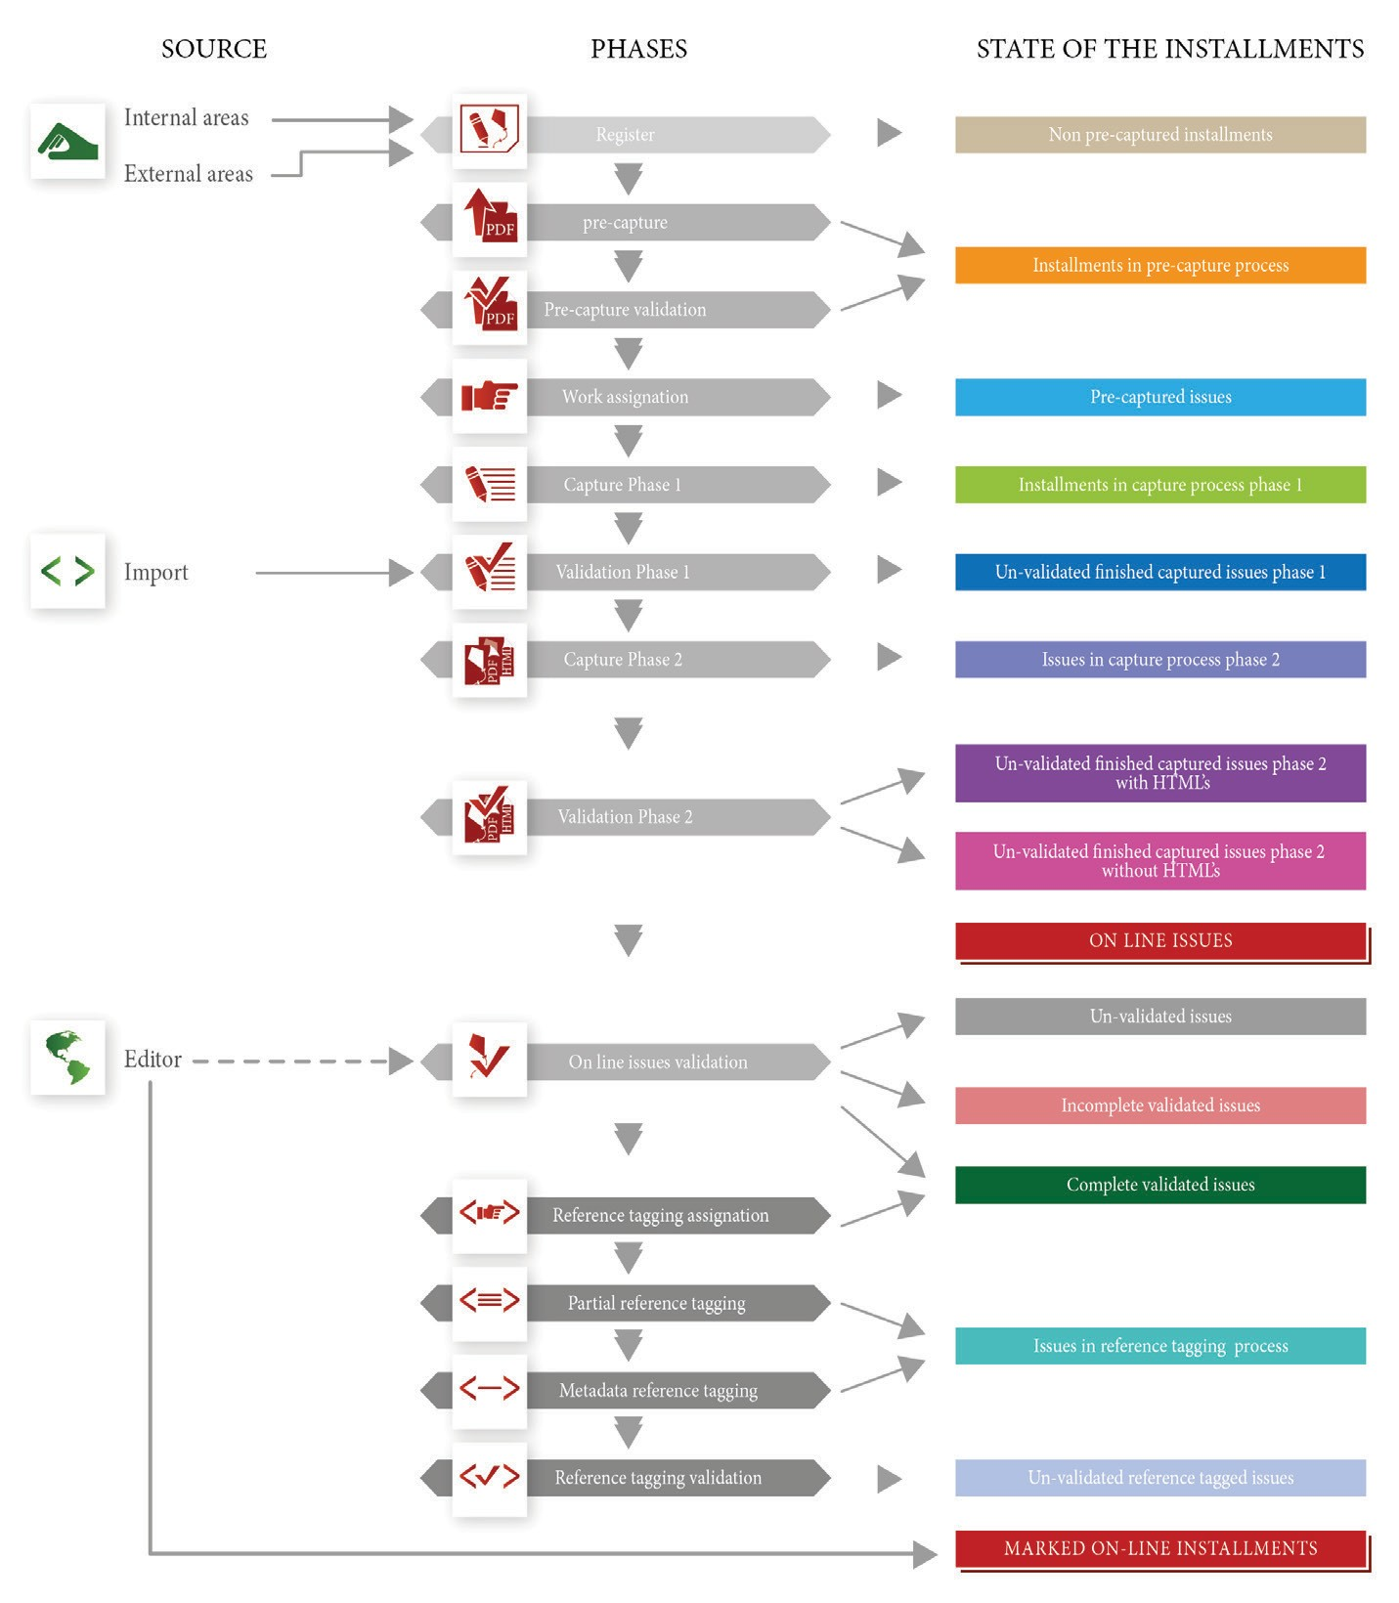

This operation of identification and assignation, which might appear simple in its approach, faces the difficulties derived from the diversity and complexity of editorial practices. For example, there is no nor- mativity to assign the institutional affiliation data of the authors and

most of the time each journal does this their own way. as such, the institutional affiliation identification depends upon an adequate read- ing of the author’s signature, which can be: concise (when the author’s name is followed by the name of an institution), complex (when the author’s name is written along with a series of data that can be cur- ricular or of affiliation), or invalid (when there is no affiliation data). That is why the determination of the country of the author’s insti- tution of affiliation also has similar difficulties and, likewise, cannot always be obtained.
because of this, the registration of institutions sets out the chal- lenge of identifying the ways in which each one of them can be as- signed. For example, the Universidade Federal do rio Grande do sul can be identified by some authors and editors as UFrGs or as Univer- sidad Federal del río Grande del sur, depending upon their norms, criteria or uses. That is why the rIIs allows a group of specialists to rely on evidence to make the decisions that allow the normalization of information and the identification of the different forms of institution nomenclature and to associate them with the official name. This way, it is possible to gather the production of an institution even though they appear in journal papers under different forms or languages.
It should also be noted that it is indispensable for each entity to be associated to a particular country, because there are homonym institutions that belong to different countries, such as the Universi- dad de los andes, Colombia (Uniandes) and the Universidad de los andes, Venezuela (Ula), or entities with many headquarters such as the Facultad latinoamericana de Ciencias sociales (FlaCso), with representation in Mexico, Chile, and ecuador.
as stated above, the lack of normalization in the authors’ names and their corresponding institutional affiliations makes hard to find the information in the database, because search engines generate dis- perse information according to the various ways an author or institu- tion name is referred. This also affects the identification of citations and bibliographical references, and in consequence, the application and interpretation of indicators developed by the labCrf to character- ize the communication and scientific collaboration patterns.8
To settle these problems, in redalyc.org the data from institutions and authors’ countries of affiliation are subject to the validation and

- even though the adequate identification of the institutions and countries in each paper can be considered a direct responsibility of the editors, who communicate with authors the importance of properly registering metadata, it is also the responsibility of the authors, who also incur the same problem when registering their own names with different variations.

normalization treatment described above, where the result is associ- ated to a unique identifier corresponding to each author, institution, and country, according to the following sequence:

  - registration: capture of author information (full name and in- stitutional affiliation) the same way the editor registered it in each paper of the journals in redalyc.org.
  - Validation: it is verified that the institution is correctly regis- tered and associated with the country specified in the paper.
  - Normalization: a unique identifier is created for each institu- tion form and the ones referring to the same organization are associated, in order to link the institutions detected as aliases and register their production in one unique entity.

This process is a continuous work and includes monitoring by quali- fied personnel who review the capture of information in different mo- ments, because the new journals registered in the rIIs catalogue are incorporated with complete archives (from 2005 to date) and affect transversally the study years total.9 In this sense, the information in- tegrated in the database can be grouped in four categories: a) jour- nal’s general information (name, institution, country, area) and issue (number, volume, type of issue, publication’s year and language); b) paper’s data (title in original language, title in a second language, if possible, paper classification, abstracts, key words, received/accepted dates and first and last page); c) author’s identification (name, last name, institution of affiliation, personal/institutional e-mail and au- thor’s signature – true copy of all the data recorded in the PdF file of the journal); and, d) institution’s data (name, initials, institutional Url, street, postal code, country, sector and function).
This way, the entry and normalization information for each jour- nal, paper, author, and institution allows the rIIs to systematize use- ful information to know how the communication and scientific collab- oration between institutions, journals, areas, disciplines, and authors takes place:

  - an indexing system that uses authorized and explicit criteria to incorporate journals into its database and guarantee its edito- rial quality.

- The institution normalization process has been done for over 10,000 institutions registered in redalyc.org. a more detailed review would be the responsibility of expert documentalists from each country.

  - a library with open access to the full text of on-line scientific papers, and with interoperable metadata to facilitate the loca- tion, visibility, and analysis.

ComPoSiTion oF THE on-LinE DiGiTAL DATABASE
The redalyc.org database has more than 300,000 full text online con- tributions –growing by 4,000 a month. This material has been pub- lished by about 870 journals, which have been evaluated based on the double blind framework to prove its editorial and academic qual- ity that guarantees the information has been previously academi- cally reviewed.
Its thematic coverage is open to the most diverse scientific dis- ciplines in science and the social and humane areas, and thereby in- tegrates the academic journals published in any country from latin america, the Caribbean, spain and Portugal. likewise, journals pub- lished in other countries can be integrated, provided that their topic of coverage is focused on problems related to Ibero america. These will be grouped under the heading: latin-americanists. Currently, sci- entific production from the social sciences represents 59% of the total disseminated material, with education, psychology and medicine the most productive disciplinary fields.

  - JoURnAL DiSTRiBUTion BY CoUnTRY
The following analysis corresponds to data collected in the first fort- night of october 2013, which consisted of 255,696 research papers that have been published in the database’s 869 open access journals. Thus, being a database created with the purpose of giving visibility to the academic production of Ibero-american scientists, it is logical for Mexico, brazil, Colombia, and spain to be the countries with the highest contribution to indexed journals, with 71.2% of the total pub- lications (see Graph 1).
Publications produced by Chile, Venezuela, and argentina rep- resent 19.3% of the total of publications registered in the database, followed by a smaller group of 12 countries and international or- ganizations.

  - JoURnAL DiSTRiBUTion BY AREA oF knoWLEDGE AnD DiSCiPLinE regarding journal distribution by area of knowledge and discipline, it is important to mention that one of redalyc.org’s main character- istics is the number of publications related to social sciences and the arts and humanities (514 and 95, respectively), which together represent 70% of the publications registered in the database (see Graph 2).

Graph 1
Redalyc.org journal distribution by country
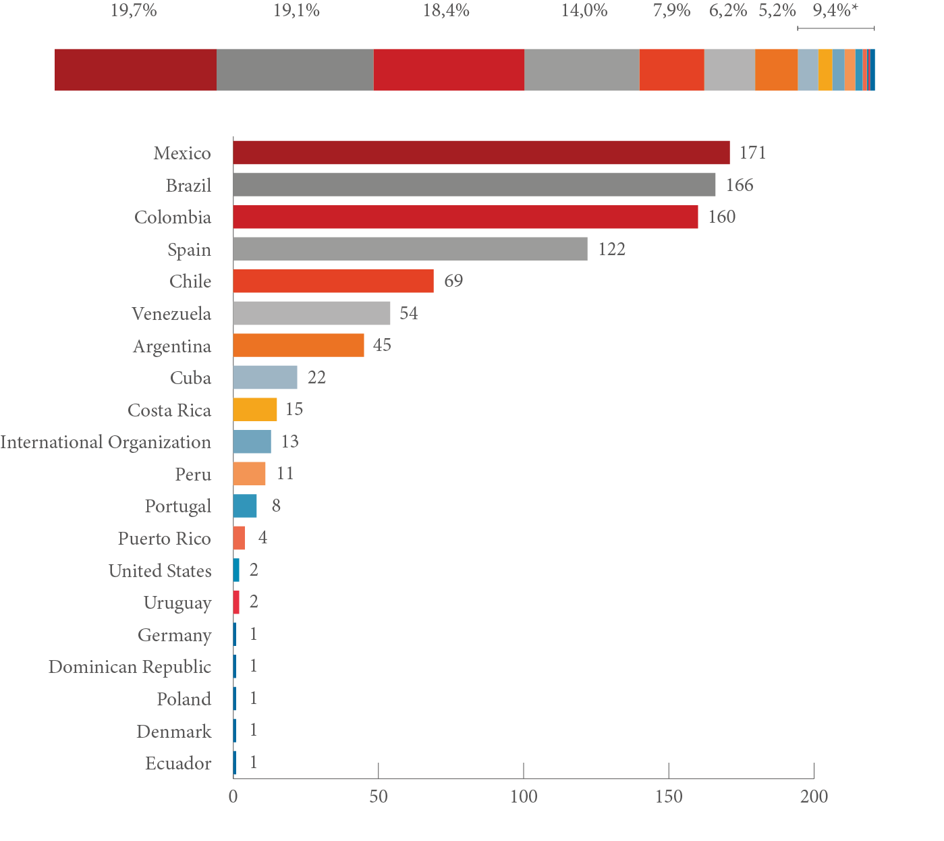

Source: Elaboration: scientometrics Lab Redalyc-Fractal (LabCrf) | Data from redalyc.org. | Metodology: http://www. redalycfractal.org/met | Creation: october 18th 2013.
* Includes: Cuba, Costa Rica, International Organization, Peru, Portugal, Puerto Rico, United Dominican Republic, Poland, Denmark and Ecuador.

regarding the participation of publications according to disciplinary fields, it is important to highlight that education, psychology, medi- cine, sociology, and agricultural sciences are the first five top-producing fields, representing 36.9% of the journals in the database. however, it is very significant that even though the database has more journals in social sciences – probably because redalyc.org was originally focused in this study area –there are disciplines associated with exact and hard sciences that, in a shorter period, have gained enough importance to

be included in the database, such as medicine, agricultural sciences, engineering, and biology, which reflect 191 publications and 22% of the database. This also indicates that the database is also being considered by the (academic) science community, which has traditionally been bet- ter represented in other bases and bibliometrical indexes (see Graph 3).

Graph 2
Redalyc.org journal distribution by area of knowledge

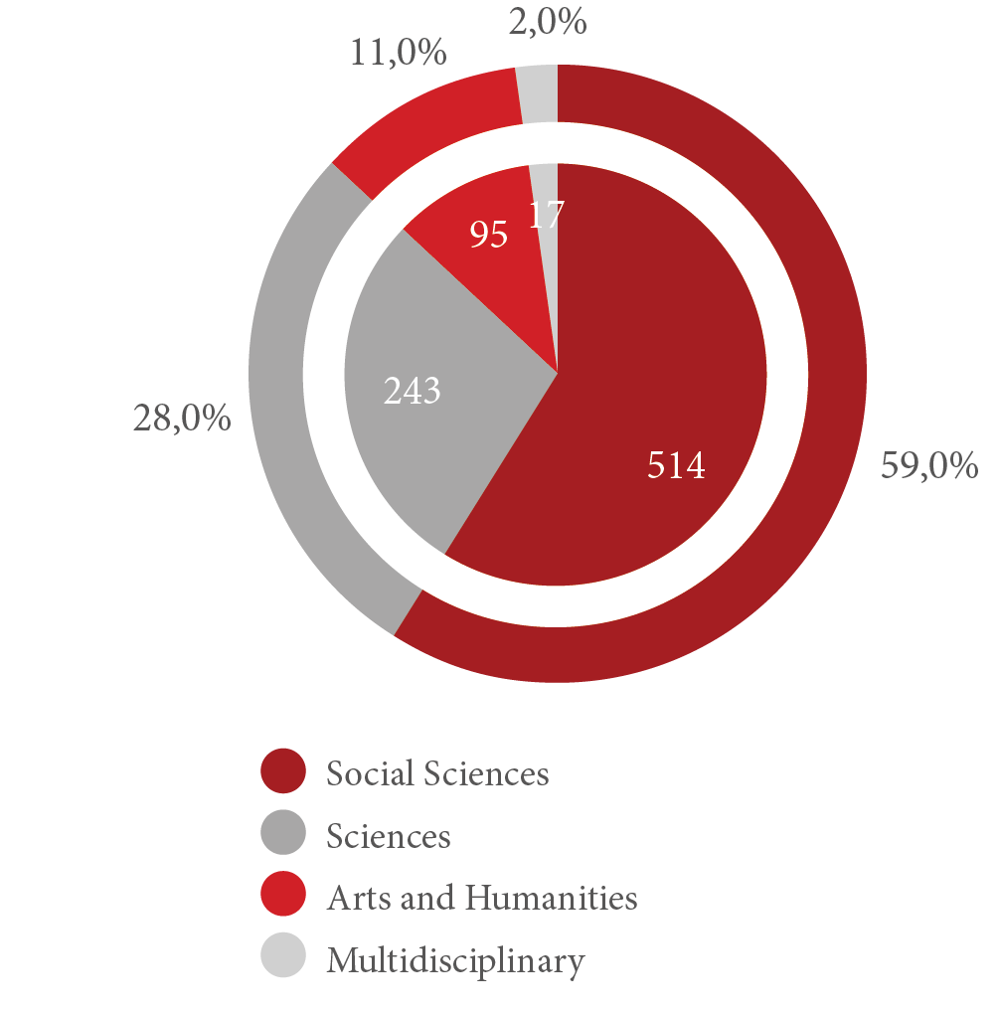

Source: Elaboration: scientometrics Lab Redalyc-Fractal (LabCrf) | Data from redalyc.org. | Metodology: http://www.redalycfractal.org/ met | Creation: october 18th 2013.

  - PUBLiSHED ConTRiBUTionS BY kinD AnD YEAR, AS WELL AS BY CoUnTRY AnD AREA oF knoWLEDGE
For the 304,391 contributions stored in the dataset, it is possible to observe different levels of intensity throughout the publication of ac- ademic work. There are at least four major periods distinguishable when the data is viewed historically, among which the last two are the more representative with 18.6% and 77.7%, respectively. additionally, from the total of work disseminated by the journals in the database, 83.9% correspond to scientific papers (255,696), with the remaining portion reflecting editorials, reviews, and other scholarly products. when looking at Graph 4, the huge effort redalyc.org has made to incorporate journals in the last 10 years is evident, as well as its con- tribution to the providing scientific papers available in full text.

Graph 3
Redalyc.org journal distribution by discipline
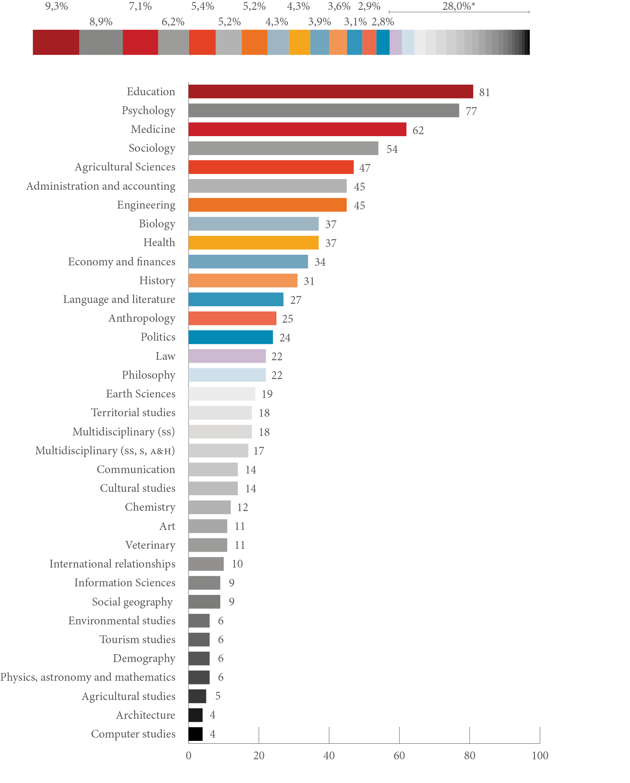

Source: Elaboration: scientometrics Lab Redalyc-Fractal (LabCrf) | Data from redalyc.org. | Metodology: http://www. redalycfractal.org/met | Creation: october 18th 2013.
* Includes: law, philosophy, earth sciences, multidisciplinary (SS), territorial studies, multidisciplinary (S, SS, A&H), cultural studies, communication, chemistry, art, veterinary, international relationships, social geography, information sciences, enviromental studies, physics, astronomy and mathematics, tourism studies, demography, agricultura studies, architecture, computer studies.

Graph 4
Published contributions in redalyc.org’s journals by year and kind

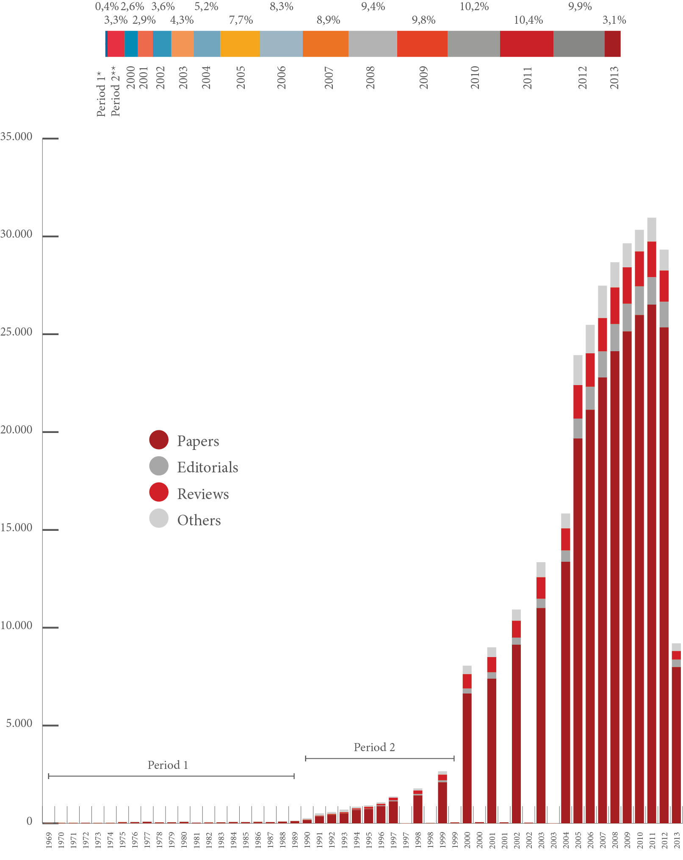

Source: Elaboration: scientometrics Lab Redalyc-Fractal (LabCrf) | Data from redalyc.org. | Metodology: http://www.redalycfractal.org/ met | Creation: october 18th 2013.
* From 1969 to 1989
** From 1990 to 1999

when viewed by country (Graph 5), brazil has the greatest contribu- tion of academic work (more than 60,000 items), followed by Mexico (about 46,000), and spain and Colombia (about 30,000 each). This is why the participation and behavior of these countries relates, in part, to the number of journals indexed by the database. It is important to point out that among the first 10 countries with highest contribution to the database, seven are latin-american, while the remaining three are individually linked with the Caribbean, spain, and North america.

Graph 5
Contributions published in redalyc.org’s journals by kind and country

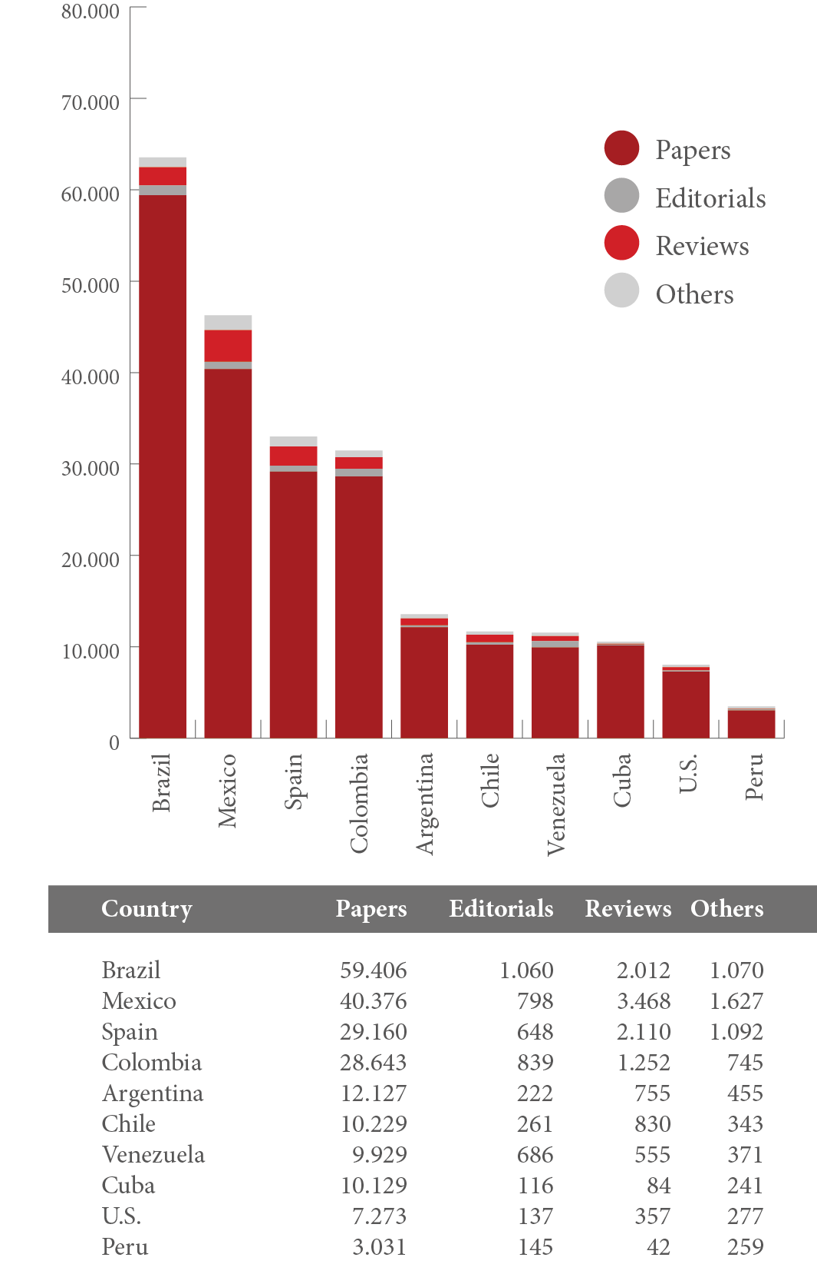

Source: Elaboration: scientometrics Lab Redalyc-Fractal (LabCrf) | Data from redalyc.org. | Metodology: http://www. redalycfractal.org/met | Creation: october 18th 2013.

The area with strongest academic support is social sciences, followed by sciences and, to a lesser extent, arts and humanities and the multi- disciplinary field (Graph 6). among them, the strong weight that sci- entific papers acquire becomes evident.

Graph 6
Contributions by kind and area of knowledge

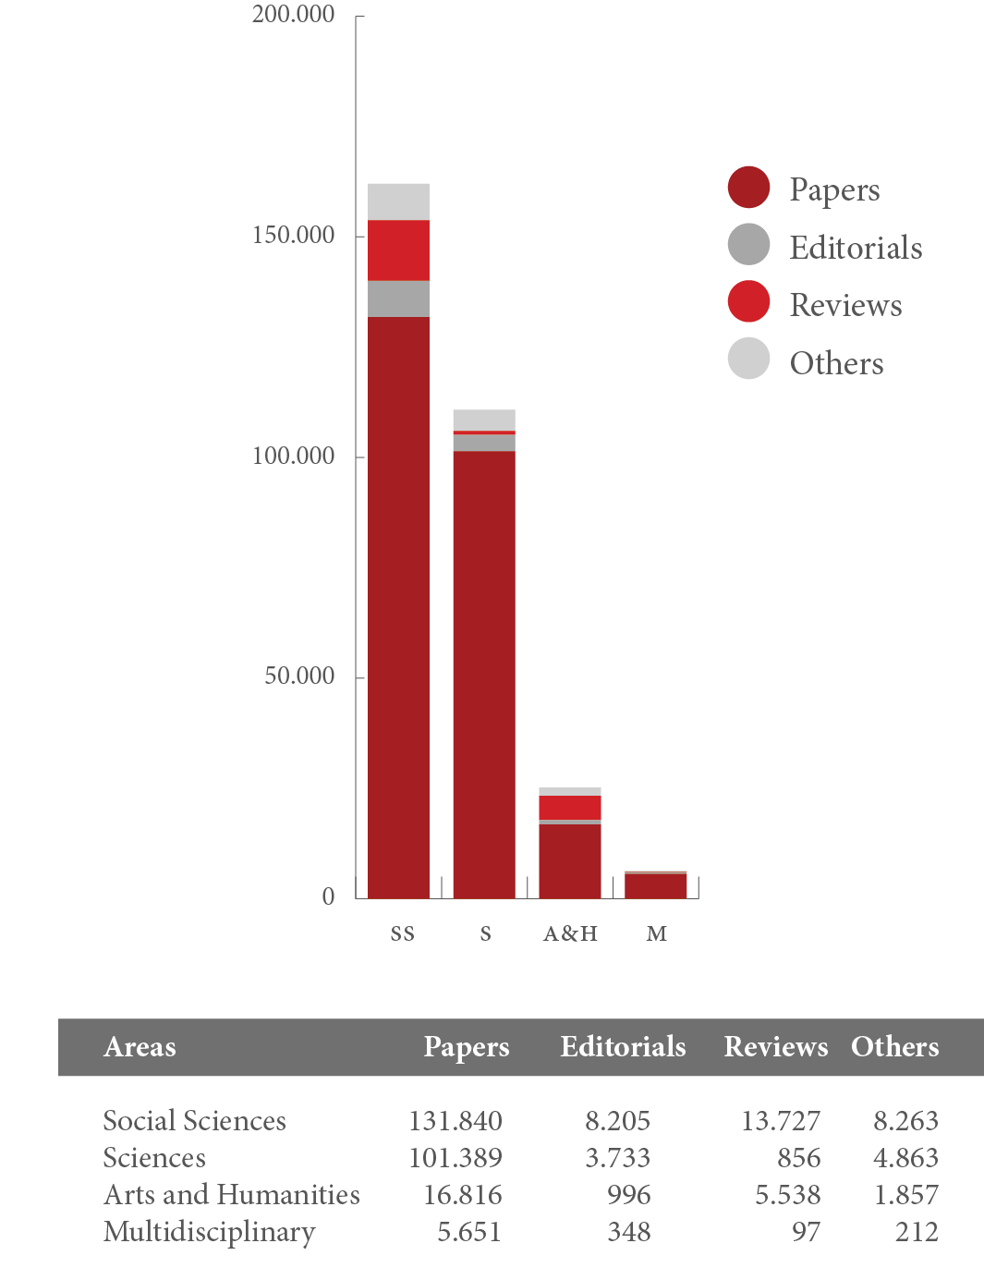
Source: Elaboration: scientometrics Lab Redalyc-Fractal (LabCrf) | Data from redalyc.org. | Metodology: http://www.redalycfractal.org/ met | Creation: october 18th 2013.

  - nUmBER oF PAPERS PER JoURnAL
The 10 journals that contribute more papers to the database are shown in Graph 7. here, it is possible to see the balance between the two main areas of knowledge – five journals for sciences and five for social sciences – and the specific case of the journal Ciencia Rural, published in brazil and focused on the discipline of agricultural sciences.
on a smaller scale, with 2,000-3,000 contributions, are also Ciên- cia & Saude Colectiva, Revista Mexicana de Astronomía y Astrofísica,

Psicothema, and Revista Brasileira de Ciência do Solo, which represent the strong participation of brazilian and Mexican publishers.

Graph 7
Papers by journal

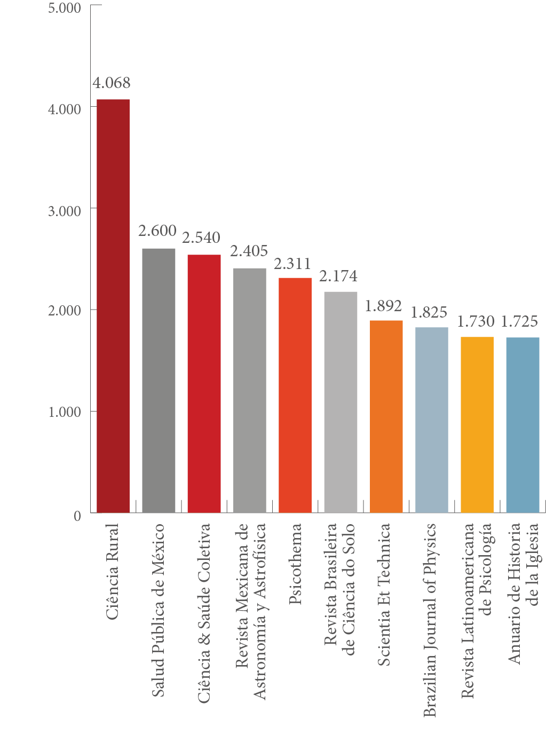
Source: Elaboration: scientometrics Lab Redalyc-Fractal (LabCrf) | Data from redalyc.org. | Metodology: http://www. redalycfractal.org/met | Creation: october 18th 2013.

  - USAGE STATiSTiCS
The following graphs show some initial data from the redalyc.org website on usage and the number of downloads for full text content accessed in different parts of the world. It is important to mention that the record filtering and georeferencing are performed using the list of robots included in the tool awstats for the generation of statistics.

Graph 8 shows the monthly downloads of redalyc.org texts in 2012. The fact that more than 79 million product downloads stands out, and speaks to the relevance and strong social impact generated by those databases that share scientific material for free to any interested audience. These types of open access policies contribute to a better informed society that is able to practice a more participatory, demo- cratic ,and inclusive citizenship.

Graph 8
Monthly downloads of full text articles of redalyc.org 2012

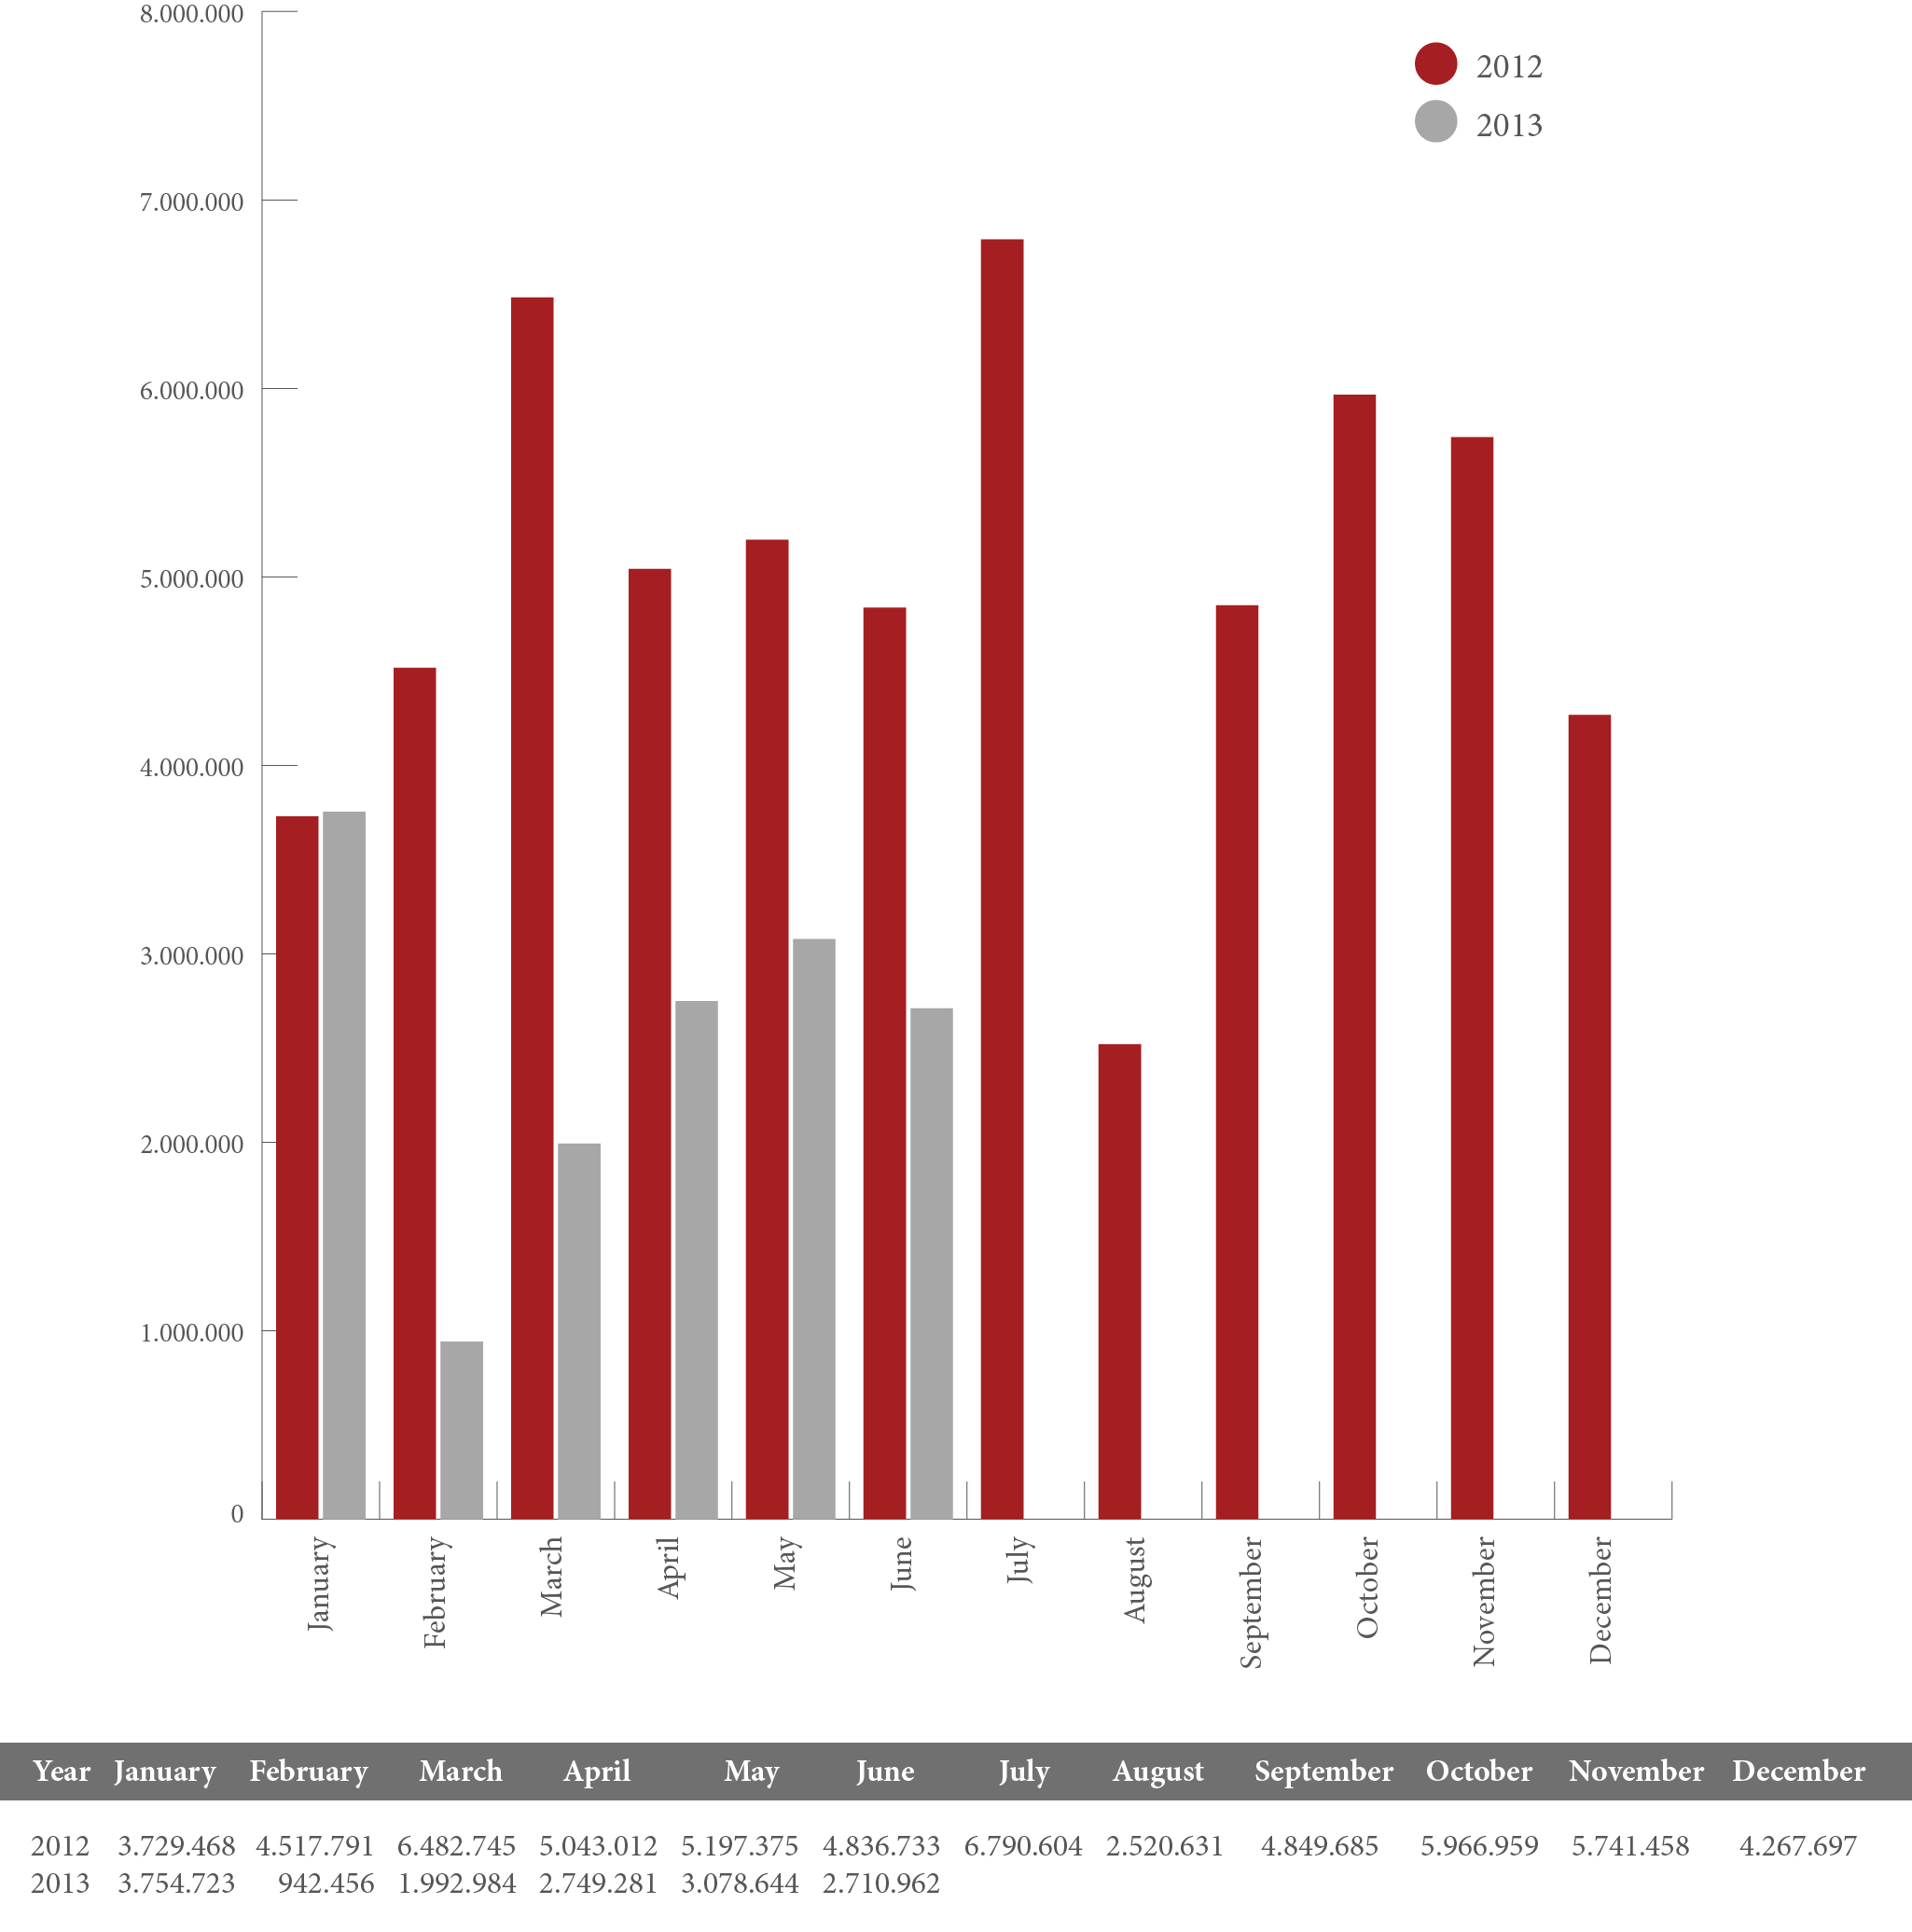
Source: Elaboration: scientometrics Lab Redalyc-Fractal (LabCrf) | Data from redalyc.org. | Metodology: http://www.redalycfractal.org/ met | Creation: october 18th 2013.

Graph 9
Monthly downloads of the redalyc.org content by country, first semester 2013

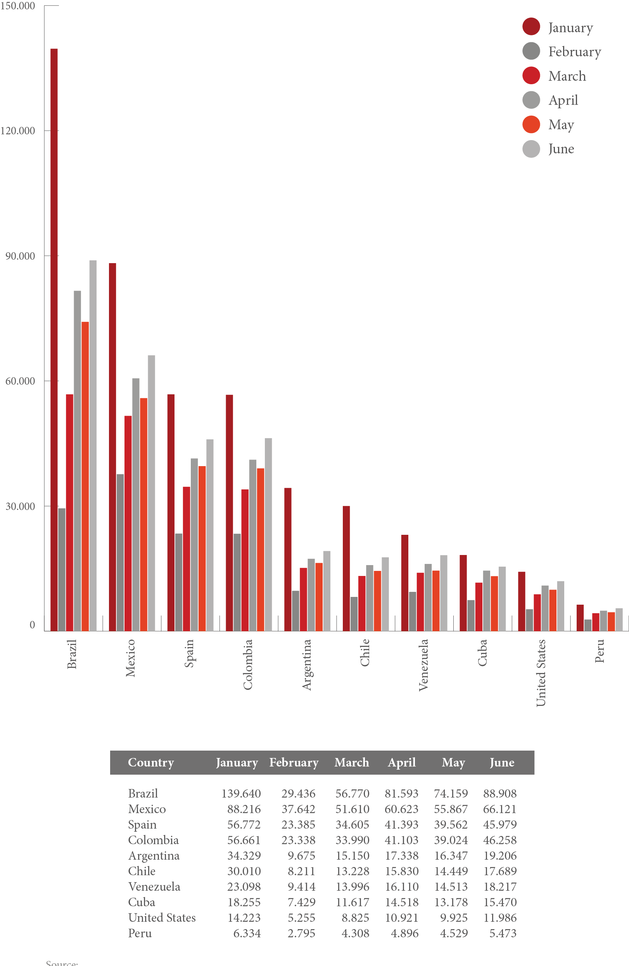
Source: Elaboration: scientometrics Lab Redalyc-Fractal (LabCrf) | Data from redalyc.org. | Metodology: http://www. redalycfractal.org/met | Creation: october 18th 2013.

brazil, Mexico, spain, and Colombia are the countries that access the website the most and have the higher download rates of scientific papers during the first semester of 2013 (Graph 9). This participa- tion confirms that a higher scientific dialogue is taking place amongst Ibero-american countries, not only related to communication and academic collaboration strategies, but to a higher consumption of scientific papers that are more appropriate and contextualized to the interests of the users and the database contents.
although the United states is the only country external to the Ibero- american linguistic context that ranks in the top 10 countries with the highest redalyc.org downloads, there are many other countries in Central and oriental europe, scandinavia, africa, and asia who frequently access materials published by journals in the database. This shows how science produced in the Ibero-american region is being consulted around the world, opening the path towards a higher internationalization of science from Ibero america and mainly from latin america and the Caribbean. regarding article downloads by discipline (see Graph 10), it is in- teresting to see that among the 10 disciplines that are accessed the most, there is a balance in number of downloads between the areas of knowl- edge. This situation proves that the database is extremely comprehensive and does not present any kind of bias towards one area of knowledge or another. however, it should be highlighted that medicine and agricultural sciences are in the 1st and 2nd places in this regard, followed by education
and psychology, and, to a lesser extent, sociology and health.

  - oVERLAP oF REDALYC.oRG JoURnAL DATABASE WiTH oTHER DATABASES
as mentioned, journals from the Ibero-american region, particularly those from latin america and the Caribbean, have encountered many barriers to inclusion in traditional international databases. In this regard, sandra Miguel (2011) mentions the limited dissemination of latin-american journals in international databases – mainly the Jour- nal Citation reports from Thomson reuters, because elsevier’s sco- pus has been broadening their inclusion and coverage policies towards Ibero-american journals. however, with the creation of regional initia- tives such as scielo and redalyc.org, the science produced in coun- tries from the global south gained a closer tool to make its scholarly products more visible at regional and international levels.
These alternative databases are of great importance for the science produced in Ibero-american nations. There are 339 shared journals be- tween redalyc.org and sCielo published by 12 Ibero-american countries and two international organizations, and combined they cover more than 1,300 scientific journals published by an Ibero-american country that not

only publish internal and regional content, but also contributions from re- searchers affiliated to institutions all around the world (Graph 11).10 This represents 36% of the total publications in scielo and around 42% of the total in the redalyc.org database. The 5 countries that share more journals in both regional bases are: Colombia (90 journals), Mexico (81 journals), brazil (57 journals), Chile (43 journals), and argentina (26 journals) – with the first four countries alone representing almost 80% of the total of journals common to both online platforms (aguirre-Pitol et al., 2013).

Graph 10
Monthly downloads of redalyc.org content by discipline, first semester 2013

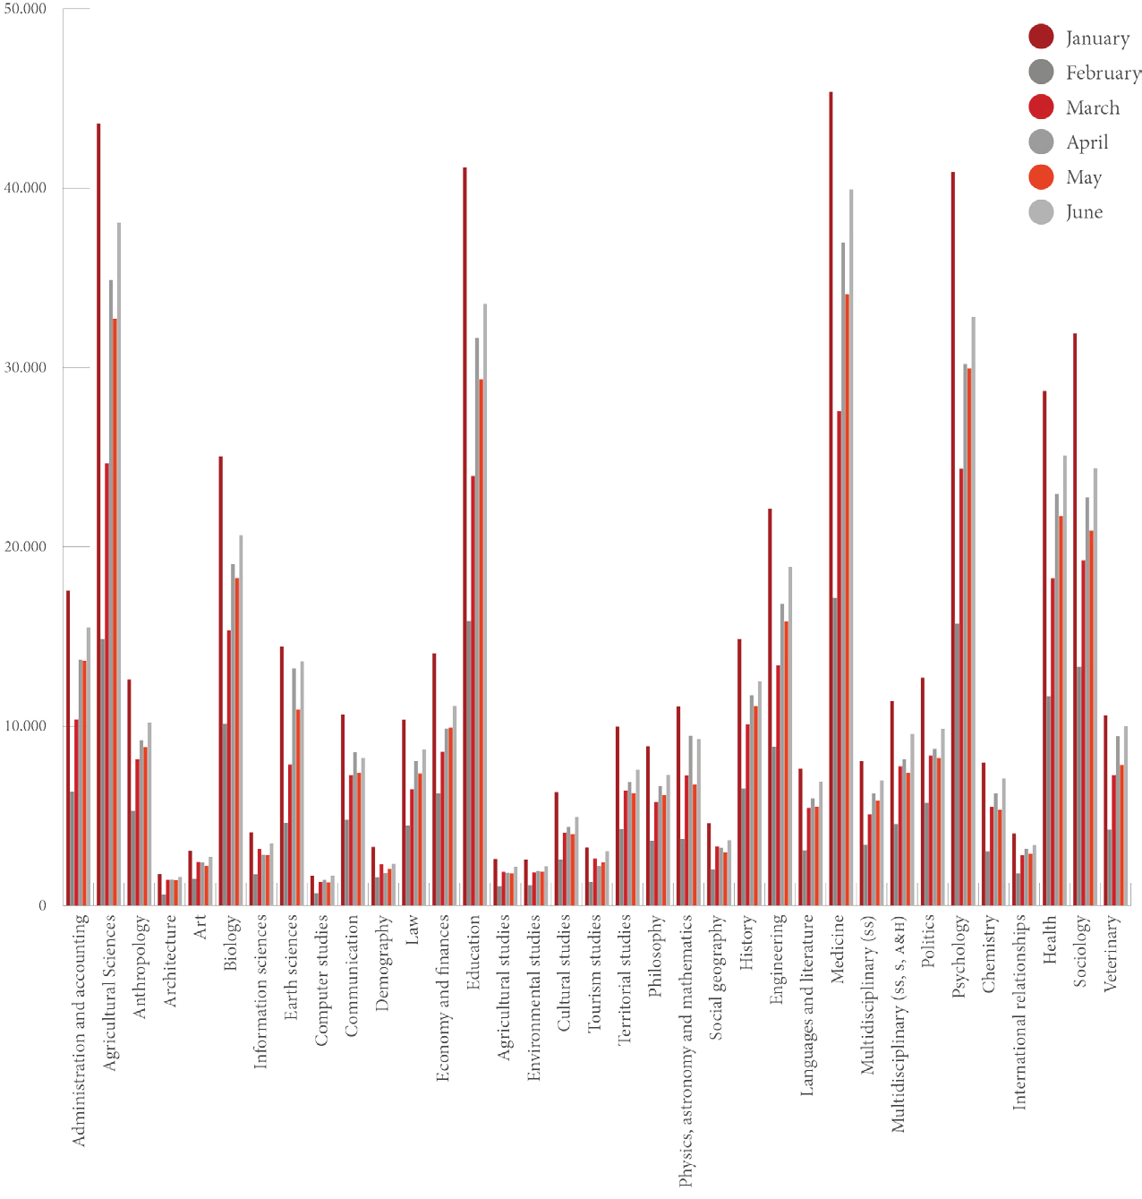
Source: Elaboration: scientometrics Lab Redalyc-Fractal (LabCrf) | Data from redalyc.org. | Metodology: http://www. redalycfractal.org/met | Creation: october 18th 2013.

- Its important to mention that this analysis was performed in February 2013.

Graph 11
Overlap of SciELO and Redalyc.org by country

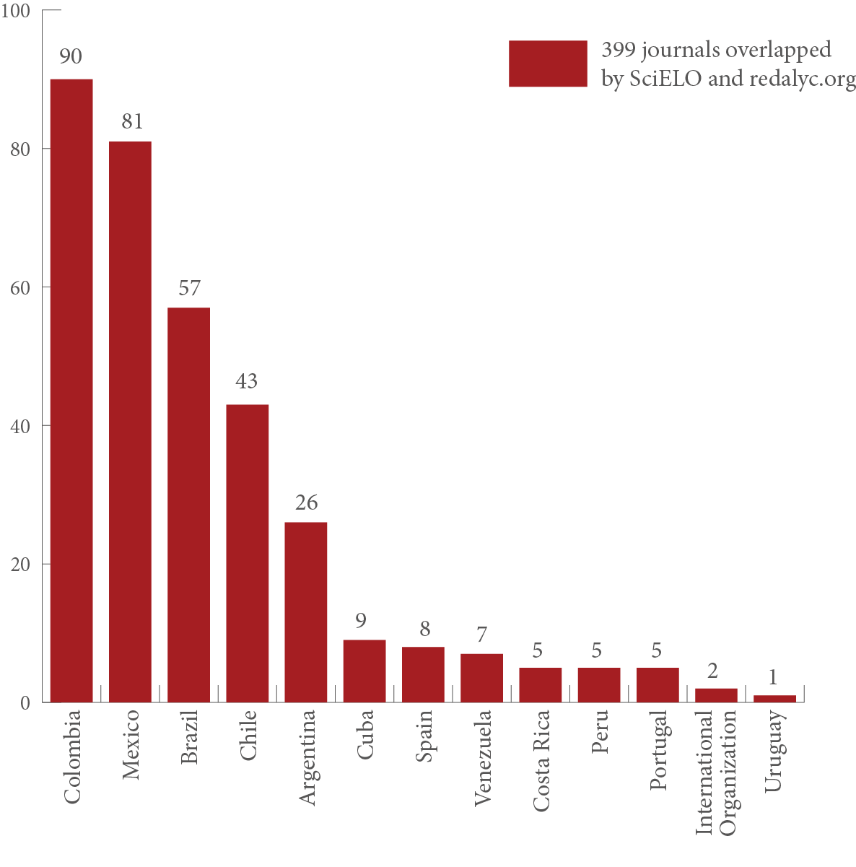
Source: Elaboration: scientometrics Lab Redalyc-Fractal (LabCrf) | Data from redalyc.org. | Metodology: http://www.redalycfractal.org/ met | Creation: october 18th 2013.

additionally, while scielo and redalyc.org are databases that evaluate the editorial quality of open access journals, Thomson reuters web of Knowledge (through the Journal Citation reports [JCr]) and scopus- elsevier (through their scimago Journal Country & rank index [sJr]) evaluate the bibliometric impact of the scientific production at a pa- per- and journal level. This is why each one systematizes different kind of data, apart from the goal of the information they produce and the geographical and thematic coverage of the scientific production they publish (Gasca-Pliego et al., 2013) (Graph 12).
as it is seen, the scientific journals from the Ibero-american re- gion are underrepresented in “mainstream science.” If we compare the redalyc.org database with the characteristics of this two indexes, we can see that they share just a few journals –288 for sJr and 125 for JCr – with most of them coming from spain and brazil.

Graph 12
Journals shared by JCR and redalyc.org, and by SJR and redalyc.org, 2012

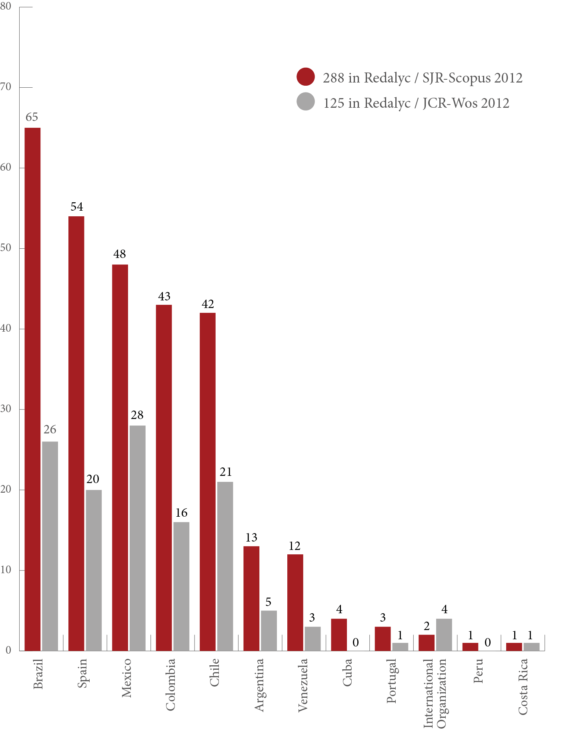
Source: Elaboration: scientometrics Lab Redalyc-Fractal (LabCrf) | Data from redalyc.org. y http://www.scimagojr.com/ journalrank.php y http://admin-apps.webofknowledge.com/JCR/JCR?SID=2AkMTXNMJG8bF9TZkfE| Metodology: http:// www.redalycfractal.org/met | Creation: october 18th 2013.

The journals that do not overlap in these big databases of high academ- ic prestige would be doomed to invisibility if not for regional projects such as redalyc.org. This is why this relevant initiative is a solid and consistent alternative that provides an alternative way to analyze the

generation of scientific knowledge in the Ibero-american context. It is worth noting that the bibliometrical bases built around the specialized publishers are having their first interactions with regional journals in an attempt to better the way in which the systems provide regional in- formation, a decision that shows the higher relevance they have been acquiring for scientific communication (Vessuri et al., 2013).
additionally, redalyc.org is ready to make an incursion into the field of Almetrics using social networks to learn about and measure the im- pact of the dissemination through these alternative metrics. This would allow authors to see the attention their scientific papers are receiving, while providing editors, librarians, and repository managers to assess the online activity around the academic literature they disseminate.
as stated above, the arguments pointing out that the content of regional databases are of low quality are misguided, because these journals can be found in scopus, redalyc.org, and in scielo. It would be relevant for the academic community and research groups to initi- ate a serious and responsible debate to distinguish, for the first time, the notions of quality and prestige that research journals may have, beyond the prejudice and false assumptions.

mETHoDoLoGY USED To GEnERATE inDiCAToRS
since the scientific papers published in journals from the database are the center of analysis and research of the labCrf, it allows us to deter- mine the characteristics of the editorial capacity of the institutions and the countries of Ibero america, and to identify the elements needed to identify the different patterns of scholarly production, communication, collaboration, and usage of written science, in the latin american re- gion. we can observe, for example, how much of what is published is made public in journals from the same institution or country, what are the participation rates of foreign media and institutions, and the propor- tion and characteristics of scientific papers that are produced in collabo- ration with national and foreign academic peers (becerril-García, 2012). one of the objectives of the studies performed by the laboratory
is to give information about the magnitude and possible impact of the strategies and practices adopted by countries, institutions, and re- searchers that contribute to the production of scientific knowledge over time. This kind of analysis captures the peculiarities in the com- munication and collaboration of scientific papers of a country or in- stitution across journals in the redalyc.org database.

DESCRiPTion oF THE EnTiTY-BASED AnALYSiS moDEL
To give greater clarity about the analysis model used below, a brief description of the interpretation criteria of the Production and Col-

laboration indicators and their Internal-External and Institutional-Non Institutional components is presented in Figure 2.

Figure 2
Interpretation of the indicators according to the entity-centered analysis model

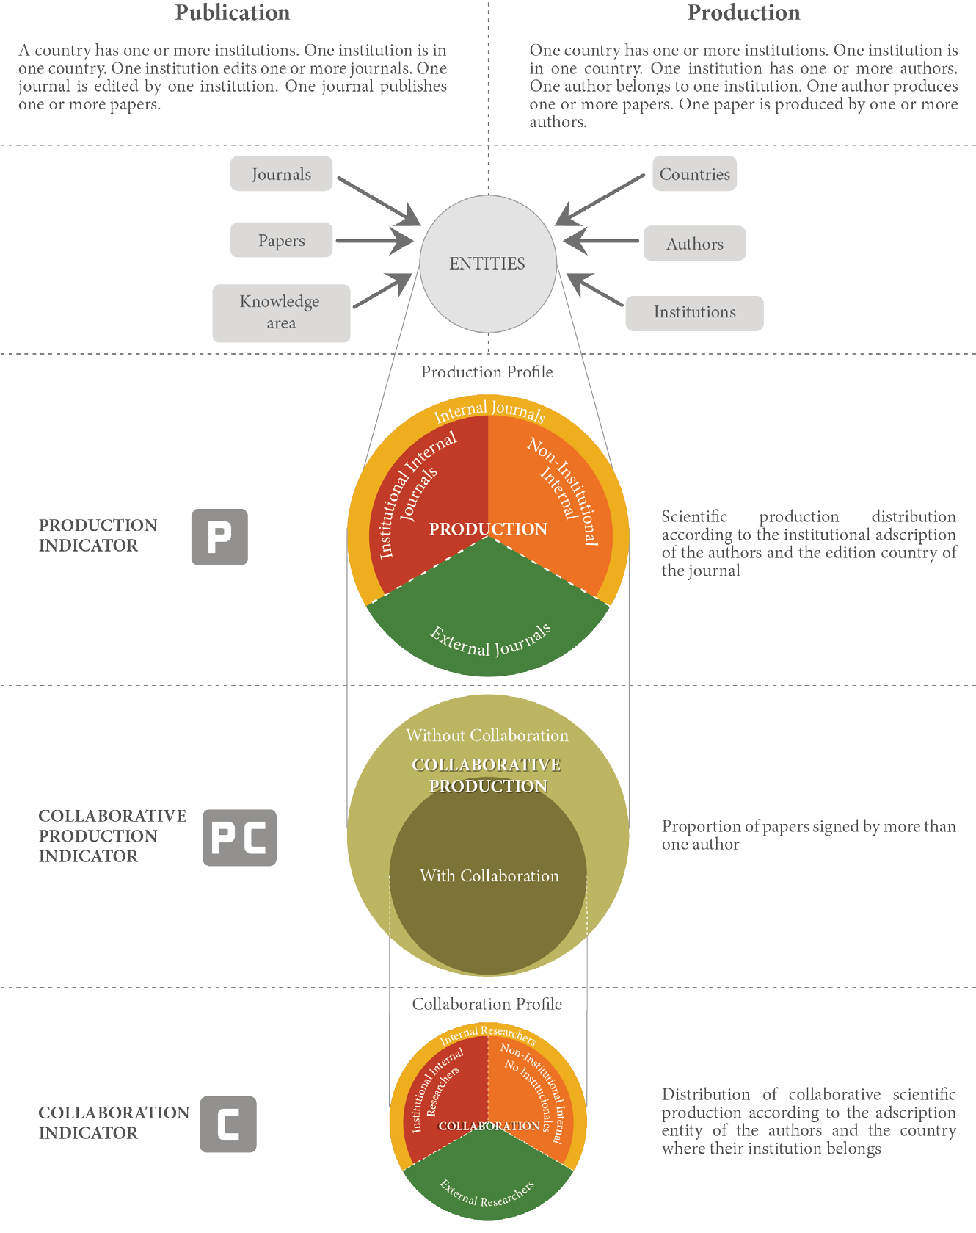

Source: Elaboration: scientometrics Lab Redalyc-Fractal (LabCrf) | Data from redalyc.org. | Metodology: http://www. redalycfractal.org/met | Creation: october 18th 2013.

It is worth mentioning that the criteria used to interpret the composi- tion of the indicators and their distribution always starts with where the entity is produced, because countries, institutions, and research- ers are the only ones capable of generating scientific papers, while the area of knowledge, the disciplines, and the journals are the keep- ers of the produced work. In order to define Internal-External and Institutional-Non Institutional composition inside the Production and Collaboration indicators, it is necessary to turn to the corresponding level and to the producing entity, which is analyzed based on nits re- lationship to the where the entity is produced and the edition of the publishing journal.

- inDiCAToRS oF PRoDUCTion, CoLLABoRATion, AnD USAGE once the main characteristics of the database are described, not only regarding their pertinence to the Ibero-american context but also in terms of the distribution of the journals and the corpus of papers that are a part of the studied universe, we then provide a description of the alternative indicators proposed by the labCrf. These are a part of the scientometric studies set to explain the scientific production from a field broader than bibliometrics, because they are not restricted to the impact of the academic papers according to their level of citation inside journals included on international indexes, but they include the analysis of other determinant factors associated to the production of written science (Pérez angón, 2006).
In accordance with the aforementioned, the process indicators developed from the analysis model were based on production and communication entities that the laboratory applied to papers pub- lished between 2005 and 2011 in some of the Ibero-american journals in redalyc.org. This data was used to generate a Scientific Production Profile determined by the characteristics and the behavior that each analyzed entity listed in the database. In this sense, labCrf identified two main indicators obtained from entity metadata related to Produc- tion (P) and Collaboration (C). These indicators allow for the identi- fication of communication and collaborative work strategies used by researchers and institutions around written science from their com- ponents (Internal-External and Institutional-Non Institutional).

PRoDUCTion inDiCAToRS
The Production (P) indicator is defined as the total number of papers produced by the analyzed entity and published in open access Ibero- american journals indexed by redalyc.org. Its construction is based on the relationship between the institutional affiliation of a paper’s first author and the country of the entity that publishes the journal.

This indicator is composed by External Production (EP) and Internal Production (IP) according to the following terms:

- External Production (EP). Integrated by the papers published by the researcher in a journal published by any institution from a country different from the country of its adscription entity. additionally, due to the fact that the universe of journals is of Ibero-american origin, all the papers from researchers af- filiated to non-Ibero-american institutions will be catalogued as foreign and, therefore, only the papers from researchers of institutions from this region can be classified as institutional and non-institutional internal information, other than external information published in any other Ibero-american country.
- Internal Production (IP). Constituted by papers published by the researcher in a journal published by any institution located in the same country as its institutional adscription, which is subdivided by:
  - Institutional Internal Production (IIP), constituted by papers published by the researcher in a journal published by the same institution where he researches and/or teaches; al- though, this can only be distinguished for institutions that have at least one indexed journal in the database.
  - Non Institutional Internal Production (NIIP), integrated by papers published by the author in a journal published by any institution other than its institutional affiliation, but located in the same country.

The components of the indicator (P) are clearly summarized in Table 1:

Table 1
Components of the Production (P) indicator

Internal Production | Links papers published in journals edited by institutions with the same country of affiliation as the author. This is subdivided by Institutional Production and Non-Institutional Production.
Institutional Internal Production | Relates papers published in journals edited by the same institution as the author’s affiliation.
Non-Institutional Internal Production | Describes papers published in journals edited by an institution from the same country, but different to the author’s adscription.
External Production | Refers to papers published in journals edited in a different country from the country of the author’s institution of affiliation.
Source: Elaboration: scientometrics Lab Redalyc-Fractal (LabCrf) | Data from redalyc.org. | Metodology: http://www. redalycfractal.org/met | Creation: october 18th 2013.

This relationship is graphically shown in Figure 3:

Figure 3
Distribution of the Production (P) indicator


Source: Elaboration: scientometrics Lab Redalyc-Fractal (LabCrf) | Data from redalyc.org. | Metodology: http://www.redalycfractal.org/ met | Creation: october 18th 2013.

inDiCAToRS oF CoLLABoRATion
The Collaboration (C) indicator is based on co-authorship and is lim- ited to the group of papers that, related to the total production, are written by a minimum of two researchers from any region of the world who decide to communicate their work together in an open access Ibero-american journal of redalyc.org. Papers written by one author are classified as Without Collaboration (WC). This distribution is shown in Figure 4.

Figure 4
Distribution of the Collaboration (C) indicator
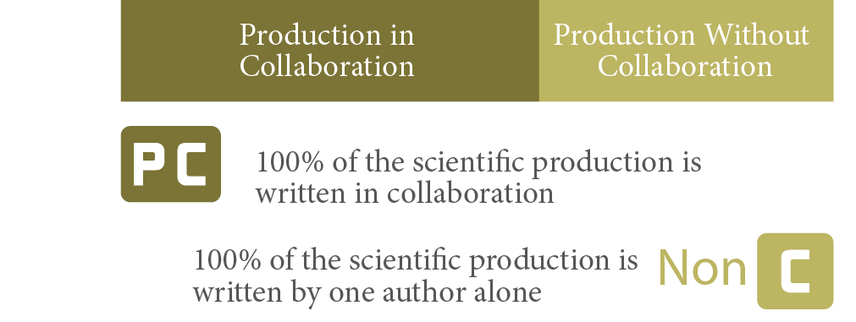

Source: Elaboration: scientometrics Lab Redalyc-Fractal (LabCrf) | Data from redalyc.org. | Metodology: http://www.redalycfractal.org/ met | Creation: october 18th 2013.

as stated above, this is obtained from the relationship between the institution- al the country of the entity and the institutional affiliations of the researchers

participating in co-authorship such that when more than two coun- tries or more than two institutions appear, it is possible to analyze the patterns showing the External Collaboration (EC) and the Internal Collaboration (IC) as detailed below:

- External Collaboration (EC). Composed of papers authored by two researchers from any region of the world, where the exter- nal character depends upon the participation of at least two countries whose institutions have one or more researchers con- tributing to the co-authorship of the scientific paper.
- Internal Collaboration (IC). established by the papers in co-au- thorship among researchers whose institutional affiliation are located in the same country. This is subdivided in:
  - Institutional Internal Collaboration (IIC). Composed of pa- pers written by at least two researchers affiliated to the same academic or research institution.
  - Non Institutional Internal Collaboration (NIIC). Composed of papers created by at least two researchers affiliated to dif- ferent institutions located in the same country.

Conceived this way, the components of indicator C are clearly shown in Table 2:

Table 2
Components of the Collaboration (C) indicator

Internal Collaboration | Refers to contributions written in collaboration exclusively by authors from the same country. The Internal Collaboration is subdivided by: Institutional Internal and Non- Institutional Internal.
Institutional Internal Collaboration | Links papers written in collaboration exclusively between authors affiliated to the same institution.
Non-Institutional Internal Collaboration | Relates papers written by authors affiliated to different institutions from the same country.
External Collaboration | Describes papers published in collaboration with authors affiliated to one or more institutions of the analyzed country, with authors affiliated to institutions of countries different from the analyzed country.
Source: Elaboration: scientometrics Lab Redalyc-Fractal (LabCrf) | Data from redalyc.org. | Metodology: http://www. redalycfractal.org/met | Creation: october 18th 2013.

additionally, the relationship among components of this indicator ap- pears in Figure 5:

Figure 5
Distribution of the Collaboration (C) indicator


Source: Elaboration: scientometrics Lab Redalyc-Fractal (LabCrf) | Data from redalyc.org. | Metodology: http://www.redalycfractal.org/ met | Creation: october 18th 2013.

DATA UniVERSE FoR THE CALCULATion oF mETRiCS
The analysis performed on the database in october 2013 used as a data source the set of 800 open access journals indexed by redalyc. org, which have published 145,515 research papers between 2005 and 2011. From now on these will be denominated as Paper core (see Ta- ble 3). although the database had more than 800 journals during the period of this study, only the titles with complete online content with analyzable metadata were considered.11

Table 3
Data universe of analysis for the application of redalyc.org metrics 2005-2011

Source Universe | Total
Analyzed journals | 800
Countries that register scientific production | 146
Paper core (scientific production) In collaboration  Without collaboration | 145,515  95,263  50,252
Institutions with scientific production | 13,414
With contribution in social sciences | 7,181
With contribution in sciences | 8,413
With contribution in arts and humanities | 1,311
With contribution in multidisciplinary | 1,066
Scientific production by continent | 153,318
Scientific production by country | 156,734
Scientific production by institution | 206,335
Source: Elaboration: scientometrics Lab Redalyc-Fractal (LabCrf) | Data from redalyc.org. | Metodology: http://www.redalycfractal.org/ met | Creation: october 18th 2013.

- a journal is considered to have complete content when all its issues are available in electronic format through redalyc.org, in function of the declared periodicity.

The study only considered the research papers and essays published between 2005 and 2011, which altogether represent 90.1% of all the academic contributions published in journals indexed in the data- base. because of this, contributions such as editorials, presentations, reviews, and various texts were not considered for the scientometric analysis, as shown in Table 4.

Table 4
Contributions analyzed for the application of indicators in the database redalyc.org, 2005-2011

Types of Contributions | Absolutes | Relatives
Papers and/or essays | 145,515 | 90.1%
Editorial and/or presentation | 3,491 | 2.2%
Reviews | 8,171 | 5.0%
Other documents | 4,263 | 2.7%
Total | 161,440 | 100.0%
Source: Elaboration: scientometrics Lab Redalyc-Fractal (LabCrf) | Data from redalyc.org. | Metodology: http://www. redalycfractal.org/met | Creation: october 18th 2013.

From this set of papers, 95,263 were written in collaboration, which means that more than half of the analyzed production (65.5%) came from a work in co-authorship involving two or more researchers that may have the same nationality and belong to one institution, or may have different nationalities and/or belong to different institutions. such papers constitute the basis to explain the characteristics of the collaboration around scientific output, where it is possible to develop statistics by country, and the type of the coauthors’ institution of affili- ation (see Table 1).
regarding the distribution by area of knowledge and discipline, one of the main features of redalyc.org lies in the number of journals participating in social sciences, arts and humanities; these journals represent 68.9% of all the publications in the database (see Graph 1), followed next by publications in the fields of education, psychol- ogy, and sociology, which represent 23.6% of publications. addition- ally, it is appropriate to highlight the speed with which the database has been embraced by the academic community in science, particu- larly in the field of medicine, agricultural sciences, and engineering (18.2% of the journals). This composition is shown in more detail in Graphs 13 and 14.

Graph 13
Distribution of the source journals for the calculation of metrics by area of knowledge, 2005-2011
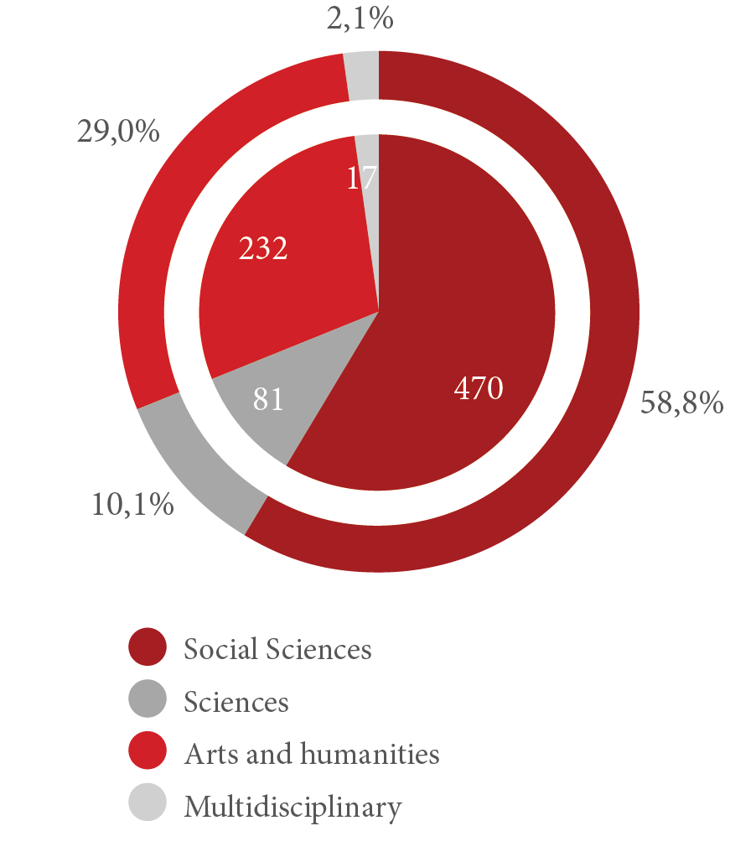

Source: Elaboration: scientometrics Lab Redalyc-Fractal (LabCrf) | Data from redalyc.org. | Metodology: http://www.redalycfractal.org/ met | Creation: october 18th 2013.

excepting international organizations12, 15 countries publish the jour- nals indexed by redalyc.org and participate in the calculation of the indicators (see Graph 15). when analyzing the scientific output based on of the country of the authors’ institutional adscription, it must be noted that the number of nations that publish their research results in journals of the database increases to 146 and, in different magnitudes, it covers countries from all continents.

- some examples of international organizations that stand out by their amount of contributions in redalyc.org are: the sociedad Interamericana de Psicología with 333 papers, the Centre International de recherches et d’Information sur l’economie Publique, sociale et Coopérative with 221 papers, and the Institut Français d’Études andines with 179 papers.

Graph 14
Distribution of source journals for the calculation of metrics by discipline

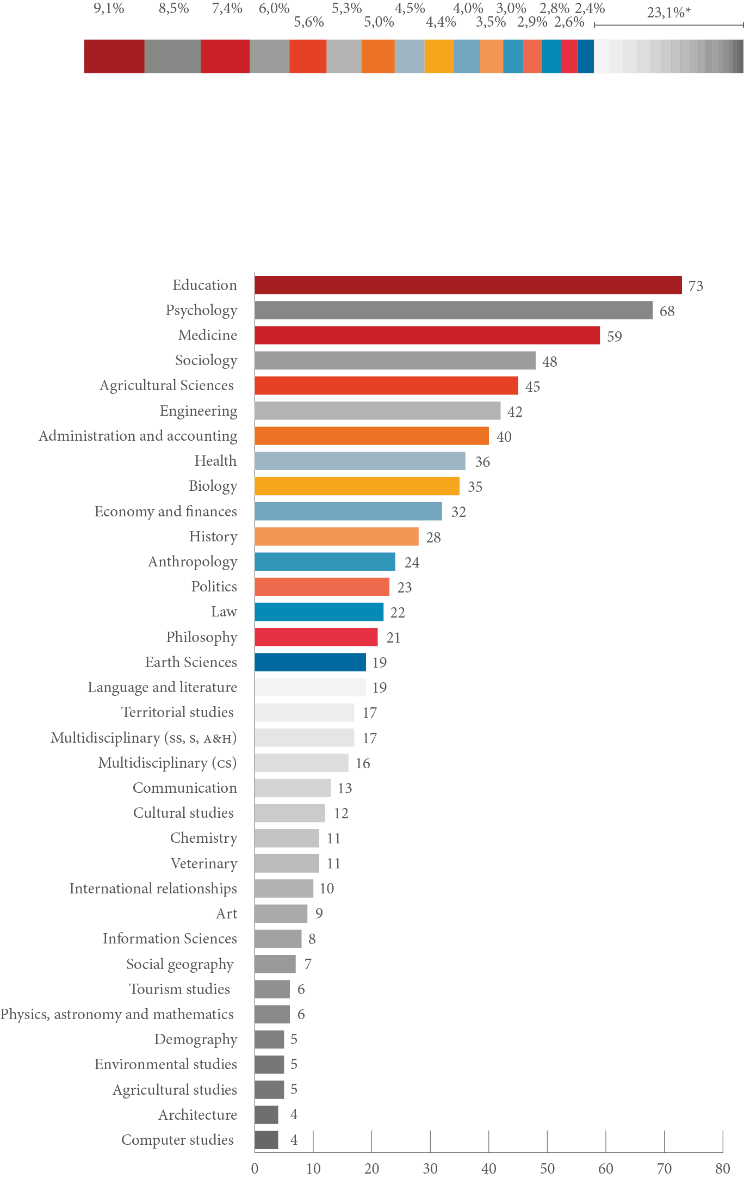
Source: Elaboration: scientometrics Lab Redalyc-Fractal (LabCrf) | Data from redalyc.org. | Metodology: http://www. redalycfractal.org/met | Creation: october 18th 2013.

Graph 15
Distribution of source journals for the calculation of metrics by country of edition, 2005-2011
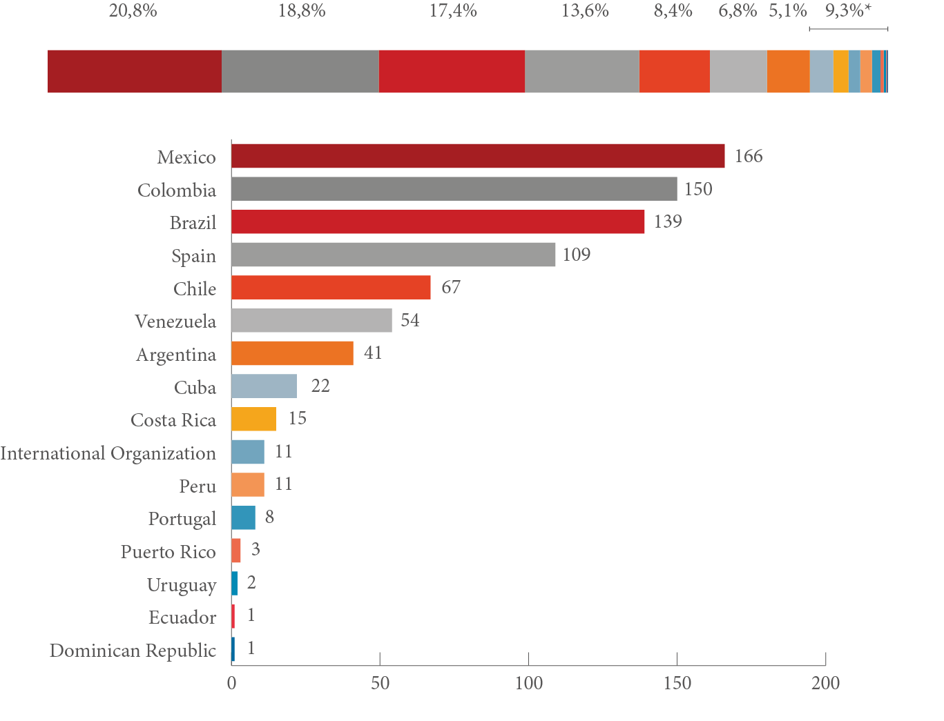

Source: Elaboration: scientometrics Lab Redalyc-Fractal (LabCrf) | Data from redalyc.org. | Metodology: http://www.redalycfractal.org/ met | Creation: october 18th 2013.
* Includes: Cuba, Costa Rica, International Organization, Peru, Portugal, Puerto Rico, Uruguay, Ecuador and Dominican Republic.

at the same time, the total number of institutions with papers pub- lished in any of the redalyc.org journals between 2005 and 2011 was 13,414. among these, 8,413 were from the sciences; 7,181 from the social sciences; 1,311 from arts and humanities; and 1,066 from mul- tidisciplinary fields, as shown in Table 1. This composition exhibits a relatively balanced distribution between the number of institutions that participate in sciences and social sciences. This is a good example of the input of the Ibero-american institutions in the communication of scientific knowledge around the region, compared with the disci- plines of the “mainstream science”.13

- For a better explanation of the “mainstream science” in relation to peripheral science, see Guedón, 2011.

To know the magnitude of the scientific output by country and authors’ institutional affiliation – and considering that one paper can be authored by more than one author– the core of papers was disag- gregated so one paper can be considered as many times as different countries and/or institutions sign it. This is a very important because if affects the total amount of Production by Continent, Country, and Institution mentioned in Table 1, coverting the core of papers into 153,318, 156,734 and 206,335, respectively.
It is important to mention that even though the author’s infor- mation is included in the papers, they do not always offer data on institutional affiliation, or such information is not specified enough or the institution’s country is not mentioned either. These cases are considered as authors with incomplete metadata. Graph 16 shows the composition of the studied universe in this regard.

Graph 16
Authors with complete and incomplete metadata, 2005-2011
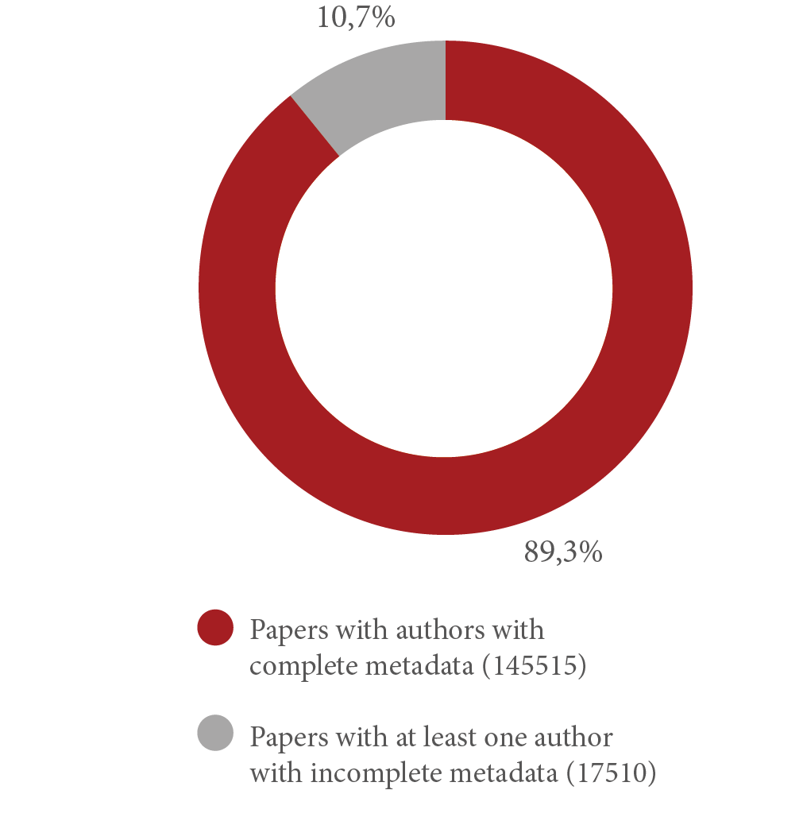

Source: Elaboration: scientometrics Lab Redalyc-Fractal (LabCrf) | Data from redalyc.org. | Metodology: http://www. redalycfractal.org/met | Creation: october 18th 2013.

The authors with incomplete metadata are excluded from the analysis, so the patterns of authored by two authors, but one of them has in-

complete metadata, the paper will be considered as published by only one author and, as such, classified as without collaboration, which means that paper will not count for the institution and/or country of the author with incomplete data.14
In conclusion, using redalyc.org as a source of scientometric analysis for research papers allows for the following:

- It is the information system with the highest number of Ibero- american journals with complete contents from 2005 to 2011, which makes it a significant database of high utility to perform different kinds of analysis.
- From the Ibero-american websites, it is the database with more journals in spanish.
- It is the information system with the lowest levels of bias and with one of the best processes of metadata registration, valida- tion, and normalization.
- almost two-thirds of the database is represented by social sci- ences, arts, and humanities journals. This describes the editorial universe that defines the database’s strengths and representa- tion. however, this is balanced with the area of sciences regard- ing the number of scientific papers due to the higher periodicity and publishing rate in journals of this area of knowledge.
- It has a set of criteria to guarantee the journal quality. These fulfill international scientific quality parameters, and are su- pervised by an International scientific advisory board that includes renowned researchers, each one related to different areas of knowledge, disciplines, and lines of research.
- To be included in the online journal database, the system re- quires the fulfillment of international standards of editorial quality, the existence of electronic files of all the papers pub- lished from 2005 to date, and the acceptance – through a good- will agreement – of the open access model.

- we are aware of the implications of this methodological decision. however, it is based on the following logic: a) less than 5% of the total source universe belongs to this category, and b) including papers with incomplete metadata in the analysis would have necessitated adding the category “unidentified” to the country and the institu- tion. This would mislead the reader because in the majority of the cases, the problem is not the author’s lack of institution or country of affiliation; the problem is the set of omissions due to editorial care. by eliminating these cases from the analysis, we ask for the minimum responsibility of every editorial quality process and, by making this clear, we make the implications of incurring in bad editorial practices, visible.

FinAL ConSiDERATionS
as stated, the fact that journals from countries in the global south are marginally represented in the “mainstream science” databases, where many results and research subjects go unnoticed, is unquestionable. This is not just a consequence of authors’ publishing in their native language, it is also because in the special case of social sciences, most of the research and the papers that account for it are strongly linked to local interests and problems. Their research, then, may not neces- sarily reflect the established approach to publication from an inter- national perspective, which contributes to why their research is often invisible to the systems of specialized publication and their existent measuring tools (Gingras & Mosbah-Natanson, 2011).
as mentioned by alperin (en adams, n.d.), the majority of the latin american journals are mainly published by public academic in- stitutions, which is why instead of looking for profit, they want to create communication spaces to encourage a greater dialogue inside and outside their academic communities. In this sense, the redalyc. org database has the social role of supporting public universities and their editorial projects – often times subject to diverse restrictions that impair a greater dissemination of the knowledge they produce – to the extent that it gives a set of tools to their academics and researchers, and to their editorial teams, which effectively increases the visibility and the interactivity around the scientific papers through an extensive network of usage and collaboration via the internet.
This online library has its similarities with the simple yet power- ful inspiring force of the great library of alexandria – the capability of gathering the greatest amount of publically-funded knowledge pro- duced and provided by a diversity of cultures with the noble goal of sharing it with anybody who is interested, without any economical, technical, social, or legal restrictions (aguado-lópez, 2013).
however, today, all the scientific disciplines are involved in a gen- eralized race towards the evaluation of their impact from bibliometri- cal indicators that take into account the number of citations one way or another. This has wrongly been seen as a measure of their qual- ity, and in the specific case of social sciences and humanities, it has played against the diversity and critical character of their academic advances. Therefore, this way of measuring, generally out of context, has proven to be ineffective for the humanistic and social disciplines, especially for the knowledge produced outside the theoretical and methodological paradigms accepted by the mainstream that are of- ten not published in the journals classified in the rankings of private companies such as the reed-elsevier and Thomson reuters (Vessuri et al., 2013).

This transformational process has opened up academic groups and their research communities beyond localized dialogue and re- gional collaboration, pushing the latin american sciences towards the internationalization of their scientific work strategies in such a way that once their analytical construct has been debated and agreed, they try to disseminate the knowledge in different ways and through different collaborations and publication fields, mainly through scien- tific papers that capture in a more efficient way the actual state of publishing as a highly changeable social phenomena.
The relevance of studying research output, collaboration, and communication from Ibero america, especially in latin america and the Caribbean, resides in characterizing each of these elements inside the process of science production according to the particu- larities of each country, with the objective of providing a more ap- propriate approximation about what happens in this region, which has historically been analyzed from more ethnocentric points of view. That is why it is important to qualitatively and quantitatively document the way science is moving from local to global – from the identification of a set of communication and collaboration networks integrated at a regional and international level, to glocal15 themed problems, which are often are associated with the millennium’s de- velopment objectives established by UNesCo, such as poverty, mi- gration, access to education and health, or climate change, to give some examples.
In this context, the ways for measuring scientific research in Ibe- ro america are being incrementally debated, even when the available information is fragmented and difficult to give a precise and accepted diagnosis in the matter (buquet, 2013). In this sense, although the mainstream databases keep leading the indicators that weight the in- vestigative capacity at a global scale16, and even though the biblio- metrical rankings are recognized to help unify the organizational field of science (sanz & de Moya-anegón, 2010), these can be dangerous if

- The term glocal, proposed by roland robertson comes from the interaction between global and local perspectives when building a culture that is global but has distinctive local characteristics that make it unique.
- The Impact Factor (IF) is the mean of the amount of citations by the number of published papers in the journals considered in the annual JCr (Journal Citation report) report of the IsI; the h index is presented as an alternative to the IF and im- plies a mean between the number of publications and citations they receive. Finally, the relative Impact (rI) is applied by discipline and is the result of the quotient of the impact presented by a certain discipline in a country, divided by the impact of that discipline in the world according to the total of citations divided by the total of papers exclusive of that area.

used to formulate generalizations, which is why they must be qualita- tively and quantitatively treated from a different perspective (archam- bault & lariviére, 2010).
This way, papers published in the journals indexed by redalyc.org and the metadata systematized by the labCrf, fulfill the purpose of making the invisible, visible. It is important to remember that, from an epistemological perspective, no community can account for of any knowledge that is not made visible if it is not published and if society will not read it (lópez-lópez, 2010).
In this sense, redalyc.org is a highly significant tool for those who design scientific policies inside nations and Ibero-american institu- tions, and for those responsible for implementing them in the scientific field, including academics and researchers interested in these matters. This has made redalyc.org worthy of many awards and acknowledg- ments from institutions as important as the Instituto de Información Científica y Tecnológica (IdICT), Cuba; the red de Investigadores so- bre Globalización y Territorio rII, belo horizonte, brazil; the Consejo superior de Investigaciones Científicas, spain; the Universidad rey Juan Carlos and the sociedad latina de Comunicación social; Univer- sidad Complutense de Madrid, spain; the Universidad de los andes, Venezuela; and the world summit award.
additionally, it must be recognized that redalyc.org strongly en- courages the continuous improvement of the editorial processes of the journals that are part of the database, as well as for those that will be added in the future, according to standards of scientific quality that respect institutional, national, and regional peculiarities of each of the participating entities.
It should be pointed out that redalyc.org web portal has sup- ported the budapest declaration in latin america and the Caribbean, not only through the encouragement for publishing in open access journals, but also through the motivation for a Mexican legislation that stimulates the open access to scientific information and the exist- ence of institutional repositories that allow better preservation and dissemination of research papers among the academic community and citizens interested in knowing the results of the research mainly developed with public funds.
as stated by ordorika (2012), the country must continue legislat- ing about public resources for production and dissemination of sci- entific knowledge, using technologies so public universities can keep broadening the sphere of their social responsibility without losing their essence as institutional formers of knowledge. That is why re- dalyc.org has been consolidated at a regional level while also having an international presence.

Therefore, this initiative invites institutions and their research groups to make this data a subject of study, capable of being ana- lyzed longitudinally and across countries, institutions, areas of knowledge, and in relation to other technological platforms and similar online databases.
Finally, through the use of metrics calculated by databases with a significant coverage, such as redalyc.org, the details of the research results communicated in journals today and published by the Ibero-american region can be known. This contributes to the debate around the spaces and policies to which those in the center and and around the periphery of science pay attention to. Thus, thanks to the scientific Production Profiles that can be obtained with the information from database, and to the resulting analysis by the academic community, redalyc.org and the scientometrics lab presents an extensive solution to understanding the contribu- tions made by countries, institutions, and authors in this open ac- cess database, no matter their size, resources, infrastructure, or age. behind this great effort, lays a central objective whose goal is to contribute to making the invisible, visible, because what can not be seen does not exist and scientific knowledge must be a common good available to everyone.

REFEREnCES
adams, C. (n.d.). open access in latin america: embraced as key to visibility of research. SPARC. retrieved from http://www.sparc. arl.org/news/open-access-latin-america-embraced-key-visibility- research-outputs
aguado-lópez, e., Fischman, G., y babini, d. (2013). ¿son los promotores del acceso abierto los alejandrinos del siglo XXI? In Cuadernos del Pensamiento Crítico Latinoamericano (ClaCso),
6. retrieved from http://biblioteca.clacso.edu.ar/clacso/ se/20131016025858/Cuaderno-No6-segepoca.pdf
aguado-lópez, e., Garduño-oropeza, G., rogel-salazar, r., y
Zúñiga-roca, M. F. (2012). The need and viability of a mediation index in latin american scientific production and publication. The case of the redalyc system of scientific Information.
In Aslib Proceedings (bradford) No 64. retrieved from http:// www.redalyc.org/redalyc/media/redalyc_n/acerca-de/inc/doc/ documento03.pdf
aguirre-Pitol, M. a.; leal-arriola, M., y Martínez-domínguez, N.
d. (2013). análisis comparativo de la cobertura de scielo y redalyc.org. México, labCfr®-UaeMeX. Repositorio

Institucional UAEMEX (Toluca, Mexico). retrieved from http:// ri.uaemex.mx/handle/123456789/571
archambault, É., y larivière, V. (2011). los límites de la bibliometría en el análisis de la literatura en ciencias sociales y humanidades. In Informe sobre las Ciencias Sociales en el mundo. Las brechas del conocimiento (Paris: UNesCo). retrieved from http://www. foroconsultivo.org.mx/libros_editados/informe_sobre_las_ ciencias_sociales_en_el_mundo.pdf
babini, d. (2006). acceso abierto a la producción de ciencias sociales de américa latina y el Caribe: bibliotecas virtuales, redes de bibliotecas virtuales y portales. Dominique Babini y Jorge Fraga (comps.) Edición electrónica, bibliotecas virtuales y portales para las ciencias sociales en América Latina y el Caribe (buenos aires: ClaCso). retrieved
from http://bibliotecavirtual.clacso.org.ar/ar/libros/secret/ babini/babini.pdf
becerril-García, a., aguado-lópez, e., rogel-salazar, r., Garduño- oropeza, G. y Zúñiga-roca, M. F. (2012). de un modelo centrado en la revista a un modelo centrado en entidades: la publicación y producción científica en la nueva plataforma redalyc.org. In Aula Abierta (oviedo: Universidad de oviedo), 40(2). retrieved from http://dialnet.unirioja.es/servlet/fichero_ articulo?codigo=3920933&orden=0
beigel, F. (n.d.). latin american publishing system in the crossroads of the world-academic system. In Sage/International Sociological Association, Current Sociology (in process).
bourdieu, P. (2012). dos imperialismos de lo universal. In Intelectuales, política y poder (buenos aires: eudeba/Clave intelectual).
buquet, d. (2013). Producción e impacto de las ciencias sociales en américa latina. In Doc. de trabajo del Consejo Latino Americano de Ciencias Sociales (buenos aires: ClaCso). retrieved from http://biblioteca.clacso.edu.ar/clacso/becas/20131016084109/ buquet_Ciencias_sociales_america_latina.pdf
Gasca Pliego, e., Martínez Carbajal, r., Tinoco García, I., arriaga Jordán, C., González lópez, s. y aguado lópez, e. (2013).
Informe sobre la producción científica de la UAEMEX en revistas iberoamericanas de acceso abierto en Redalyc.org 2005-2011 (Toluca, Mexico: UaeM-Facultad de Ciencias Políticas y sociales laboratorio de Cienciometría redalyc-Fractal).
Gingras, y. y Mosbah-Natanson, s. (2011). ¿dónde se producen las ciencias sociales? In Informe sobre las Ciencias Sociales en el

mundo. Las brechas del conocimiento (Paris: UNesCo, Foro Consultivo Científico y Tecnológico). retrieved from http:// www.foroconsultivo.org.mx/libros_editados/informe_sobre_las_ ciencias_sociales_en_el_mundo.pdf
Guédon, J.C. (2011). el acceso abierto y la división entre ciencia principal y periférica. In Revista Latinoamericana de Ciencias Sociales (buenos aires: ClaCso), 6.
hernes, G. (2011). Prefacio. Un planeta, mundos aparte ¿el mismo mapa? In Informe sobre las Ciencias Sociales en el mundo. Las brechas del conocimiento (Paris: UNesCo, Foro Consultivo Científico y Tecnológico). retrieved from http://www. foroconsultivo.org.mx/li- bros_editados/informe_sobre_las_ ciencias_sociales_en_el_mundo.pdf
hicks, d. M. (2004). The four literatures of social science. In h.
Moed (ed.), Handbook of Quantitative Science and Technology Research (Netherlands: Kluwer academic). retrieved from http:// citeseerx.ist.psu.edu/viewdoc/download?doi=10.1.1.10.500&rep= rep1&-type=pdf
llorens, a. (2013). le Monde: la importancia del acceso abierto y el ejemplo latinoamericano. retrieved from http://editarenmexico. wordpress.com/2013/04/01/le-monde-la-importancia-del-acceso- abierto-y-el-ejemplo-latinoamericano/
lópez lópez, w. (2010). Internacionalización y visibilidad del conocimiento. Universitas Psychologica (Colombia: Pontificia Universidad Javeriana), 9(2). retrieved from http://www.redalyc. org/articulo.oa?id=64716832001
Melero, r. (2005). acceso abierto a las publicaciones
científicas: definición, recursos, copyright e impacto. In El Profesional de la Información (barcelona: swets blackwell), 15(4). retrieved from http://eprints.rclis. org/6571/1/ePI-rmelero.pdf
Miguel, s. (2011). revistas y producción científica de américa latina y el Caribe: su visibilidad en scielo, redalyC y sCoPUs.
Revista Interamericana de Bibliotecología, 34(2). ordorika sacristán, I. (2012). Tareas pendientes de la política
en educación superior y la importancia de reafirmar la
visión progresista de la autonomía universitaria en el contexto actual. Perfiles Educativos (Mexico), 34. retrieved from http://132.248.192.201/seccion/perfiles/2012/nea2012/ mx.peredu.2012.ne.p176-180.pdf
Pérez angón, M. a. (2006). Usos y abusos de la cienciometría. Revista Cinvestav (México: Cinvestav). retrieved from http://www.

cinvestav.mx/Portals/0/sitedocs/sec_difusion/revista-Cinvestav/ enero-marzo2006/6%20usos.pdf
Quevedo-blasco, r. y lópez-lópez, w. (2011). situación de las revistas iberoamericanas de psicología en el Journal
Citation reports de 2010. Universitas Psychologica (bogotá), 10(3). retrieved from http://www.redalyc.org/articulo. oa?id=64722377023
rogel-salazar, r. y aguado-lópez, e. (2011). redalyc ocho años haciendo presente la ciencia iberoamericana en el contexto de la sociedad de la Información. In María de Lourdes López-Gutiérrez, José Luis López-Aguirre & José Samuel Martínez-López (coords.) La comunicación que necesitamos, el país que queremos, (Mexico: XV encuentro Nacional CoNeICC). retrieved from http://es.scribd.com/ doc/71612437/ebook-la-comunicacion-que-necesitamos- el-pais-que-queremos
russell, J. M., y ainsworth, s. (2011). Investigación en ciencias sociales en américa latina en comparación con China e India. In Informe sobre las Ciencias Sociales en el mundo. Las brechas del conocimiento (Paris: UNesCo, Foro Consultivo Científico y Tecnológico). http://www.foroconsultivo.org.mx/libros_editados/ informe_sobre_las_ciencias_sociales_en_el_mundo.pdf
santillán-aldana, J. (2011). la necesidad de sistemas de información abiertos no excluyentes: entrevista a ana María Cetto Kramis. Biblos (Peru), 42. retrieved from http://www.redalyc.org/ articulo.oa?id=16120044005
sanz Menéndez, l. y de Moya anegón, F. (2011). Una nueva industria: la calificación de las universidades en las ciencias sociales. In Informe sobre las Ciencias Sociales en el mundo. Las brechas del conocimiento (Paris: UNesCo, Foro Consultivo Científico y Tecnológico). retrieved from http://www. foroconsultivo.org.mx/libros_editados/informe_sobre_las_ ciencias_sociales_en_el_mundo.pdf
UNesCo. (2010). world social science report 2010: knowledge divides. Paris, France: author. retrieved from http://www. unesco.org/new/en/social-and-human-sciences/resources/reports/ world-social-science-report-2010/
UNesCo. (2013). report of the regional latin american and Caribbean consultation on open access to scientific
information and research-concept and policies. retrieved from http://www.unesco.org/new/en/communication-and- information/resources/news-and-in-focus-articles/all-news/

news/first_regional_latin_american_and_caribbean_ consultation_on_open_access_to_scientific_information_ and_research
Vessuri, h., Guédon, J.C., y Cetto, a. M. (2013). excellence or quality? Impact of the current competition regime on science and scientific publishing in latin america and its implications for development. Current Sociology. http://csi.sagepub.com/ content/early/2013/12/02/0011392113512839



