ERGONOMÍA OCUPACIONAL
INVESTIGACIONES Y APLICACIONES

VOL. 6

SOCIEDAD DE ERGONOMISTAS DE MÉXICO A.C. (SEMAC) 2013

ERGONOMÍA OCUPACIONAL
INVESTIGACIONES Y APLICACIONES

VOL. 6

EDITADO POR:
CARLOS ESPEJO GUASCO
Presidente Fundador SEMAC

ENRIQUE DE LA VEGA BUSTILLOS
Presidente SEMAC 2002-2004

ELISA CHACÓN MARTÍNEZ
Presidente SEMAC 2012-2014

2013 Sociedad de Ergonomistas de México A.C. (SEMAC)
ISBN 978-0-578-12323-3

CONTENT

ANTHROPOMETRY

P a g e

PROTOTYPE DESIGN CHAIR ANTHROPOMETRIC  Cristian Vinicio López Del Castillo, Penélope Guadalupe Álvarez Vega, Luis Francisco Cano García, Ing. Mayra Alejandra Noriega Urrea, Ing. María Jesús Quijada Frisby, Ing. Lizbeth Yelene López Galindo, Lic. Alejandro Vega Granillo | 1
APPLICATION OF ANTHROPOMETRIC MEASUREMENTS IN COMPUTER ASSEMBLY  Gerardo García Acosta | 12
TRADITIONAL ANTROPOMETRIC MEASUREMENTS VS DIGITAL ANTROPOMETRIC MEASUREMENTS, AN INNOVATION IN ERGONOMICS  Joaquín Vásquez Quiroga, Enrique Javier de la Vega Bustillos, Francisco Octavio López Millán | 16
ANTHROPOMETRIC AND ERGONOMIC PRELIMINARY STUDY TO DETERMINE IF PUSH OR PULL A CAR LOADED WITH MATERIAL IS CAUSING BACK PAIN  Martha R. Contreras-Valenzuela, Roberto C. Garcia-Rojo | 22
OBTAINGING BODY MASS INDEX USING ANTROPOMETRIC DATA FROM STUDENTS OF THE DEPARTMENT OF INDUSTRIAL INGENEERING AT THE UNIVERSITY OF SONORA, MEXICO  Martina Elisa Platt Borbon, Amina Marin Martinez, Maria Magdalena Romo Ayala, Graciela Rodriguez Vega | 28

BIOMECHANICAL

STUDY OF MAXIMUM GRIP FORCE ACCEPTABLE FOR WOMEN  WORKING IN INDUSTRIAL MANUFACTURING APPLYING A POLYNOMIAL REGRESSION MODEL CONSIDERING THE WEIGHT  Gerardo Meza Partida, Enrique Javier de la Vega Bustillos, Fco. Octavio Lopez Millan, Manuel Rodriguez Medina | 34
REVIEW OF VARIABLES AFFECTING RECOVERY TIME FOR THE SHOULDER  Francisco Octavio López Millán, Enrique Javier De la Vega Bustillos, Manuel Rodríguez Medina, Gerardo Meza Partida | 40

COGNITIVE ERGONOMICS
COGNITIVE ERGONOMICS: CONTEMPLATIVE TECHNIQUES TO  EXERCISE ATTENTION AND FOCUS SKILLS  Julio Gerardo Lorenzo Palomera | 48

INTRODUCTION TO MULTIPLE RESOURCES THEORY AND MODEL  Aide Aracely Maldonado Macías, Rosa María Reyes Martínez, Jorge Luis García Alcaraz, Arturo Realyvásquez Vargas | 60

DESIGN AND WORK ANALYSIS

ERGO-MODAPTS: DEVELOPMENT OF A MODEL BASED ON THE STUDY  OF TIMES PREDETERMINED MODAPTS AND SUSAN RODGERS ERGONOMIC EVALUATION  Deyanire Uribe Lam, Enrique de la Vega Bustillos, Francisco Octavio Lopez Millan, Karla Lucero Duarte | 69
RISK CONDITIONS AND DISCOMFORT BY BODY REGION WITHIN A LABORATORY OF TOXIC WASTE IN HERMOSILLO, MEXICO  Laura Elena López-Imperial, Amina Marín Martínez, Jaime Alfonso León Duarte, Alfonso Cisneros-Campos | 77
ANALYSIS OF RISK FACTORS OF MUSCULOSKELETAL INJURIES IN UPPER EXTREMITY IN ASSEMBLY LINE WORH WITH DYNAMIC LOADS  Ana Carolina Esparza Urquijo, Francisco Octavio López Millan, Enrique Javier de la Vega Bustillos, Gerardo Meza Partida | 86
CHARACTERIZATION OF OCCUPATIONAL ERGONOMICS PROGRAM  Ramona Monserrat Fuentes Córdova, Francisco Octavio López Millán, Enrique Javier De la Vega Bustillos | 93
METHODOLOGY FOR THE IMPLEMENTATION OF A SYSTEM OF JOB ROTATION CONSIDERING AN ERGONOMIC APPROACH  Francisco Armando Loreto López , Enrique de la Vega Bustillos, Francisco Octavio Lopez Millan, Gerardo Meza Partida | 99
PROPOSED PROCEDURE FOR THE ERGONOMICS EVALUATION FOR CUMULATIVE TRAUMA DISORDERS  Jaime Guadalupe Pérez Muñoz, Marbella Muñiz Sánchez, María Eugenia Lazcano Herrero, Felipe Martínez Vargas | 112
HAPTIC GRAPHIC DESIGN MATERIALS FOR THE VISUALLY IMPAIRED  Jorge Eduardo Zarur Cortés | 121
PSYCHOSOCIAL FACTORS NEGATIVE WORK ENGAGEMENT AND BURNOUT IN ADMINISTRATIVE A TEXTILE COMPANY BASED IN ARGENTINA AND MEXICO. 2011-2012  Juan Carlos Gutiérrez Muñoz, Manuel Pando Moreno, Carolina Aranda Beltrán, Mónica Contreras Estrada, Cecilia Colunga Rodriguez, Pedro Reynaga Estrada | 128
VERIFICATION OF THE RELATIONSHIP: PERCENTILE-MAXIMUM LIFTING LOAD, TABULATED IN LIBERTY MUTUAL TABLES, FOR MAN AND WOMAN YOUNG  Jesús Rodolfo Guzmán Hernández, Joaquín Vásquez Quiroga, Enrique Javier De La Vega Bustillos, Octavio López Millan | 133

ANALYSIS OF THE RELATIONSHIP DRY EYE VISUAL PROBLEM AND  EXPOSITION TIME, TYPEFACE AND TEXT/BACKGROUND COLOR CONTRAST WHEN READING FROM LIQUID CRYSTAL DISPLAY COMPUTER SCREENS  Rosa María Reyes Martínez, Jorge de la Riva Rodríguez, Aide Maldonado Macias, Jaime Sánchez Leal, Rodolfo de la O Escápita | 140

OCCUPATIONAL HEALTH

ORTHOPEDIC JEWELRY, SILVER SPLINT ULNAR DEVIATION FOR  PHASE I  Erika Salas Tapia | 149
DESIGN OF ERGONOMIC ORTHOPEDIC CRANE FOR PATIENTS WITH IN MOBILITY AND DISPLACEMENT DIFFICULTIES  Gabriel Bermúdez, Araceli Vázquez, Joel Manríquez, Aurelio Olmedo | 160

OFFICE ERGONOMICS

PROPOSAL FOR ERGONOMIC FURNITURE PROVISION AND  IMPROVEMENT FOR STUDENTS HANDED IN DGETI CAMPUSES OF THE STATE OF CHIHUAHUA  Miguel Francisco Nassri Chávez | 171

PACKAGING AND CONTAINERS

PROTECTIVE PACKAGING DESIGN, USING ERGONOMIC CRITERIA  Rosa Maria Bernardette Coss y León Perez and Elvia Luz González Muñoz | 182

WORK EVALUATION

APPLICATION OF THE OWAS METHOD FOR EVALUATING RISK FOR A  LABORER OF SACKSFLOUR  Jesús Efraín Villegas Duarte, Aarón Fernando Quirós Morales, Mauricio López Acosta, Luis Carlos Montiel Rodríguez, Gilda María Martínez Solano, Rubén Varela Campos | 191
STUDY TO DETECT CARPAL SYMPTOMATOLOGY IN DENTISTS  Jesús Iván Ruiz Ibarra, Alberto Ramírez Leyva, Claudia Castro Estrada, Arleth Valdez Quintero, Jesús Mondaca Armenta, Rafael Salido Valdez, Ileana León Heras, Rosmar Vega Valenzuela | 200
APPLICATION OF REBA METHOD FOR RISK ASSESSMENT IN CEMENT BAGS LIFTING  Jesús Isaac González Gaxiola, Luis Carlos Montiel Rodríguez, Aarón Fernando Quirós Morales, Mauricio López Acosta, Jesús Enrique Sánchez Padilla, Gilda María Martínez Solano | 208
OCCUPATIONAL RISK ASSESSMENT IN A WINDOW REGULATORS ASSEMBLY COMPANY: A CASE OF L.E.S.T. METHODOLOGY  Amina Marín Martínez, Martina Elisa Platt Borbón, Magdalena Romo Ayala | 219

WAYS TO APPLY OWAS METHOD TO EVALUATE THE POSITIONS  TAKEN BY A CHARGER IN A SUPERMARKET STORAGE AREA  Gabriel Tadeo Zubirán Hurtado, Gilda María Martínez Solano, Rubén Varela Campos, Mauricio López Acosta | 230
ERGONOMIC EVALUATION IN AN AUTO SHOP USING THE REBA METHOD  Diego Moisés Sepúlveda Losoya, Mauricio López Acosta, Gilda María Martínez Solano, Luis Carlos Montiel Rodríguez | 239
STOVE CHINANTLA  Efren Toledo Toledo, Raymundo Ocaña Delgado, Francisco Platas López, Jorge E. Zarur Cortes y Santiago Osnaya Baltierra | 249
IMPLEMENTATION OF SOME PRINCIPLES OF LEAN MANUFACTURING WITH ERGONOMIC SUPPORT ANALYSIS  Rigoberto Zamora Alarcón, Tania Castañeda Madrid, Ariel Rubio Villegas, Jesús Edgardo Figueroa Lizarraga, Alan de Jesús Córdoba Pacheco | 256

COMITÉ ACADÉMICO

ROSA MARIA REYES MARTINEZ  Instituto Tecnologico de Cd. Juarez | MONICA AIDE BARRERA  Continental, Cd. Juarez
AIDE ARACELY MALDONADO MACIAS  Universidad Autonoma de Cd. Juarez | ELISA CHACON MARTINEZ  Nchmarketing, Cd. Juarez
ROSALIO AVILA CHAURAD  Universidad de Guadalajara | CARLOS ESPEJO GUASCO  Createc, Cd. Juarez
JEAN PAUL BECKER  Ergon, Guadalajara, Jal. | FRANCISCO OCTAVIO LOPEZ MILLAN  Instituto Tecnologico de Hermosillo
GABRIEL IBARRA MEJIA  Universidad Autonoma de Cd. Juarez | VICTORIO MARTINEZ CASTRO  Salud y Asesoria en Salud Industrial S.A. de C.V.
MIGUEL BALDERRAMA CHACON  Valeo, Cd. Juarez | AMINA MARIN MARTINEZ  Universidad de Sonora
ENRIQUE DE LA VEGA BUSTILLOS
Instituto Tecnolgico de Hermosillo

PROTOTYPE DESIGN CHAIR ANTHROPOMETRIC

1M.C. Cristian Vinicio López Del Castillo; 2M.C. Penélope Guadalupe Álvarez Vega,3Ing. Luis Francisco Cano García, 4Ing. Mayra Alejandra Noriega Urrea, 5Ing. María Jesús Quijada Frisby, 6Ing. Lizbeth Yelene López Galindo, 7Lic. Alejandro Vega Granillo

1,2,3,4,5,6,7 División de Ingeniería y Tecnología, Universidad de la Sierra,
Carretera a Cumpas km 2.5 Moctezuma, Sonora 84560

1viniciolopez77@hotmail.com, 2pgalvarez@hotmail.com, 3luis_01_cano@hotmail.com,4mayra_noriega90@hotmail.com,5mariajesus_q@live.com.mx, 6lopez_z5@hotmail.com, 7alexvegag@hotmail.com

Resumen:La antropometría es una disciplina fundamental en el ámbito laboral, debido a que mantiene una relación tanto con la seguridad como con la ergonomía. Esta disciplina permite realizar un estudio (elaborar cartas antropométricas) a una determinada región; los datos derivados de éste último son utilizados para mejorar las estaciones de trabajo que provocan enfermedades profesionales a los trabajadores. Las medidas obtenidas nos permiten alinear las características geométricas del puesto, crear un buen diseño del mobiliario, de las herramientas manuales, de los equipos de protección individual, etc. Para ello la antropometría hace uso de una serie de herramientas para obtener las medidas y dimensiones del cuerpo humano.
Este proyecto se realizó con el fin de mejorar y agilizar la toma de medidas antropométricas, debido a que al momento de utilizar el equipoantropométrico existen problemas de error y variación en la medición; íntegro el equipo de medición es ligero y fácil de transportar, sin embargo cuenta con algunas desventajas al momento de medir ya que se requiere más de una persona para sostener los instrumentos debido a que no se mantienen fijos y esto se vuelve algo laborioso y por lo tanto tardado. Otro inconveniente se presenta en que existe un índice de error dependiendo del individuo, ya a que no todos los usuarios colocan correctamente las herramientas y con la mínima desviación del instrumento se genera un dato erróneo. Como parte del proyecto de investigación y diseño denominado “Diseño de Prototipo de Silla Antropométrica” se hizo un análisis de variación de los resultados de las medidas tomados con el antropómetro norma, por alumnos que integran la Red de Ergonomía de la Universidad de la Sierra, con éste se detectaron posibles riesgos de accidentes al momento de tomar las medidas en este caso en la postura sentado, para ello se dio la tarea de diseñar un dispositivo que nos permita fijar las herramientas antropométricas en un dispositivo (silla) para que nos facilite su utilización y mayor exactitud en la toma de medidas, éste también evitará posibles accidentes o lesiones al individuo a medir, y como resultado obtendremos una medición rápida y confiable.
Para la realización de este proyecto se tomó en cuenta las principales dimensiones del cuerpo humano en la posición sedente (altura del asiento a la cabeza, altura del suelo a la parte posterior de larodilla, altura del asiento al muslo, codo, hombro y ojos).

Palabras clave: Antropométrica; Ergonomía; Diseño

Abstract: Anthropometry is a fundamental discipline in the workplace, because he has a relationship with both safety and ergonomics. This discipline allows a study (develop anthropometric charts) to a given region; the data derived from the latest is used to improve workstations that cause occupational diseases to the workers. The obtained measures allow us to aline the geometric characteristics of the post, to create a good design of the furniture, hand tools, of the equipments of individual protection, etc. So the Anthropometry makes use of a series of tools for the measures and dimensions of the human body of work that cause occupational diseases to workers. The obtained measures allow us to align the geometric characteristics of the post, to create a good design of the furniture, hand tools, of the equipments of individual protection, etc. So the Anthropometry makes use of a series of tools for the measures and dimensions of the human body.
This project was carried out in order to improve and streamline the taking of anthropometric measurements, since at the time of using the anthropometric equipment problems of error and variation in the measurement; complete measurement equipment is lightweight and easy to carry, however it account with some disadvantages when measure because more than one person is required to hold the instruments since they are not fixed and this becomes difficult and therefore time-consuming. Another drawback is that there is an error rate depending on the individual, some users not all misplace the tools and with minimum deviation of the instrument an error data is generated. As part of the project research and design called "Prototype design of anthropometric Chair" became a variation analysis of the results of the measures taken with the anthropometer standard, for students that make up the network of ergonomics from the University of the Sierra, with this possible risk of accidents were detected at the time of the measures in this case in the posture sitting, it was given the task of designing a device that will allow us to set the anthropometric device (Chair) tools that provide us with easy use and greater accuracy in taking measures, this will also prevent possible accidents or injury to the individual to measure, and as a result we get a fast and reliable measurement.
For the realization of this project was taken into account the main dimensions of the human body in the seated position (seat height to the head, height of the floor to the back of the knee, seat height to the thigh, elbow, shoulder and eyes).

Key Words: Anthropometric; Ergonomics; Design

INTRODUCTION.

The man in his eagerness to expedite its work and save effort has had to adapt their workstation due to the large amount of equipment and machinery that is imported from industrialized countries, is not designed for the different physical characteristics that exist in different regions or a country.
That is why today it makes use of anthropometry in the field of labor, because that allows us to create engineering designs, scale models, manufactured products, all to ensure the adequacy of these products to users in a given region; for example the correct design of the machinery, as well as the personal protective equipment.
The anthropometry makes use of a set of tools to take the series of measures for each individual, it should be seeing that the measuring equipment is lightweight and easy to carry, but it also has some disadvantages at the time of measure, since more than one person is needed to substain the instruments because they are not fixed and this becomes laborious and therefore

slow. Another drawback is that there is an error rate depending on the person, since not all users correctly put the tools and with the minimum deviation of the instrument is generated a erroneous data and this will affect directly to the design.
After these disadvantages it is necessary to create a tool or device that attach the measuring instruments with the purpose of grouping the number of steps in a single device, those avoided decrease the error at the time of measure, since the anthropometric equipment will be fixed and in addition will reduce the time of measurement, as well as the same will help the user better absorb the number and the points of the anthropometric measurement, those avoiding awkward postures with the time generate injury to the individual.

OBJETIVES.

Design a device which will help to improve, to better and speed up the retrieval of the various measurements and dimensions of the human body in the posture protractors, developing a chair which allows for the placement of anthropometric equipment according to the necessity of taking the measures, thereby reducing potential errors in the measurement and avoiding risks of accidents when you run the anthropometric measures.

DELIMITATION.

The project will be limited, only to positions if you are sitting down.

METHODOLOGY.

  - Observation and analysis of operation.
As a first step was necessary to observe and analyze how to measure the human body, in this case the seated position. To observe the technique and the process of obtaining measures and dimensions on the part of the members of the Network of ergonomics, the Sierra University, some anomalies were identified by the operators in the handling of the anthropometric tools (Figure 1); the failures were identified the same to be able to perform the diagnosis that has aimed at obtaining certainty in the results, to avoid possible accidents and reduce the measurement time.

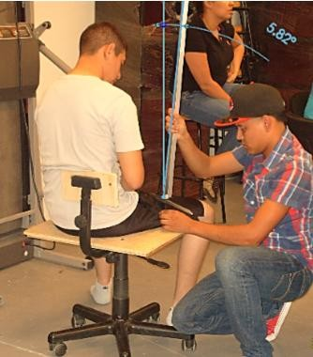

  - Proposal.
Figure 1.Incorrect placement of anthropometer.

Due to the need to streamline decision of anthropometric measures, developed a before-prototype of the design for the solution of diagnosis yielded by the analysis, which came to the conclusion of a multifunctional device attached to the anthropometer; a chair with two anthropometric porta span; anthropometric devices (Figure 2), which allowed its fixing and mobility for multiple measurements, which will be efficient and decrease unnecessary movements. Account anthropometric with other tools in the ends of the chair to measure other extremities, such as the seat height to the elbow, as well as that of the seat to the eye, shoulder, thigh, among others. In addition he was placed a mechanism of self-measurement in the bottom of the chair, which is useful to measure the height from the ground to top of the seat.
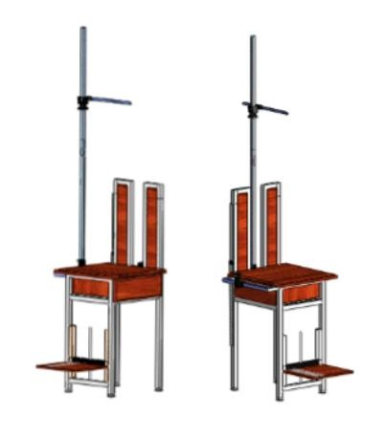
Figure 2.Design of the anthropometric chair.

  - Design of prototype.
It takes into account different factors for the design of the device as size, material of the components, resistance and design at the 5 and 95% percentile.
Once you have obtained the model design, the step to the development of the device, building the structure of the steel chair with PTR, coupled with begin welding, which allowed her to gain extra weight to the chair to keep it stable. In such a structure is placed a horizontal axis in the part of the seat to the right side, where it slides one of the porta anthropometer, this moving from side to side, which allowed the easy measurement of the various limbs of the body in the posture protractors, in addition to a vertical axis positioned on the right bank of the seatback, where he was positioned a metric ruler, this slides of up-down, being efficient to the measures of long elbow to the middle finger. The mechanism of self-measurement platform did you hear about in a manufactured on the basis of wood, placed at the bottom of the chair, which slides through two channels soldiers in the front legs, this admitted to take the auto-measure, when the subject feels, automatically, with the strength of your legs sliding down the platform, which allowed him to observe the height of the floor to the back of the knee as well in the same platform in your surface account with a metric ruler fixed, we could measure the length of the foot (Figure 3).
We were given the task of preparing a few letters considering anthropometric dimensions taken by the Chair anthropometric, which you can run 11 different measures, this was developed based on the enumeration and style of the letters of the anthropometric Society of ergonomists from Mexico, S. A (Figure 3).
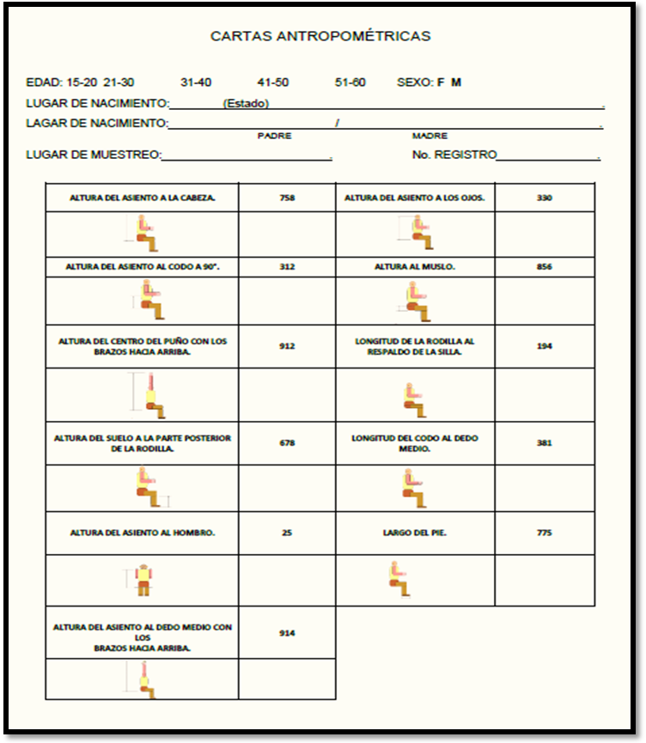
Figure 3.Anthropometric Letter, appropriate to the measures taken by the anthropometric Chair.

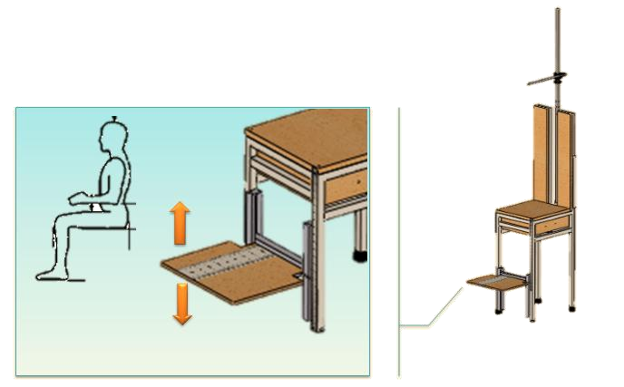
Figure 4.Mechanism of auto-measure.

  - Studies and tests.
These studies were made within the facilities of the Sierra University, in the laboratory of manufacturing, tests were carried out for anthropometric measures with students of Industrial Engineering, which was a comparison test with normal use of the anthropometer and the prototype of the anthropometric Chair.
These studies included observing 10 measurements of a single individual, with the normal anthropometer, taken by 10 different members of the Network of ergonomics, similarly 10 measurements were analyzed with the anthropometric Chair (Figure 5). On the basis of observations made during the tests the students that were measured had difficulty when attempting to perform the action without the help of another person, with normal the anthropometer, taking errors in the measures and a reduction of tim, at the time of measures with the anthropometric Chair, got to know that they are provided more its use, since more than three measures could not be carried out with the anthropometer in a single location, which was substantially a reduction in time and this in turn a minimum of error in the measures. At the time of measures normally, it was noted that the student showed inadequate postures, in which he may cause injury or discomfort, in the same manner are a possibility of damaging the subject to measure. To perform the measurements with the anthropometric Chair, were minimal positions that presents.

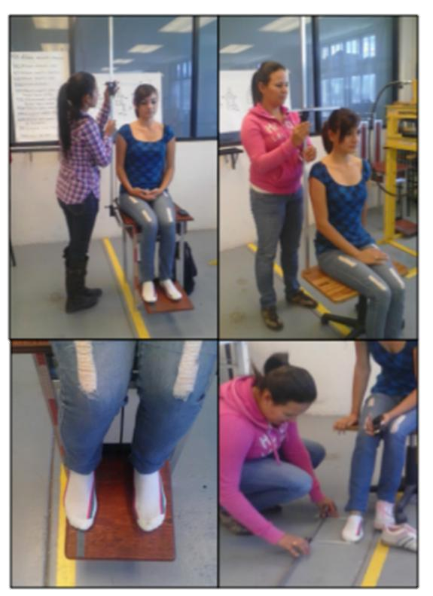
Figure 5. Comparison of measures,
with normal anthropometer, anthropometric and chair.

RESULTS.

We compared the measurements of Antropometer normal (ST) with the Antropometic Chair, we proved that the measurements of the (SA) is smaller than the measurements of (ST). With this that we proved we came to the conclusion that with the (SA) we get a better and exact measurements in less time. To get to this conclusion we made a test and base on that data we obtain this results of the (SA) is much better in measurements. (Table 1).

 | 758
Usuarios | ST | SA
P1 | 88.4 | 87.5
P2 | 87.4 | 87.6
P3 | 88.3 | 86.5
P4 | 89 | 87.5
P5 | 87.4 | 86.9
P6 | 88 | 86.6
P7 | 88.3 | 87.4
P8 | 86.7 | 86.9
P9 | 88.1 | 86.9
P10 | 87.3 | 86.5
Media | 87.89 | 87.03
Desviación | 0.6773314 | 0.4347413
Table 1. Results of data of measurements 758 (Hight of the chain o head).
ST | SA
Muestra 1 | Muestra 2
n1 = 10 | n1 = 10
X1 = 87.89 | X2 = 87.03
S1 = 0.6773 | S1 = 0.4347

α= 0.05 (Selection of 95% sare)

Hipotesis: H0: µ1=µ2
H1: µ1>µ2 (Test of the line on the Right)

Statistical Test Calculations:
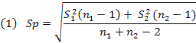
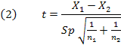
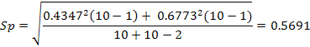

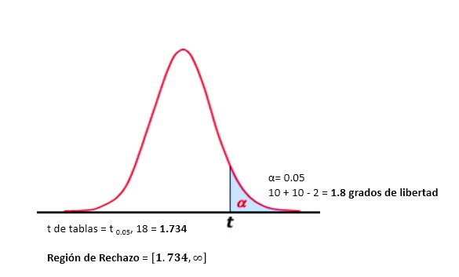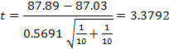

Decision: With the statistical test, it rejects H0.

With the test Results we got a confidence of 95% That the Antropometric Chair is better than the Antropometer (Table 2).
We got a prototype of the chair, the functions of the prototype was really good in the laboratory. We compared the results obtained with the Chair and the Antropomenter normal to validate the measurements ,we obtained a faster way of taking the measurements of the sitting down posture.(Table 3) This way it reduced the possible risk´s of the accidents of the person measuring and the person sitting down.

Table 2. Comparison of the measure 758, anthropometer vs normal Anthropometric Chair
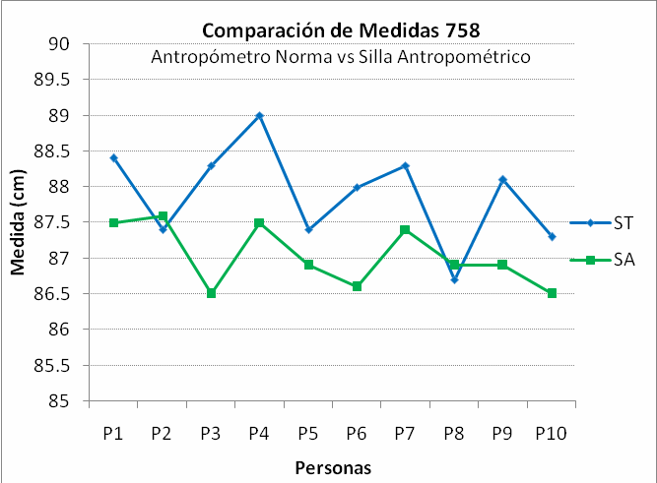

Table 3. Comparison of times.
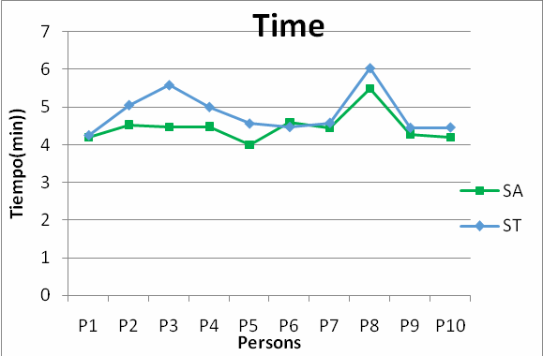

CONCLUSIONS.

Based on the results obtained from the analysis of comparative data on hypothesis testing, showed that the prototype of the anthropometric chair is a device which together with anthropometer allows us to obtain more accurate and reliable measurements. This accuracy help the companies responsible for manufacturing machinery, personal protective equipment and workspace designers to adapt the worker, not the worker adapt the work area that is commonly done.
Also in the future to help health workers to prevent ergonomic injuries evil designs of products or work areas.

REFERENCES.

Mondelo, P. R., Gregori, E., Blasco, J., & Barrau, P. (2004). Ergonomía 3, Diseño de Puestos de trabajo. México, D.F: ALFA OMEGA GRUPO EDITOR, S.A de C.V.
Vega Bustillos , E., & López Hernández, P. (1996). Cartas antropométricas de la población laboral de la República Mexicana.

APPLICATION OF ANTHROPOMETRIC MEASUREMENTS IN COMPUTER ASSEMBLY

Gerardo García Acosta gerardo.garcia@foxconn.com jerrygga@hotmail.com
Blvd. Oscar Flores Sánchez 8951 Tel. 656 649 9999 ext. 3330
Col. Puente Alto 32690 Cd. Juárez Chihuahua

Introducción:
Las cartas antropométricas dan la información acerca de las dimensiones de una población determinada y son muy utilizadas por los diseñadores. Los expertos en diseño afirman que una ayuda física diseñada para una población específica, no es óptima para cualquier otra; esto parece lógico, pero en nuestro país, no es posible ratificar o rectificar esta afirmación debido a que desconocemos las Cartas Antropométricas Mexicanas.
La antropometría es la determinante de las condiciones ergonómicas; por tanto, los estudios Antropométricos deben referirse a una población específica, se incluye un ejemplo de las tablas antropométricas por edad y por sexo de un estudio realizado a 405 trabajadores de una Empresa de Manufactura Electrónica y se describe la metodología utilizada.

Palabras Clave: Antropometría, Estaciones de Trabajo.

Introduction:
The anthropometric letters give all the information about a given population and are widely used by designers. Design experts say that a physical application designed for a specific population will be not optimal for any other; this seems logical, but for Mexico, here will be not possible to confirm or correct this statement because they unknown Mexican Anthropometric the letters.
Anthropometry determines proper ergonomic conditions; so anthropometric studies should refer to a specific population. There is attached an example of anthropometric tables by age and sex of a study of 405 workers of a Electronics Manufacturing Company corporate group describing the methodology.

Keywords: Anthropometry, Workstations.

Objectives:
Develop an anthropometric database of adults that are living in Juarez City Chihuahua, and are workers at a Electronics Manufacturing Company.

Delimitation:
The study includes a sample of the population available of Electronics Manufacturing Company of Juarez City, healthy male and female, between 15 and 60 years old and residents of Juarez City, Chihuahua, held during August 2012.

Methodology:
Four hundred five participants (154 men and 251 women) who met the criteria were recruited to a voluntarily participation. The objectives and methodology of the study were previously explained to each participant through a survey. Demographic information and anthropometric data were get from the survey.
In this study, 51 anthropometric dimensions were measured for men and women in centimeters (cm) and kilograms (kg). The dimensions were related to the dimension and weight of the human body. (Table 1) The measurements were made with participants that bring light clothes and work shoes.

Survey team
The team responsible for the data collection was by 6 workers of Electronics Manufacturing Company, who were trained during three sessions to be familiarize with the measurement mode.

Table1. The definition of each anthropometric measurement collected during the study.
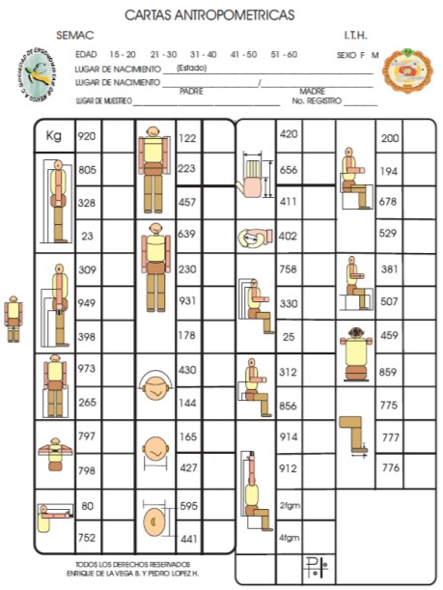

Materials and equipment Anthropometric model digital scales Anthropometric Letter Computer
Microsoft Excel 2010 Software

Data analysis
Microsoft Excel 2010 was used to analyze data to determine the descriptive statistics (mean, standard deviation, minimum, maximum), in order to achieve the first objective of this study is to determine the anthropometric dimensions of the sample.

Results:
Preliminary results of the anthropometric database for workers at a Electronics Manufacturing Company, workers are presented in the following images.
Statistical analysis, measurements from population mean, minimal measurement, maximum measurement from men and women are highlighted.

Figure 1. Sample population mean
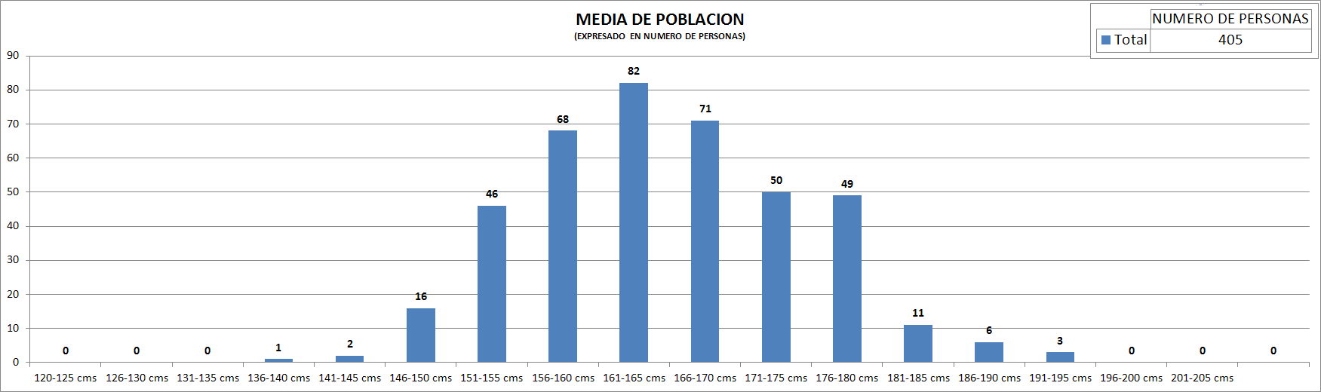

Figure 2. Maximum and Minimum Sample Sizes by body segment
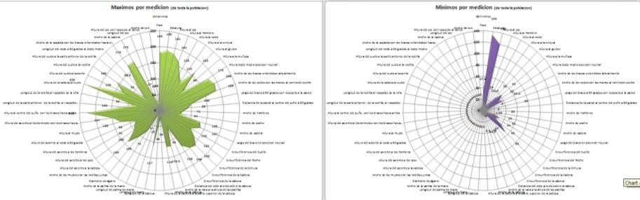

Figure 3. Shows Age and Sex Percentages.
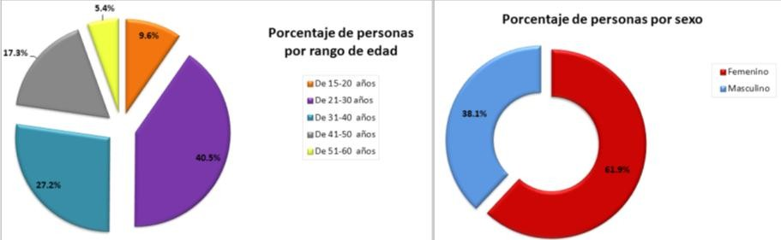

Conclusions:
This study was conducted with a sample of the population of Electronics Manufacturing Company of Juarez City, Chihuahua of 154 men (38%) and 251 women (62%), where anthropometric measurements were obtained to be considered for the design of the work stations. Note that this is the first study; therefore it is important to give subsequent monitoring, considering a similar sample size in order to maintain an updated database, which is used for the correct design of workstations, for proper placement of tools and is taken into account for the management of materials and equipment.
It was able to show as anthropometry helps increase the productivity of the person, reduce fatigue and chance of injury because the movements performed during working hours, considering the height of the work surface and the maximum and minimum distances, within the design of the workstation.
With the development of anthropometric tables set the stage for the development of new workstations, improve working conditions in the area and most importantly the quality of life of workers.

References:
Ergonomics Manual Method II Mapfre Ergonomics 3 Design jobs
Peter R. Mondelo - Enrique Gregori Joan Blasco - Pedro Barrau
SEMAC "Abstracts on CDs memories"
VI International Congress of Ergonomics XII International Congress of Ergonomics XVIII International Congress of Ergonomics
ERGOCUPACIONAL Using anthropometric tables ergonomics, http://www.ergocupacional.com/4910/35922.html

TRADITIONAL ANTROPOMETRIC MEASUREMENTS VS DIGITAL ANTROPOMETRIC MEASUREMENTS, AN INNOVATION IN ERGONOMICS.

Joaquín Vásquez Q1uiroga , M.C. Jesús Rodolfo Guzmán Her
2

ndez,

ná
Dr. Enrique Javier de la Vega Bu3stillos , M.C. Francisco Octavio Lópe 3 Millán
z
1
Coordinador de Programa y Profesor del Departamento de Física, Matemáticas e Ingeniería
Universidad de Sonora Unidad Regional Norte Campus Caborca. E.mail: jovaqui@caborca.uson.mx
2
Profesor del Departamento de Física, Matemáticas e Ingeniería Universidad de Sonora Unidad
Regional Norte Campus Caborca. E-mail: rguz@caborca.uson.mx
3
Catedrático e Investigador del Instituto Tecnológico de Hermosillo. E-mail:
e_delavega_mx@yahoo.com.mx , lopezoctavio@yahoo.com.mx

RESUMEN
De los recursos con que cuenta la sociedad, el hombre quizá sea el más valioso, debido a que éste es el que impulsa y hace avanzar la sociedad, la economía, la política y la tecnología, es por eso que nace la inquietud de desarrollar una investigación de revisión bibliográfica descriptiva en el área de ergonomía. La ergonomía busca crear espacios de trabajo adecuados, herramientas y equipo apropiados para cada una de las personas. Esta ciencia tiene una de sus bases en la antropometría la cual es responsable de las medidas de las dimensiones del cuerpo humano, los conocimientos y técnicas para llevar a cabo las mediciones, así como su tratamiento estadístico. En los últimos años se han creado equipos para desarrollar o desplazar a las formas tradicionales de medir, es decir hay equipo y software que ayudan a determinar su dimensiones antropométricas, ésta innovación tiene ventajas y desventajas que se analizaran en esta revisión bibliográfica.

Palabras claves: Antropometría tradicional, Antropometría digital, Ergonomía y Revisión bibliográfica.

ABSTRACT
From the resources that humanity has, the man may be the most valuable, because he is who promotes and makes the society progress, the economy, politics and technology, that’s why the concern to develop a descriptive research literature review in the area of ergonomics. Ergonomics aims to create appropriate workspaces, tools and equipment to each of the people. One of the bases of this science is anthropometry, which is responsible for the measure of the dimensions of the human body, knowledge and techniques to drive measures and their statistical treatment. In recent years, teams have been created to develop or skip traditional ways of measuring, per say there is software that helps to determine anthropometric dimensions, this innovation has advantages and disadvantages that are discussed in this literature review.

Keywords: Anthropometry traditional, digital Anthropometry, Ergonomics and literature review.

    - INTRODUCTION

Today is extremely important to consider the design and anatomic structure of an individual to understand and improve all the areas in which performance of the human being is involved to maximize productivity, said Vink, Koningsveld and Molenbroek (2006), this is not new, is been analyzed in countries like Samani, Sogaard and Madeleine(2012) that studied muscular activity, postural carrying and cardiovascular during cleaning. With all these technological advances that came out, we can have a better level of life (Garcia Lizana 2012), innovative studies have been developed introducing new technologies on many areas, one of them is anthropometric, which determine the dimensions of the human body, there is some studies on this are from developed countries such is the case of Habibi, Asaadi and Hosseini (2011) that examined the adequacy of school furniture from freshmen students in Iran on primary schools of ages from 7 and 12 years, also on the same line is Castellucci (2010) who studied mounting design of school furniture in which principal objective was to realize the anthropological register, considering the main dimensions anthropometrics of Portuguese students of primary education.
Along history there’s a lot of research that evolved in the area of anthropometrics. Lately this researches have incremented becoming an important resource for ergonomics, such is the case of Andreasi, Michelin, Rinaldi and Burini (2010) in were they analyzed the association between physical condition related to health and the anthropometric indicators and demographic of the children on tree primary schools in Botucatu, Brazil; same as Brown, Gotshalk, Katzmarzyr and Allen (2011) which compared the adiposity measures in two cohorts of school children from the zone of Hilo, Hawaii and the measures related to the parents of ethnicity informs, income of the family,and level of education or the Kovárová, Vingerová, Bláha and Osancová (2002) that studied the prevalence of obesity were the evaluation was realized thru the transversal method in primary schools from the region of Chez Republic to children from 7 to 11 years old, the survey cover a total of 3,362 children ( 1,668 girls and 1,694 boys), 12 anthropometric measures were taken, from the results show that the percentage of children with obesity from both genders in the Chez Republic (meaning children with values of IMC over the percentile 97 in reference to the population) was incremented or the one from Makhoul, Abulhija, Smolkin, Shehadeh and Hochberg (2012) were the objective was evaluate the contribution of the measures from the head with the anthropometry. In México this investigations have increased due to the recommendations from the Federal Rules of Safety, Hygiene and Environment of Work on the article 102 and associations like SEMAC (Sociedad de Ergonometristas de Mexicana A.C.), which organizes conferences that expose research works as:
Implantation of an ergonomic process for the industries to control musculoskeletal injuries, presented by Sánchez (2002).
Redesign of work stations “drying clay”, presented by Maldonado (2003).
The Investigation and Ergonomics of México, presented by de la Vega (2004).
Anthropometric tables for adults with dwarfism from ages between 18 and 45 years old for furniture design, presented by Bautista (2006).
These studies are an example of the importance that has the use of ergonomics in developing and preventing disease of population as is been said by Paula, Ribeiro, Rosado, Abranches, and Franceschini (2012) on the anthropometrical analysis of measurements of corporal composition and his potential to predict the metabolic syndrome (MS) on women of advanced age, that why sometimes a lot of manager associate ergonomics to health and job security and legislation, and not the performance of the business (Dul and Newmann 2009).

OBJETIVE.

The meaning of making a descriptive research literature of this kind is to be able to give to the reader useful concepts on innovative areas of anthropometric studies, other than the traditional, to ease the understanding and add benefits of design to de worker in all the areas where is involved, it could be designing work spaces according to each person, design of tools, security equipment and personal protection, clothing, like having dimensional references of the population.

DEVELOPMEN

According to Cavassa (2004) there are two types of anthropometric: the static or structural anthropometric, which refers to dimensions where the body is in static state, an example; size, weight, etc. The other type is dynamic anthropometric: which refers to measure where the body is in operation; an example stretch an arm to reach something.
When designing, there is some facts influencing the anatomical structure of the human body such: age (until mature), sex (male or female), occupation, what is wearing (specially in cold weather) and even time of the day (in the morning we measure 6mm more, because the spinal discs are not compressed) (Konz 1999).
When developing designs for a couple of people it is important to consider some basics
like:
Design principle for ends: this kind of design considers the maximum value and the minimum of the characteristics of the users.
Design principle adjustable: this is use for installations and equipment that could be adapted to many individuals.
Design principle for the average: this approach is less expensive but less used, because it’s hard for the design to adapt to 50% of the population (Niebel 2001).
Due to this considerations and the constant changes necessary and innovative in the way of register traditional anthropometric measures like the ones we mention before, new digital techniques come up like those use in the research made by Bretschneider, Koop, Scheiner, Wenck and Jaspers (2009) form the corporal scanner VITUS, this system based on laser supported by a principle called triangulation and exploration produced describes the distance to the surface on each point of the image. The body scanner has multiple applications such determination of body measure to strategic research, anthropometrics and cosmetic surgery, same way the research made by Hemami and Dariush (2012). There is intensive investigations about the effect of gaining weight and therefore the body shape on health risk as said by Daniell, Olds and Tomkinson (2012) same as Aziz, Noor-Ui-Ain, Majeed, Khan, Qayum, Ahmed and Hosain (2012).
Another research ambraski (2010) that use tridimensional laser of exploration of the surface of all the body (3DS) to obtain specific anthropometric measures to estimate the percentage of body fat. Taking anthropometric measure is a complex process as the study by Yamada, Mishima, Moritani, Janune, Matsumura, Ikeya and Yamamoto (2010) after an osteotomy surgery Le Fort I, the nasal and labial changes are sometimes undesirable. The object of this study it’s been realize an evaluation on three dimensions of the morphological changes of nose and lips after an osteotomy Le fort I with a laser in three dimensions, or the study by Paul and Wischniewski (2012) which use the Digital Human Model (DHM) as a useful tool to design a ergonometric workplace and product development, or footwear of Ujevic, Nikolic, Dolezar and Szirovicza (2007), such the

personal protection equipment made by Yu, Benson, Cheng, Hsiao, Liu, Zhuang and Chen (2012). Jobs like this are changing the traditional way of use flex meter or anthropometric to measure the human body, because it reduces the possibility of error as said by Tomkinston and Shaw (2012) when making the repeatability of the measurement.

CONCLUSSIONS.

Recently, the tools and techniques used are incrementing their sophistication and precision. The technological innovations have made possible to register and process data to obtain immediate results in clear graphics and simulations. Anthropometric has a lot of practical uses, some of them just started that’s why I + D is important, as an example; it’s used to advise states of nutrition, to monitor children’s growth, assist the design of work environments and daily use objects, etc.
The study made by Joe, Ito, Shih, Oestenstand, and Lungu (2012) compared the traditional method to measure against tridimensional (3D), this means the change that pretend to make anthropometric studies, although there is distrust to the new method as said by Sousa, Vasconcelos, Janson, Garib and Pinzan (2012) however results found the opposite, new technologies created for this case found the opportunity of development on a blue ocean based in the study by Fourie, Damstra, Gerrits and Ren (2011) which found that the scanning systems (3D) has proven to be reliable against physical measurements same as Schranz, Tmkinston, Olds, Petkov and Hahn (2012). When develop this new technology of measurement may be offensive, to be leader in I + D of the new design. The method that use the 3D scanner is faster and precise, but at the same time more complicated and expensive.

BIBLIOGRAPHY

Andreasi, V., E. Michelin, A. E. Rinaldi and R. C. Burini (2010). "Physical fitness and associations with anthropometric measurements in 7 to 15-year-old school children." J Pediatr (Rio J) 86(6): 497-502.
Aziz, S., W. Noor-Ul-Ain, R. Majeed, M. A. Khan, I. Qayum, I. Ahmed and K. Hosain (2012). "Growth centile charts (anthropometric measurement) of Pakistani pediatric population." J Pak Med Assoc 62(4): 367-377.
Baustista 2006 Ruben Bautista Balderas. Tablas antropométricas de adultos con enanismo de entre 18 a 45 años de edad para el diseño de mobiliario. Encuentro Universitario de Ergonomía. México, D.F., México 10 y 11 de Noviembre de 2006. Consultado en Diciembre del 2006. http://www.semac.org.mx/congreso/Encuentro5-4.pdf.
Bretschneider, T., U. Koop, V. Schreiner, H. Wenck and S. Jaspers (2009). "Validation of the body scanner as a measuring tool for a rapid quantification of body shape." Skin Res Technol 15(3): 364-369.
Brown, D. E., L. A. Gotshalk, P. T. Katzmarzyk and L. Allen (2011). "Measures of adiposity in two cohorts of Hawaiian school children." Ann Hum Biol.
Castellucci, I. (2010). Ergonomic Design of School Furniture: Challenges for the Portuguese Schools. M. A. Gonçalves. AHFE International, Ignacio Castellucci. 1: 10.
Cavassa 2004 César Ramírez Cavassa. Ergonomía y Productividad. Editorial LIMUSA. ISBN 968-18-3797-5. Mexico, D.F. 2004.

Daniell, N., T. Olds and G. Tomkinson (2012). "Technical note: Criterion validity of whole body surface area equations: a comparison using 3D laser scanning." Am J Phys Anthropol 148(1): 148-155.
De la Vega 2004 Enrique de la Vega. La investigación de la Ergonomia en Mexico. VI CONGRESO INTERNACIONAL DE ERGONOMÍA. Guanajuato, Guanajuato, México 26 al 29 de Mayo de 2004. Consultado en Diciembre del 2006 http://www.semac.org.mx/congreso/6- 6.pdf.
Dul, J. and W. P. Neumann (2009). "Ergonomics contributions to company strategies." Appl Ergon 40(4): 745-752.
Fourie, Z., J. Damstra, P. O. Gerrits and Y. Ren (2011). "Evaluation of anthropometric accuracy and reliability using different three-dimensional scanning systems." Forensic Sci Int 207(1-3): 127-134.
García Lizana, F. (2012). "[European innovation partnership on active and healthy aging: moving from policy to action.]." Gac Sanit.
Garlie, T. N., J. P. Obusek, B. D. Corner and E. J. Zambraski (2010). "Comparison of body fat estimates using 3D digital laser scans, direct manual anthropometry, and DXA in men." Am J Hum Biol 22(5): 695-701.
Habibi, E., Z. Asaadi and S. M. Hosseini (2011). "Proportion of elementary school pupils' anthropometric characteristics with dimensions of classroom furniture in Isfahan, Iran." J Res Med Sci 16(1): 98-104.
Hemami, H. and B. Dariush (2012). "Central mechanisms for force and motion-Towards computational synthesis of human movement." Neural Netw 36C: 167-178.
Joe, P. S., Y. Ito, A. M. Shih, R. K. Oestenstad and C. T. Lungu (2012). "Comparison of a novel surface laser scanning anthropometric technique to traditional methods for facial parameter measurements." J Occup Environ Hyg 9(2): 81-88.
Konz 1999: Stephan Konz. Diseño de sistemas de trabajo. Editorial Limusa. 1999. ISBN 968- 18-1653-6.
Kovárová, M., J. Vignerová, P. Bláha and K. Osancová (2002). "Bodily characteristics and lifestyle of Czech children aged 7.00 to 10.99 years, incidence of childhood obesity." Cent Eur J Public Health 10(4): 169-173.
Makhoul, I., H. Abulhija, T. Smolkin, N. Shehadeh and Z. Hochberg (2012). "Modified anthropometry in prepubertal Israeli children while excluding the head's weight and height." Acta Paediatr 101(11): e496-499.
Maldonado 2003 Araceli Maldonado, Gilberto Mota, Juan Carlos Cano, Humberto Ponce y Sergio Chávez. Rediseño de estaciones de trabajo “secado de arcilla”. V CONGRESO INTERNACIONAL DE ERGONOMÍA. Ciudad Juárez, Chihuahua, México. Mayo 2003. Consultado en Diciembre del 2006 http://www.semac.org.mx/congreso/5-12.pdf.
Niebel 2001: Benjamín Niebel y Andris Freivalds. Ingeniería Industrial. Métodos, estándares y diseño de trabajo. Editorial Alfaomega. 2001. ISBN970-15-0597-2.
Paul, G. and S. Wischniewski (2012). "Standardisation of digital human models." Ergonomics 55(9): 1115-1118.
Paula, H. A., R. e. C. Ribeiro, L. E. Rosado, M. V. Abranches and S. o. C. Franceschini (2012). "Classic anthropometric and body composition indicators can predict risk of metabolic syndrome in elderly." Ann Nutr Metab 60(4): 264-271.

Samani, A., A. Holtermann, K. Søgaard and P. Madeleine (2012). "Following ergonomics guidelines decreases physical and cardiovascular workload during cleaning tasks." Ergonomics 55(3): 295-307.
Sánchez 2002 David Sánchez Monroy. Implantación de un proceso ergonómico para la industria para control de lesiones musculoesqueleticas. IV CONGRESO INTERNACIONAL DE ERGONOMÍA. Ciudad Juárez, Chihuahua, México. Mayo 2002. Consultado en Diciembre del 2006 . http://www.semac.org.mx/congreso/4-5.pdf.

Schranz, N., G. Tomkinson, T. Olds, J. Petkov and A. G. Hahn (2012). "Is three-dimensional anthropometric analysis as good as traditional anthropometric analysis in predicting junior rowing performance?" J Sports Sci 30(12): 1241-1248.
Sousa, M. V., E. C. Vasconcelos, G. Janson, D. Garib and A. Pinzan (2012). "Accuracy and reproducibility of 3-dimensional digital model measurements." Am J Orthod Dentofacial Orthop 142(2): 269-273.
Tomkinson, G. R. and L. G. Shaw (2012). "Quantification of the postural and technical errors in asymptomatic adults using direct 3D whole body scan measurements of standing posture." Gait Posture.
Ujević, D., G. Nikolić, K. Dolezal and L. Szirovicza (2007). "New anthropometric instruments." Coll Antropol 31(4): 1031-1038.
Vink, P., E. A. Koningsveld and J. F. Molenbroek (2006). "Positive outcomes of participatory ergonomics in terms of greater comfort and higher productivity." Appl Ergon 37(4): 537-546.
Yamada, T., K. Mishima, N. Moritani, D. Janune, T. Matsumura, Y. Ikeya and T. Yamamoto (2010). "Nasolabial morphologic changes after a Le Fort I osteotomy: a three-dimensional anthropometric study." J Craniofac Surg 21(4): 1089-1095.
Yu, Y., S. Benson, W. Cheng, J. Hsiao, Y. Liu, Z. Zhuang and W. Chen (2012). "Digital 3-d headforms representative of chinese workers." Ann Occup Hyg 56(1): 113-122.

ANTHROPOMETRIC AND ERGONOMIC PRELIMINARY STUDY TO DETERMINE IF PUSH OR PULL A CAR LOADED WITH MATERIAL IS CAUSING BACK PAIN.

Martha R. Contreras-Valenzuela1, Roberto C. Garcia-Rojo1
1Facultad de Ciencias Químicas e Ingeniería Universidad Autónoma del Estado de Morelos
Avenida Universidad 1001 Col. Chamilpa.
Cuernavaca Morelos. CP 62209

Resumen: Los estudios realizados en México y sobre todo en el Estado de Morelos relacionados a la ergonomía y antropometría aplicados a centros de trabajo industriales que han sido publicados, son pocos por no decir inexistentes. Si establecemos el contexto en el que la antropometría utilizada en la ergonomía, es una ciencia encargada de estudiar las dimensiones del ser humano como peso y volumen así como la fuerza y desplazamiento angular de sus movimientos (Mondelo 1998); y a la ergonomía como la ciencia del trabajo, que relaciona al ser humano con su ambiente laboral buscando “acomodar el lugar de trabajo al sujeto y el producto al usuario (Pheasant 2003). Estaremos entonces definiendo también, el contexto del presente documento. En primer lugar, tenemos el centro de trabajo representado por una empresa manufacturera de autopartes y una actividad que consiste en empujar un carro cargado con materiales para su distribución en planta. En segundo lugar, el análisis ergonómico y antropométrico que permita definir si las condiciones bajo las que se realiza dicha tarea están exentas de riesgos ergonómicos que puedan afectar la salud del trabajador a corto y largo plazo.

Abstract: Studies published in Mexico and especially in the Morelos State related to ergonomics and anthropometry studies applied to industrial workplaces are few or inexistent. If we set the context, where the anthropometry used by the ergonomics is the science that studies human dimensions as weight and volume as well as the force applied by the workers and the movements angular displacement (Mondelo 1998), and ergonomics as the science of work that relates the human abilities and their work environment where the objective is to achieve the best possible match between the product and its users in the context of the task that is to be performed; in other words “ ergonomics is the science of fitting the job to the worker and the product to the user” (Pheasant 2003). We then define also the context of this paper. In the first place, we have the workplace represented by an auto parts manufacturing company and an activity that involves pushing a car loaded with materials for distribution plant. In the second place, an ergonomic and anthropometric analysis were made to define whether the conditions under which this task is performed are exempt from ergonomic hazards that may affect the health of workers in the short and long term.

INTRODUCTION

Anthropometry basically decides ergonomically conditions, is for that reason the anthropometric studies should be specialized in a single sector, hence the interest in the production workers from auto Parts Company in order to improve the work environment.
The information in this work provides an anthropometric and ergonomic preliminary study to determine if the action of push or pull a car loaded with material is causing back pain to the workers in the production area. Obtaining accurate data on their physical characteristics that help better assess efforts and have a more comprehensive study for the performance of stations adequate working to prevent occupational diseases. We are used the Snook and Ciriello methodology to measure the activity, this approach determines the maximum acceptable force value that can be pull or push without risk of injury to the worker (INSHT 2013) . However, we do not use the tables developed by this authors. The tables used in this paper are based on the International Standard ISO 11228-2 and are published by the Instituto Nacional de Seguridad e Higiene en el Trabajo de España (INSHT 2013) in the document called “Evaluación del riesgo por empuje y arrastre de cargas” (pushing and pulling loads Risk assessment)

OBJECTIVES

The main objective of this paper is show an anthropometric and ergonomic preliminary study to determine if pushing a cart with materials is causing back pain to the production area workers from auto Parts Company. The idea is use this information define ergonomic risk.

METHODOLOGY

The methodology is divided in two steps:

Anthropometric data collection.

    - The workers height was measured with an electronic scale brand Tanita WB 3000.
    - A hand dynamometer brand GRID D Model TKK5401 was attached to the handlebar to measure the forces developed by the operator during the task (see figure 1)
    - The workers pushed or pulled the dynamometer attached to the handlebar until the car starts to move.
    - The maximum force performed by the worker was measured in an experiment apart where the person pushes or pulls the dynamometer until feel back discomfort.

Ergonomic risk evaluation:
    - Implement a survey to define ergonomic variables.
    - Compare the data from real process vs the maximum acceptable force value determined by the tables.
    - Estimate the level of risk using the following formulas:
    - We determine the risk level using the following formulas:

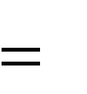RIIF
(1)
IFD LIFT

Where
RIIF is the risk index regard to initial force, IFD is the initial force developed by the worker in Newtons and LIFT is the limit of the initial force from tables ISO 11228-2. (INSHT 2013)

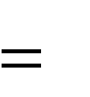RIKF
(2)
KFD LKFT

Where
RIKF is the risk index regard to kept force, KFD is the kept force developed by the worker in Newtons and LKFT is the limit of the kept forces from tables ISO 11228-2. (INSHT 2013)

    - Define if it is necessary redesign the car or the work method.

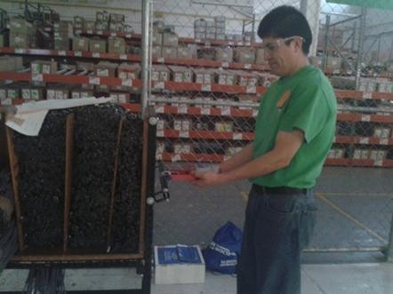
Figure 1. Measurement of the forces developed by the workers during the task

RESULTS

We define the anthropometric characteristics of the user population and they are showed in the table 1. And we set our design limits for the 5 and 95%ile range as Pheasant recommendation (Pheasant 2003). 32 workers were measured, representing 100% of the population that push the car with material. 18 workers are women and 14 workers are men See table 1.

Table 1. Anthropometric study
Design limits | Worker height Mts. | Height of chest Mts. | Shoulder height Mts. | Gripping Height Mts.
Results by men and women
Percentile 5 | 1.47 | 1.15 | 1.24 | 1.02
Mean | 1.61 | 1.25 | 1.36 | 1.16
Percentile 95 | 1.76 | 1.36 | 1.48 | 1.27
Results by women
Percentile 5 | 1.46 | 1.15 | 1.23 | 1.02
Mean | 1.55 | 1.23 | 1.31 | 1.13
Percentile 95 | 1.67 | 1.36 | 1.42 | 1.27
Results by men
Percentile 5 | 1.53 | 1.21 | 1.30 | 1.03
Mean | 1.69 | 1.28 | 1.42 | 1.20
Percentile 95 | 1.77 | 1.35 | 1.48 | 1.27

As we already mentioned in the methodology, a hand dynamometer brand GRID D Model TKK5401 was attached to the handlebar to measure the forces developed by the operator during the task (see figure 1). The workers pushed or pulled the dynamometer attached to the handlebar until the car starts to move. Exactly as the Snook and Ciriello methodology has suggested to measure this kind of activity, the idea is determine the force value that the worker is developing during the task performance. On the other hand the maximum force made by the worker was measured in an experiment apart where the person pushes the dynamometer until feel back discomfort. See Table 2.

Regarding ergonomic risk evaluation, the results of the survey to define ergonomic variables are the following (we are included the questionnaire too):

- How many times a day, do you move the car? Answer: 22 move times daily
- Which activities are developed when you move the car? Pull and push? Just pull? or Just push?
Answer: Pull and Push
- What are the maximum and minimum distances handling of the car?
Answer: the maximum distance is 51.7m and the minimum distance is 4.2m approximately
- How many men and women handle the car? Answer: 14 men´s and 18 women´s
- What is the height at which the force is applied to push or pull?
Answer: The Table 3 shows the different heights of grip where force is applied to pull and push.

Table 2. Study of forces
Design limits | Maximum force applied by workers N | Initial push force  N | Kept push force  N | Pull force N
Results by men and women
Percentile 5 | 127.49 | 270.78 | 65.51 | 127.49
Mean | 466.40 | 300.28 | 94.34 | 466.40
Percentile 95 | 1157.19 | 397.64 | 134.55 | 1157.19
Results by women
Percentile 5 | 161.61 | 275.34 | 51.98 | 69.63
Mean | 375.89 | 300.28 | 70.02 | 84.83
Percentile 95 | 891.23 | 325.22 | 105.52 | 124.35
Results by men
Percentile 5 | 116.11 | 330.96 | 49.23 | 63.55
Mean | 579.38 | 368.14 | 76.30 | 106.21
Percentile 95 | 1263.10 | 405.32 | 116.40 | 135.23

Table 3. Table gripper carriage height
Car Number | Gripping Height (cm) | Car Number | Gripping Height (cm)
1 | 105 | 15 | 108
2 | 103 | 16 | 101
3 | 103 | 17 | 108
4 | 96 | 18 | 108
5 | 97 | 19 | 108
6 | 97 | 20 | 108
7 | 101 | 21 | 101
8 | 98 | 22 | 106
9 | 103 | 23 | 106
10 | 106 | 24 | 98
11 | 98 | 25 | 101
12 | 108 | 26 | 102
13 | 99 | 27 | 106
14 | 108 | 28 | 100
 | Percentile 5 | 96.34
 | Media | 103
 | Percentile 95 | 109.58

Finally, in order to determine whether the activity performed is free of ergonomic risk that may affect the health of workers in the short and long term. We determine the risk level using the 5%ile

from the real data (table 2), and we are made additionally the following assumptions to located into the tables the value for LIFT and LKFT: Gripping Height between 95 to 89 cm, event duration 1/5 min. and 30 mts. as average distance to push the car.

Table 4. Risk index
Index | Value obtained | RI ≤ 1  Recommended or accepted | RI > 1  unacceptable
RIIF men | 1.18 |  | X
RIIF women | 1.38 |  | X
RIKF men | 0.41 | X
RIKF women | 0.86 | X

5. DISCUSSION/CONCLUSIONS

From the Risk index calculate in the table 4, we observe the follow:
- The risk index regard to initial force (RIIF) is unacceptable,
- The risk index regard to kept force (RIKF) is acceptable.

Thus, we can conclude that push a cart with materials as daily work in production areas is the main cause of the back pain in workers, for that reason it is necessary redesign the work method, in order to decrease the weight loaded in the car.

6. REFERENCES

Mondelo P.R., Joan Blasco E.G., Barrau P. (1999). Ergonomía 3: Diseño de puestos de trabajo.
Segunda Edición. Mutua Universa. Pp 31 34.
Pheasant P. (2003). Bodyspace: Anthropometry, Ergonomics and the design of work. Second Edition. Taylor & Francis Inc. pp 5.
Instituto Nacional de Seguridad e Higiene en el trabajo. INSHT (2013). Portal de trastornos musculo-esqueléticos. Evaluación del riesgo por empuje y arrastre de cargas. España. http://www.insht.es/portal/site/MusculoEsqueleticos/menuitem.2b2dac6ee28e973a610d8f20e 00311a0/?vgnextoid=cb12802f1bfcb210VgnVCM1000008130110aRCRD

OBTAINGING BODY MASS INDEX USING ANTROPOMETRIC DATA FROM STUDENTS OF THE DEPARTMENT OF INDUSTRIAL INGENEERING AT THE UNIVERSITY OF SONORA, MEXICO

MARTINA ELISA PLATT BORBON1, AMINA MARIN MARTINEZ11, MARIA MAGDALENA ROMO AYALA1, GRACIELA RODRIGUEZ VEGA1
1Departamento de Ingeniería Industrial Universidad de Sonora
Rosales y Colosio Hermosillo, Sonora
Correo: mplatt@industrial.uson.mx; amarin@industrial.uson.mx; magdar@industrial.uson.mx; grodriguez@industrial.uson.mx

Resumen: Las medidas del cuerpo humano son el punto de partida para el diseño de los equipos, herramientas, productos y dimensionamientos de los puestos de trabajo en relación con las necesidades operacionales del fin que se persigue como podría ser funcional, productividad, calidad, seguridad, confort. (Bridger, 2003; Wanjek, 2010)
El presente artículo contiene los datos antropométricos, realizados en un proyecto de investigación en donde se obtuvieron las tablas antropométricas de los estudiantes del departamento de ingeniería industrial y algunos de estos datos como peso y estatura fueron utilizados para realizar un diagnóstico de obesidad utilizando el índice de masa corporal.

Palabras Clave: Antropometria, IMC

Abstract: Measurements of the human body are used in ergonomics as the first step in designing physical dimensions of workplaces, equipment, tools and products to accommodate a wide range of users. A work environment that fits its occupants allows complying functional requirements of workplaces and promotes safety and comfort as well as productivity improvements(Bridger, 2003; Wanjek, 2010).
This article presents anthropometric data collected on a sample of students from the Department of Industrial Engineering at the University of Sonora in Hermosillo, Mexico. Anthropometric tables are shown and body-mass index was obtained using weight and height of the individuals to determine the amount of body fat.

Keywords: Anthropometry; BMI

INTRODUCTION

Anthropometry is the science that studies the dimensions of the human body. Anthropometric variables are collected and two key statistics parameters of the normal distribution, the mean and the standard deviation, are used to estimate parameters of the population. It is known that in a normal distribution, one standard deviation on either side of the mean accounts for two-thirds of the observations of the population(Bridger, 2003).

This study aims to determine body-mass index of a sample of students using anthropometric data, a technique that is the least expensive and universally applicable for assessing the size, proportions and composition of the human body. From a sample size of 730 students, 51 anthropometric variables and body-mass index were obtained. Body-mass index or BMI according to the World Health Organization (WHO, 2013)is a simple index of weight-for- height and it is used to classify underweight, overweight and obesity in adults. BMI is defined as the individual’s body mass in kilograms divided by the square of the height in meters (kg/m2). WHO cut-off point for overweight is equal or more than 30 kg/m2.

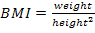.
BMI value is not constant; it varies with age and sex. BMI also depends on factors such as muscle and body fat tissue. BMI reflects adult’s health and nutritional status and predicts performance(McDowell et al., 2008), health and survival, according to proposed values of the World Health Organization or WHO.

Table 1.Classification of nutritional status of adults according to BMI (WHO, 2013).

Classification | BMI (kg/m2)
 | Main cut-off points | Additional cut-off points
Underweight | <15,99 | <15,99
Severe thinness | <16,00 | <16,00
Moderate thinness | 16,00 - 16,99 | 16,00 - 16,99
Mild thinness | 17,00 - 18,49 | 17,00 - 18,49
Normal range | 18.50 – 24.99 | 18.5 - 22,99
Normal range | 18.50 – 24.99 | 23,00 - 24,99
Overweight | ≥ 25,00 | ≥ 25,00
Pre-obese | 25,00 - 29,99 | 25,00 - 27,49
Pre-obese | 25,00 - 29,99 | 27,50 - 29,99
Obese | ≥ 30,00 | ≥ 30,00
Obese class I | 30,00 - 34,99 | 30,00 - 32,49
Obese class I | 30,00 - 34,99 | 32,50 - 34,99
Obese class II | 35,00 - 39,99 | 35,00 - 37,49
Obese class II | 35,00 - 39,99 | 37,50 - 39,99
Obese class III | ≥ 40,00 | ≥ 40,00

Most of the population in the Organization for Economic Cooperation and Development countries is now overweight or obese. In Mexico obesity rate among adults - based on actual measures of height and weight - was 30% in 2006, up from 24% in 2000. Mexico is the second country with the highest obesity rate following the United States (Nutrition Center, Obesity and Metabolic Alterations, 2012). Obesity’s growing prevalence increases the occurrence of health problems and higher health care costs(OECD, 2013).
The prevalence of obesity up to 75% of the population in the states of Nuevo Leon, Sonora, Sinaloa, Yucatan and Tabasco was reported by the Mexican National Health and Nutrition Survey 2006. A 2012 Federal Health and Nutrition Survey in Mexico found that 64% of men and 82% of women were overweight or obese and 34.4% of children were obese(Haskins, 2012).

The World health Office report in 2010 published that NCDs or non-chronic diseases are the most frequent causes of death in the Americas … “a total of 57 million deaths occurred in 2008; 36 million or 63% were due to NCDs or non-chronic diseases, mainly cardiovascular diseases, diabetes, cancer… Nearly 80% of these NCD deaths, 29 million, occurred in low- and middle- income countries… The prevalence of NCDs is rising rapidly and WHO projections show that they will significantly increase total number of deaths in the next decade. NCDs deaths are projected to increase by 15% globally between 2010 and 2020, to 44 million deaths.

According to the International Labor Organization (ILO) workplaces should be a point of intervention to offer workers healthy food alternatives as a way to prevent NCDs(Wanjek, 2010). Businesses productivity can increase by up to 20% when workers eat well and exercise. Some studies in England and in the United States indicate that if workplaces are involved in changing eating habits and by introducing healthy breaks, it is possible to decrease workers’ overweight and thus improve their productivity.

OBJECTIVE

This papers aims to determine body-mass index from anthropometric data of the students of the Department of Industrial Engineering at the University of Sonora, Mexico.

METHODOLOGY

A group of researchers, professors, and students of the Department of Industrial Engineering conducted a survey, from January to December 2012, to obtain anthropometric data of the population of students. The group of students who conducted this survey completed a body measurement training using a pre-planned measurement protocol and practiced exercises with an expert examiner. Anthropometry examinations were taken to participants without footwear and wearing light clothing. Manually operated instruments were used, such as: anthropometers, calipers, stadiometers, a standard scale and flexible tape measures. In total 51 physical characteristics from 730 survey participants, all of them students were obtained. Body weight and stature were measured in kilograms and in centimeters.
A literature research about body-mass index was conducted and body-mass index formula was obtained. Percentages of obesity in women and men were determined.

  - Anthropometric variables
Measurements of anthropometric variables used to determine body-mass index were obtained when subjects stood erect, facing front, with weight evenly distributed on both feet, wearing light clothes without footwear or objects on their heads, as follows:
    - Body weight, a standard weighing scale, CAM type, with a capacity of 150 kg. was used. Full weight in kilograms and grams was registered.
    - Stature, vertical distance from the floor to the vertex or the highest part of the head was taken in standing position, using a firm stadiometer graduated in centimeters and millimeters, supported on a flat vertical surface (wall), and matching zero with the horizontal surface (floor). Measurement in centimeters and milimeters was recorded.

  - Range of anthropometric data
Standard deviation and the mean were used to estimate weight and stature percentages of the population. Minimum and maximum values were also determined. Both, percentages and minimum and maximum values were calculated by gender and the total population. See table 2.
Tabla 2.Anthropometric variables by gender.
Anthropometric variable | Sex | Mean | S.D | Minimum | Maximum
Bodyweight Kgs. | Women | 61.10 | 12.71 | 41.8 | 140.3
Bodyweight Kgs. | Men | 76.19 | 15.43 | 45 | 138.2
Bodyweight Kgs. | TOTAL | 72.26 | 16.29 | 41.8 | 140.3
Stature | Women | 161.84 | 5.97 | 136.5 | 179
 | Men | 174.5 | 14.52 | 147.9 | 197.1
cm. mm | TOTAL | 171.16 | 8.52 | 136.5 | 197.1

  - Body-Mass Index
Body-Mass Index, BMI, overweight and obesity was estimated by gender, using body weight and stature of the participants. This information is presented in table 3.

Table 3.Percentages of overweight/obese students.
 | TOTAL n = 730 | MEN n = 537 | WOMEN n = 193
Bodyweight (Kg) | 72.26 | 76.28 | 61.10
Stature (cm.mm) | 171.16 | 174.50 | 161.85
BMI > 25 kg/m2 | 287 | 236 | 51
% overweight/obesity BMI > 25 kg/m2 | 39 % | 43 % | 26 %

RESULTS

A survey aimed to develop anthropometric data was conducted. A sample size of 730 students of the UNISON. Body-Mass Index was determined using two anthropometric variables: body weight and stature. See table 4.

Table 4.BMI of the population by gender, mean and standard deviation.
POPULATION | OVERWEIGHT BMI >25 | %  BMI > 25  kg/m2 | OVERWEIGHT BMI >30 | %  BMI > 30  kg/m2 | MEAN BMI | S. D. BMI
MEN  n=537 | 236 | 43 | 91 | 16 | 25.01 | 4.66
WOMEN n=193 | 51 | 26 | 16 | 8 | 23.29 | 4.50
TOTAL n=730 | 287 | 39 | 107 | 14.6 | 24.55 | 4.68

Sample size was 26.4% (n = 193) women and 73.6% (n = 537) men. Women’s mean body weight and stature were 161 ± 5 cm and 61.1 ± 15 kg, respectively; while men’s mean body weight and stature were 174 ± 6 cm and 76.2 ± 15 kg, respectively.
Total mean Body-Mass Index was 24.55 ± 4.68 kg/m2. Mean BMI for women was 25.01 ±
4.66 kg/m2 and mean BMI for men was 23.29 ± 4.5 kg/m2.
From the sample size of the students population of the Department of Industrial Engineering, 39% presents overweight and 14.6% obesity.

DISCUSSION AND CONCLUSIONS

This study confirms the OECD’s information about overweight and obesity of the world’s population and provides latest estimates on the number of overweight and obese students (39%). As overweight and obesity are common, preventable risk factors of NCDs, non-chronic diseases, such as diabetes, cardiovascular diseases, hypertension and some types of cancer it is assumed that there is a current burden of NCDs in the population of students and a public health problem.

Recommendations
Brochures are necessary to communicate information concerning healthy lifestyle habits, not only to students but also their families.
Lectures and workshops aimed at students are recommended, to orient them on the advantages and disadvantages of certain eating habits associated with modifiable behavioral risk factors: tobacco use, physical inactivity, unhealthy diet and harmful use of alcohol.
At the Institution, a network of new healthy lifestyle must be encouraged and it should be used as a point of intervention. Low-calorie, low processed foods, low-sodium and low-sugar meals, healthy food alternatives must be available within campus in restaurants and cafes. Also, physical activities on a daily basis, must be promoted within the Institution.
Others solutions are experienced in some countries. In Denmark, free fruit is delivered to workers. In a company in California, USA, each week, a group of farmers offer low-price fruits and vegetables. In Atlixco, Mexico, MexMode, vendors offered meals for $14 Mexican pesos, which are paid by the company.
Obesity is a current world-wide burden and it is a recent issue in our country. In México diabetes costs US $15.1 billion, annually. Obesity and overweight rates are among the highest in Latin America. In Mexico, Sonora is one of the States with a percentage of inhabitants with more obesity.
The challenge is that government authorities, professionals of health insurances, education workers and subjects themselves, begin to look for solutions that, in the short term, will avoid a huge scale of costs, bankruptcy of health system, absenteeism at work, and solutions to decline not only costs but also deaths due to poor healthy habits.

5.- REFERENCES

Bridger, R. S. (2003).Introduction to Ergonomics. London and New York: Taylor & Francis Group. Haskins, Owen (2012). Mexico faces diabetes epidemic. Bariatric News. Available in:
www.bariatricnews.net › News › ResearchEncaché-

McDowell, Margaret, Ph.D., M.P.H., R.D.; Fryar, Cheryl D., M.S.P.H.;Ogden, Cynthia, Ph.D.; and Flegal, Katherine M, Ph.D (2008). Anthropometric Reference Data for Children and Adults: United States, 2003-2006. U.S. Department of Health and Human Services, Centers for Disease Control and Prevention, National Center for Health Statistics. U. S. A.
OECD (2013). Better Life Index. Available in: http://www.oecdbetterlifeindex.org/topics/health/ OECD (2012).Obesity Update 2012. Available in: www.oecd.org/health/49716427.pdf
Wanjek, Christopher (2010). Food At Work: Workplace Solutions for malnutrition, Obesity and Chronic Diseases. International LabourOrghanization. Ottawa, Canada.
World Health Office (2010).Global status report on noncommunicable diseases 2010. Available in: http://www.who.int/nmh/publications/ncd_report2010/en/
World Health Office (2003).Diet, Nutrition and the Prevention of Chronic Diseases. Geneva. WHO Library Cataloguing-in-Publication Data.
WHO (2013).Global Data Base for Body-Mass Index. Available in: http://apps.who.int/bmi/index.jsp?introPage=intro_3.html

STUDY OF MAXIMUM GRIP FORCE ACCEPTABLE FOR WOMEN WORKING IN INDUSTRIAL MANUFACTURING APPLYING A POLYNOMIAL REGRESSION MODEL CONSIDERING THE WEIGHT.

Gerardo Meza Partida1, Enrique Javier de la Vega Bustillos1 Fco. Octavio Lopez Millan1, Manuel Rodriguez Medina2.
1Instituto Tecnológico de Hermosillo, Ave. Tecnológico s/n Hermosillo, Sonora, Mx. 83170
Email del autor: ge_meza@ith.mx

2Instituto Tecnológico de Ciudad Juárez. Ave. Tecnológico #1340.
Ciudad Juárez, Chihuahua, Mx. 32500

Resumen: La región anatómica donde se presentan el mayor número de lesiones laborales (IMSS, 2012), es la mano y muñeca con el 26.9%. De aquí parte la necesidad del desarrollo de estudios relacionados a la realización de esfuerzos manuales repetitivos durante la actividad laboral diaria. Un grupo de personas que desempeñan diariamente actividades de agarre manual, se organizaron en 23 categorías de peso, para analizar sus esfuerzos y estudiar su comportamiento mediante un modelo de regresión polinomial y así obtener una mejor interpretación de los datos. La categoría que puede sostener una mayor fuerza de agarre es la de 95 kilogramos con 76.34 libras en la semana uno, 68.98 libras en la semana dos, 66.35 libras en la semana tres, 66.31 libras en la semana cuatro y 66.66 libras en la semana cinco.

Palabras claves: Fuerza de agarre manual; Esfuerzos manuales repetitivos; Regresión polinomial.

Abstrac: The anatomical region where the highest number of workplace injuries (IMSS, 2012), is the hand and wrist with 26.9%. From here the need for the development of studies related to the performance of repetitive manual effort during daily work activities. A group of persons performing daily handgrip activities were organized in 23 weight categories, to analyze their efforts and study their behavior using a polynomial regression model and get a better interpretation of the data. The category that can hold a greater grip strength of 95 kilograms is 76.34 pounds in week one, 68.98 pounds in week two, 66.35 pounds in week three, 66.31 pounds in week four and 66.66 pounds in week five.

Significance. This research can be used as a support for developing studies related to reducing injuries from overuse or hand fatigue.

Keywords: hand grip strength, repetitive manual effort; polynomial regression.

INTRODUCTION.

It should take into account the increasing problems of stress or surmenage (Chronic Fatigue Syndrome) at a time when the welfare and comfort are a priority for people. Countless studies

published on the imbalance that occurs in people a lifestyle marked by excessive activity, agitation and dispersion (Marulanda, 2007), simplifying things considerably, experts help distinguish between tiredness, fatigue and wear. Three terms are often confused, but they respond to three different experiences.
Tiredness is normal and temporary consequence of any effort made somewhat strong or durable. Every activity carries a dose of tiredness. But this tiredness is healthy if kept within normal limits; stimulates the body, encourages sleep and gives the person a sense of vitality. It is a mistake to seek to eliminate the tiredness, the important thing to know is dosed and rest through sleep and adequate rest.
Fatigue is another thing. If a person engages in an occupation that requires performance of physical effort, but not to recover properly scope of their tiredness, the person is acting beyond its limits. The individual undertakes a task after another, without a moment's respite, always something to do. Soon appear different perturbations are only warning signs, the person can not sleep, it becomes increasingly irritable, growing insecurity, loss of appetite or excessive eating eagerly, deteriorates their relationship with people, this deconcentration the individual and increases the risk of a workplace injury.
To get rid of this fatigue, and not enough on normal rest, it takes a few weeks of rest and a fresh approach to everything. The person is cured when learning to rebuild his life, better organize their work and ensure a healthy pace of activity and rest.
If the individual does not react and the state of prolonged fatigue, wear inevitably comes with its unmistakable symptoms of inefficiency at work, premature aging, permanent insomnia, apathy, depression and general decay phases.

OBJECTIVES.

General: Conduct a study on the behavior of the grip strength of manufacturing workers by applying polynomial regression.

Specific:
 Get a polynomial regression model, which represents the grip force them to conduct the manufacturing workers based on their weight.

Determine the maximum grip force acceptable to women workers according to their weight class.
Using statistical tools for data processing.
Determine the type of activity that can develop women workers according to the amount of force that can generate grip.

The study considers only working-age female gender play activities of manufacturing with high repetition rate in the city of Hermosillo and will focus it to the anatomical region of the hand.

METHODOLOGY.

Randomly selected a group of 35 women, work experience and performing daily activities in manufacturing, in the community of Hermosillo. We pooled 23 weight categories, these categories range from 46 kilograms to 95 kilograms. Test subjects underwent medical review to prevent

injuries. The women's age group is between 19 and 39 years, with an average age of 26.2 years. The group's average height is 162 cm. (± 6.44). The weight average is 68.97 kg. (± 11.72).

Data collection.

Dynamometers were prepared to measure grip strength manual. Test subjects were instructed to stand in front of a structure that held the dynamometer at a height that form a right angle with your elbow. The wrist is kept in a neutral position with the hand resting on the dynamometer. Test subjects were instructed to perform hand grip force on the dynamometer. There were 3 shots hand grip strength at the beginning, middle and end of the working day, for five weeks. Test subjects were instructed to apply the maximum acceptable force, assuming that the level of grip that can be sustained repeatedly selected.

Data processing.

Data were recorded on a spreadsheet for easier handling. The peak force was recorded for each insertion with dynamometers.

Statistical analysis.

It made use of Minitab 16 software to analyze the main effects of the data and make comparisons on their behavior and fitness for a linear regression model, quadratic or cubic.

RESULTS.

With the captured data analysis and processing of the third order polynomial regression using the software Minitab 16, Table 1 is generated showing the weight class and their values of β0, β1, β2 and β3 for:

Table 1. Values of β0, β1, β2 and β3

Category | β0 | β1 | β2 | β3
46 | 56.2 | -5.91 | 1.81 | -0.278
48 | 54.07 | -3.8 | 0.726 | -0.1389
50 | 40.53 | 16.89 | -6.399 | 0.7083
56 | 94.93 | -53.35 | 18.1 | -1.889
60.5 | 70.53 | -17.9 | 6.131 | -0.6389
61 | 26.53 | 27.92 | -10.02 | 1.056
62 | 77 | -21.13 | 7.661 | -0.875
63 | 51.6 | -2.98 | 2.321 | -0.3611
64 | 48.77 | 5.83 | -1.458 | 0.0417
66 | 52.07 | 5.52 | -2.56 | 0.25
67 | 62 | -11.96 | 3.946 | -0.4306
67.5 | 105.1 | -70.36 | 24.73 | -2.583
68 | 48.62 | 8.5 | -3.961 | 0.4514
70 | 52.27 | -11.67 | 3.667 | -0.3333

Force 48
74 | 63.73 | -11.04 | 1.893 | -0.0648
75 | 51.6 | 3.68 | -3.054 | 0.4306
77 | 29.07 | 33.89 | -11.33 | 1.111
78 | 38.2 | 15.87 | -4.738 | 0.3889
79 | 52.93 | 12.31 | -4.024 | 0.3333
80 | 103.4 | -58.09 | 19.27 | -1.972
83 | 60.67 | 4.175 | -1.714 | 0.1111
86 | 37 | 12.68 | -5.595 | 0.7222
95 | 90.6 | -18.44 | 4.536 | -0.3611

The general model of third-degree polynomial regression is presented in equation 1 (Wackerly et al, 2008):

Y = β0 + β1X + β2X2 + β3X3 + ϵ (1)
It is noted that for the category of 48 kilograms, the graph is obtained from the third order polynomial regression presented in figure 1:

Figure 1. Fitted line graph for the category of 48 kg.
Gráfica de línea ajustada
Force 48 = 54.07 - 3.80 Week 48
+ 0.726 Week 48**2 - 0.1389 Week 48**3
55
50
45
40
35
30
1
2
3
Week 48
4
5

S | 2.98343
R-cuad. | 80.9%
R-cuad.(ajustado) | 75.7%

The graph shows as throughout the course of the week the force decreases, presenting fatigue. With the obtained values in Table 1 and applying the equation 1 can generate the corresponding values for each weight category according to the corresponding week, as shown in Table 2:

Table 2. Estimated values by week.

Week  Category | 1 | 2 | 3 | 4 | 5
46 | 51.822 | 49.396 | 47.254 | 43.728 | 37.15
48 | 50.8571 | 48.2628 | 45.4537 | 41.5964 | 35.8575
50 | 51.7293 | 54.3804 | 52.7331 | 51.0372 | 53.5425
56 | 57.791 | 45.518 | 46.777 | 50.234 | 44.555
60.5 | 58.1221 | 54.1428 | 54.7587 | 56.1364 | 54.4425
61 | 45.486 | 50.738 | 48.622 | 45.474 | 47.63
62 | 62.656 | 58.384 | 58.934 | 59.056 | 53.5
63 | 50.5799 | 52.0352 | 53.7993 | 53.7056 | 49.5875
64 | 53.1837 | 54.9316 | 54.2639 | 51.4308 | 46.6825
66 | 55.28 | 54.87 | 52.34 | 49.19 | 46.92
67 | 53.5554 | 50.4192 | 50.0078 | 49.7376 | 47.025
67.5 | 56.887 | 42.636 | 46.849 | 54.028 | 48.675
68 | 53.6104 | 53.3872 | 50.6588 | 48.1336 | 48.52
70 | 43.9337 | 40.9316 | 41.2639 | 42.9308 | 43.9325
74 | 54.5182 | 48.7036 | 45.8974 | 45.7108 | 47.755
75 | 52.6566 | 50.1888 | 46.7802 | 45.0144 | 47.475
77 | 52.741 | 60.418 | 58.767 | 54.454 | 54.145
78 | 49.7209 | 54.0992 | 53.6683 | 50.7616 | 47.7125
79 | 61.5493 | 64.1204 | 62.6431 | 59.1172 | 55.5425
80 | 62.608 | 48.524 | 49.316 | 53.152 | 48.2
83 | 63.2421 | 63.0528 | 60.7687 | 57.0564 | 52.5825
86 | 44.8072 | 45.7576 | 44.1844 | 44.4208 | 50.8
95 | 76.3349 | 68.9752 | 66.3543 | 66.3056 | 66.6625

The data indicate that the category of 95 kilograms can exert greater grip strength. During the first week with 76.34 pounds, 68.98 pounds the second week, the third week in 66.35 pounds, in the fourth week 66.31 pounds and 66.66 pounds the fifth week.

CONCLUSIONS.

It is noted that the category that can apply a greater force is manual gripping of 95 kg using an average of 68.93 pounds force, followed category with 60.59 kilograms 79 lbs and subsequently 83 kilograms category with 59.34 lbs.

As advances in weight class, can be applied relatively greater grip strength. It is recommended that underweight people engage in activities that do not require a large hand grip strength to perform work activity.
The trend of the data collected to better conform to a model of third-degree polynomial regression versus a linear regression or quadratic.

REFERENCES.

    - Instituto Mexicano del Seguro Social (IMSS). www.imss.gob.mx/estadisticas/financieras/memoria_est.htm.
    - Marulanda, I. C. (2007), Estrés laboral enemigo silencioso de la salud mental y la satisfacción con la vida. Ed. Uniandes.
    - Wackerly, D. et al. (2008). “Mathematical Statistics with Applications”. 7th. edition. Ed. Cengage learning.

Review of variables affecting recovery time for the shoulder
López Millán Francisco Octavio1, De la Vega Bustillos Enrique Javier2, Rodríguez Medina Manuel3, Meza Partida Gerardo1
1Departamento de Ingeniería Industrial Instituto Tecnológico de Hermosillo
Ave. Tecnológico S.N. Colonia El Sahuaro.
Hermosillo, Sonora, Mex.
      - mail: lopezoctavio@yahoo.com.mx

2División de Estudios de Posgrado e Investigación Instituto Tecnológico de Hermosillo
Ave. Tecnológico S.N. Colonia El Sahuaro.
Hermosillo, Sonora, Mex.

3División de Estudios de Posgrado e Investigación Instituto Tecnológico de Ciudad Juárez
Ciudad Juárez, Chihuahua, Mex.

Resumen. En el presente trabajo se presenta una revisión sobre la evolución del trabajo industrial durante el Siglo XX y como se han desarrollado algunos tipos de lesiones que afectan grupos musculares de las extremidades asociadas a la realización del trabajo. Se muestra algunos de los modelos mas representativos para la evaluación de la fatiga y para la estimación de los tiempos de recuperación. Al final se hace una revisión estadística utilizando el método de componentes principales para encontrar el conjunto de variables relacionadas con la fatiga y los tiempos de recuperación.

Palabras clave: Fatiga, tiempo de recuperacion, analisis estadistico, variables

Abstract. In this paper we present a review of the evolution of industrial work in the twentieth century and how they have developed some types of injuries affecting muscle groups of the extremities associated with task performance. It shows some of the most representative models for the evaluation of fatigue and to estimate recovery times. Finally a statistics review is presented using the principal component method to find the set of variables related to fatigue and recovery times.

Keywords: Fatigue, recovery time, statistical analysis, variables

Introduction
The twentieth century can be described, in the industrial environment, as the century of growth and consolidation of mass production and can be said that the automobile industry has been the engine of the industrial economy, in Womack et al (1992) is mentioned it as the industry of industries. One important characteristic of the industry is the large number of people employed by itself and associated companies supplying components.

To highlight the importance of the automotive industry in the creation of jobs, a report by the International Labor Organization (ILO, 2000) using the example of the industry in France, establishes the relation of jobs created; the auto industry held 313,000 workers, was this an impact on 773,000 jobs in the manufacturing industry
Even with the influence of the economic crisis, automobile production keeps growing, graph 1.1 shows annual vehicle production worldwide. By 2011 there were 79,989,155 vehicles, occupying 8,397, 451 people (the figure corresponds to 39 countries). The International Organization of Motor Vehicle Manufacturer (2013) estimated at 5% the automotive industry involving in the creation of jobs worldwide. These data show the magnitude of the manufacturing industry and its importance to the economy of countries.

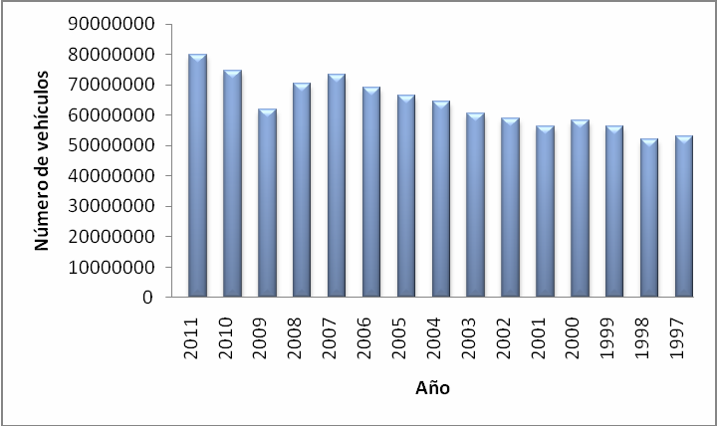

Figure 1.1. World production of vehicles. Source: International Organization of Motor Vehicle Manufacturer (2013)

Mexico is part of the scenario, with an annual production of 2,680,037 vehicles in 2011 and an occupation of 137,000 direct jobs, is among the most productive countries. Making true the proportion of IOMVM, it would estimate a population employed in industry has been increased to
2.5 million people.
The automotive industry allows an overview on employment and manufacturing in general.
Relevance is about working in the industry, many of the activities are hands working as the main element, this implies the displacement of the upper extremities to generate movement and to reach materials, tools, or to do some assembly.
The advancement of technology and industrialization has not stopped, Kumar (2001) mentions the influence on these processes in humans, none of the systems of the body was designed to support occupational stress, power demand, repetition activities or positions taken for prolonged periods of stress on human physical systems, is inherently unnatural. It concludes that, based on a complex multivariable system, there are ample opportunities for the emergence of unexpected things.
In an attempt to control this type of injuries, it is essential to understand them. Bernard (1997) refers to this type of damage as a situation associated with the birth of industrialization in society, but it is up to the decade of the seventies that the causes of these lesions were studied using epidemiological methods.

In Britain, Allen and Chappell (1999) refer to work-related injuries as typical of the twentieth century and considered as the most frequent type of workplace health problems. Of musculoskeletal injuries, those presented in the upper extremities are the most impact, just below the back injuries. The origin of this type of disorders is associated with the demands of the industry to increase productivity, while interest has presented health sector due to the rapid increase of disabilities and their impact on costs, costs for medical care, disability payments, lost workdays, employee turnover, absenteeism indirect costs including labor. Also affects the low morale of the workers and poor work quality. Emphasize the importance of prevention and to warn employers and employees about the problems caused by musculoskeletal injuries and the strategies that can be followed to avoid them.
In the report of the European Agency for Safety and Health at Work (2010), it mentions that musculoskeletal injuries (WMSD) are related to repetitive work, in 60% of cases it has been identified as a cause. The 30% of the WMSD are related to the shoulder-neck region. The WMSD can cost from 0.5% up to 2% of gross domestic product of the countries
According to the Bureau of Labor Statistics (BLS) in the U.S., in 2005 lost 1 234.700 days work.
In the same study reported 47.861 shoulder disorders and 92,576 disorders due to repetitive motion, 55% affected the wrist. For 2008 the BLS recorded in 29% of injuries in workplaces recognized as WMSD, this involved a median of 10 days lost through injury, the incidence rate is 33 cases per 10,000 full-time workers.
In Mexico, in 2011 the Instituto Mexicano del Seguro Social reported 281 injuries related to the shoulder region, most cases were about industrial companies. In 2010, 210 reported shoulder injuries. Regarding the recent years, the number of cases is increasing. In South Korea, 82% of occupational injuries are related to the manufacturing industry, Kun et al (2010).
Can all this be summarized, according to Punnet and Wegman (2004) that the WMSD are common in many countries, with significant costs and impact on quality of life. Although not solely caused by work, constitute a significant proportion of all registered diseases and / or work-related compensable in many countries. Accurate data on the incidence and prevalence of WMSD are difficult to obtain, and official statistics are difficult to compare between countries.

2 Fatigue and recovery time.

Fatigue and its effect on the development of human activities has been studied for some time, Rohmert (1973) has been established as the basic reference on the subject. Law and Avin (2010) refer to research in sport, exercise, rehabilitation and ergonomics. In ergonomics is important to identify potential mechanisms or causes of injuries that affect the quality of life of workers and optimize production. Muscle fatigue is one of those processes implicated as a potential cause of WMSD, involving the relation duration of the task and load.
In the same way, Law and Avin (2010) mention endurance time or sustain maximum load (ET: endurance time) as a basic variable to quantify the development of muscle fatigue. The intensity and time of holding (ET) has been widely recognized as nonlinear. The interpretation of this relationship is used to relatively low-intensity activities can be development for long periods of time.
Muscle fatigue can be caused by static or dynamic work, Price (1990), differentiates depending on the frequency of the loads. Mentions as the emergence of local muscle fatigue when energy moderate loads are located in muscle groups.

Fatigue has been associated with physical activity, work is physical activity. Santy and Duwal (2010) found that fatigue occurs equally in performing light or heavy duty work. Pertinently mention the fact on fatigue as a cause of injury that has not been scientifically proven, however, has been the belief of many researchers that a fatigued muscle is more susceptible to injury.
Abound in the various definitions of fatigue and lack of consensus on the issue. They conclude that the effect of fatigue can be mitigated more effectively by reducing the daily work. Reduce the daily work relates to allow workers time off to relieve muscle fatigue.
In relation to fatigue and work design, Wiker et al (1990) found that sustained periodic elevations dominant upper extremity above shoulder level caused discomfort and fatigue in light manual work and efforts demands a low level. They mention that dealing with work that requires elevation of the hands above the head should be avoided even in light work.
Developing models for estimating fatigue and recovery times are based on the calculation of maximum resistance (MET) based on the maximum voluntary contraction MVC. Several models are focused on getting the times before fatigue using the MET. There are few models aimed at calculating recovery times. In virtually all models have been used Rohmert curves (1973) for the estimates.
Curves to determine the exposure times Rohmert (1973) assume that efforts below 15% MVC can be repeated without any restriction it means do not produce fatigue. This suggests that the light work, for example manual assembly produces no physical fatigue. This assumption has motivated the search for fatigue prediction models for these jobs.
Mathiassen and Åhsberg (1999) propose a model in addition to the MVC based on age and gender, LnTlim = β0 + β1 + β2 * G * A * M + β3 + β4 + β5 * GA * GM + β6 * AM where G is the gender, A is the age and M is the MVC. After statistical analysis the final model was LnTlim = 3.704 - 0.097M. Expressed linearly the model is; Tlim = 40,609 * e-.097M. In the final expression we see that the significant factor was the strength. This text makes a strong criticism of the application of the formula in the sense Rohmert 15% MVC mentioned in the previous paragraph.
The Rohmert formula appears in Garg et al (2002) noting that the MET calculations are over estimated for % MVC <45% and sub estimated for %MVC> 45%. Abound on the 15% MVC arguing that for 5% MVC subjects appear as unable to sustain the efforts indefinitely. The study tested for different angles of flexion in the shoulder and elbow for different % MVC for the MET. The formula used is: METime = 43.44 * (% MVC) -0.9027 and statistical analysis mentioned a coefficient r2 = 0.8824.
In the same way, El Ahrache et al (2006) have developed a model to calculate the MET for a given percentile. The following equation is proposed:

In applying equation results are obtained maximum time, in minutes, for different values of resistance of % MVC.
The model can be generalized to different parts of the human. For example, the average time for the 10% MET shoulder MVC is 17.75 minutes. For 15% MVC average time is 9.19 minutes.
In El Ahrache et al (2006) as part of its analysis also considered models and Åhsberg and Mathiassen (1999) and Garg et al (2002) model: Sato (1984); 0.398* fMVC-1.29 and Rohmert FMVC (1986); .2995*fMVC-1.658.
It has been mentioned that the formulas can be applied to different human joints, Rose et al (2000) designed the model for the shoulder, adaptation is: MET = 20.6*e-6.04Mn, where Mn is the

resultant moment in the elbow joint. Alternatively propose a model to calculate the time of resumption of a task. This refers to the time period of rest between tasks. This is different to the concept of recovery time. The resume time is given by;
Tr = 0.0167 e8.84/(1.46+0.346Mn) where Mn is the resultant moment.
Fatigue is a common phenomenon in industrial work and even when there is no evidence that the relationship with WMSD, it was considered important in studies for MET, maximum endurance time. Most MET models are based on percentages of maximum voluntary contraction % MVC. In the literature review only Rose et al (2000) used different concepts.
Considering the background this work aimed to establish a statistical relationship through a set of variables and their relationship with fatigue and recovery times, in this case, for the shoulder muscle group.

Method.

The research variables for the first phase corresponding to variables differed between the person and variables for the task. Statistical analysis was performed using principal components. The variables considered are: Gender, laterality, age, height, weight, shoulder angle, angle at the wrist, hand length, hand width, hand height, length of the middle finger, thumb length, width middle finger, thumb width, wrist width, height of the wrist, arm length, elbow length to the middle finger, recovery time, fatigue perceived severity index and average force on the hand.
The principal components analysis yielded two groups with acceptable control values after three iterations, the first included all variables and formed seven components, the KMO test has a value of 0.717 considered acceptable and then shown the table for the rotated component matrix and the coefficients of importance for the formation of the components.
After several variables combinations and using by reference to the larger coefficients are sought to reduce to two groups, in this configuration the reference values remain acceptable and above 0.7, the table is the final result.
Although this arrangement implies a slightly lower explanation of variance, two components conforms quite acceptable in the sense of the practical, using as reference values greater than each component, a first group consists of variables of a personal nature, is observed; gender, height, weight and strength. The other group is formed with the variables related to anthropometric characteristics, hand length, hand width, width of the thumb, middle finger width and height of the wrist. Severity not influences the end of the data variation.
Using as a reference the first group of variables and taking larger values, it is defined a set of variables of interest: Gender, height, weight and strength. A second approach to the selection of variables included the duration of the effort, the force for the use of materials or tools, shoulder posture, repetition frequency of efforts, the resultant moment on the shoulder and the recovery time and a subjective assessment based on the Borg scale. After three iterations using principal components have the new set of variables, the table below shows the final result.

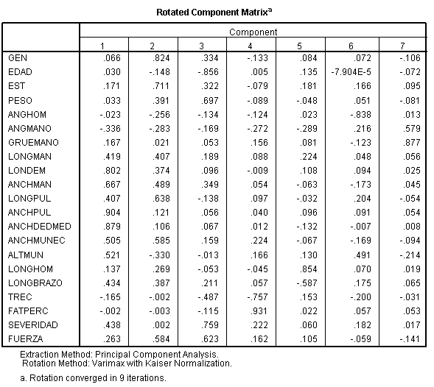

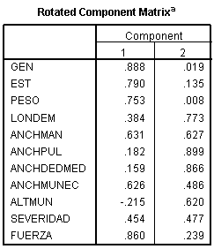

Matriz final de componentes rotados
 | Componente
 | 1 | 2 | 3
Sexo | .940 | -.132 | .046
Peso | .841 | .005 | -.029
Estatura | .840 | .123 | .028
Duración | .261 | .827 | -.352
Fuerza | .093 | -.020 | .963
TRR | -.294 | .805 | .419

Referencing larger values of each group, the results for the selection of variables is: sex, weight, height, length, force and recovery time.

Conclusions.

The selection of the variables is essential for modeling and for ergonomic analysis support. For the case of performing the risk assessment shoulder injury should consider the relationship of the set of variables that has resulted from statistical analysis. The next step should include recovery time as the response variable and the independent variables; sex, weight, height, length and force of the effort exerted. A multiple linear regression model may be the most appropriate statistical tool.

References

Bernard, B. (1997). “Musculoskeletal Disorders and Workplace Factors; A Critical Review of Epidemiologic Evidence for Work-Related Musculoskeletal Disorders of the Neck, Upper Extremity, and Low Back”. Centers for Disease Control and Prevention, National Institute for Occupational Safety and Health (NIOSH).
Bureau of Labor Statistics (2012). “Injuries, Illnesses, and Fatalities (IIF) program”. www.bls.gov.
El Ahrache Khalid, Imbeau Daniel, Farbos Bruno. “Percentile values for determining maximum endurance times for static muscular work”. International Journal of Industrial Ergonomics 36: (2006), 99-108.
Garg A. HegmannK.T. SchwoererB.J. KapelluschJ.M. “The effect of maximum voluntary contraction on endurance times for the shoulder girdle”. International Journal of Industrial Ergonomics 30: (2002), 103-113.
Instituto Mexicano del Seguro Social, (2013). “Información estadística en salud; accidentes de trabajo. www.imss.gob.mx
International Organization of Motor Vehicle Manufacturer. www.oica.net. 2013.
International Labor Organization. El impacto social y laboral de la mundialización en el sector de la fabricación de material de transporte. 2000.
Kim Hyung Kun, Kyoo Sang Kim, Day Sung Kim, Sun Je Jang, Ki Hun Hong, and Seung- Won Yoo. Characteristics of Work-related Musculoskeletal Disorders in Korea and Their Work-relatedness Evaluation. J Korean Med Sci 2010; 25: S77-86.

Kumar, Shrawan (2001) 'Theories of musculoskeletal injury causation', Ergonomics, 44:1, 17 – 47.
Law Laura A. Frey. Avin Keith G. (2010). “ Endurance time is joint-specific: A modelling and metaanalysis investigation”. Ergonomics, 53:1, 109-129.
Mathiassen Svend Erik. Elizabeth Åhsberg. “Prediction of shoulder flexion endurance from personal factors”. International Journal of Industrial Ergonomics 24: (1999), 315-329.
Musculoskeletal Disorders and the Workplace: Low Back and Upper Extremities. Panel on Musculoskeletal Disorders and the Workplace, Commission on Behavioral and Social Sciences and Education, National Research Council. 2001.
Price A.D.F. “Calculating rest allowances for construction operatives part-2: Local muscle fatigue”. Applied Ergonomics, 1990. 21:4, 318-324.
Punnett, L. Wegman, D. H. (2004). Work-related musculoskeletal disorders: the epidemiologic evidence and the debate. Journal of Electromyography and Kinesiology 14, 13–23.
Rohmert, W. “Problems in determining rest allowances. Part 1: Use of modern methods to evaluate stress and strain in static muscular work”. Applied Ergonomics, 1973, 4.2, 91-95.
Rohmert W. Wangenheim M. MainzerJ. Zipp, P. Lesser W. (1986): “A study stressing the
need for a static postural force model for work analysis”. Ergonomics, 29:10, 1235-1249.
Santy. S. Z. Dawal. “Investigation on Time to Fatigue for Upper Limb Muscle during a Repetitive Light Assembly Task”. Proceedings of the International MultiConference of Engineers and Computer Scientists”, 2010. Vol III, IMECS 2010.
Schneider Elke, Irastorza Xabier. OSH in figures: Work-related musculoskeletal disorders in the EU —Facts and figures. European Agency for Safety and Health at Work (EU-OSHA). 2010.
Wiker, F. Steven. Chaffin B. Don. Langolf D. Gary. “Shoulder postural fatigue and disconfort”.
International Journal of Industrial Ergonomics, 5 (1990), 133-146.
Womack, P. James, Jones T. Daniel, Roos Daniel. La maquina que cambió el mundo. Editorial McGraw Hill Management. 1992.

COGNITIVE ERGONOMICS: CONTEMPLATIVE TECHNIQUES TO EXERCISE ATTENTION AND FOCUS SKILLS.

Julio Gerardo Lorenzo Palomera1,
1 Faculty of Architecture, Design and Urbanism. Universidad Autónoma de Tamaulipas.
Tampico – Madero Campus.
Tampico, Tamaulipas. disartaka@yahoo.com

Resumen: En el contexto de la ergonomía cognitiva y emocional, se introduce el conocimiento y ejercicio de técnicas contemplativas, con el fin de ejercitar la atención y la concentración.
Con base en técnicas contemplativas del budismo tibetano, así como referencias del reciente paradigma de atención plena (mindfulness), se diseña un programa de inducción a la meditación, como instrumento efectivo de mejora en el desempeño. Ulteriormente la productividad y competitividad parten del estado mental de toda persona en la empresa, que se mantiene en el momento presente.

Palabras Clave: ergonomía, meditación, productividad.

Abstract: In the context of cognitive and emotional ergonomics was introduced contemplative techniques and exercise, in order to practice attention and concentration.
Based on Tibetan Buddhist contemplative techniques, with references from the recent paradigm of “mindfulness”, was designed an introductory program to meditation, as an effective tool for improving performance. Subsequently productivity and competitiveness are based on the mental state of everyone in the company, which remains in the present moment.

Keywords: ergonomics, meditation, productivity.

            - INTRODUCTION

In the Zen circles, they tell a tale about a man and a horse. The horse gallops fast, being that apparently, the man who is riding it is headed somewhere important. Another man on the edge of the road shouts at him:
-Where are you going? And the man answers:
-I don’t know! Ask the horse.

A system is a group of interrelated, interdependent elements, which interact to reach a goal in common. In a corporate system, ergonomics encompasses quality, productivity and well-being. With the man-surroundings adaptation, productivity is sought, which doesn’t only mean doing more or doing the same tasks with less resources, but doing the right things, reaching the outlined targets and goals, improving standards every time.
The fundamental element in a company is the person. In any hierarchic level, this addition of knowledge, abilities, skills, emotions, conducts, habits, is the source of organizational development opportunities. Every act in an activity station is preceded by other acts inside the

person. Each mental act that directs the action is conditioned by the person’s own characteristics in his or her interrelation with the environment. The ability to sustain a conscience focused on the basic work activity is the seed of productivity.
Ergonomics have been known traditionally as a science, which is focused on the prevention and control of muscular lesions caused at work or by accidents. However, ergonomics that are applied on the manufacture industry and service organizations, can contribute to the increase of productivity through improvements of the physical mental capacities of the worker that is used for production.
When the limit of these physical abilities is surpassed, the worker can develop different issues, which go from fatigue to the appearance of irreversible musculoskeletal lesions. Meanwhile, when mental abilities are exceeded, they can give way to errors in the development of the task or even the appearance of work neurosis, acknowledged since several years ago as a professional illness.
Although it is true that the most serious problems (irreversible lesions or work neurosis) take a long time to come up, it is also true that a worker who is tired physically and mentally, he or she makes errors and his or her productive level decreases even from the first day at the job.

Cognitive Ergonomics.

It is the study of all human activities, considering abilities and limitations, associated with the knowledge and processing of information, which influence or are influenced by the design of machines and objects used by the people, associated with work processes and environments with which they interact. (Romero 2006)
Cognitive ergonomics is interested in the mental processes, such as: perception, memory, reasoning and motor response, as long as these affect the interactions between human beings and the other elements that make up the system.

Cognitive Ergonomics is a sub-discipline of Ergonomics, which studies cognitive processes at work, with an emphasis on comprehending the situation and on the support of a reliable, effective and satisfying performance. This perspective deals with issues such as the distribution of focus, decision-making, the forming of learning abilities, ease in the use of man-machine systems, the cognitive aspects of the mental load, stress, and human errors at work.
According to Niebel and Freivalds (2005), matters that are deemed relevant are: mental workload, decision-making, expert functioning, human-computer interaction, human trustworthiness, work stress, and the training.
Among others, Romero (2006) establishes the target of cognitive ergonomics:
    - Reducing cognitive effort and errors when using the product
    - Improving the performance, productivity and efficiency with the task
    - Improving safety
    - Improving comfort
The mental components of work are fundamental, for the use of superior structures (attention, memorizing, abstraction and decision) and the development of intelligence and personality.
Numerous models have been developed to explain how people process information. The figure represents a general model, which consists of four important stages or components; response perception, decision, and selection, response execution, memory and the attention

resources distributed on the different stages. (Sanders and McCormick, 1993; Wickens, Gordon and Liu. 1997).
The processes of conscious perception and comprehension of the situation are generically named “situational conscience”. In many of the application ergonomic domains, this concept is needed to describe the cognitive processes which are responsible of acquisition, storage and usage of available information for the person who does the work.
According to this model by Endsley (1995), knowledge of a situation is the perception of the elements in the environment inside a volume of space and time, the comprehension of its meaning and the projection of its situation in the near future.
Nowadays this is a subject of vital importance in many areas of ergonomics, that some level of situational conscience and attention is always necessary to control the performance of any task, no matter how simple and safe it appears to be.
In Ferrer et al. (1995), it is proposed that sensibility toward the environment is different in various living organisms and that the main characteristic is that it is adaptive. The sensitivity is an informative activity, which responds to energy stimuli, and its role is to translate them into signals of the perceptual code.
Perception is a process through which the organism is informed by the objects and processes that are manifested in them, through the sensorial configuration of informative stimuli. In the perception, cognitive, affectionate and motivational functions are overlapped, which is why it is open to interpretation of the stimulus information. This process starts with an opening to reality, attention.
In order for the organism to pay attention, it must be activated. This activation is liberation of energy that represents a psychological activation, whose mission is to alert the organism. In order for the organism to pay attention, and the cortex can decode the impulses that arrive, an adequate level of activation is needed.
Brain waves, electrical currents that the brain produces, are registered with an encephalogram, according to its state of activation.

- Beta; state of alert. Represented by rapid waves of around 20 cycles per second, low voltage and badly synchronized. They are mixed with some slow waves.
- Alfa; relaxed state. Produced by a synchronization of slower and well-formed waves. It happens in subjects who are awake, but relaxed and with their eyes closed. It disappears when a stimulus breaks the calm and gives way to beta waves of alert.
- Theta; state of somnolence. The lack of synchronization, mixed with narrow, slow waves and gusts of thorn waves, reappear.
- Delta; state of sleep, where one can differentiate:
- Light sleep: a mix of delta waves, slow and irregular with gusts of high-voltage thorn waves.
- Deep sleep: very slow, big, irregular and high voltage waves predominate.

The activation is necessary so that the perceptive process can start, but, even when the organism is awake, one still cannot consider this attentive conduct, since, in order to have a conscience about the environmental stimuli, it needs to go through a first phase of contact with the environment (alerting), where the attention is diffused for trying to perceive the biggest possible amount of data, without focalization of the full attention and without selectivity. In the second

phase, one proceeds to a curious conduct, motivational activity where the subject intervenes, looking for an object which stands out among others in a setting and granting it special attention.

Attention.

From psychology’s point of view, attention is not just one concept, but the name attributed to a variety of phenomena. Traditionally, it is regarded in two different ways, albeit related. On the one hand, attention as a quality of perception references the function of attention as a filter for environmental stimuli, deciding which stimuli are the most relevant and giving them priority through focus of the psychic activity on the objective, for a deeper process in consciousness. On the other hand, attention is understood as the mechanism that controls and regulates the cognitive processes; from learning through conditioning to complex reasoning. In many cases it acts unconsciously, starting in the left hemisphere of the brain and it is maintained in the right hemisphere.
According to Carbó (1999), the organism’s activity headed toward the gathering of stimuli has received the name of attention. The study of attention inside the paradigm of cognitive psychology was not formulated regarding attention as an activating process, but as a selective control of the information process or as a skill in simultaneous processing of different types of information.
Attention is a very important inner determinant of conduct in the perceptive process, and according to Ferrer et al. (1995), its main parameters are:

    - Breadth. To how many things can one pay attention at a time? The informative capacity of the nervous system is very limited and there seems to be a focalization of attention, which centers on a not-very-broad field. It can improve with learning and suffer variations regarding the level of real interest and needs of the subjects.
    - Limits. Can one simultaneously grasp various sequences of stimuli? It seems to be that the limitation of one’s capacity to pay attention does not have to do with the amount of information that comes in as it does with the impossibility of encoding the information content.
    - Selectivity. Due to the narrow limits of attentive capacity, the nervous system is forced to establish priorities in a strict way, both in the entry of stimuli and in their shape.

The attention acts as a selective filter for the stimuli of information that come into the subject’s sensory channels. The attention is interpreted in only one channel of limited capacity. The filter, the attention, allows the passage of information of one channel at a time, and its job is to say “this comes in/this doesn’t” and only what comes in is encoded.
Further, mind concentration is a psychic process which happens through reasoning; it consists of voluntarily focusing all the mind’s attention on an objective, object or activity which is in the process of being done, or is being considered to be done in a moment, pushing aside every fact or other objects that could possibly interfere in its achievement or the attention.
One can observe that, the more one concentrates on one object, the more one loses attention capacity for others, which is to say, focalization of one object leads to defocusing on others. There's also a problem with the capacity to remain in the attentive state, which is that one generally cannot remain in it for very long.

Full Attention.

Various definitions for full attention have been used in modern psychology. Full attention refers to a psychological quality, which involves taking a full attention to the present experience in a moment-to-moment basis. It involves paying attention in a particular manner: on purpose, in the present moment and without judging. It involves not a kind of elaborative consciousness, but without prejudices, centered on the present in which one recognizes every thought, feeling or sensation that emerges in the attentive field and is accepted as it is.
Thich Nhat Hanh, among other Buddhist monks, drew the interest of westerners to full attention. During a retreat held by an American doctor in the United States, Jon Kabat-Zinn realized the convenience of full attention in the treatment of chronic medical conditions. Kabat- Zinn later adapted the teachings of Hanh in the structure of an eight-week program based on Mindfulness for stress reduction, which has since spread throughout the western world. Mindfulness and other Buddhist meditation techniques receive support in the West from figures such as the scientist Jon Kabat-Zinn, professor Jack Kornfield, professor Joseph Goldstein, psychologist Tara Brach, writer Alan Clements, and professor Sharon Salzberg. They have played a big role in the integration of the attributes of Buddhist meditation practices for diverse applications.
Bishop, Lau, and colleagues (2004) offer a model of two components of full attention: the first component consists of self-regulation of the attention in order for the person to remain in the immediate experience, thus allowing a better recognition of the mind occurrences in the present moment. The second component consists of adopting a particular orientation toward one-s own experiences in the present moment; the orientation is characterized by curiosity, openness and acceptance.
Full attention (mindfulness), is a term derived from sati (pali) and smrti (sanskrit).
The word sati derives from a root that means ‘to remember’, is a mental factor which means ‘the presence of spirit, the attention to the present, instead of the faculty of the memory in relation to the past. It has the characteristic of ‘no swaying’, which is to say, not floating away from the object. Its function is the absence of confusion or non-forgetfulness. It manifests as responsibility, or as the state of confronting an objective field.
The word smrti refers to not letting what one knows, escape from the mind. Its function is to avoid getting distracted.
Oxford English Dictionary defines the term mindfulness as "the state or quality of being conscious, the attention; observing". This word was registered for the first time as myndfulness in 1530, as mindfulness in 1561, and attention in 1817.

Tibetan Buddhist meditation.

Meditation is a Buddhist practice par excellence, for more than 2500 years. The meaning of the term meditation or bhavana is “the cultivation of the mind”. It is therefore an activity that involves a certain predisposition for the practitioner to place oneself in reality and thus increase his or her comprehension and wisdom, which are essential for the eradication of suffering or dissatisfaction (dukkha).
Meditating consists in cultivating positive states of mind, attentive, agile, focused states of mind, which reflect reality, as it is, analytical mental processes that are lacking of discursiveness or distraction.

There are many and varied Buddhist meditation techniques depending on each tradition and school, they are all based on two families of meditation called Shamatha (mental calmness, tranquility) and Vipashyana (direct knowledge, intuition).
The practice of Shamatha consists in stopping, stabilizing and resting the mind. In essence, it is the cultivation of the focused, unifocal mind. It is about pacifying the mind from internal dialogue, from discursiveness. It is taking an object of attention and setting the mind on it without distractions. This is not the same thing as ceasing to think, but learning to use the mind in such a way that one can pay attention to that in which one is interested, and hold the attention.
The second family of meditation practices, is the one denominated Vipashyana, as in vipas / hyana, to see / special, to see things integrally, thoroughly, just as they are. The objective of Vipashyana is to cultivate the special seeing. This is, seeing without the emotions’ and disturbed attitudes’ filter, seeing without the attachment, aversion and ignorance filter, just seeing things directly as they are in their essential structure, in their impermanence and lack of absolute identity.
Meditation has to do with the cultivation of attention stability (Shamatha) and the cultivation of a thorough vision of reality (Vipashyana). Buddhist meditation is a methodology meant to stop the mind’s compulsivity and its projections and prejudices that we make of reality, in order to see clearly.
In this context it is important to note that it is complex to describe and explain Tibetan Buddhist methodology in a succinct manner in this space. However, it is appropriate to consider the foundations of attention and meditation. For the scope of this paper, only the first two concepts are to be exposed.
The foundations of attention in the Buddhist tradition are:

    - Attention to the body.
    - Attention to the sensations.
    - Attention to the mental formations of the conscience.
    - Attention to mental objects (phenomena).

The foundations of meditation are:
    - Have an appropriate space.
    - Primary needs covered.
    - Time.
    - Breathing.
    - Postures.

DEVELOPMENT.

Well-being-centered productivity strategies are acquiring a greater importance. The balance of the personal potential regarding one’s attention and focus skills is an element that adds value to the overall performance.
In the context of cognitive and emotional ergonomics, the knowledge and application of contemplative techniques are introduced, with the ultimate goal of exercising attention and focus.
A program to introduce meditation as an effective tool to improve performance was designed based on contemplative techniques of Tibetan Buddhism, as well as references from the recent

paradigm of mindfulness. Further, productivity and competitiveness emerge from the mental state of every person in a company who stays in the present moment.

Objectives.

To know, experiment and appreciate contemplative techniques as a tool to improve attention and focus in the workplace.

Delimitation.

This technique is applied on an academic portion of the population located in the Faculty of Architecture, Design and Urbanism of the Universidad Autónoma de Tamaulipas. Two workshops take place during the period of summer 2011 (workshop 1) and summer 2012 (workshop 2).

Methodology.

The purpose of the action research technique is to solve daily and immediate problems; to make the social world understandable and to try and improve people’s quality of life. Elliot (cited on Álvarez-Gayou, 2012) defines action research as “the study of a social situation with a view to improving the quality of action within it”. Halsey (cited on Álvarez-Gayou, 2012) defines it as “small-scale interventions in the functioning of the real world and a close examination of the effects of such interventions”.

    - The participants who are going through an issue are the best prepared to approach it in a naturalistic setting.
    - These people’s behavior is influenced significantly by their natural surroundings.

The sample is established voluntarily thanks to the interest shown by the participants.
The action research technique was applied through introductory mindfulness workshops. As of the problems in the academic performance, people are gradually taught postures, surroundings, basic contemplative techniques, in such way that during theory and practice cycles, the areas of opportunity are recognized for their application, just as evidences of personal change and improvement. The individual findings are shared.

The workshop’s program was as follows:

1 Welcome.  Introduction. Expectations. Goals. Commitments. | The participants are welcomed to the workshop, and they introduce themselves expressing their expectations. A contract is established to reach the goals in every stage of the sessions.
2 Practice of silence. | Participants are asked to turn off their cellphones during every session. Silence is exercised, starting with short periods of time of no speaking.
3 Sharing of experiences in the workplace. | Each participant freely expresses pleasant as well as unpleasant experiences during his or her work

 | performance, in this case, in the academic field.
4 Attention | - Attention to the body. Breathing. Sensorial perceptions (to do with sight, hearing, taste, touch, and smell). awareness of the breathing (anapanasati). Paying attention to the inhalation and exhalation cycles, recognizing that thoughts emerge but not dwelling on them, letting them flow. Focalizing the contact between the body and the seat.  - Attention to sensations. Pleasant, unpleasant, neutral.
5 Focus. Holding the attention. | 5.1 Anchoring technique. Counting of the respiratory cycles.
6 Postures. | - Sitting.  - Standing.  - Walking.
7 Shamatha Meditation. | Theory and practice.
8 Vipashyana Meditation. | Theoretical foundations.
9 Applications.
10 Close. Testimonies. | Narrative. Written logs.

Theory and practice cycles are combined in the process, so that they can apply the techniques individually in the action field. Contemplative techniques are exercised, just as gradually increasing the time and intensifying the depth in every session. This is verified by the sharing of the participants’ testimonies to the group, so as to enrich the training.

Results.

    - Workshop 1. Summer, 2011. Length: 20 hours.
Since the first sharing, a great number of experiences, fears, and anecdotes were poured in, which, by the tone of their voices, the sensible way of expressing themselves, and the nonverbal communication, the emotional character of the group became evident. The most part of the attendees participated with enthusiasm in the introductory activities. It is important to note the case of a person who had a shy and quiet personality; this person, as of the second session, was able to collaborate happily for the remainder of the workshop.
There was willingness to do every activity. Only when attempting to meditate in the supine position (lying down), was there any resistance.
Several participants felt encouraged to experiment the foundations of the techniques, on groups of students under their supervision, with heartening results. They said to have started their classes dedicating a few minutes to their focused breathing.
The participants turned in freestyle, written logs. They recorded activities, workspace and daily life experiences, and anecdotes that occurred along the duration of the workshop. Figure 1.

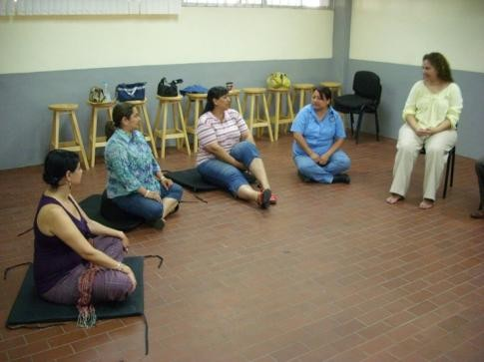 | 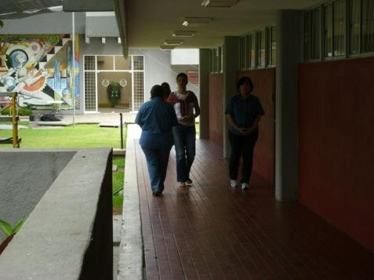

Figure 1. Workshop 1. Summer 2011.

    - Workshop 2. Summer 2012. Length: 20 hours.

This group was receptive, but unlike the first one, it turned out to be more rational. The application of the techniques was kept at a personal level, without generalizing it to their academic work. Their prompt willingness to exercise the 24 minutes of the basic cycle of meditation was notorious. Furthermore, significant changes on the facial expressions of some participants in the course of the workshop indicated an adequate diligence.
It was decided to not turn in the written logs, but openly express to the group, their testimonies about the experience instead. Figure 2.

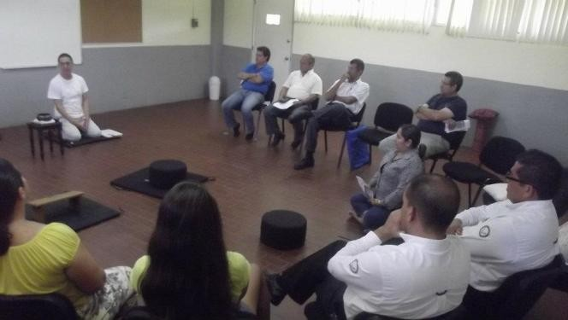 | 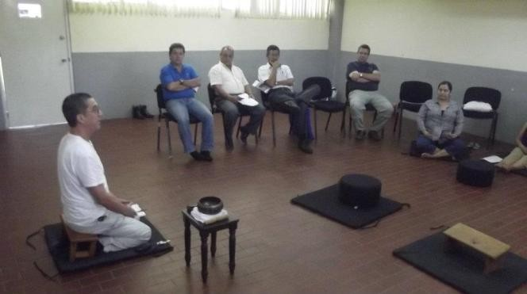

Figure 2. Workshop Summer 2012.

    - Testimony.

To close this section, here’s the transcript of a person’s testimony:

“This kind of practices started to demonstrate a substantial change within me from the first day that I took them, and even inspite of myself or my surroundings and its daily distractions, and what’s worse, the circumstances that we experience in this area, the changes presented themselves favorably.
I would like to say that during the summer course I started getting nourished by a sensation that provided me with more confidence, a contact with my inner self, as well as with my surroundings in a way that was more conscious every time, and I recognized that I’m a part of nature, and that (as we all know) ‘Nature is never wrong’ and managing my positive energy depends on me, as does its influence on those who, and that which surrounds me; my decisions

and behavior affect my nature and consequently, the natural environment in which I live, whether it is for work, or pleasure, or a simple daily action.”
“At the same time as I took the summer course, I was teaching a summer course to the FADU students, and I share this new method with them as an experiment, (...) the relaxation exercise, and their remarks and reactions gradually evolved favorably, and so did their comments (they actually proposed to do it more often).” 1

As benefits obtained, it can be said that they accomplished to remain silent for over 5 minutes, as well as practicing for longer periods of time until they achieved two cycles of 24 minutes with a brief pause in between. The participants expressed that they noted positive personal traits, which were rekindled with the experience. A better interpersonal communication was evident, with a noticeable peaceful attitude.

Conclusions.

Meditation is a positive tool as a training technique to improve attention and focus in the workspace. It is low-cost, since the individual can practice it on his or her own with just the basics, for whatever periods of time he or she needs and likes.
In both focus groups, changes in attitude were demonstrated during the length of the workshops, as well as afterwards, since the participants noticed the advantages of exercising the techniques in their own spaces. This experience doesn’t have concluding measure units, but just what is observable and the testimonies.
It would be ideal for companies to establish several short periods during the working day to apply this. It can be done, for example, in two ways. In an official manner on scheduled times, but the great majority probably wouldn’t accept stopping the production so that the employees would meditate. On the other hand, by emitting a particular signal (a gong, a bell, etc.), without suspending the activities, people simply become fully aware of their breathing and the productive actions.
Productivity and competitiveness in companies can be boosted through tools such as meditation. Training attention and concentration skills can contribute to keep organizational health, which is a key factor in productivity. This is because, through a daily practice, we can reduce and eliminate obstacles such as:

    - Interpersonal conflicts, reluctance, stress, angst, fears, external pressure, negative or unnecessary thoughts, low tolerance to teamwork.
    - Meditation gives us back our conscience, which means, it centers us in ourselves.
    - Through introspection, the individual gets to know him or herself in depth, to understand and accept him or herself; this leads to an increase in self-esteem.
    - Meditation brings about a natural calm state in the individual, the speed of thoughts is reduced, judgment becomes sharper and intuition develops. If the individual has a better skill for dealing with the changing environment, this will not affect his or her productivity.
    - What’s been said regarding thoughts, is that quality is more important than quantity. That’s what meditation is about: diminishing the incidence of thoughts that act against us. With a greater clarity of internal processes, comes a greater acceptance of oneself; with this, it will be easier for the individual to understand and accept others, thus benefitting teamwork.

1 Testimony of Arch. Gabriela Sánchez de la Garza, academic member of the Architecture course of study in the FADU-UAT.

    - Being as how meditation centers the individual in the present and it keeps unnecessary thoughts about the past away, it frees the individual from angst, thus leaving him or her free to focus on what he or she is doing in the present, increasing therefore productivity.

Basic contemplative techniques are an easy tool of immediate application, in different settings. By practicing them in a consistent manner one can obtain results that go from the workspace to an improvement in daily life.
The trial, in an academic setting, yielded good results. According to testimonies during and after the workshops, the participants added to their daily lives, actions mainly related to their attitude.
Meditating daily for a few minutes, improves the work performance, enriching the skills. In the daily life, the individual gets familiarized with virtuous states of mind.

            - REFERENCES

Álvarez-Gayou J., J. L. (2012). Cómo hacer investigación cualitativa. Fundamentos y metodología. México. Paidós Educador.
Carrasco, José Bernardo (2004) Estrategias de Aprendizaje. Madrid. Ediciones RIALP, SA. Carbó Ponce, Esteve (1999). Manual de Psicología aplicada a la empresa: Psicología de la
Organización. Barcelona. Ediciones Granica, SA.
Chögyan Trunpa y Coleman, D. (2007). Nuestra salud innata: Un enfoque budista de la psicología. Barcelona. Editorial Kairós. Edición castellana.
Cañas, J. J. - Velichkovsky, B. B. - Velichkovsky, B. M. (2011). Human Factors and Ergonomics. En IAAP Handbook of Applied Psychology, editado por Martin, P.R; Cheung, F.M; Knowles, M.; Cyrios, M.; Littlefield, L.; Overmier, J.; Prieto, J.M. West Sussex, UK. Wiley-Blackwell.
Ferrer V., F. et al. (1995). Manual de Ergonomía. Madrid. Editorial MAPFRE SA.
Gerald Devins (2004)."Mindfulness: A proposed operational definition". Clinical Psychology: Science & Practice. Volume 11, Issue 3, pages 230–241, September 2004
Karam, Marco Antonio. Programa de Educación Continua. Seminario Introducción a la Teoría y Práctica del Budismo Tibetano. Seminario La Liberación en la Palma de la Mano. Casa Tibet México. http://www.casatibet.org.mx/
Mahathera, Narada. A Manual of Abhidhamma Abhidhammattha Sangaha. En Project Buddha Society; http://buddhasociety.com/online-books/a-manual-of-abhidhamma-narada-maha- thera-10 marzo del 2013.
Mañas M., I.; Franco J., C. y Faisey, M. Mindfulness and psychology: Foundations and terms in Buddhist psychology. En: http://www.thesauro.com/imagenes/ArticulosRef14.pdf marzo del 2013
Niebel, Benjamin W. Freivalds, Andris. (2005). Ingeniería Industrial; Métodos, estándares y diseño del trabajo' ' The McGraw-Hill companies, Inc, , 11 Edición.
Romero, Medina (2006) Ergonomía cognitiva y usabilidad. En: http://www.um.es/docencia/agustinr/Tema6-0607a.pdf
Sanders, M. y Mc Cormick, E. (1993). Human Factors in Engineering and Design. McGraw-Hill. Scott R. Bishop, Mark Lau, Shauna Shapiro, Linda Carlson, Nicole D. Anderson, James Carmody,
Zindel V. Segal, Susan Abbey, Michael Speca, Drew Velting &.
Thich Nhat Hanh, The Miracle of Mindfulness (1975), Beacon Books, ISBN 0-8070-1239-4

Wickens, Gordon y Liu, An Introduction to Human Factors Engineering. Indiana. Prentice Hall.
2003 2a Ed.

Introduction to Multiple Resources Theory and Model

Maldonado Macías Aide Aracely1,2, Reyes Martínez Rosa María2, García Alcaraz Jorge Luis1, Realyvásquez Vargas Arturo 1

1Department ofIndustrialand ManufacturingEngineering UniversidadAutónoma de Ciudad Juárez
610 North Avenida delCharroStreet Ciudad Juárez, Chihuahua 32310

Undergraduated Studies and Research Division Instituto Tecnológico de Ciudad Juárez 1340Avenida Tecnológico Street
Ciudad Juárez, Chihuahua

amaldona@uacj.mx, rosyreyes2001@yahoo.com, jgarcía@uacj.mx, al110443@alumnos.uacj.mx

RESUMEN: En este documento se presentan los elementos clave para conocer el Modelo de Recursos de Atención Múltiple (MultipleResourcesTheory and Model MRT) propuesto por Wickens (2002, 2008); como parte de una revisión de literatura sobre tema. Los objetivos son dar a conocer los conceptos más importantes del modelo y sus componentes; así como su aplicación en la obtención de la interferencia total al analizar tareas duales a partir de casos desarrollados por Horrey and Wickens, (2003).

ABSTRACT: This document describes the main elements of the Multiple Resources Theory (MRT) and model developed by Wickens (2002, 2008), as part of a literature review about the topic. The objectives of this article are to introduce the model´s most important concepts and its components; so as to explain its application to derive the total interference when dual tasks are analyzed.

INTRODUCTION

For Wickens (2008), the model´s historical backgrounds are based on some attention models such as that proposed by Kahneman (1973), the “bottleneck” model developed by Broadbent (1971) and the model of Welfor (1971). These models considered that human performance when concurrent tasks must be carried out, was supported by a general pool of mental effort with indistinguishableand limited attention resources. On this way, it can be explained the unavailability of attention´s resources on dual or multiples tasks that affected the human performance during the execution. Later, researches emerged on the literature such as Bahrick, Noble and Fitts (1954); Bahrick and Shelly (1958); Briggs, Peters and Fisher (1972); contributing to the divided attention theory on which tasks did not compete among them for only one mental effort´s source, but they used multiple attention resources.
Wickens (1980) analyzed the variation on the execution´s efficiency of concurrent tasks to determine which of them used the same or different mental structures. He also found that during the execution of concurrent tasks that used different mental structures, the workers did not express any difficulty when they executed both of the tasks, and there was not any task that

avoided significantly the execution of the other one when both of them were performed simultaneously.
This finding could define clearly separated attention resources on three dichotomies as shown on Figure 1.
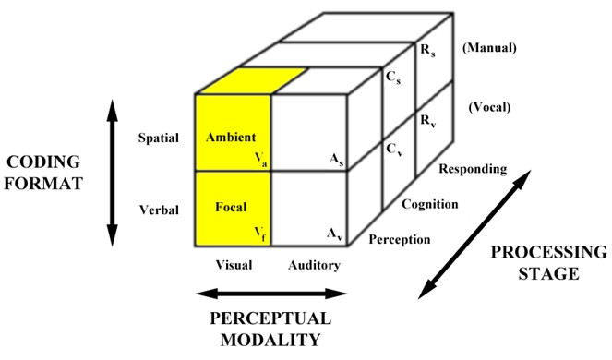
Figure 1.The 4-D multiple resource model.
Wickens (2002) has proposed an update of his theory widely applied on the interference during the execution of dual tasks or Multiple Resource Theory (MRT). On this update, Wickens proposes an extension of the model by adding the fourth (but nested) dimension into the visual perception modality, it means, the Visual Channel dichotomy (focal vs. environmental). Then, the MRT four dimensions included now are:
I. (a).Perceptual Modality(Visual / Auditory)

I. (b).Visual Channel (Focal / Ambient) II.Processing CodeFormat (Spatial/ Verbal)
III. Information processingstage(Perception/Cognition/Responding).

These four dimensions are explained below: I.(a). Perceptual Modality
The modalities dimension (nested within perception and not manifested within cognition or response) indicates that apparently auditory perception uses different resources than visual perceptiondoes. In this way, sometimes divided attention between the eye and the ear is better than between two auditory channels or two visual channels. That is, cross-modal time-sharing is better than intra modal time sharing in Wickens´ model. This phenomenon still remains unresolved; some authors like Wickens et al. (1983) and Parkes and Coleman (1990) have found advantages in cross-modal (auditory-visual or AV) over intramodal Verbal-Verbal (VV) or Auditory- Auditory (AA) time sharing tasks. In most real situations when visual scanning is involved in dual- tasks, interference can be reduced by off-loading some information channels from the visual to the auditory modality (Seagull et al. 2001). Also, concurrent auditory messages are very hard to process and usually displaying one of them visually is recommended to gain some advantage in processing them (Rollins and Hendricks, 1980).

I.(b). Visual Channels
Visual channel distinguishes between focal and ambient vision (Leibowitz& Post, 1982; Previc, 1998), a nested dimension within visual resources. Focal vision, primarily (but not exclusively) foveal, supports object recognition and, in particular, high acuity perception such as that involved

in reading text and recognizing symbols. Ambient vision, distributed across the entire visual field and (unlike focal vision) preserving its competency in peripheral vision, is responsible for perception of orientation and movement for tasks such as those supporting walking upright in targeted directions or lane keeping on the highway (Horrey, Wickens, &Consalus, 2006). According to Wickens (2002), successful time sharing between focal and ambient visual tasks must be gained because of two main reasons, ambient vision uses separate resources, or because it uses no resources at all, that is automated.

- Processing Codes
The processing codes distinguish between analogue/spatial processes and categorical/symbolic (verbal or linguistic) processes. According to Wickens (1980) spatial codes use different resources than do verbal/linguistic codes whether functioning in perception, working memory and response. This separation is associated with the two cerebral hemispheres(Polson and Friedman, 1988). In this way, manual and vocal responses can be time-shared very efficiently. Manual responses are assumed to be spatial in nature (tracking, steering, joysitck or mouse movement) and vocal ones are verbal (speaking). One useful implication of these processing codes distinction is the ability to predict when it might or might not be advantageous to employ voice versus manual control (e.g., speech vs. manual control; Liu & Wickens,1992; Wickens& Liu, 1988).
The model in Figure 1 shows how this distinction between verbal and spatial codes that is conserved across all stages of processing, also the distinction between auditory and visual processing is defined only at perception, but not within cognitive and response processing. Ambient and focal vision is nested only within the visual resources.

- Stages of Information processing
The stages of processing dimension indicates that perceptual and cognitive (e. g., working memory) tasks use different resources from those underlying the selection and execution of action (Isreal, Chesney, Wickens&Donchin, 1980).
Wickens (2002) also outlines an approach for constructing an instance of a computational model based upon MRT. Horrey and Wickens (2003) describe such an instance of computational MRT (cMRT) modeling in the dual-task domain of automobile driving vs. in-vehicle technology usage. Part of this application will be explained in the following sections.

A COMPUTATIONAL MULTIPLE RESOURCE MODEL

This model has its greatest value in predicting the relative differences in task interference between different task configurations. The typical model includes four main characteristics:
  - Each task can be represented as a vector of its resource demands, both at aqualitative level (which resources) and a quantitative level (how manyresources).
  - The amount of load within each of these resources will be task-dependent.
  - The model computes a loss of performance on one or both tasks from itssingle task level by a formula that penalizes performance to the extent that:
(a) The total demand on both tasks is high, and (b) both tasks compete foroverlapping resources (common levels on one of the dichotomous dimensions)within the four dimensions of the multiple resource model (or withinthe dimensions of whatever other model is selected).

  - The extent to which one or the other of the two tasks loses performance can be established by an allocation policy. If both tasks have equal priority, each task will share equally in the performance decrement.

The computational model using Multiple Resource Theory (MRT)

In Figure 1 the model represents 8 unique resources for which dual tasks can compete: visual- focal (Vf), visual-ambient (Va), auditory-spatial (As), auditory-verbal (Av), cognitive-spatial (Cs), cognitive-verbal (Cv), response-spatial (Rs) and response-verbal (Rv).
2.1.1Computational Example for dual tasks

In this example developed by Horrey and Wickens (2003) two tasks were analyzed. Task C: Rural Curve Driving and Task F Auditory In Vehicle Task (IVT). According to Horrey and Wickens (2003), the first step in implementing a cMRT model is to construct a Conflict Matrix which captures the extent to which two tasks may interfere with each other for all possible resources to be represented in the domain of interest. The Conflict Matrix is shown in Figure 2. The “expected” level of resource-vs-resource interference (based upon the domain and the modeler’s expertise) is represented by a coefficient ranging from 0.0 (primary-secondary tasks share perfectly without interference) to 1.0 (the tasks cannot share the resource at all; e.g., you can’t give two vocal responses simultaneously). In practice, Horrey and Wickens (2003) initialized the starting value of each cell in the Conflict Matrix to 0.2 in order to include the “cost of concurrence” (i.e., resources consumed by the central executive for task management overhead). After that, they added an increment of interference (i.e., 0.2) to each cell based upon each dimension of the MRT model shared by the two competing resources represented by the cell. To finish, additional “tweaks” to the amount of interference represented in each cell were made in order to capture unique requirements of the test domain as well as the past experience and expertise of the modeling team.
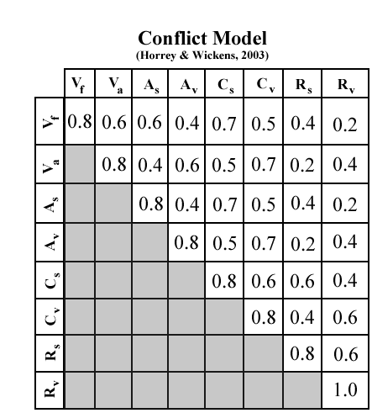
Figure 2. Conflict Matrix (from Horrey&Wickens, 2003)

Then, the Demand Vector must be determined for each the task being modeled. This vector represents an estimate of how much task performance depends upon each of the resources being represented in the model. Each resource is assigned a coefficient value ranging from 0 to 3; such that: 0 = no dependence, 1 = some dependence, 2 = significant dependence, 3= extreme dependence (The value of 3 should be used only in special situations or conditions). The sum of the coefficients assigned to the resources in the Demand Vector corresponds to the overall nominal estimate of “difficulty” assigned to the task under consideration.Horrey and Wickens (2003) considered three levels of primary task (automobile driving) difficulty as well as three levels of in-vehicle technology (secondary task) difficulty. The Demand Vectors for each of these tasks is presented in Table 1.
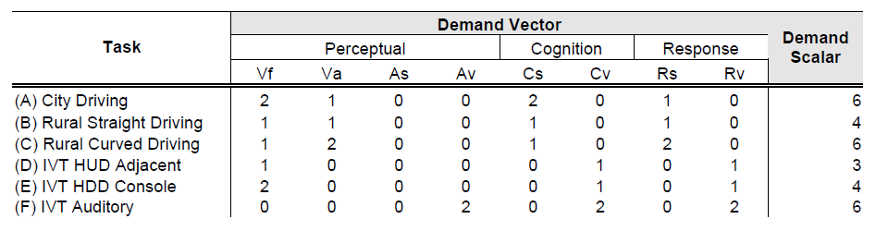

Table 1. Demand Vectors for primary and secondary task conditions. IVT = In-Vehicle Task, HUD
= IVT Head-up display, HDD = IVT with Head-down display; Auditory = IVT with sound display.

Interference Computation for dual tasks

For the previous example, given the construction of the Conflict Matrix for the domain of interest and the estimates of the Demand Vectors for the tasks being employed, all of the information necessary for computing the estimate of dual-task interference is complete. This prediction is based upon two computationally derived components:

Total Interference = Total Demand + (Normalized) Total Conflict (1)

The computation of each of these components is described next.

Total Demand is computed by: (1) Calculating the average demand for each of the Demand Vectors representing the two tasks being evaluated; then (2) Computing the sum of the two Demand Vector averages. For example, the Total Demand represented by concurrent performance of the primary task of Rural-Curve Driving and the secondary task of IVT Auditory Tasks C and F, respectively, in Table 1 above, would be computed as follows:

Total Demand = Sum Task Demand Means (2)

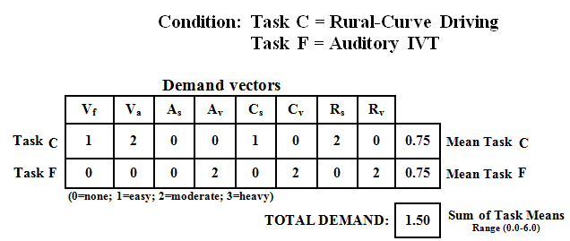

Figure 4. Computing the Total Demand parameter

The algorithm for computing Normalized Total Conflict is some more complex. The first step in the computation is to identify all of the cells in the Conflict Matrix that are “shared” by the competing tasks under examination. Figure 5 graphically captures how this can be complete. Any cell in the matrix that corresponds to a non-zero Demand Vector entry for BOTH tasks represents an opportunity for conflict. These are the cells circled in red (see Figure 5).

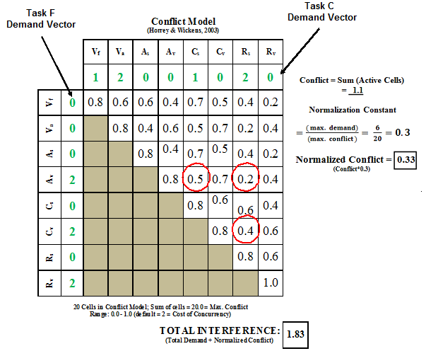
Figure 5. Worksheet for computing Total Conflict between tasks using a Conflict Matrix

The Total Conflict score is computed by summing the coefficients for all of the cells identified as sources of resource competition. Figure 5 shows all of the identified sites for structural conflict in the Horrey and Wickens (2003) case of the cMRT model. The sum of these cells (0.5 + 0.2 + 0.4) represents a Total Conflict of 1.1 computed from the model. However, because the theoretical maximum value of this Total Conflict score is equal to 20 (i.e., sum of all the cells in the Conflict Matrix) it becomes likely that the Total Conflict sum might “diminish” the contribution of the Total Demand parameter (since its theoretical maximum value is only equal to 6). In order to minimize such effects, the Total Conflict score can be normalized so that its maximum attainable value is matched to the range of the Total Demand parameter (see Von Engelen, 2011). For the current

example, this can be accomplished by multiplying the Total Conflict score by the scalar value of
0.3 (i.e., maximum possible Total Demand divided by the maximum possible Total Conflict = 6 / 20
= 0.3). Hence, given the Total Conflict score of 1.1 for the current example, the Normalized Total Conflict parameter can be computed as follows:
Normalized Total Conflict = 0.3 (Total Conflict) = (0.3)(1.1) = 0.33 (3)

Given the Total Demand incurred by the two tasks (see Figure 4) and their Normalized Total Conflict computed above, the Total Interference metric predicted by this case of the computational model is calculated as:

Total Interference between TASK C and TASK F

Total Interference= Total Demand + Normalized Total Conflict = 1.50 + 0.33 = 1.83(4)
This value represents a prediction of the level of performance of two or more time shared tasks. In other words themodel is used to predict the level of disruption or interference between two taskswhen they must be time-shared. The following results for some other tasks were also obtained by Horrey and Wickens (2003).
Total Interference between TASK A and TASK D:

Total Interference = Total Demand + Normalized Total Conflict = 1.12 + 0.87 = 1.99
Total Interference between TASK A and TASK B:

Total Interference = Total Demand + Normalized Total Conflict = 1.12 + 0.87 = 1.99

Also, these results were used by Horrey and Wickens (2003) to relate the total interference value with In Vehicle Task (IVT) response latency decrement, in all cases there was found a posi tive relationship among these variables. The higher value of cMRT interference predicted value, the higher value of IVT response latency decrement.

CONCLUSIONS

As conclusions, a description of the theory and its main components has been presented, based on a literature review. In reference to the model´s applications Wickens (2002), affirms that the MRT and its computational model is most applicable in a highdemand multi-task environment, characteristic of the vehicle driver, overworked secretary,or commandant in an emergency operations mode. In this situation, the model can beemployed either in a more informal intuitive way, or in a more formal computational manner.
In the informal use, the model can serve to guide designers in making decisionssuch as: when is it better to use voice control than manualcontrol, to use auditory rather than visual displays, or to use spatial graphic, ratherthan verbal material (e.g. maps versus route lists for delivering navigational instructions). In the other hand in the formal way, model can be applied to compute the amount of interference predicted between two tasks. Also, when the single-linetime model identifies the periods in which two (or more) tasks must be performed concurrently, and identifies this as an `overload’ period, the models helps to determine that tasks vary in their resource demands in ways not accounted for bytime.
Further research is needed and the MRT and model face challenges that were pointed out by Wickens (2008):

A new modality dimension related to tactile input must be included.

The consideration of other mechanisms unrelated with resources also account for variance in dual task performance.
Model is unable to characterize the resource demand on a single scale so the reserve capacity from the work overload region cannot be placed as a "red line".
A better comprehension of what drives the resource allocation policy is needed. Usually this has been driven in the laboratory by the primary and secondary tasks instructions however, in the real world many distractions and interruptions occur and cannot be represented in the model.
Additionally, applications in real world situations as multi-tasks in manufacturing and advanced manufacturing technology interactions present opportunities for research.

References

Baddeley, A.D. (1986). Working memory.Oxford, UK: Clarendon.
Bahrick, H. P., Noble, M., &Fitts, P. M. (1954).Extra task performance as a measure of learning a primary task.Journal of ExperimentalPsychology, 48, 298–302.
Bahrick, H. P., Noble, M., &Fitts, P. M. (1954).Extra task performance as a measure of learning a primary task.Journal of ExperimentalPsychology, 48, 298–302.
Briggs, G., Peters, G., & Fisher, R. (1972).On the locus of the divided attention effects.Perception & Psychophysics, 11, 315–320.
Broadbent, D. (1971). Decision and stress.London: Academic Press.
Horrey, W.J. &Wickens, C.D. (2003). Multiple resource modeling of task interference in vehicle control, hazard awareness and in-vehicle task performance. Proceedings of the 2nd International Symposium on Human Factors in Driving Assessment, Training and Vehicle Design.Park City, UT.
Horrey, W. J., Wickens, C. D., &Consalus, K. P. (2006).Modeling drivers’ visual attention allocation while interacting with in-vehicle technologies.Journal of Experimental Psychology: Applied, 12(2), 67–86.
Isreal, J., Chesney, G., Wickens, C. D., &Donchin, E. (1980). P300 and tracking difficulty: Evidence for a multiple capacity view of attention. Psychophysiology, 17, 259–273.
Leibowitz, H., & Post, R. (1982).The two modes of processing concept and some implications.In J. Beck (Ed.), Organization and representationin perception (pp. 343–363). Hillsdale, NJ: Erlbaum.
Liu, Y., &Wickens, C. D. (1992).Visual scanning with or without spatial uncertainty and divided and selective attention.ActaPsychologica, 79, 131–153.
Parkes A.M. and Coleman N. (1990). Route guidance systems: a comparison of methods of presenting directional information to the driver, in E. J. Lovesey (ed.) Contemporary Ergonomics 1990 (London: Taylor & Francis), 480-485
Previc, F. H. (1998).The neuropsychology of 3-D space.Psychological Bulletin, 124,123–164. Polson, M.C. and Friedman, A. (1988), Task-sharing within and between hemispheres: a multiple-
resource approach, Human Factors, 30, 633-643
Rollins, R.A. and Hendricks, R. (1980), Processing of words presented simultaneously to eye and ear, Journal of Experimental Psychology: Human Perception & Performance, 6, 99-109.
Seagull, Fl.J.,Wickens, C.D. and Loeb, R. G. (2001). When is less more? Attention and workload in auditory, visual and redundant patient-monitoring conditions, Proceedingis of the

45thAnual Meeting of the Human Factors & Ergonomics Society (Santa Monica, CA: Human Factors & Ergonomics Society)
Von Engelen, D. (2011). Attention Drivers! Analyzing Driver Distraction. Diploma Thesis, Computer Science Department, RWTH Aachen University, Germany
Wickens, C. D. (1980). The structure of attentional resources.In R. Nickerson (Ed.) Attention and performance VIII (pp. 239–257). Hillsdale, NJ: Erlbaum.
Wickens, C.D. ,Sandry, D. and Vidulich, M. (1983). Compatibility and resource competition between modelities of input, output, and central processing, Human Factors, 25, 227-248.
Wickens, C. D. (2002). Multiple resources and performance prediction.Theoretical Issues in Ergonomics Science, 3(2), 159–177.
Wickens, C. D. (2008). Multiple resources and Mental Workload.Human Factors: The Journal of The Human Factors and Ergonomics Society, Vol. 50, No. 3. 449-455.DOI 10.1518/001872008X288394.
Wickens, C. D., & Liu, Y. (1988). Codes and modalities in multiple resources: Asuccess and a qualification.Human Factors, 30, 599–616.

ERGO-MODAPTS: DEVELOPMENT OF A MODEL BASED ON THE STUDY OF TIMES PREDETERMINED MODAPTS AND SUSAN RODGERS ERGONOMIC EVALUATION.
Deyanire Uribe Lam1, Enrique de la Vega Bustillos1,
Francisco Octavio Lopez Millan1, Karla Lucero Duarte1

1 Instituto Tecnológico de Hermosillo, Departamento de Posgrado, Ave. Tecnológico y Periférico Poniente S/N C.P. 83170 Colonia Sahuaro., Hermosillo, Sonora, México. deyanireuribe@gmail.com, en_vega@ith.mx

Resumen. Este artículo proporciona la información necesaria para la realización de un análisis ergonómico basado en el método de estudio de tiempos predeterminados Modapts (Modular Arrangement of Predetermined Time Standards), el cual se Combina con la evaluación ergonómica Susan Rodgers (Método de Predicción de la Fatiga Muscular), dando así como resultado el tiempo que tarda en realizar el operador su trabajo y el análisis de la evaluación ergonómica, con el fin de hacer simultáneamente los tiempos predeterminados y la evaluación ergonómica de la estación de trabajo, en el momento de realizar el método MODAPTS proporcionará la severidad de la estación de trabajo ya sea bajo, moderado, alto y muy alta.

Palabras clave: Ergonomía, Modapts, Susan Rodgers.

Abstract. This article provides the information necessary to perform an ergonomic analysis, based on the study method of predetermined times MODAPTS (Modular Arrangement of Predetermined Time Standards), which is combined with the ergonomic evaluation Susan Rodgers (Method of Predicting Muscle Fatigue ), resulting the time it takes to perform it the work and the ergonomic assessment analysis, for the purpose to make simultaneously the predetermined times and the ergonomic evaluation of the workstation, at the moment to realize the MODAPTS method will provide the severity of workstation either low, moderate, high and very high.

Keywords: Ergonomics, Modapts, Susan Rodgers.

INTRODUCTION.

The predetermined times are tool that used mainly to assess the time required to perform some tasks, based on activity, requirements and standard durations set out in a table of default times for movements. These systems are particularly useful to evaluate and establish workload (line balance) in Assembly. Examples of default times are methods time measurement (MTM), the sequence Maynard technical operation (MOST), Universal systems analysis (MTM-UAS, MTM or SAM-in Sweden). Despite the popularity of the predetermined times, in the field of mechanical engineering, only in three are included you an ergonomic component: ErgoSAM and ErgoMOST ErgoMTM. (Perez, 2011)
Likewise the terms of ergonomics and human factors are sometimes used as synonyms, both describe the interaction between the operator and the demands of the task to run and the two

have to do with trying to reduce unnecessary stress on these interactions. Emphasis has been placed on methods to reduce fatigue by designing tasks that fall within the capabilities of people. (Chengalur, Rodgers, & Bernard, 2004)
Before, this variation was made with the ERGOMOST methodology, this is a innovation of the method, which uses a biomechanical model to calculate the stress of pushing / pulling and lifting, to stand out the awkward postures and repetitive movements of the body, and quantify the relative risk in the workplace, using ergonomic stress indices. Also identifies ergonomic corrections and generates reports. (Niebel & Freivalds, 2007)
There is also currently a model called ERGO-MTM, which is is an innovative model to establish the standard times of manual tasks. MTM, developed in the 1940s by industrial engineers, is assigned a basic time to execute a given movement , based on the concept of normal performance (speed, effort and precision), in this model determines a mapping of fatigue (so-called ergonomic allocation), this applies in the total time of the work station to allow adequate recovery periods required to maintain the biomechanical load within safe limits. The end result is a time standard based on a standard level of performance and job sequence controlled biomechanical loading. (Caragnano & Lavatelli)

OBJETIVE

Currently, there are methods for stations ergonomic analysis such as the analysis of the method SUSAN ROGERS (method of prediction of the fatigue Muscular), RULA method, method REBA, among others, also exist methods of predetermined times such as the method MTM and MOST, which give you the results needed to analyze the time as workers should carry out their work. (Niebel & Freivalds, 2007).
The main objective of this research is to design an ergonomic assessment model using the method of predetermined times MODAPTS and method of evaluating ergonomic SUSAN ROGERS (method of prediction of the fatigue muscle), joining them together to get a full analysis of ergonomics, at the time of the evaluation of MODAPTS also analyze ergonomically, and define the risk of the operator.

DELIMITATION

Given the importance of industry companies, exploit the full capacity of their workers is essential, this research aims to make an innovation to existing methods of predetermined times and ergonomic analysis, because ergonomics is one of the most important parts and interesting you should have in any company industrial. The aim with this research is to provide a tool that simplifies the existing ones, and facilitate to the analyst or engineer to realize a ergonomic analysis of all workstations, using the method of MODAPTS and Susan Rodgers, this means that will be made a combination of those two analyzes, resulting in an analysis of the time that the workers take in make their job, and at the same time give results of the ergonomic analysis of the station.
This research is delimited mainly to companies that have a productive process to handle the taking of times of the tasks performed by an operator, so as to achieve an analysis of the MODAPTS method, and same time perform a ergonomic analysis to the worker.

METHODOLOGY

Uses the method of Dr. Suzanne Rodgers called method SUSAN RODGERS (Rodgers Muscle Fatigue Analysis), which was analyzed and found that it was more appropriate since this method measures the greater part of the body since it allows to predict muscle fatigue caused by the interaction of the level of effort, the duration of the effort prior to the relaxation and the frequency of activation of the muscles per minute for each muscle group. (Chengalur, Rodgers, & Bernard, 2004).
Also uses the method of predetermined times MODAPTS (Modular Arrangement of Predetermined Time Standards), which is a system that relates the execution times of movements that runs the human body when they are performing work activities. (Criollo, 2005).

Ergonomic Evaluation Method SUSAN RODGERS

The analysis of muscle fatigue was proposed by Dr Suzanne Rodgers is a means to evaluate the amount of fatigue that accumulates in the muscles during different work patterns within 5 minutes of work. (Chengalur, Rodgers, & Bernard, 2004).
Each of the parameters: effort, duration, and frequency, are evaluated individually, on a scale of 1 to 4, for each part of the body. Levels of effort are valued as low (1), moderate (2), high (3), very high (4) based on descriptions qualitative for different parts of the body, the duration is titrated with 1, 2, 3, 4 for each muscle group. The duration of the effort should be measured only to the level of effort that is being evaluated. This method is not suitable to evaluate tasks of high frequency (more than 15 efforts per minute). For works in which muscles are active several times per minute due to a very repetitive task, even short-term efforts can be a problem. (Villalobos & Ripoll, 2003).
This method is also most appropriate to evaluate the risk for the accumulation of fatigue in tasks that are done during one hour or more and where forced postures or frequent efforts are present. Based on the risk of fatigue, a priority for change can be assigned to the task. (Chengalur, Rodgers, & Bernard, 2004).

Method of Predetermined Times (MODAPTS)

The MODAPTS system measures the time taken to do a job without measuring each individual movement, with such force that currently applies in industry, offices and hospitals. (Criollo, 2005).
The letters used by MODAPTS are directly related to the actions described so they are easier to remember than the equivalent in comparable systems and retain the same level of precision. The numbers used in the MODAPTS codes indicate the time you need the part of the body that performs the action to execute it at a comfortable pace that can maintain a working day complete as part of a cycle of work. (Heyde, 1990).
This predetermined method is used for the calculation of reliable standards of production, eliminating waste, improving the productivity of an organization, analysis of the efficiency of the Department and the improvement of relations with the employees. (Sun, Cheng, & Li, 2009).

ERGO-MODAPTS METHODOLOGY

1.- Description of activities.
- - Perform the Modapts method. In the model, the activities are placed since it begins until it ends, including the movement required for the activity in the checkbox corresponding to motion, if you use an M1 in both initial and terminal activity the final movement will be M1 which will be placed in the checkbox appropriate to final movement.
- - Accommodate in checkbox every code for initial activities and terminals, and will be generated automatically the method Susan Rodgers. Taking into account the following.

Intensity of effort: to get the intensity of the effort, it is necessary to recognize if this has three main codes that are X4 which means that it applies extra force, b17 this indicates if the activity requires an sitting effort, and finally L0 and L1 these indicate if you have a weight less than 2 kg and greater than 2 kg weights respectively, once identified in the activity are placed in the appropriate checkboxes, if activity has none of this three codes the risk will be 1.
Duration: To get the duration of the activity, add up the total activity 1 and apply a conditional formula, which would be if the sum of activity is less than 6, then the score is of 1, if the sum is less than 20 sec, your score would be 2, on the other hand if the amount would be less than 40 sec the corresponding score would be 3, if there are longer than 40 sec you have a very high score of 4.
Efforts per minute: minute efforts are automatically calculated once generated the Modapts method, was calculated based on the total time of all activities for to know how many efforts are generated in a minute.

Once done, the score of the combination is automatically generated and consequently the final score of the workstation as well as their degree of severity based on the methodology Susan Rodgers.

Table1. Degree of severity based on the methodology Susan Rodgers

Description | Score | Severity
If this between: | 1 -4 | Green
If this between: | 5-7 | Yellow
If this between: | 8-9 | Red
If in: | 10 | Black

APPLICATION FORMAT ERGO-MODAPTS

Table1. Demonstrates an application of the model made
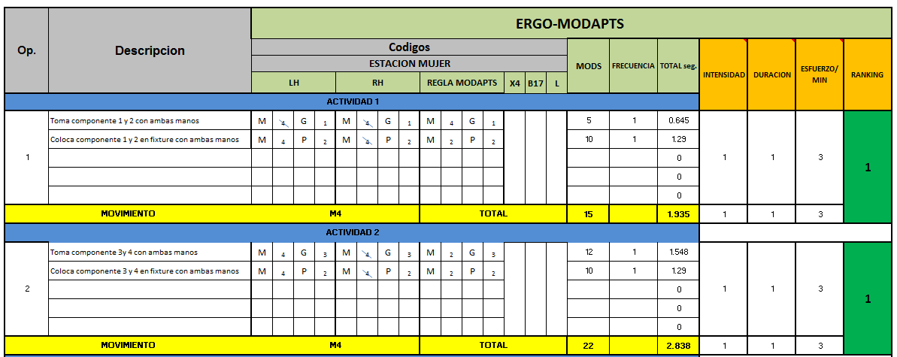

Table 2. Continuation of the model.

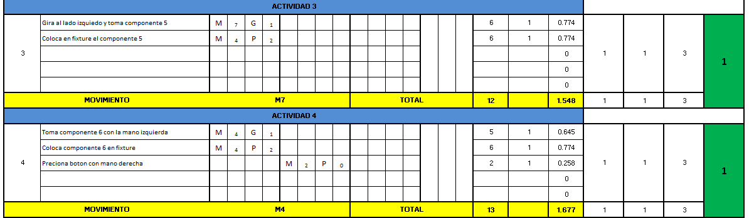

Table 3. Continuation of the model.

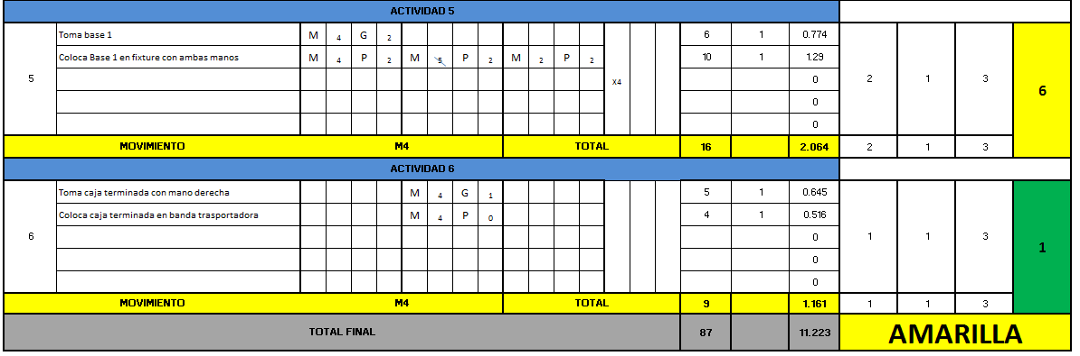

RESULTS AND CONCLUSIONS

The severity is estimated based on the combination of one; two, three and four, number four would be very high this means that in any activity that contains a number 4 has to make an immediate change in activity either in the levels of effort, duration, or frequency. The severity (harsh conditions of the job) is directly related to the priority of change, for example, a post with very severe conditions, presents a priority very high change. Very high or high priority for change tells us that the position presents a high potential risk to the health of the operator that works it, so that measures should be taken to reduce the causes giving rise to such harmful effects. Priority of low or moderate change indicates that the conditions of the job currently have an acceptable degree of satisfaction but should re-evaluate periodically in order to verify that these conditions do not affect in the future. (Villalobos & Ripoll, 2003).
For the application of the model Ergo-Modapts was necessary to make analysis of workstations as in the previous example, was performed a take of time with the Modapts method which was placed in the Excel template in the appropriate checkboxes for each code.
Once the model was performed, resulted that the station was located with a moderate risk since the station went yellow with its highest final score of 6. This indicates that you must be periodically assessing the workstation and improvements will be made.
Once done the analysis with the model Ergo-Modapts, the results obtained were those raised in the main objective, which was the realization of a combination of the two proposed methods, in order to facilitate the work of the engineer or ergonomist for make only one method at a time, resulting is the time it takes to perform the work and the degree of ergonomic severity of the station.

REFERENCES

Caragnano, & Lavatelli. (s.f.). ERGO-MTM model: an integrated approach to set working times based upon standardized working performance and controlled biomechanical load.
PricewaterhouseCoopers Advisory SpA.
Chengalur, S. E., Rodgers, S. H., & Bernard, T. E. (2004). Kodak´s Ergonomic Design for People at Work. Canada: Wiley.
Criollo, R. G. (2005). Estudio del Trabajo: Ingenieria de Métodos y Medicion del Trabajo. Mexico: Mc Graw Hill.
Heyde, C. (1990). Modular Arrangement of Predetermined Time Standards. MODAPTS Manual. Niebel, B. W., & Freivalds, A. (2007). Ingenieria Industrial Metodos, Estandares y Diseño del
Trabajo. Mexico: Alfaomega.
Perez, J. (2011). Virtual Human Factors Tools for Proactive Ergonomics: Qualitative Exploration And Method Development. Digital Commons @ Ryerson.
Sun, X. F., Cheng, G., & Li, W. (2009). Study on Work Improvement in a Packaging Machine Manufacturing Company. School of Mechanical and Electronic Engineering, 1155-1159.
Villalobos, A. R., & Ripoll, F. S. (2003). Clasificacion y Analisis de Puestos de Trabajo atendiendo a la Fatiga Muscular en una linea de montaje de atomoviles. V Congreso de Ingenieria de Organizacion. Valladolid.

RISK CONDITIONS AND DISCOMFORT BY BODY REGION WITHIN A LABORATORY OF TOXIC WASTE IN HERMOSILLO, MEXICO

Laura Elena López-Imperial1, Amina Marín Martínez2, Jaime Alfonso León Duarte3, Alfonso Cisneros-Campos4

1, 2, 3, 4 Departamento de Ingeniería Universidad de Sonora
Blvd. Luis Encinas y Rosales S/N Hermosillo, México. 83000.
  - ails: laura_elena2@hotmail.com, amarin@industrial.uson.mx, jleond@industrial.uson.mx, a_cisnerosc@hotmail.com

Resumen: El presente trabajo tiene como finalidad la medición y análisis de síntomas de incomodidad por región corporal presentados por el personal de un laboratorio dedicado a analizar residuos tóxicos en alimentos, ubicado en Hermosillo, México. Asimismo, se hace identificación preliminar de riesgos mediante visitas de diagnóstico. Los resultados de esta investigación, forman parte de la primera etapa de estudio y medición del trabajo de una tesis de investigación en el laboratorio. Este estudio se llevó a cabo mediante la aplicación de cuestionarios al personal de todas las áreas de trabajo del laboratorio, para conocer los síntomas de incomodidad presentados; y recorridos de observación y toma de evidencia fotográfica, para la identificación de riesgos.

Palabras Clave: Incomodidad por región corporal, condiciones riesgo.

Abstract: The purpose of this paper is to measure and analyze discomfort symptoms by body region manifested by the staff of a laboratory dedicated to analyze toxic residues in food, located in Hermosillo, Mexico. Similarly, there is a preliminary identification of risks through diagnostic visits. The results of this research are part of the first stage of study and work measurement of a research thesis in the laboratory. This study was carried out through the application of questionnaires to the staff from all work areas from the laboratory, to know the symptoms of discomfort submitted, observation, for the identification of risks.

Keywords: Body region discomfort, risk conditions.

INTRODUCTION

This paper has been developed as part of the preliminary study and measurement of laboratory work activities of a laboratory where a research thesis is performed on occupational health. The instruments used are assumed for the initial collection of information and priorities definition.

Diagnosing the problem

There is a need for certainty about the validity of the safety criteria implemented in the laboratory. The risks, to which personnel are exposed by the nature of their activities, are not monitored or

evaluated as an internal control. There are only minimum guidelines used as an instructive and visits by the Health and Safety Commission, to the laboratory system regarding to safety, however, within these guidelines are not considered precise specifications for the conditions under which they should work given the tasks performed in the laboratory. A diagnostic visit to facilities was made to observe generally critically workspaces. The findings of that visit are shown by photographic evidence. Besides, discomfort symptoms questionnaires were applied, submitted by the staff, to prioritize the analysis and future strategies interventions.

Delimitations

The present research was conducted in a laboratory dedicated to the analysis of toxic waste, located in Hermosillo, Mexico.
This study involves laboratory work areas that can be seen in illustration 1, involving 13 workers representing the entire population of study within the laboratory areas. All staff is female and their ages range from 23 to 54 years, with work experience of 3-25 years.
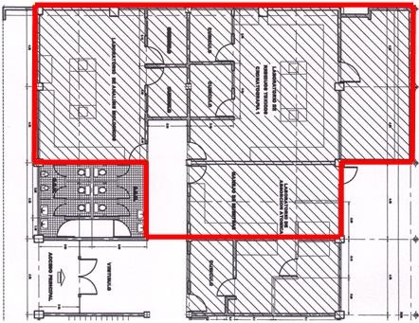

Illustration 1. Layout and presentation of toxic waste analysis laboratory areas.

Visits were made to the institution, where general walks of the facilities were made to identify hazardous conditions. Furthermore, for measurement of bodily discomfort symptoms, questionnaires where applied to demonstrated their bodily ailments.

Evaluation method by body map

A discomfort survey by body region can give more information when trying to identify workstations or high-risk tasks. The Body Map Evaluation Method proved to be a "reliable indicator" of work related musculoskeletal disorders. The body map is based on the evaluation of the frequency and the degree or level of discomfort that are indicated by the worker (Fernandez, et al., 2011).
With this model of Marley and Kuman (1996), it is possible to have an assessment of the worker categorized according to the following: (1) most likely to seek for treatment, (2) is somewhat likely to seek for treatment; (3) it is unlikely to seek for treatment.

This classification scheme has been statistically validated in large industrial populations. Body Map users have found it useful in early assessment of the impact of redesigning workstations and other ergonomic interventions. This map also has proven useful and valid as regular audits and supervision tool. In practice, this tool has been used by ergonomists and safety professionals to prioritize the analysis and intervention strategies (Fernández, et al., 2011).
To sort the priority attention of the body regions, the worker should select and qualify in a Body Map, the level of discomfort and perceived frequency in each region. According to their evaluation are cataloged in priority areas. In illustration 2 shows the reference to ratings body map of Marley and Kumar (1996).

N/Frec | 0 | 1 | 2 | 3
0
1
2
3
4
5
6
7
8
9
10

Symbol:
"Green Zone", is unlikely to seek treatment
"Yellow Zone", is something likely to seek treatment
"Red Zone", is likely to seek treatment
Unlikely Zone (no record)

Illustration 2. Reference for body map ratings by Marley and Kumar (1996).

All three areas have a realistic chance to help ergonomics, safety or medical professional to prioritize ergonomic intervention. It suggests that individuals and their respective work activities that have scores in the red zone receive the highest priority, the values of the yellow zone receive a medium priority, and the values in the green zone receive lower priority for ergonomic intervention (Marley and Kumar, 1996).

OBJECTIVES

- Identify key observed risks through diagnostic walks.
- Identify symptoms of increased level of discomfort and frequency.
- Locate work areas with higher priority bodily discomforts presented.
- Identify priority areas to assess with global ergonomic evaluation, based on the symptoms presented.

METHODOLOGY

  - Observation and tours to identify unsafe conditions

We performed a walk-around by the laboratory facilities where hazardous conditions were observed for female workers taking photographic evidence

Process of measuring symptoms of discomfort by body region

It was applied the body map evaluation method proposed by Marley and Kuman (1996), to 13 laboratory workers. To evaluate workers, they were asked to select the areas marked on the instrument where symptoms of discomfort are presented of discomfort, assessing their level and frequency.

RESULTS

  - Observation and tours to identify unsafe conditions
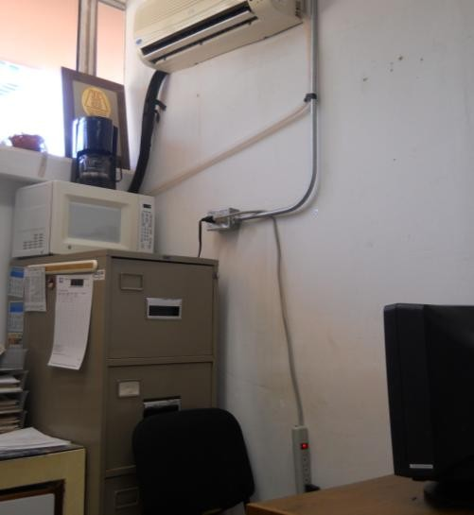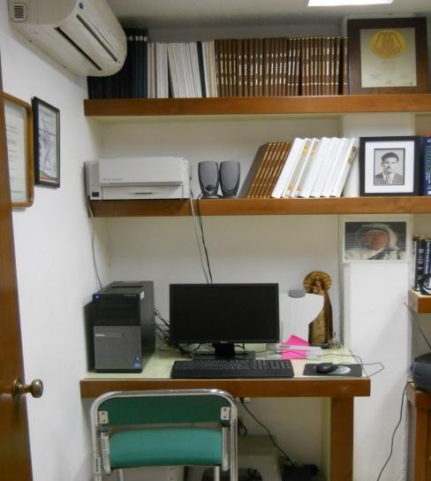

Illustration 3. Office areas with electrical hazard conditions.

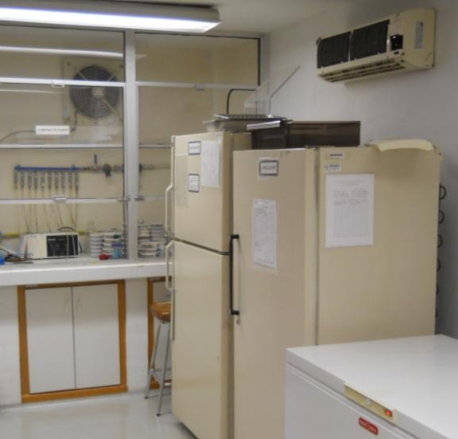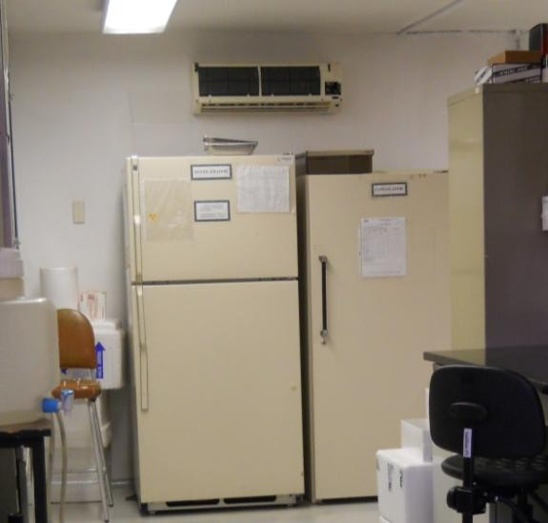

Illustration 4. Test areas with electrical hazard conditions.

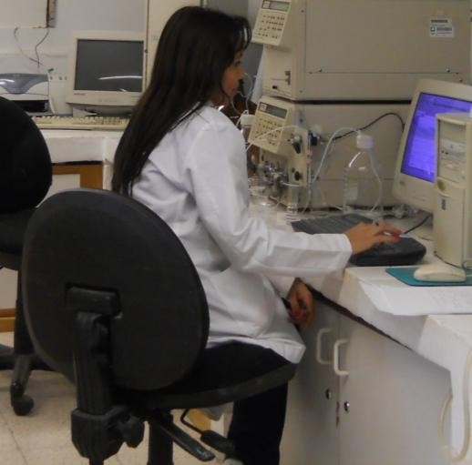
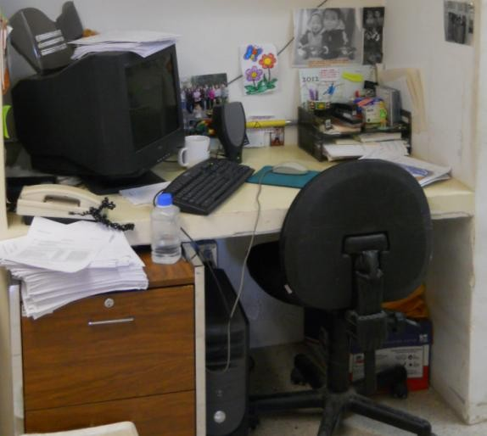

Illustration 5. Office areas with ergonomic risk conditions.

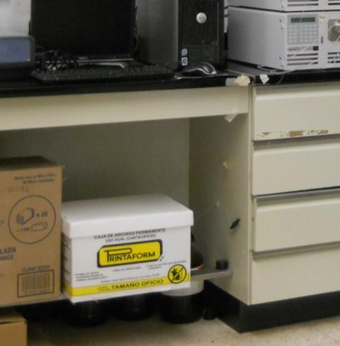

Illustration 6. Test areas with hazardous conditions due to improper storage.

Process of measuring symptoms of discomfort by body region

Table 1. Evaluation results of Body Map by Marley and Kumar (1996) in the laboratory.

Body Region |  | Number of people with discomfort | Porcentaje
 |  | Number of people with discomfort | Unlikely Zone | Green Zone | Yellow Zone | Red Zone
1 | Neck | 12 | 7.7 | 30.8 | 38.5 | 23.1
2 | Left Shoulder | 7 | 46.2 | 15.4 | 23.1 | 15.4
3 | Left Arm | 7 | 46.2 | 30.8 | 7.7 | 15.4
4 | Left Elbow | 4 | 76.9 | 15.4 | 7.7 | 0.0
5 | Left forearm | 4 | 69.2 | 0.0 | 23.1 | 7.7
6 | Left Wrist | 5 | 69.2 | 23.1 | 7.7 | 0.0
7 | Left Hand | 6 | 61.5 | 38.5 | 0.0 | 0.0
8 | Buttocks | 5 | 69.2 | 15.4 | 15.4 | 0.0
9 | Left Thigh | 3 | 84.6 | 0.0 | 15.4 | 0.0
10 | Left Knee | 5 | 61.5 | 23.1 | 7.7 | 7.7
11 | Left Leg | 4 | 69.2 | 15.4 | 7.7 | 7.7
12 | Left Ankle or Foot | 4 | 69.2 | 23.1 | 7.7 | 0.0
13 | Eyes | 10 | 23.1 | 15.4 | 38.5 | 23.1
14 | Upper Back | 12 | 7.7 | 30.8 | 46.2 | 15.4
15 | Right Shoulder | 5 | 69.2 | 7.7 | 15.4 | 7.7
16 | Right Arm | 4 | 76.9 | 15.4 | 7.7 | 0.0
17 | Right Elbow | 2 | 92.3 | 0.0 | 7.7 | 0.0
18 | Right Forearm | 3 | 76.9 | 7.7 | 7.7 | 7.7
19 | Right Wrist | 7 | 53.8 | 15.4 | 23.1 | 7.7

20 | Right Hand | 7 | 46.2 | 23.1 | 23.1 | 7.7
21 | Lower Back | 10 | 23.1 | 38.5 | 23.1 | 15.4
22 | Right Thigh | 2 | 84.6 | 7.7 | 7.7 | 0.0
23 | Right Knee | 5 | 61.5 | 7.7 | 30.8 | 0.0
24 | Right Leg | 5 | 61.5 | 15.4 | 7.7 | 15.4
25 | Right Ankle or Foot | 5 | 61.5 | 15.4 | 15.4 | 7.7

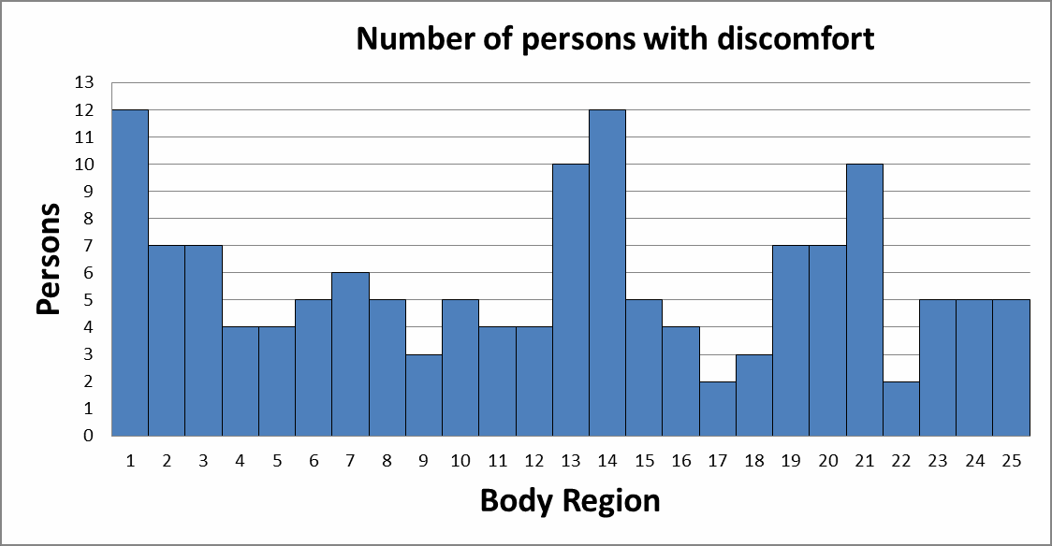

Chart 1. Number of persons with body region discomfort.

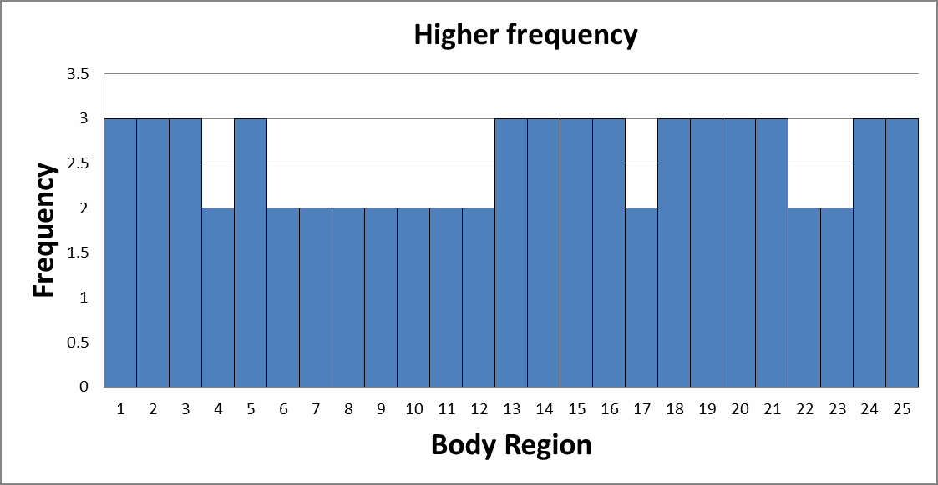

Chart 2. Higher frequency by body region.

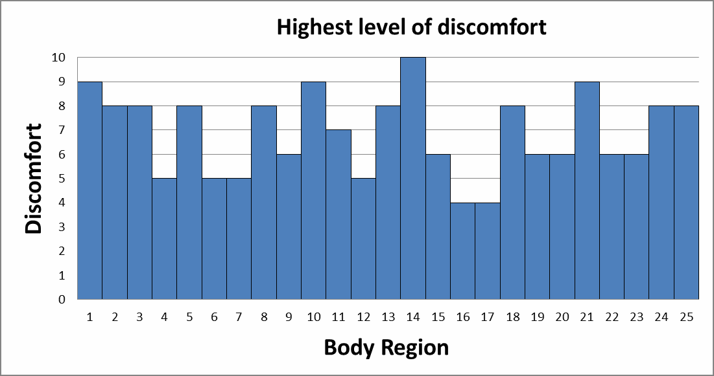

Chart 3. Highest level of discomfort by body region.

CONCLUSIONS

As results of observation and tours to identify unsafe conditions, is shown in the Image 3 and 4 that in the workplace are unsafe electrical conditions on office ant test areas in the laboratory.
On the other hand, in images 5 and 6, were observed for positions ergonomic risks while using computer equipment due to the design of jobs. Finally, risks were also found improper storage of waste materials and work areas.
The results of the discomfort survey by body region shown in Table 1 and Charts 1, 2 and 3 indicate that the presented symptoms are discomfort in upper back and neck with a reference frequency of 12. Secondly, they are manifestations of eye discomfort and low back/medium with a reference frequency of 10 persons.
It also shows that the higher frequencies in discomfort are presented in: neck, shoulder, arm and both forearms; eyes, upper and lower back; wrist and right hand, right leg and ankle/right foot. Moreover, the highest level of discomfort occurs in the upper back, followed by neck and back left knee low /medium.

BIBLIOGRAPHY

Fernández J., Marley R., Noriega S. e Ibarra G. (2011). Ergonomía Ocupacional: Diseño y Administración del Trabajo. 1era ed. México: Universidad Autónoma de Ciudad Juárez.
Marley, R., y Kumar, N. (1996). An improved musculoskeletal discomfort assessment tool.
International Journal of Industrial Ergonomics. Vol. 17, pp. 21-27.

ANALYSIS OF RISK FACTORS OF MUSCULOSKELETAL INJURIES IN UPPER EXTREMITY IN ASSEMBLY LINE WORH WITH DYNAMIC LOADS

Ana Carolina Esparza Urquijo1, Francisco Octavio López Millan1, Enrique Javier de la Vega Bustillos1, Gerardo Meza Partida1.
1Instituto Tecnológico de Hermosillo, Departamento Posgrado, Ave. Tecnológico S/N. Col. El Sahuaro, C.P. 83170, Hermosillo, Sonora.
  - ail: carol.esparza@hotmail.com, lopezoctavio@yahoo.com.mx, en_vega@ith.mx

RESUMEN. Se presenta una investigación descriptiva de corte transversal, que tuvo como propósito realizar un análisis de carácter integral en cuatro estaciones de trabajo de una línea de ensamble, de una industria manufacturera. Con el fin de identificar la fuerza aplicada con la que se realiza dicha operación. No hay nada malo en mover las articulaciones en toda su extensión ocasionalmente; sin embargo, las posturas inadecuadas sostenidas durante varias horas o repetidas durante todo un día de trabajo implican un problema. El análisis del proyecto, se inició con la recopilación de datos de una estación de trabajo que consiste en darle ajuste (golpeteo) a la pieza ensamblada en la estación anterior, para llevar a cabo esta operación se utiliza como herramienta un cincel y martillo, para ello se realizaron mediciones con un acelerómetro CXL-LP Series. Los datos obtenidos nos servirán como indicador de cuantos golpeteos se dan por operador en un turno de trabajo y así empezar a monitorear los esfuerzos dinámicos, para así poder calcular y observar la fuerza que se le aplica a un ajuste alto, mediano o bajo. Las mediciones observadas al realizar el ajuste en una sola unidad en un tiempo aproximado de 55 segundos fueron de 20 golpeteos, observando cuatro ajustes con un impacto de entro los 110 y 90 Libras/Fuerza y el resto de entre los 4 y 35 Libras/Fuerza.

Palabras clave: Ergonómia, Esfuerzos dinámicos, Fuerza.

ABSTRACT. Here is presented a cross-sectional descriptive study, which its purpose was to achieve a completeness ergonomic evaluation in four work stations in assembly line of a manufacturing industry. In order to identify the strength that was applied on which this operation was performed. There is nothing wrong on moving the articulations in all its extension occasionally; however, the inadequate sustained postures within hours or repeated in a day of work, involve a problem. The analysis of the project started with the compilation of data in a work station which it consists in giving it adjustment to the assembled piece in a previous station, to perform this operation is necessary a chisel and a hammer as tools, for this, the measures were done with an accelerometer CXL-LP Series. This data will help us as an indicator of how this has to be adjusted for operator in work turn in order to start to monitor the dynamic force, so we can estimate and observe the force that is applied to a tall, medium and short adjustment and identify this strength applied in an adjustment done to each of the work units, which it could cause some type of musculoskeletal injury. The measures observed when creating the adjustment in a single unit, it is an average time of 55 seconds, there were 20 poundings, observing four adjustments with an impact of 110 and 90 Lb./Force and the rest between 4 and 35 Lb./Force.

Key Words: Ergonomics, Dynamic Strength, Force.

INTRODUCTION

The ergonomics is a multifunctional discipline that studies the capacities and abilities of the human being adapting the work that belongs to the man and not vice versa, to bring security, comfort, satisfaction, productivity and to keep health for the workers (Pastrano, Guevara, González, & Piñero, 2006). In the other hand, the ergonomics, also named engineering in human factors, it is the study of the physics’ demands of the work that guarantee a secure and productive environment to work. The function of the specialist in ergonomics it is to design or to improve the place, work station, tools, equipment and procedures of the workers in order to limit the fatigue, discomfort and injuries to reach the efficient objectives, personal and from the organization. The goal is to maintain the job demands into the physical capacities of the workers. (LaDou, 2007, page. 165)
Muscle disorder – skeletal that defines as injuries and disorder of the muscles, nerves, tissues, ligaments, joints, and cartilage and spinal discs and do not include the injuries as a result of slips, trips, falls, or similar accidents (Chablat, Ma, Bennis, & Zhang, 2009).
The objective it is to analyze the impact strength on which the operation is done, it consists in an adjustment (pounding). By studying with the collect of data with an accelerometer CXL-LP Series, and later trying to determinate a standard of the strength applied in the operations where there are dynamic efforts, for its characteristics an exposure times, they would be able to affect the health of workers.

METHODOLOGY

In order to obtain the data the dynamic force in the work stations we must follow an investigation of a cross-sectional descriptive study, which its purpose was to achieve a completeness ergonomic evaluation in four work stations in assembly line of a manufacturing industry. (Hernández Sampieri, Fernández Collado, & Baptista Lucio, 2010, pág. 151)
The repedetly aplication of a great strength to hold or take tools of heavy use or industries are accompanying of alteration in the tissues on the forearm, muscle fatigue and carpal tunel syndrome. The operations and the tools must be redesigned to dicrease the strenght required to perform and dicrease the handle time of the strenght aplication within the operation cycle. The operations that merit fast movements of hand and shoulder, or movements that repeat every few seconds within the day, had been seen with alterations of the tissues. The exposure to these oparations are controled limiting the number of hours a day that an oparator performs these movements or with the rotation of the workers with different oparation to avoid overload the same unit of the muscle, tissue and bone in a work day. (LaDou, 2007, pages. 175-176).
The study took place with a triaxial accelometer, which is an artefactor that measures the acceleration. Most of the accelometers are nothing but transductors of strenght designed to measure strenght of the reaction asosciated with some acceleration measured. The accelerometer to use is CXL-LP Series, the accelerometers of the serie LP are low price, from general use, lineal acceleration and a sensor of vibration of ± 25 g. As shown in the next figure:

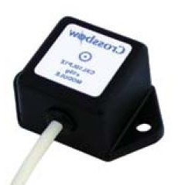

Figure 1. Accelerometer CXL-LP Series.

This accelerometer is placed to the operator in the medium part of the hand to be used to give the adjustment, as shown in the next figure, the answers of the body differ according with the direction of the movement. The vibration measures often in the interfaces between the body and the surfaces that vibrate in three directions orthogonals. Taking this figure as a reference for its movements of the operation to analyze. (Salvendy, 2006)
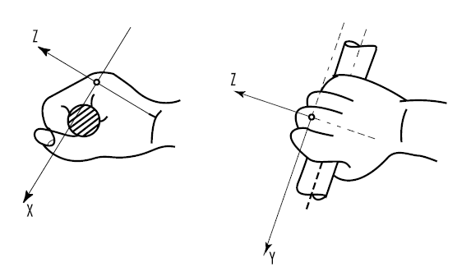
X

Figure 2: Coordinates system for the measuring of the vibrations transmitted to the hands.

The procedured for the obtantion of data was performed like this:

- Knowing the work stations to evaluate and knowing the number of oparators that meet in each one of them.
- Characterize the adjustment (pounding) that the operator performs on each unit, performing the data where it is specified the amount of poundings that are performed per unit (tall. Medium and short).
- Perform measurments with the accelerometer.
- Analyze data.

RESULTS

Nowdays, there was a study made in four work stations in a assembly line, of a manufacture industry; each work station divides in three operations: door installation, torque and adjustment; eache one of the stations are integrated of 3 operators, having a total of 12 operators per turn, and each one rotates every 15 days.

The study is taking place in the last oparation that is the one that adjusts with a tool (hammer and chisel). For this, there were visits done to the four work stations, all this to analyze with detail the oparation to study an identifying specific solutions that will reduce the risk factors most important, commented with the parts involved (workers, supervisors, engeneers, installations and maintenance, manager).
With this, there could be identified the variables that could affect the operator, like the weight of the tools. ( chisel that has an aproximately weight of 850 grams and the weight of the hammer is 900 grams) the type of adjustment or poundings per unit (tall, medium and short), another factors that affect the operation, like the installation of hinges, punching, nut, and installation of the door and crane.
For the analysis of the data, there was started a compilation in each work station that consists in giving adjustment (pounding) to the piece assembled in the last station, to start this operation it is used as a tool a chisel and a hammer. This data obtained will help us as an idicatior of how many poundings must be for each operator in each work turn and start to monitor the dynamic strength like how to measure the force that is being impacted. An example of this data is shown on the following figures:
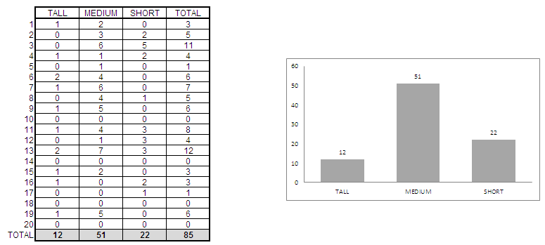

Figure 3: Caracterization of adjustment per unit every 55 secons aproximately.

Later on, there will be performed the measurment of the characterization made before, with the accelerometer CXL-LP Series. To identify if the strenght applied in the adjustment made to each work unitm it could cause a musculoskeletal injury in a long, medium or short term.
With the accelerometer there would be obtained 100 data per second, on which there would be peaks selected that were obtained with this measurment, as are shown on the following image:

Chart 1: Acceleration values in G, in the coordinates Z, Y, X
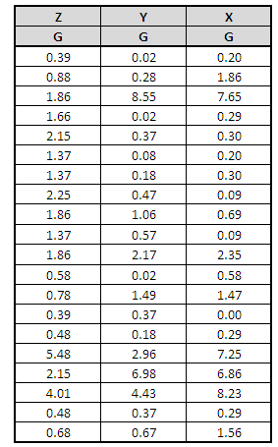
G is a gravitational value 1 G = 9.81 m/s2
As the accelerometer, gives us values in G, we need to perform an conversion, which it consists in multiplying its value 9.81 m/s2. The information generated before, we will use it to estimate the force applied on each of the adjustments made, which is going to take place with this formula:

F = m*a (1)

Where:
F = Force, value to estimate in units of Lb./Force
m = Matter, one constant (5 percentil of the weight of the operator + the weight of the tool of 900 grams).
a = Acceleration (data given from the accelerometer)

The results obtained are found expresed en Newtons and for our analysis we convert them to Lbs/Force, giving us as a result the following information:

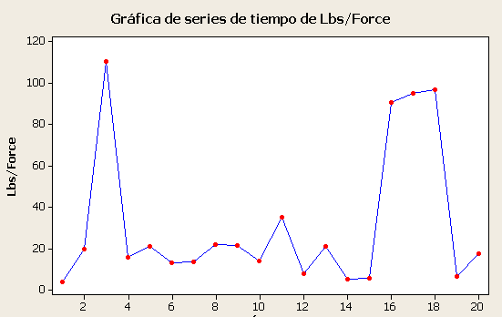

Figure 4. Graphic of the results obtained i Lbs./Force of the measurments made with Minitab.

As there is shown in figure 4 according to the characterization made before, we have four picks of 110, 96, 94, 90 Lbs/Force, also the other adjustments that are inside of the 4, 35 Lbs/Force.

CONCLUSIONS

Once the measurment has been made with the accelerometer CXL-LP Series, we observe that when performing the adjustment in a single unit, in an aproximately time of 55 seconds, there were given 20 poundings, observing four adjustments with an impact of delivery the 110 and 90 Lbs/Force and the rest between the 4 and 35 Lb./Force. For the moment there has not be found any standard in where we could stablish if the force applied in these adjustments, there are into the maximun limits and determine the cycles of exposure in the working stations. This study is going to require the realization of a psychophysical analysis, in order to determine a standard of force applied in the operations where there exists dynamic strength, for its characteristics an exposure time, they could be able to affect the health of the workers
There had been researches but without a tool, one of the investigations studies the maximum force made with the hand that the people will find acceptable when making the tasks and examine how these tolerances could change depending the posture of the hand (palm or ulnar) and using some protection (naked hand or with a glove) (Murphy & Potvin, 1999)

REFERENCES

Chablat, D., Ma, L., Bennis, F., & Zhang, W. (2009). Dynamic Muscle Fatigue Evaluation in Virtual Working Environment. 14.

Hernández Sampieri, R., Fernández Collado, C., & Baptista Lucio, M. d. (2010). Metodología de la Investigación. México D.F: Mc. Graw Hill.
LaDou, J. (2007). Diagnóstico y tratamiento en medicina laboral y ambiental. México: McGraw- Hill.
Murphy, M. P., & Potvin, J. R. (1999). A Psychophysical Study To Determine Maximum Acceptable Hand Impact Forces During Door Trim Installation: Effects Of Hand Posture and Impact Gloves. 103. Windsor, Ontario, Canada.
Pastrano, I., Guevara, H., González, S., & Piñero, S. (2006). Evaluación Ergonómica y Trastornos Musculoesqueléticos Relacionados con el Trabajo en una Empresa Manufacturera de Cartón. Informe Médico, 553-561.
Salvendy, G. (2006). Handbook of Human Factors and Ergonomics. New Jersey: Wiley.

CHARACTERIZATION OF OCCUPATIONAL ERGONOMICS PROGRAM
Fuentes Córdova Ramona Monserrat1, López Millán Francisco Octavio1, De la Vega Bustillos Enrique Javier1
1 Instituto Tecnológico de Hermosillo, Departamento de Posgrado, Ave. Tecnológico y Periférico Poniente S/N C.P. 83170 Colonia Sahuaro., Hermosillo, Sonora, México.
Email: a9723288@hotmail.com.mx

Resumen: Un programa de ergonomía completo bien llevado a cabo por cualquier empresa, puede ayudar a evitar accidentes o lecciones causadas por el mal uso de herramientas o condiciones de trabajo, logrando así empresas más redituables y seguras para sus empleados. El presente trabajo pretende ayudar aquellas empresas que cuentan o no con un programa ergonómico. Por medio de un metanálisis se desarrolla un modelo de evaluación que cuenta con variables relevantes en un programa de ergonomía exitoso, el cual asigna puntos de acuerdo al número de variables aplicadas, percibiendo cual es el nivel actual y que se requiere para ser mejor en el área de ergonomía dentro de la empresa.

Palabras Clave: Programa ergonómico, Metanálisis, Modelo de evaluación.

Abstract: A well performed ergonomic program, conducted by any company, can help to prevent accidents or injuries caused by using unsafe tools or unsafe working conditions, leading to achieve more profitable and safe companies. This paper aims to help companies having or not an ergonomic program. By means of a meta-analysis, it is developed an evaluation model that has relevant factors in a successful ergonomic program. The meta-analysis assigns values based on the number of applying variables, to know the current conditions and what is needed to improve the ergonomic conditions within the company.

Keywords: Ergonomics Program, Meta-analysis, Evaluation Model

INTRODUCTION

This paper is focused on the ergonomics program process for manufacturing companies, by developing a level characterization model by means of a meta-analysis, to classify having factors and those necessaries to achieve a successful ergonomics program. The above to know where is a particular company located in the presented model.
Ergonomics program is intended to promote the health and safety of workers and protection of the environment and the community. Safety and environmental systems embody philosophical and cultural commitment that begins with leadership. When leadership is accomplished, the organization creates and supports good behaviors and satisfactory systems (Borja, 2009).
Occupational accidents and diseases constitute one of the main problems of labor population all over the world, because of the high cost in human lives and the repercussions that it usually generates. Further than reducing work capacity, occupational accidents and diseases, imply severe consequences in the quality of the life of workers and their families, so it is important to consider that an efficient and effective ergonomics program within the companies helps to reduce

cumulative trauma disorders (DTA’s.) produced by repetitive tasks, inadequate work performance, misused tools and a some other problems that can arise from bad work practices.
Through a meta-analysis, which constitutes the greatest advancement of applied statistics and its usefulness to synthesize information from different independent studies on the same research question, this study is conducted targeting on the ergonomics implantation program for manufacturing companies, seeking to characterize the current status of any particular company, using the designed model.

OBJECTIVES
  - General Objective
Present a model that helps to understand how is characterized the application process of occupational ergonomics program in manufacturing companies.

Specific Objectives
Documentary research through systematic reviews (books, magazines, databases, etc.) to formatting the ergonomics model, focusing on the resulting factors considered as relevant in this investigation.
Field investigation, data collection, and analysis to understand the current performance of implementing ergonomics program in manufacturing companies in the state of Sonora.

DELIMITATION
This research, carried out by means of meta-analysis, is performed only in medium and large manufacturing companies in the industry such as the automotive, aerospace, textiles, and electronics.

METHODOLOGY

This study is divided as follows, first determine the area of study, followed by the type of occupational ergonomics program research, the implemented model, the procedure for obtaining and validating data, and at last the materials used for the fulfillment of this study.

Type of Research.
According to our goal, it is conducted by means of an exploratory research which serves to identify the most important variables, and to recognize alternative courses of action and suitable tracks for further investigation. In this research is observed a large number of units of analysis conducting an intensive study.

Model Research.
The research method is by means of a meta-analysis, conducted through systematic reviews (SR) designed to find and synthesize the available scientific evidence on the research questions presented in this paper. This methodology allows synthesizing the results from primary studies using strategies that minimize bias and random error. (J. Zamora)
This research includes review of literature from books, journal articles, and web pages such as OSHA, Shingo Prize, NIOSH, MASH and some more. Field research in a practical way to manufacturing companies in the industry that have repetitive activities, which can be evaluated in

the ergonomics program if have one, and if not, to propose the method developed through this research.

Procedure for obtaining and validating data.
As mentioned before, the method to processing information is through a systematic review which involves several steps including formulating the right question, an extensive data search, the selection process and summary without bias, critical appraisal and data synthesis of these. (J. Zamora)

RESULTS

To obtain the results in the present study, searching for information was done with the help of diagrams (Fig. 1, 2, 3) of reliable sources such as: Database, magazines, websites, etc., which are shown in the boxes below, the number of research documents founded.
Fig.1. Search method using connectors Or / Or - And / And, among keywords.
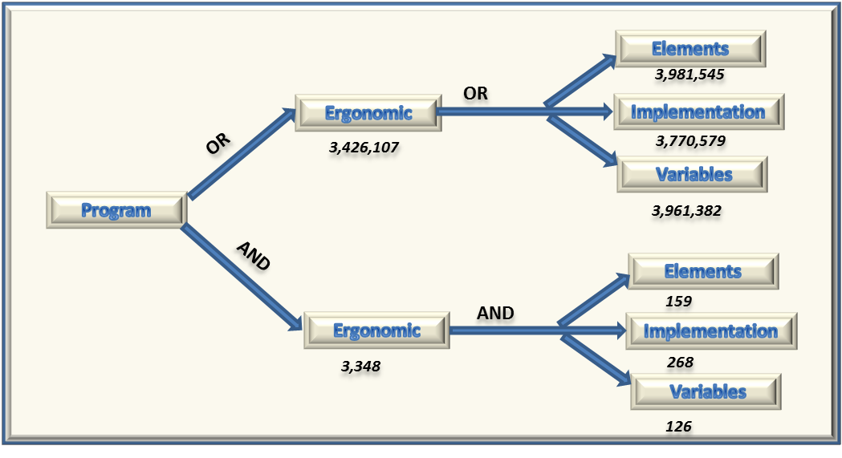
Fig.2. Search method using connectors Or / And - And / Or, among keywords

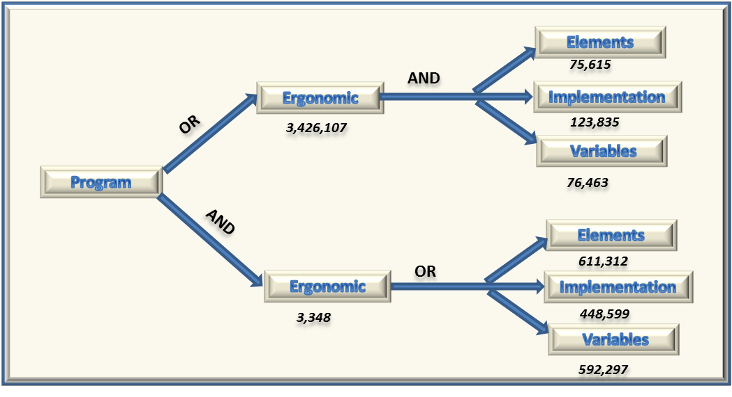
Fig.3 Search method, successful ergonomics program using connectors or / and / or - and / or / and.
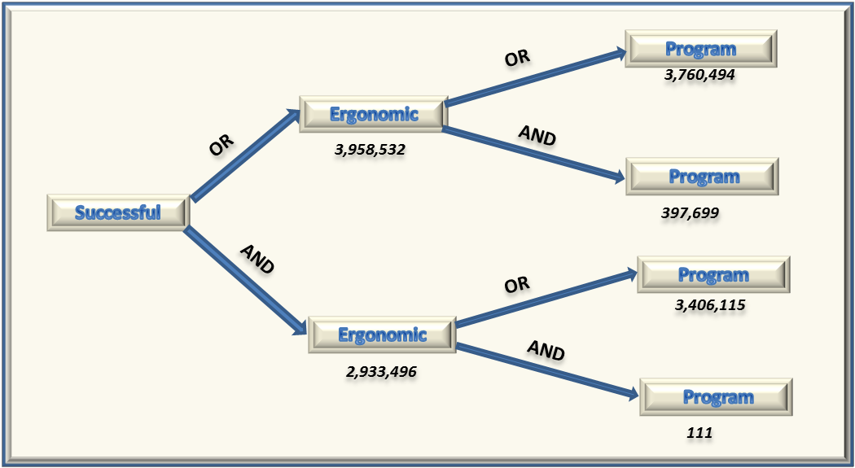

Performing the analysis of the collected information has proved the following important points in the development of a successful ergonomics program:
Management commitment.- Management commitment is critical to the success of any ergonomics program. Management provides staff and financial support for ergonomics initiatives and can help to lead the ergonomics program so that it aligns with site and corporate goals and strategies. In addition, management involvement as active participants in the ergonomics process demonstrates the importance of safety and health in the organization.

Employee involvement.- Employees are most familiar with the physical requirements of the routine and non-routine aspects of a job. Employees provide vital input in the analysis of jobs as well as solution development and implementation. If employees are active participants, the likelihood of successful increases the ergonomic interventions.

Identification of issues. - Historical data is often used initially to identify problem jobs in a work area, such as workers compensation records, turnover and absenteeism, near misses, incident investigations, and employee complaints and grievances. The data is reviewed to identify the development of musculoskeletal disorders. Specific trends such as seasonal work, product mix, or overtime should be noted.

Analyzing and developing controls for issues. - There are several validated ergonomics job analysis tools. These vary in the depth of the analysis and amount of training required to use them accurately. Ergonomics job analysis tools focus on the identification of ergonomics risk factors: force, repetition, awkward and static work postures, contact stress, and environmental factors including vibration, lighting, and temperature.

Training and education. - Training is an integral part of any ergonomics process. Although the content and length of the training will vary, training should be conducted across all levels of the organization including upper management, environmental health and safety staff, engineering, packaging, purchasing, facilities, supervisors, and employees.

Medical management. - Musculoskeletal disorders are cumulative and develop over time. Early reporting and intervention will assist in minimizing the number and severity of injuries. A comprehensive medical management program includes communication with medical Suppliers to ensure they are familiar with the work environment and job task requirements.

CONCLUSIONS

Search carried out with the schemes presented above databases books, magazines etc., show the same results in which only changes the words but the meaning is the same. Should considering some points as author of this work thinking on the relevant to the achievement of the objectives and assessment model development and validation.

REFERENCES

Borja, A. M. (2009). Programa de Gestion de Salud, Seguridad y Ambiente. Bogota, Colombia: Universidad Icesi.
Monroe, K. (2006). Ergonomics 101: revisiting the basics of successful ergonomics programs. Ann Arbor, MI: Industrial Engineer (Norcross, Ga.: 2003) 38 no3 41-5 Mr 2006.
Niebel, B. (2004). Ingenieria industrial. Mexico, D.F: Alfa Omega.
Susan E. Dudley, W. B. (2001). OSHA's Ergonomics Program Standard and Musculoskeletal Disorders: An Introduction. JOURNAL OF LABOR RESEARCH, 2-14.

Zamora, M. Revisiones sistematicas y metanalisis de estudios sobre prebas diagnosticas de cribaje. 27 Congreso Nacional de Estadistica e Investigacion Operativa. Unidad de Bioestadistica Clinica, Madrid, Espana.

METHODOLOGY FOR THE IMPLEMENTATION OF A SYSTEM OF JOB ROTATION CONSIDERING AN ERGONOMIC APPROACH
Francisco Armando Loreto López1, Enrique de la Vega Bustillos1,
Francisco Octavio Lopez Millan1, Gerardo Meza Partida1

1 Instituto Tecnológico de Hermosillo, Departamento de Posgrado, Ave. Tecnológico y Periférico Poniente S/N C.P. 83170 Colonia Sahuaro., Hermosillo, Sonora, México.
franciscoarmandoloreto@gmail.com, en_vega@ith.mx

Resumen. El presente artículo proporcionara una metodología para la planificación de un sistema de rotación de puestos basado en un enfoque ergonómico, esto con el fin de prevenir los desordenes musculo esqueléticos (TME) que se producen por no rotar en las estaciones de trabajo. Se propondrá una metodología para generar un sistema de rotaciones que tome en cuenta ciertos criterios ergonómicos como son la evaluación ergonómica Susan Rodgers, método ERGOS para los factores psicosociales, el gasto metabólico de energía y la antropometría para poder proporcionar una rotación optima y así poder reducir o eliminar los trastornos musculo esqueléticos.

Palabras clave: Ergonomía, TME, Susan Rodgers, Rotación.

Abstract. This article will provide a methodology for the planning of a job rotation system based on an ergonomic approach, in order to prevent disorders musculoskeletal (MSDS) that occur by not rotating on the workstations. It will propose a methodology to generate a system of rotations that take into account ergonomic criteria such as: ergonomic evaluation Susan Rodgers, ERGOS method of psychosocial factors, metabolic expenditure of energy and Anthropometry, in order to provide a rotation optimal and reduce or eliminate the muscular skeletal disorders.

Keywords: ergonomics, MSDS, Susan Rodgers, rotation.

INTRODUCTION

The posts rotation is a form of work organization that extends between manufacturing and service companies (Vezina, 2004). The results that are obtained by rotation systems, benefit both companies and workers, have low implementation costs compared to other possible measures to improve working conditions. (Kogi, Kawakami, Itani, & Batino, 2003)
For manufacturing firms, worker rotation involves adequate knowledge to perform different tasks, enabling companies increase the ability of workers to fill various stations, minimizing the impact of abandonment rate and favoring a greater flexibility for possible changes in demand and this is achieved by firms acquire more knowledge about the capabilities of their employees. (O'Donnell, 1986)
Moreover, the variation of tasks helps reduce fatigue and the risk of musculoskeletal injuries and cumulative trauma disorders (DTAs), provided that the alternation of activities is an effective change of the muscle groups involved. However, some studies on the implementation of posts

rotation as a measure to prevent musculoskeletal injuries adverse results have been obtained (Frazer, Norman, & Wells, 2003).
Currently musculoskeletal disorders (MSDs) in manufacturing enterprises are a major health problem that affects workers. Musculoskeletal problems affecting workers is important for businesses as it affects them economically. Job rotation has been used as a mechanism to prevent MSDs by companies as a means of containment to prevent injuries. (OSHA, 2013)

OBJETIVE

The main objective of the research is to develop a methodology to obtain a rotation system designed to prevent musculoskeletal disorders in a methodical way.
The specifics objectives is find or identify a maximum level of worker exposure, to reduce ergonomic problems such as musculoskeletal disorders, develop a rotation system that takes into account multiple criteria associated with MSDs, to diversify the tasks done during the working day and finally consider the disabilities permanent or temporary of workers and comply with restrictions imposed by the of rotation system and the organization.
This work aims to make a methodology for implementing a system of rotations that considers the physical aspects of the work and the worker, which together can be a safe and efficient for both the operator and businesses.

METHODOLOGY

Presents a methodology to generate and evaluate a rotation system that considers multiple factors that may influence a correct assignment stations and ergonomic constraints that ensure the practical feasibility of the results. Thus it seeks to maximize the benefits derived from the application of this technique, such as preventing musculoskeletal injuries, improve psychosocial workers, facilitate the training of workers, facilitate the incorporation of workers in rehabilitation and increase productivity and economic benefits derived from the implementation of a rotation system. (Asensio-Cuesta, 2009)
The methodology presents a structured sequential method to obtain a rotation scheme presented through 10 phases of which are represented here:
Phase 1: Detect the Need.
Phase 2: Obtaining support for part of the management and workers.
Phase 3: Selection of stations to rotate.
Phase 4: Selection of operators to rotate.
Phase 5: Choice of criteria for the generation of a rotation scheme.
Phase 6: Definition and assessment of indicators or restrictions
Phase 7: Definition and evaluation of capabilities required in stations and limited operators.
Phase 8: Determination of the number and duration of the rotations.
Phase 9: Obtaining a rotation scheme through the application of the rotation system
Phase 10: proposal and implementation of the plan of rotation.

Classification of MSDS
There are many different ailments within TME. We propose two possible classifications of MSDs. The first classification considers the damaged element, while the second proposal gathers

musculoskeletal injuries according to the area of the body where they are located. (Asensio- Cuesta, 2009)
The musculoskeletal diseases are divided into: articular pathologies that affect joints (hand, wrist, elbow, knee ...), usually result from maintaining awkward postures, which also influences the overuse of the joint. The main symptoms are the most common joint pain or joint pain. Among the diseases belonging to this group are TME arthritis and osteoarthritis. Peri articular pathologies: are known as soft tissue rheumatism. This group of diseases tendon injuries, tenosynovitis, ligament injuries, bursitis, ganglion, myalgias, contractures and muscle tear. Bone disease: lesions involving bone. (Bruce P. Bernard, 1997)
There are a variety of musculoskeletal injuries, some well defined as carpal tunnel syndrome, and other nonspecific whose causes and sources of pain are unknown. (Bruce P. Bernard, 1997)

Ergonomic Evaluation Method (SUSAN RODGERS)
The introduction of a rotation schedule of jobs with a high level of risk, exposes workers to a situation that even short-term, may be sufficient to produce skeletal muscle injury. (Vezina, 2004)
The analysis of muscle fatigue was proposed by Dr Suzanne Rodgers as a means to evaluate the amount of fatigue that accumulates in the muscles during different work patterns within 5 minutes of work. (Chengalur, Rodgers, & Bernard, 2004). Each of the parameters: effort, duration, and frequency, are evaluated individually, on a scale of 1 to 4, for each part of the body. Levels of effort are valued as light (1), moderate (2), strong (3), very strong (4) based on descriptions qualitative for different parts of the body, the duration is titrated with 1, 2, 3, 4 for each muscle group. The duration of the effort should be measured only to the level of effort that is being evaluated. This method is not suitable to evaluate tasks of high frequency (more than 15 efforts per minute). For works in which muscles are active several times per minute due to a very repetitive task, even short-term efforts can be a problem.(Villalobos & Ripoll, 2003).
The method for the analysis of work is also most appropriate to evaluate the risk for the accumulation of fatigue in tasks that are done during one hour or more and where forced postures or frequent efforts are present. Based on the risk of fatigue, a priority for change can be assigned to the task. (Chengalur, Rodgers, & Bernard, 2004)

Methods for the Evaluation of Psychosocial Factors
Psychosocial factors appear to be related to MSDs. It is therefore necessary to complete assessments focused on ergonomic risk factors directly related to MSDs (repeatability, lifting, awkward postures, etc.). With assessments of psychosocial factors is sought a study of mental workload. (Bruce P. Bernard, 1997)

3.3.1 ERGOS Method.

The ERGOS method, procedure developed in 1989 by the Prevention Service of the former National Steel Company (ENSIDESA), facilitates an indication of the risk factors present in the non-physical job. The concept of mental workload of the job objective may be addressed in a practical way through a simple questionnaire. (Llaneza Álvarez, 2009)
It has been considered for the determination of an indicator mental load, mental load factors. As the result of mental load requirements of the task interacting with environmental conditions, with

the emotional functions and characteristics of the organization, not easy to determine the degree of impact that mental load exerted on each of them.

Factors and criteria for evaluation
General Inquiries Evaluation Criteria Central Processes
Labour Relations dependent Working Hours
Insulation Initiative Monotony Complexity Attention
Time pressure (Llaneza Álvarez, 2009)

Anthropometry

The anthropometry is the treaty that measures the proportions of the human body. We can understand the mechanics Biomechanics as applied to the study of living things, the mechanics can be divided into two branches: static and dynamic. To study the biomechanics of posture of man sitting at rest, we will use the biostatic, to analyze actions receiving a player's wrist to throw the ball, use the Biodynamic, in both cases we must rely on anthropometry. (Bustamante, 2004)

Predictive Method for Metabolic Expenditure

This method uses a process of job analysis. For determine the metabolic energy expenditure for specific jobs. Once a job has been analyzed, the metabolic energy expenditure of each share of the tasks is added to determine the metabolic cost of labor power.
Predictive models are fast, do not interfere with the employee and give details of the work being developed. The weakness in these models involves the level of detail required for the task analysis. Each share of each task that affects metabolism should be recognized and included in the total energy metabolic cost. (SEMAC, 2012)

RESULTS

The methodology proposed earlier in the plant's stamping and Assembly FORD Hermosillo in the area B1con crew working FRONT DOOR RH - LH and MOON ROOF, was applied resulting in the following.
Phase 1. On the ground of FORD Hermosillo Stamping and Assembly decided to implement a rotation system for the new area of B1 which is dedicated to conducting parts of a vehicle such as: front and rear doors, hood, trunk and what call "sun roof "the part where there is a window on the roof of certain vehicles as a proposed solution to the problem was a new area and do not have a rotation plan for operators workstations of 3 shifts. For purposes of this article was presented to the crew above.

Phase 2. The adoption of the plan was supported rotations of the address, and was framed within an Ergonomic Improvement Plan (PGME) plant. The purpose of this was to reduce the rate PGME TME and absenteeism. To ensure the commitment of the workers involved in the new rotation plan was decided to select only B1 area workers.
Phase 3. For selection of seats to rotate an evaluation of the repeatability of ergonomic movements of the 31 stations to be included in the rotation plan. The ergonomic evaluation method was applied Sue Rodgers and results are described in Table 1.
Ergonomic evaluation was performed with the method to detect Susan Rodgers ergonomic risks to workers of each season. Below is the concentrate of the analysis in the crew.

Table 1. Concentrated ergonomic checklist.
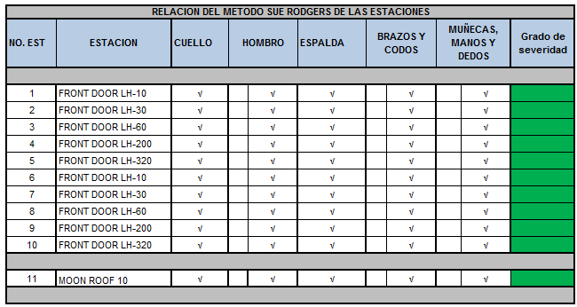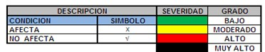

This table shows that to do ergonomic evaluations of the stations of the crew came in green severity; it tells us that the working conditions are currently an acceptable degree of satisfaction, which, should reassess the position regularly in order to check that these conditions not reach to cause one risk to the worker.
Phase 4. Workers, who occupied the selected jobs to rotate, were chosen. All selected workers belonged to the same labour category and crew.
Phase 5. Design criteria defined for improvement were as follows:
Problem 1: existence of a high monotony of the everyday activities of workers, lack of satisfaction of these and high absenteeism rate:
Design criteria: involving an effective change of activity the content of work.
Design criteria: that the preferences of workers for certain jobs are taken into account.
Problem 2: need for incorporation of workers in rehabilitation or with physical or mental limitations period:
Design criteria: that the limitations of workers are compatible with the requirements of the jobs.

Phase 6. Listing restrictions: Turnover by crew's work, this will be to:
FRONT DOOR (RH - LH Y MOON ROOF).

Types of rotation based on loaded and inspection: FRONT DOOR Loaded (10, 30, 60, MOON ROOF).
FRONT DOOR Inspection (200, 320).
Ideal rotation for pregnant women: Beginning of gestation
Before 20 weeks can operate in all weather restricted to Sue Rodgers y GME. After 20 weeks, it will only operate stations where there is no bending back.
End of gestation.
Inability to 41 days will be in the prenatal period. Inability to 41 days will be in the postnatal period.
Phase 7: definition and assessment of capacities in the stations and operators limited. Obtaining the metabolic cost of power stations and the anthropometric analysis of the workers took place for this.
Continuation of sample analysis of the metabolic expenditure in the B1 area concentrates.

Table 2. Concentrated analysis of energy expenditure.
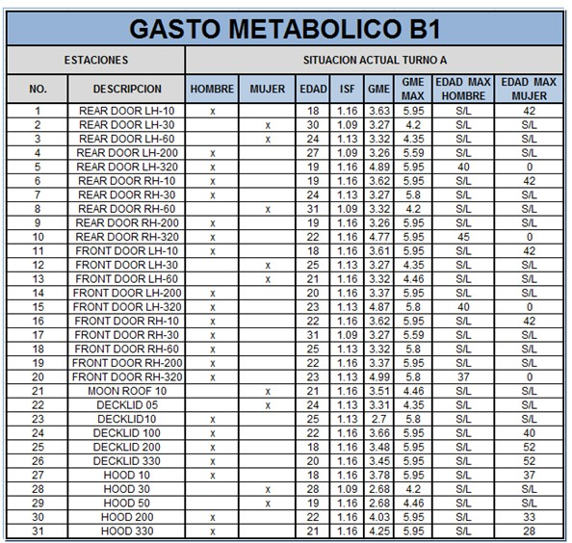

In the table above is seen as energy metabolic expenditure analysis stations of the first turn where you see in the GME column the result obtained from the study of each of the stations and in the GME MAX column the maximum level of exposure to the station, this refers to determine that operators both male and female and age can be on certain workstations, taking into account the age to be able to contemplate them to the time to rotation.
Below is the anthropometric study in men and women.

Phase 8: Determination of the number of the length of rotations. In this phase is taken as a criterion for the organization do the rotations to two weeks.
Below is a schedule of rotation with a period of two weeks:

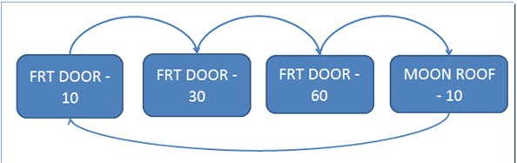

Figure 1. Flow chart loaded stations

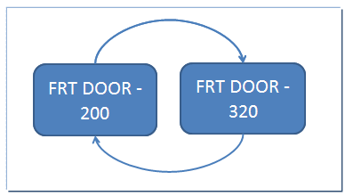

Figure 2. Flowchart inspection stations.

Table 3. Anthropometry men
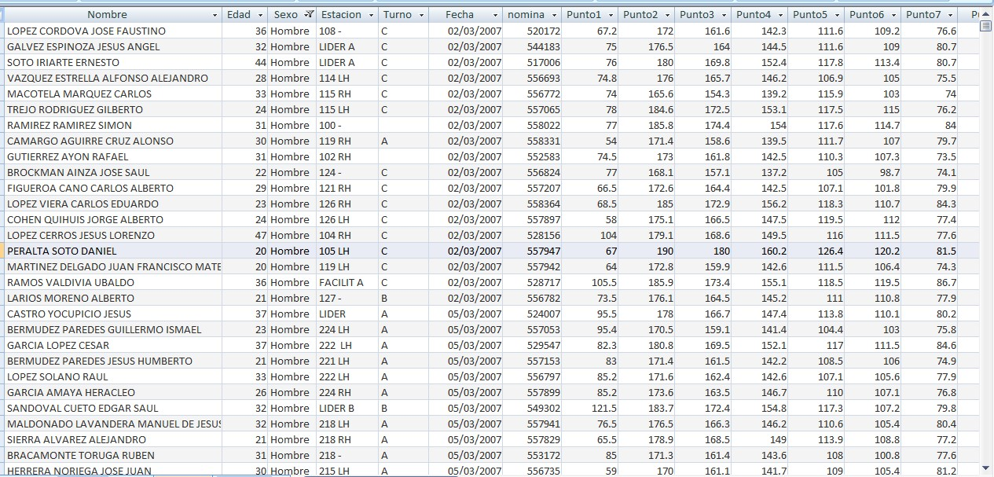

Table 4. Anthropometry women
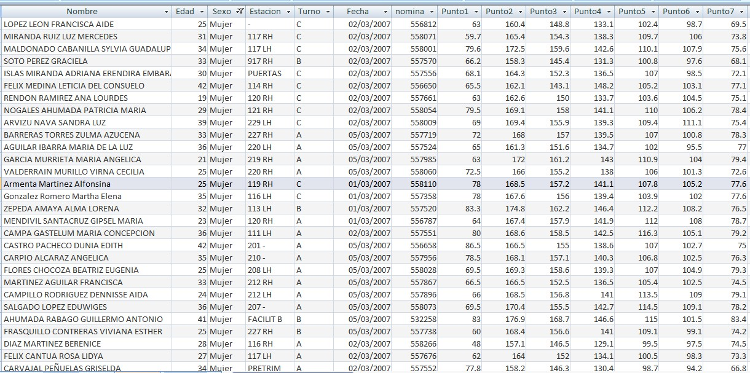

Phase 9: Obtaining a rotation through the application of a SR. scheme The aforementioned crew rotation plan, which were obtained the following rotation plans:
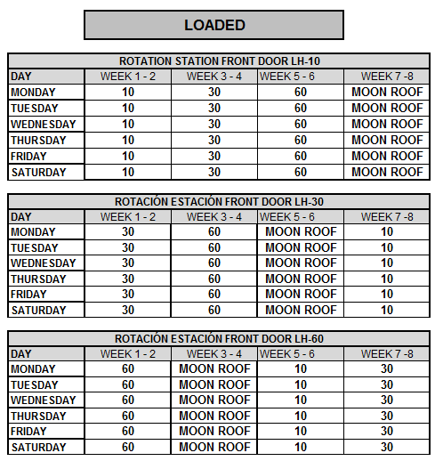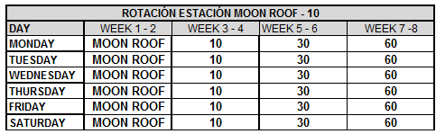Then arose the plan of rotation for the crew when there is a case of pregnancy. Table 5. Rotation schedule without loaded pregnancies.

Table 6. Rotation schedule without inspection pregnancies.
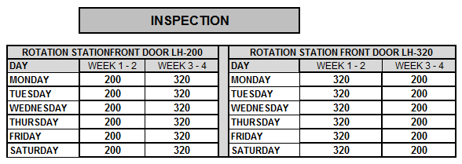

Then arose the crew rotation scheme where there is a case of pregnancy.

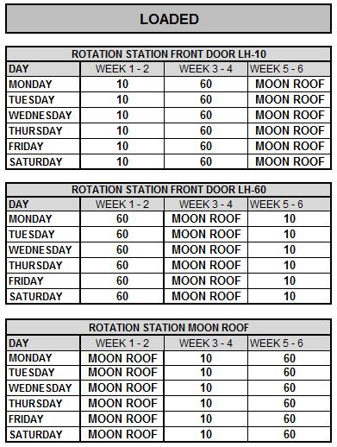
Table 7. Rotation schedule with loaded pregnancies.

Table 8. Rotation schedule with pregnancies in inspection.
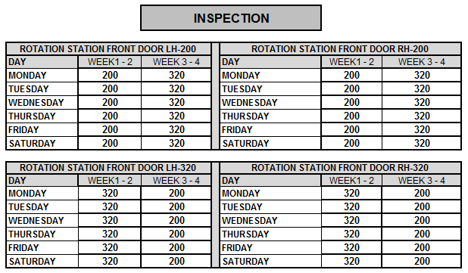

CONCLUTIONS

To end this article I include in basis of the results obtained for two types of rotations when there are cases of pregnancy or not.
Based on the analysis of the rotations are found that there are two inspection stations where operators cannot be mixed with other operators from the loading area since they dont have a training in inspection, if an operator of inspection will be changed to charged would need one in inspection to supplement the station who were alone. For this reason it was thought in separates the agendas of rotation by loading and inspection.
On the other hand, where there are cases of pregnant workers taking into account pregnancy restrictions mentioned above in the article just may be in the station referred to in table 8 by be a station where there is a Flex back and between all stations which require less physical effort from the operator. For loaded station (320), was restricted only to male operators given by the analysis of the metabolic expenditure which restricted to female operators to operate this station.

REFERENCES

Asensio-Cuesta, S. (2009). Metodología para la generación de agendas de rotación de puestos de trabajo desde un enfoque ergonómico mediante algoritmos evolutivos. Universidad Politecnica de Valencia, Valencia.
Bruce P. Bernard, M. M. (1997). Musculoskeletal Disorders and workplace factors: A Critical Review of Epidemiologic Evidence for Work-Related Musculoskeletal Disorders of the

Neck, Upper Extremity, and Low Back. National Institute for Occupational Safety and Health, july.
Bustamante, A. ( 2004). ERGONOMÍA,ANTROPOMETRÍA E INDETERMINACIÓN. Aubonne.
Chengalur, S. E., Rodgers, S. H., & Bernard, T. E. (2004). Kodak´s Ergonomic Design for People at Work. Canada: Wiley.
Frazer, M. B., Norman, R. W., & Wells, R. P. (2003). The eﬀ ects of job rotation on the risk of reporting low back pain. Taylor & Francis ltd.
Kogi, K., Kawakami, T., Itani, T., & Batino, J. M. (march de 2003). Low-cost work improvements that can reduce the risk of musculoskeletal disorders. International Journal of Industrial Ergonomics, 179-184.
Llaneza Álvarez, F. J. (2009). Ergonomía y psicosociología aplicada : manual para la formación del especialista (13 ed.). España: Lex Nova.
Niebel, B., & Freivalds, A. (2007). Ingenieria Industrial Metodos, Estandares y diseño del Trabajo. En B. Niebel, & A. Freivalds, Ingenieria Industrial Metodos, Estandares y diseño del Trabajo. (págs. 483-514). Mexico: Alfaomega.
O'Donnell, R. y. (1986). Workload assessment methodology. Revista de Psicología del Trabajo y de las Organizaciones.
OSHA. (2013). Occupational Safety and Health Administration (OSHA). Recuperado el enero de 2013, de http://www.osha.gov/dcsp/products/etools/printing/glossary.html#J
SEMAC. (2012). www.semac.org.mx. Recuperado el 22 de noviembre de 2012, de http://www.semac.org.mx/archivos/5-3.pdf
Vezina, N. (2004). Rotation implantation: what is at stake? what are the makers? PISTES.
Villalobos, A. R., & Ripoll, F. S. (2003). Clasificacion y Analisis de Puestos de Trabajo atendiendo a la Fatiga Muscular en una linea de montaje de atomoviles. V Congreso de Ingenieria de Organizacion. Valladolid.

PROPOSED PROCEDURE FOR THE ERGONOMICS EVALUATION FOR CUMULATIVE TRAUMA DISORDERS.

Jaime Guadalupe Pérez Muñoz; Marbella Muñiz Sánchez; María Eugenia Lazcano Herrero; Felipe Martínez Vargas
Academic body: "Technologies for ergonomic environmental evaluation factors in the work environment"
Department of Industrial Engineering Instituto Tecnológico de Puebla
Av. Tecnológico No. 420 Puebla, Pue. Author’s e-mail: jpm104@yahoo.com.mx

RESUMEN

En la actualidad se ha identificado la necesidad de involucrar las diferentes disciplinas científicas y técnicas para el logro de una meta común. El presente trabajo de investigación involucra disciplinas como la medicina y la ingeniería fusionándolas en la ergonomía para proporcionar una herramienta que nos facilite la comprensión y realización de una propuesta de evaluación ergonómica para identificar desórdenes por trauma acumulativo en las estaciones de trabajo en posición sedente o de pie, para las extremidades superiores y de espalda baja en las empresas manufactureras. Dicho procedimiento tiene como base el reconocer los factores de riesgo que pueden originar uno o un grupo de desórdenes por trauma acumulativo en dichas estaciones, en donde se presentarán opciones para detectar, identificar, reducir y/o eliminar, así como, el controlar los factores de riesgo encontrados en las estaciones de trabajo. Por medio de un flujo grama el cual presenta tres etapas, la Primera Etapa: Preparación e Identificación, donde se tiene como responsable a la administración; La Segunda Etapa: Análisis y Control de Factores de Riesgo Ergonómicos, aquí recae la responsabilidad en el comité de ergonomía; Y la Tercera Etapa: Administración Médica ó Vigilancia, que es responsabilidad de los médicos. De esta manera la investigación busca reducir la incomodidad corporal, disminuir los accidentes, las incapacidades e indemnizaciones y el absentismo.

Palabras Clave: Desordenes, Trauma, Acumulado

ABSTRACT

Currently we have identified the need to involve different scientific disciplines and techniques to achieve a common goal. The present work research involves disciplines such as medicine and engineering fusing on ergonomics to provide a tool that facilitates the understanding and realization of a proposal to identify ergonomic evaluation cumulative trauma disorders in workstations in the sitting position or foot to the upper extremities and lower back in manufacturing companies. This procedure is based on the recognition of risk factors that can lead to one or a group of cumulative trauma disorders in those stations where presenting options to detect, to identify, to reduce and / or to eliminate, as well as the control factors found risk workstations.
Using a flow chart which has three stages, the first stage: Preparation and Identification, which is

responsible for the management, the second stage: Analysis and Control of ergonomic risk factors, here the responsibility lies on the ergonomics committee, and the third stage: Surveillance or medical administration, it is the responsibility of physicians. Thus, the research seeks to reduce bodily discomfort, reduce accidents, disability and compensation and absenteeism.

Keywords: Disorders, Traumatic, Cumulative.

INTRODUCTION.

One characteristic of Homo sapiens is the ability to make and use tools, mankind has always devoted much work to the development of devices and structures that make it useful to employ resources.
In the early 50's was born in Europe a discipline that gave it the name of "ergonomics", today is also known as "human factors". Its objective has since been exploring the relationship between man and his working environment, adapting the environment to man, within that work environment is a set of concepts, which for purposes of this research is highlighted in the identification and control of cumulative trauma disorders.
The work presented aims to give a broader picture of the problem that has the industry in the world and in our country mainly, both in terms of quality, productivity, Resource Management, Maintenance, and Safety and other factors involved in the process, but the research is considered in the care of the human being, through ergonomics and engineering. Since this action is interference in all processes.
The interest of this work is to generate a proposed procedure for the ergonomic evaluation of cumulative trauma disorders workstations, to help people both directly and indirectly involved in the process of managing the activities taking place in the thereof, which comprises the trinomial man-machine-environment, since despite its technical preparation, have not had the opportunity to train administrative awareness and feel the need for it and at the same time focus to senior management to activities of ergonomics, which is the site where the foundation that will support current and future economies. Which tends to be held by workers, where they have a very active role in managing their resources is performed in a systematic way.
According to statistics (IMSS, 2009-2011) in our country has 14, 375.948 workers, which the rate of occupational diseases per 10,000 workers is 2.71% and work disability per 100 cases is 5.30% on average for the period 2009-2011. Just as they have for accidents according to the anatomical region, Wrist and Hand 76.121 23.359 men and women for the head and neck (excluding eye injury and its annexes) 28.962 12.976 men and women and for the most rugged Abdomen, lumbosacra region, lumbar spine and pelvis 25.683 11.533 men and women. For the same period, but more specifically, have disease according to the nature of the injury and sex; For synovitis, tenosynovitis and bursitis 40 men and 157 women; For Carpal Tunnel 17 men and 98 women, those in the same period of time and finally Dorsopatías that occurred only in 2011 with 110 men and 14 women, it is clear that they are already considering based on ICD-10.
This information indicates that 80% of population suffers disabling pain to work during their working lives. (Dukes-Dubos, 1997) says that back pain and other conditions as the neck and shoulders and hand-wrist are leading causes of absenteeism in companies, in most industrialized countries. Reducing body discomfort can help to prevent back pain.

OBJECTIVE

Develop a proposed method for ergonomic evaluation of cumulative trauma disorders workstations in sitting or standing position for the upper extremities and lower back in manufacturing companies, based on identifying ergonomic risk factors, with the reference to international standard ISO 6385:2004 and the American National Standards Institute ANSI Z-3.65, as well as strengthen the Federal Rules of Safety, Health and Working Environment of the Ministry of Labor and Social Security in order to reduce occupational diseases and partial or total disability.

DELIMITATION

The problems currently encountered by organizations both manufacturing and service, as the way they have been developing Occupational Health Programs through time, this shows that despite great efforts human, physical and financial resources are allocated to they reach their goals, have not favorably impact on levels of accidents and occupational diseases, or significantly change the safety culture within most organizations.
Therefore “lacking” within organizations with a proactive process interested in the detection and control of injuries and illnesses come to have unnecessary costs by partial or total compensation, low worker productivity and team work, absenteeism and turnover, to quote a few effects. Although it is more common that technology and applications made more of the daily activities, relieving humans from having to perform repetitive, difficult or dangerous activities, there are still many tasks to be done manually and require a maintaining physical effort or uncomfortable and unnatural positions for extended periods of time.
On the other hand, the diffusion and application of technology, mechanization and automation systems generally accelerates the pace of work, causing problems as diverse as making work is uninteresting to stressful situations for operators.
One of the underlying principles of ergonomics is "user-centered design," which generally means that "if an object, system or environment is intended to be used by humans, their design should be based on the capabilities and physical and mental characteristics of the users ", in order to find the best link between the product and the users within the context of the activity carried out, or in other words," ergonomics is the science that is responsible for adapting activity the worker and the product user "(Pheasant, 1996). Taken from (Martinez, 2005)
On the labor front, the application of anthropometric data is reflected in the design and construction of equipment and machinery properly and safely, workspaces sufficient and appropriate, and the design of tasks that match the user's abilities and opportunities. However, the diversity of potential users, it has become necessary to know the size and characteristics of the human body, so in many countries have been studies that are intended to have an anthropometric database of the population. In addition, the area of biomechanics has fostered his research and involvement in the search for weight limits and repetition during movement of loads, biomechanical injuries, and repetitive micro trauma, in the industrial world are becoming more numerous and frequent.
In addition, the most important thing to understand the problem we must mention that the General of Health and Safety at Work Management, facilitates compliance with the obligations of both managers and workers that is broadcast regulation and law commissions will bring. Thus, the

Mexican Official Standards on Safety and Health at Work, none is geared specifically to Ergonomics, much less to Cumulative Trauma Disorders, even when the Federal Rules of Safety, Health and Working Environment (Published in the Official Journal of the Federation on January 21, 1997), make the following provisions:
Title III; Hygiene conditions, Chapter tenth; ergonomics, "Article 102. (Unique) The Secretary shall promote in plant, machinery, equipment or tools of the workplace, the employer takes into account the ergonomic aspects, in order to prevent accidents and illnesses." and defines ergonomics as "the adaptation of the workplace, equipment, machinery and tools to workers, according to their physical and mental, in order to prevent accidents and illnesses and optimize this activity with the least effort and avoid fatigue and human error, "therefore, means that the pattern just focus on ergonomics, without knowing its magnitude, which is the problem in the absence of a procedure for the evaluation ergonomic risk prevention and illnesses, as well as for the DTA's specifically.
There is a justification from the fact that the lack of ergonomics standards in Mexico (Bonilla, 2001) says that "in Mexico there are no guides or ergonomic standards as in Europe (Germany has its own rules) or the U.S.. We analyzed the labor laws of Hygiene and Security (STPS, 1992), especially the Federal Regulation of Health and Safety and Standards 1 to 25; construction standards and Enlightenment, the Official Mexican Norm (NOM) of different products and materials, and no explicit ergonomic standards. It should be a general guide for tracking ergonomic evaluation in Mexico."

METHODOLOGY

It identifies and analyzes the overall context of the Community legislation in European Union, United States and Mexico, as a guide to the proposal, on Cumulative Trauma Disorders, focusing in particularly:
- The International Standard ISO 6385:2004 "Ergonomic principles in the design of work systems", in order to define the ergonomic criteria for design, specifically in paragraphs:
3.6.6 Design workspace and the workplace with their subsections, 1, 2, 3 and 4. In order to provide guide steps for centering the proposed document.
- The ANSI Z-365 "Control of the work related to cumulative trauma disorders" issued by the American National Standards Institute. In addition, OSHA procedures and NIOSH, in order to adopt, accept and create steps in the proposed assessment, and to be described in the document.
- Federal Regulation of Health, Safety and Working Environment Ministry of Labor and Social Security, and that in regard to the Mexican Official Standard is not aware of the term or reference. Likewise, the Federal Labor Law. To complement the proposal in the national regulatory framework.
The procedure and methods for ergonomic evaluation of cumulative trauma disorders proposed, is determined to identify ergonomic risk factors, which include, as such the procedure and collection of information to give the evaluation results.
The basis of the estimate ergonomic workstation consists of a systematic and careful description of the task or job, for which observations and interviews are used in order to obtain the necessary information. In some cases, require simple measuring instruments, such as for lighting a light meter, a noise level meter to a thermal environment thermometer, etc. As well as assessment methods generally and specifically for the DTA's.

RESULTS.

The procedure for the ergonomic evaluation of cumulative trauma disorders proposed consists of three stages, which explains how to use, what areas involved and the people responsible for each, whose main tool a flow chart where allowed to continue in a clear and easy analysis of a workstation, to thereby reaching an evaluation result and determine if the employee continues its activities, business must change or else will who have an incapacity to recover.

First Stage: Preparation and Identification:

The senior management of the company is responsible for determining policies, objectives and targets generate very clear and focused on the goals of the organization and its vision, to preserve the health of the workers, which performs actions in posts work to help manage the risk factors associated with DTA's, training in self-care workers in their work, periodic examinations to detect early onset of symptoms and to take conduct aimed at minimizing the risks of ATD's.
By workers, it is expected a responsibility to self-care through different practices: run the job in ergonomics and biomechanics, go to training, adequate and timely report symptoms related to work, attend medical appointments for periodic review.
Workers involved in developing the list of ergonomic risk factors of the company by identifying them. Also, to form the ergonomics committee and work for conviction and responsibility.
The color blue, for this stage only requires the direct participation of the Directors or senior management for approval and be convinced of the good decision to carry out the assessment in ergonomic workstations. Of course you should consider the necessary resources for the proper performance of this activity and bring it to fruition.

Second Stage Analysis and Control of Ergonomic Risk Factors:

This step runs the multidisciplinary ergonomics committee, since it involves conducting assessments of workstations with regard to anthropometry, environmental conditions and then to identify the risk factors first in each job by the categories defined in ergonomic risk factors and secondly by determining the ergonomics and biomechanical job thirdly by evaluating specific workplace in relation to the possibility of musculoskeletal pathologies. In each of these three assessments control actions are defined according to the problems encountered. It is important to state for epidemiological management interventions in all work processes. So to generate statistics and records to control and improve future workstations.
Therefore, it is very important the support of the administration committee on training in specific courses and topics to evaluate the induction of the company doctor, the area of health and safety and / or the ergonomist. Similarly, the committee integrated multidisciplinary teams from other areas to deliver courses and encourage participation at all levels.
In the same way you can see the flow chart in his speech to the procedure, directly with the color yellow.

Third Stage: Medical Management and Monitoring:

At this stage, the overall responsibility lies with the medical staff as they performed the detection of musculoskeletal health problems, taking appropriate behavior with each of these situations in an orderly and report to your medical records. Since the specific tests as screening, treatment and
/ or referral to recovery. In the same way, will be shown in the flow chart his intervention with the procedure, with the green.
Figure No. 1 shows the flow chart with the proposed procedure and indicating the three stages in a more representative. (Perez, 2007)

CONCLUSION

The present research provides a procedure for evaluating proposed ergonomically cumulative trauma disorders workstations. Due to the lack of a procedure governed by our official rules for these disorders, was raised as to propose a method to fill this gap, so research was integrated with paragraphs above. That's not it either, to present options for solving the problem concerning the design of workstations. Since each company using this tool will have different problems and therefore a different solution. With all this, we have identified the need to involve undeniable, regardless of the level at which it is made, to ergonomics in production processes in higher education and in everyday life.
To involve ergonomics in production processes to be an awareness of workers and managers to determine that as the best conditions of work, not be a wrongful expenditure, as doing so everyone involved in the production process will benefit. On the one hand employees will be more satisfied with the work they do, with this increased attention put on their work and achieve better quality products with excellent avoiding waste and rework costs. To achieve a quality product with excellent customer buy more giving higher returns to producers.
It is vital to the support of senior management for the proper performance of the ergonomic evaluation of DTA's on the workstations, otherwise it will be an impending failure, since often fall by half due to lack of continuity or not to see short-term results. Perhaps for lack of planning or lack of well-structured organizational vision.
Also, constant training is required of all personnel in one way or another involved in the production process, to either of them, and of course the ergonomics team or committee to be always at the forefront of technology, as currently requires greater capacity and dexterity than strength and / or effort to perform their duties.
The medical and / or ergonomist must be updated in the latest medical information and methods to better perform their work and instruct workers frequently regard on ergonomic risk factors and cumulative trauma disorders in office working. The worker must be more aware of providing information of any anomalies that may develop a DTA's in their activities and therefore rely on visual aids to detect musculoskeletal disorders at work. It is to be spread more vigorously the term ergonomics throughout the community, as in household activities is very common and perform them improperly generated more cumulative trauma disorders that develop from poor posture, causing it to reach the company have unsatisfactory performance and / or defective products are created or up to accidents.

Liderazgo Administrativo
Participación de los

nomía
Identificación e información de RE

Investigaciones y Soluciones. Vol 6 2013

Análisis

Ergo

Ocupacional.

Selección del Puesto

No

Nueva Evaluación
¿Es el Sí
puesto de
trabajo de
Detallado de Antropometría
Análisis Detallado de Condiciones Ambientales

Desarrollo de la Solución

No

¿Se resolvió Sí el problema?
Implementació n de la

Medi o o
Evaluar cada 3

Diagnóstico de FRE
Alto

Intervención General

Malo
Bueno

Nueva Evaluación

Excelente, Bueno o Razonable
Evaluar cada 2

Análisis detallado de ergonomía y biomecánica
Pésimo o Deficiente

Intervención Específica

Malo

Bueno

Nueva Evaluación

Evaluar cada año

Moderado o Bajo
Evaluación específica por DTA’s
Alto

Intervención Específica

Malo
Bueno

, Diagnóstico
Detección Precoz
Pruebas específicas según detección
Tratamiento y/o remisión
Negativo

Positivo
Control periódico cada 2 años o con

Figure No. 1 Ergonomics Evaluation Process (DTA's) Cumulative Trauma Disorders
Verificar en el FRE
(FRE) Ergonomic Risk Factors

Recuperació No

Reubicación

SOCIEDAD DE ERGONOMISTAS DE MEXICO, A.C. Página 118 Sí
Sigue en el Puesto

It is recommended that no matter the size of the company, to know if they have a procedure for evaluating ergonomic workstations, instead do the following:
- For companies that do not have or have ergonomic procedure, that is they must cover the three stages.
- For companies which perform diagnostics and medical ergonomic, with or without ergonomic procedure must comply with the last two stages.
- For companies that have missing procedure of applying ergonomic and surveillance, it is necessary to perform the third stage.
In addition is very important to know your staff and that will reach old age and will have to adapt in order to perform the job equally or better, so you have to take into consideration this point. Allowing other research to explore the possibility of considering workstations for seniors age or older, and that soon there will be a large population of this type and is cautious ahead.
Also, this research will open the gap in educational and industrial organizations to consider ergonomics and what is involved in a scientific and technical knowledge be helpful for employees, workers, students and any human being, enabling them to conduct its business with better working conditions in the household and up for fun, reducing disability, compensation and why not to deaths.
In the same way, that agencies such as the Ministry of Labor and Social Welfare, the Social Security Institute and the laws concerning as the Chambers of Deputies and Senators to take action on the matter and is a security measure to with workers in general. Since the Federal Rules of Safety, Health and Working Environment, nothing gives its definition and does not consider the cumulative trauma disorders, energy expenditure, the physical work capacity and manual handling as preventive measures, which lead to reduced overhead to administrators, to increase their productivity and become more competitive.
“Cumulative trauma disorders are a bird, which must shoot with a shotgun, not with a revolver.” (Perez, 2007)

7. REFERENCES

Agencia Europea para la Seguridad y Salud en el Trabajo. www.osha.eu.int
Asociación Española de Normalización y Certificación; Principios ergonómicos para el diseño de sistemas de trabajo; UNE-EN ISO 6385: 2004.
Bonilla Rodríguez E. (2001). La ergonomía y sus técnicas de aplicación; Revista Higiene y Seguridad; Año 35, No.422.
Diario Oficial de la Federación. (1997). Secretaría del Trabajo y Previsión Social,
Reglamento Federal de Seguridad, Higiene y Medio Ambiente de Trabajo; www.segob.mx.
DUKES-DUBOS, F. (1997). Occupational Health and Safety: “What Is the Best Way to Lift and Carry?” ; Vol.46, No.1; pp.16-18.Tomado de Salvendy, G. (1991). Manual de Ingeniería Industrial. Volumen I.
Elements of Ergonomics Programs. www.cdc.gov/niosh/97-117pdf.html
Grandjean, Etienne. (1990). Fitting the task to the Man. Human Engineering. Ed. Taylor & Francis Ltd., 4ta Reimpresión.
Kroemer K.H.E., Kroemer H.B., Kroemer-Elbert K.E. (1994). Ergonomics: How to Design for Ease and Efficiency. Ed. Prentice Hall, Primera Edición. NJ.
Martínez, de la Teja G. (2005). Curso a Distancia: Ergonomía Laboral.

Memorias estadísticas IMSS, 2009-2011; Tomado de http://www.imss.gob.mx/estadisticas/financieras/Pages/memoriaestadistica.aspx; y DPM/ División de Información en Salud (DIS) - ST-5, SIMF y SISAT.
Mondelo, R. Pedro; Gregori, Torada E. Barrau, Bombardo P.(2000). Ergonomía 1: Fundamentos. Ed. Alfaomega, México, D. F.
Musculoskeletal disorders and worplace factors, (Julio 1997). www.niosh.gov/Department of Health and Human Services
Niebel Benjamin W. & Freivalds Andris. (2001). Ingeniería Industrial. Métodos, Estándares y Diseño del Trabajo. Ed. Alfaomega, Décima Edición, México, D. F.
Oborne D. (1995). Ergonomía en Acción: La Adaptación del Medio Ambiente del Trabajo al Hombre. Ed Trillas. México D. F.
Pérez M. Jaime G. (2007). Propuesta de Procedimiento para Evaluación Ergonómica de los Desórdenes por Trauma Acumulativos en las Estaciones de Trabajo, Tesis de Maestría por UPIICSA-IPN
Putz-Anderson, Vern. (2001). Cumulative Trauma Disorders: A manual for musculoskeletal diseases of the upper limbs. Ed. Taylor and francis, London.
Ramírez, Cavassa C. (1991). Ergonomía y productividad. Ed. Limusa. México D. F. Sanders Mark S. and McCormick Ernest J. (1993). Human Factors in Engineering and
Design. Ed. McGraw Hill, U.S.A.
Wilson John R. and E. Nigel Corlett. (1990). Evaluation of human work: A practical ergonomics methodology. Ed. Taylor & Francis Ltd., London

HAPTIC GRAPHICDESIGNMATERIALSFORTHE VISUALLY IMPAIRED

Jorge Eduardo Zarur Cortés. Department of Industrial Design. University of the State of México.
Old road at Km 3.5 Jilotzingo.Beautiful valley.
Zumpango.State of México.
  - ail: jezarurc@uaemex.com.edu

Resumen.
La calidad de vida es un concepto que debe ser aplicado a todas las personas, incluidas las personas con discapacidad visual. El análisis de cómo la gente percibe a través del tacto, proporciona una valiosa información para generar una serie de elementos importantes que son específicos de las propuestas de diseño gráfico para caracterizar las imágenes artísticas de pinturas valiosas. De esta forma, el diseño y la elaboración de propuestas, son la base para considerar los materiales táctiles más sobresalientes que crean gráficos del diseño gráfico y el diseño industrial.

Palabras clave: calidad de vida, la percepción, diseño gráfico háptico.

Summary.
Quality of life is a concept that should be applied to all people, including people with visual disabilities. The analysis of how people perceive through touch, provides valuable information to generate a number of important elements that are specific to the graphic design proposals to characterize images valuable artistic painting. In this way, the design and development of proposals, are the basis for considering the most salient haptic materials that create graphics from graphic design and industrial design.

Keywords: quality of life, perception, haptic graphic design.

Introduction.

It has long been observed that people with visual disabilities have been relegated from society individuals for their condition, likewise, suffer from many limitations in their development as any other person in various aspects of life of these is Art. Unfortunately for the same condition, these people are somewhat removed from one of the most important fine arts is painting. Because this art is of a two-dimensional visual disabled people have few options for access to knowledge of the paintings, then how could be haptic perception of a painting?, From a materials design process is performed by a creative development which is involved not only the aesthetic but also functional and ergonomic aspect. For the development of the proposal was necessary to work with adults and children with visual impairment. Initially tests were conducted with participants performing observations, and then applied a questionnaire with questions about the experiences of each user with haptic sheets. The data collected showed that this group of people knew some important paintings, however, had no direct access to tables to find the images represented, but only by oral description. Haptic material offered the possibility of obtaining information for the purpose. The material is adapted in its structure and conformation, according to the needs of these users.

OBJECTIVES.

-Analyze the way we perceive by visually impaired people.
-Characterize the conditions for "show" images of original paintings to visually impaired people from haptic graphic design materials.
-Establish the most suitable for the perception of haptic material elements of graphics.

DELIMITATION.

Quality of life is a concept used to evaluate the overall welfare of individuals and societies.1 must be a concept inherent in all people, including people with disabilities, although the causes are varied within the development of societies, which do not allow this. Quoted by Vidal (2007), the model Schalock and Verdugo (2002)2, includes eight dimensions to the quality of life: 1.Bienestar emotional 2. Interpersonal relationships, 3.Material welfare 4.Personal Development, 5.Physical, 6.Self-determination, 7.Social inclusion and 8. Exercise
of rights. In this model in which the eight dimensions listed in detail important to the quality of life of people with disabilities, emotional well-being of a person with disability, ranks first in importance of the eight dimensions, since this will be the basis for a person to develop their full potential, skills and attitudes, and is closely related to self-worth, the living environment and happiness.
With this peace, people with disabilities are more likely to access the leisure as an essential part of growth and human development. Also, free time, offers the opportunity to get away from the activities understood as necessary within the context of work and productivity of people and society, a situation that allows the time spent with family or performing other activities of a experiential and form part of the right to leisure. For example, access to culture that distinguishes between the arts, is one of the factors that are important in the quality of life of people, as these take their place as members of a community with which they identify, live and operate. The
Convention on the Rights of Persons with Disabilities, in his Facultativo3 Protocol, mentioned in
Article 30 Participation in cultural life, recreation, leisure and sport, that states recognize the equal right of persons with disabilities, to participate in the cultural life of the community, from accessibility to materials and places that provide them, such as museums, theaters, cinemas, libraries, monuments and tourist services. This is related to the eight dimensions of that model Schalock and Verdugo, from the aspects of emotional, physical andaccess to the social environment, as outstanding for their association with leisure as a concept and as a set of activities that are part of the quality of life of all
people and, in particular persons with disabilities and visual impairment. The entertainment is about the right of everyone to the enjoyment of the fields of culture, tourism and sport.

3.1PerceptionandBlindness.
The input information during object exploration occurs through active touch, ie through movement, this is known as haptic perception. This type of perception is made through the skin and

- Calidad de vida (s/f). Disponible en: http://es.wikipedia.org/wiki/Programa_de_las_Naciones_Unidas_para_el_Desarrollo Fecha de consulta: 22 de mayo de 2010
- El modelo citado por Vidal en el año 2007, está presente como propuesta en el Capítulo 1 de Revisión actualizada del concepto de Calidad de Vida, en el subcapítulo de Tres décadas de Calidad de Vida, La década actual, del texto .Verdugo, Miguel A. (2006)Como mejorar la calidad de vida de las personas con discapacidad. Instrumentos y estrategias de evaluación. Salamanca, AmarúEdiciones. p.34
- CONAPRED.(2009) Protocolo Facultativo de la Convención sobre los Derechos de las Personas con Discapacidad. México.

kinesthesia, in which the latter has to do with the perception of human movement, so the cinestesia4 (Del fr.Cinesthésie, and this of gr. Κί νησις motion and αἴ σθησις, sense), is conceived as the perception of balance and position of body parts. The movement of the muscular skeletal system and leads active touch. From the work of Gibson (1966) 5, has drawn a distinction between the two types of tactile perception, called active touch and passive touch, interacting with the haptic system. Lederman and Klatzky (1987) 6, suggest that in this mode creates specialized movements to touchcan analyze different attributes of objects, for example, texture, volume, shape, hardness, weight, etc. wherein is inserted among others, the perception of the Braille characters. These movements are called exploratory exploratory procedures (PE) and correspond to certain patterns of stereotyped movements, consistent with fixed characteristics (Martinez, 2009) 7. According to Lederman and Klatzky (1990) 8, exploratory procedures that are performed to extract specific information about the structure of the objects, are:
Maintenance unsupported. - Used to obtain information about the weight of an object and the object is to raise the hand stretched without making any attempt to surround the object with the hand.
Enclosure. - Used to obtain information on the overall shape or volume of the object. In this procedure simultaneously with the hand contact as much as possible of the object. The same can be seen an effort to adapt the hand to the object's shape.
Object contour following. - Used to grasp the exact shape of the object and its volume is a dynamic activity at all times, making a smooth non-repeating. When the subject finished exploring a segment of the object, stops and changes direction.
This movement is not done when it comes to exploring homogeneous surfaces. Furthermore, exploratory movements associated with the extraction of the substance-related properties of the objects are as follows:
Lateral motion. - Perception is performed to the texture of an object and is manifested by movements of friction between the fingertip and the object's surface.
The subject finger touch usually fast scanning in both directions only a small area of the
object.
Pressure. - Runs to detect the hardness of an object and is performed by applying a force
on a particular spot on the surface while the rest of the object remains stable.
Static contact. - Is made to determine the temperature of an object. In this case, a hand rest passively on the object without any intention to surround or contour adapted to the hand of the object. The preferred PE during scanning the free subjects are those which serve to obtain information about objects in an optimal manner, or are needed to perform tasks in comparison with the sample stimulus.

- Cinestesia. Definición. Disponible en: http://buscon.rae.es/draeI/SrvltConsulta?TIPO_BUS=3&LEMA=cinestesia. Fecha de consulta: 22 febrero de 2011.
- GIBSON, J.J. (1966) Thesensesconsidered as perceptual systems. Boston, Houghton Mifflin. En: Blanco, F. (1991) Ceguera y desplazamiento mental en una isla ficticia: del ojo de la mente a la mano de la mente. Seminario Internacional de Ciencia Cognitiva. Valencia. 357 pp
- LEDERMAN, S.J. y KLATZKY, R.L. (1987). “Hands movements: a window into haptic object recognition”. CognitivePsychology, 19 (3), 342-368 En: BLANCO, F. Ceguera y desplazamiento mental en una isla ficticia: del ojo de la mente a la mano de la mente. Seminario Internacional de Ciencia Cognitiva. Valencia. 1991.
- Martínez de la Peña Angélica. La percepción y su importancia en la generación de un diseño háptico para personas con discapacidad visual. (Tesis de doctorado). México, D.F. Universidad Autónoma Metropolitana, División de ciencias y artes para el diseño. Facultad de diseño. 2009. 357 pp
- LEDERMAN, S.J. y KLATZKY, R.L. (1990). Haptic object processing: Empirical and theoretical developments. Trabajo presentado en la Conferencia sobre La Representación del Objeto en los Sistemas Visual y Háptico. Madrid; UNED. En: :Martínez de la Peña Angélica. La percepción y su importancia en la generación de un diseño háptico para personas con discapacidad visual. (Tesis de doctorado). México, D.F. Universidad Autónoma Metropolitana, División de ciencias y artes para el diseño. Facultad de diseño. 2009. 357 pp.

These movements are performed in a sequence that goes from the general to the more specialized. For example, a common way to start is to address haptic exploration enclosing the object with the hand. The strain thus obtained can be used to guide the subsequent scan. If the dimension has detected a prominent object, then the movement will be exploratory to apprehend such information. (Martinez, 2009).
The analysis and two-dimensional pattern recognition through haptográficos materials by people with visual disabilities, has been a problem in the performance aspect of them, because these designers have tried to play on the idea that what works for Vista should work well for touch (Blanco, 1991:70)9, which is not only wrong, but a problem for people who come into contact with the material in the search for information, as sense that each has different characteristics to those of everyone else. One of the signs of White, is that research conducted by Lederman,
establish that the mental image processing by people with visual disabilities during haptic haptográficos materials, mainly from kinesthetic heuristic processes which basically can associate each person experiencing process generated by contact with the material and dimensional objects.

4.Methodology.

Participant observation.
Observations carried out served as a starting point to proceed to the realization of a series of haptic graphic sheets, which way would be tested prototypes with several participants characterized as being visually impaired, proposals (prototypes), should be made mainly from the mental construct that people ownnot to keep a visual memory as visual constructs are based on social conventions that are recognizable by people normovisuales, altering the function and the result of the final material.
The investigation was limited under the terms of the dynamics of listening to a description of the original work, namely the picture of Mona Lisa (1503-1506) author of Italian Leonardo da Vinci. After this description, the participant held a graphical representation of the image generated in the mind from references and personal experiences with a graphite pencil and a card in a format Bristol 32.6 x 50.2 cm, after working with graphical representation, held a recognition of three dimensional haptic material cited image developed through volumes, shapes and textures to re-draw the graph. The results of these two dynamics were classified so that some of the representations proceeded to generate haptic graphic sheets with which various groups of participants were contacted to provide more information then representations.
The performance of the prototype was conducted from drawings made by the participants. Initially all were digitized drawings by each participant, so that in this way you could do an analysis of the characteristics of each of the strokes, taking into account whether it was acquired congenitally blind or blind, with the understanding that those participants with acquired blindness, would type residual visual information, generating images (drawings) attached to this kind of perception. Subsequently, each drawing exploded in parts features, allowing a careful analysis of the elements most representative images taken. The parties considered were: 1.eyess, 2.nose, 3.mouth, 4.head, 5.neck, 6.hair, 7.neckline, 8.body and 9.arms-hands. These parts are selected so that they can reinterpreting graphics haptic materials, in this selection, we sought to make a contrast on the haptic recognition of images, namely the images to observe whether worked from visual were better understood referring to the who did not.
- Blanco, F. (1991). Ceguera y desplazamiento mental en una isla ficticia: del ojo de la mente a la mano de la mente. Seminario Internacional de Ciencia Cognitiva. Valencia.

Results.

From the above, at this stage of testing the participants were shown the pictures haptic graphs were touched and described, so that one of the objectives of this research is to allow access to the knowledge of the paintings to from the haptic, characterized by the search for information through the movement of the hands themselves exploring the details of the object, thus obtaining information through the sense of touch, through movements thereof, allowed the arrest of essential features of three-dimensional material, so that through these, you understand the plot.
The films were shown to be generated graphs haptic functional materials, as provided information with which participants identified the image represented, from characteristics of shape, size, texture and number of elements of the film, all these details were worked as part an ergonomic proposal, namely, where the material, its
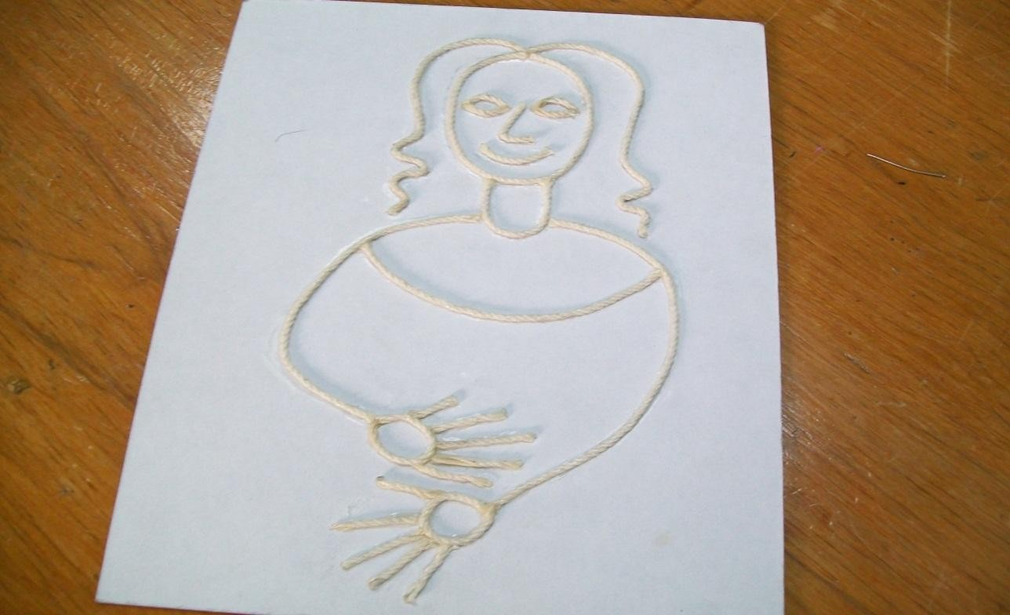
Figure1. Print haptic graphical representation of the Mona Lisa.

measures and how to manipulate a system of signs offered themselves for people with visual disabilities, understandable and with manipulation, retesting only allowed to establish the appropriate changes for greater effectiveness of the material and communication process.

Conclusions.

Haptic graphic materials must meet a number of features that make them functional in the shape, size, volume and texture, promote knowledge of what represented there. Therefore, their creation is extremely important, so it is necessary the intervention and professional design work and / or artists to from serious research and based on theoretical concepts and results from other proposals, to set aside work done with the intention of what is believed it could work, or, from the

visual approach, and taking into account the real requirements of this group of people. The models, maps, images in high relief, those worked in low relief, sculptures or models, or haptic graphic films, among others, are examples of work done for people with visual impairments access to knowledge on various topics.
This way, you get more and more specialization in the proposals for the visually impaired, observed from design considerations such as how to represent images, elements, the use of techniques and materials, and from people with visual impairment as their visual memory, as well as carry out the marking of specific needs and parameters, in which industrial and graphic designers, for example, can base the development of proposals to address communication needs and / or recreation and spiritual culture such as arts and painting. The creation of these proposals, due to needs of the people and are the object of study, and are designed for those who use objects and actions in the human body should be a startingpoint.
Haptic graphic materials stand out as one of the more important given the possibility for them to touch and thereby gaining knowledge about the images that are to be seen, for example, the art of painting.

Table 1. Results haptic perception in adultfemale and male: three women and eight men within an age range of 20 to
65. It states the name of the participant, the duration of the test, and the concepts generated by each participant mentally when making contact sheets haptic graphs.
Ángela Martínez Mendoza. | 15  minutos | Planta simétrica
Jair Derek Sánchez Cuevas. | 14  minutos | Oso con orejas | ojos | gordito
Christian Moreno Domínguez. | 14  minutos | Manos | florero | cuerpo de embarazada | sombrero | boca, nariz, ojos | cabello
Roberto Muñoz Santillán. | 17  minutos | Rostro | Boca, nariz, ojos
Alberto Nataret Aquino. | 25  minutos | Figura humana | Cabello | hombros | manos | falda | vestido
Alejandro Delgado Castañedo. | 17  minutos | Nada
Sergio Morales Bobadilla. | 15  minutos | Animal de 4 patas | Gato | panza | cabeza, boca, nariz
Luz María Ponce León. | 16  minutos | Cara | ojos, nariz, boca | cuello | pecho | cuerpo | manos

7. References.

- Blanco, F. (1991). Ceguera y desplazamiento mental en una isla ficticia: del ojo de la mente a la mano de la mente. Seminario Internacional de Ciencia Cognitiva. Valencia.
- CONAPRED. (2009) Protocolo Facultativo de la Convención sobre los Derechos de las Personas con Discapacidad. México.
- GIBSON, J.J. (1966) The senses considered as perceptual systems. Boston, Houghton Mifflin. En: Blanco, F. (1991) Ceguera y desplazamiento mental en una isla ficticia: del ojo de la mente a la mano de la mente. Seminario Internacional de Ciencia Cognitiva. Valencia. 357 pp
- LEDERMAN, S.J. y KLATZKY, R.L. (1987). “Hands movements: a window into haptic object recognition”. CognitivePsychology, 19 (3), 342-368 En: BLANCO, F. Ceguera y desplazamiento mental en una isla ficticia: del ojo de la mente a la mano de la mente. Seminario Internacional de Ciencia Cognitiva. Valencia. 1991.
- LEDERMAN, S.J. y KLATZKY, R.L. (1990). Haptic object processing: Empirical and theoretical developments. Trabajo presentado en la Conferencia sobre La Representación del Objeto en los Sistemas Visual y Háptico. Madrid; UNED. En:Martínez de la Peña Angélica. La percepción y su importancia en la generación de un diseño háptico para personas con discapacidad visual. (Tesis de doctorado). México, D.F. Universidad Autónoma Metropolitana, División de ciencias y artes para el diseño. Facultad de diseño. 2009. 357 pp.
- Martínez de la Peña Angélica. La percepción y su importancia en la generación de un diseño háptico para personas con discapacidad visual. (Tesis de doctorado). México, D.F. Universidad Autónoma Metropolitana, División de ciencias y artes para el diseño. Facultad de diseño. 2009. 357 pp
- Verdugo, Miguel A. (2006) Como mejorar la calidad de vida de las personas con discapacidad. Instrumentos y estrategias de evaluación. Salamanca, Amarú Ediciones. p.34
Calidad de vida: http://es.wikipedia.org/wiki/Programa_de_las_Naciones_Unidas_para_el_Desarrollo Cinestesia: http://buscon.rae.es/draeI/SrvltConsulta?TIPO_BUS=3&LEMA=cinestesia.

PSYCHOSOCIAL FACTORS NEGATIVE WORK ENGAGEMENT AND BURNOUT IN ADMINISTRATIVE A TEXTILE COMPANY BASED IN ARGENTINA AND MEXICO. 2011-2012.

Gutiérrez Muñoz Juan Carlos1, Pando Moreno Manuel1, Aranda Beltrán Carolina1, Contreras Estrada Mónica1, Cecilia Colunga Rodriguez1, Pedro Reynaga Estrada1.
1 Doctorate of Science in Occupational Health. CUCS University of Guadalajara
Wet Saw 950, Building "I". Colonia Independencia
Guadalajara, Jalisco, México C.P. 44340.
Email autor: carlosgutierrez05@yahoo.com.mx

Resumen
Se debe mejorar las condiciones de trabajo debe ser compartida y reflexionando que los factores de riesgo entre ellos los de origen psicosocial afectan en su salud a los trabajadores; el presente trabajo permitió conocer la correlación existente entre Work Engagement o Burnout y los Factores Psicosociales Negativos existentes en una población de trabajadores administrativos de una empresa textil con sede en tres países de Latinoamérica.
Los Factores Psicosociales Negativos son interacciones que existen en el trabajo con su organización y entorno social, pueden generar dos posibles patrones conductuales: el primero donde se trabaja de forma enérgica, con dedicación, se potencializa saludablemente llamado Work Engagement; el segundo patrón perjudicial negativo donde se favorece un ciclo vicioso de perjuicios para la salud, con efectos a nivel emocional, cognoscitivo, del comportamiento social, laboral y fisiológico llamándole Burnout, con altos costos y pérdidas por baja productividad, ausentismos elevado e incapacidades numerosas y/o prolongadas. Material y métodos: Estudio multicéntrico, transversal, analítico, correlacional, realizada en 198 administrativos de empresas del ramo textil. Se utilizaron las escalas de Factores psicosociales, el MBI, el UWES y el cuestionario sociodemográficos-laborales. Se analizó la correlación de Pearson, (p<0.05, r>1). Datos procesados con el SPSSV17. Resultados: El promedio de edad de 36.9 años y la antigüedad en la planta de 8.59 años. Los FPS con prevalencia de 86% de empleados. Burnout con prevalencia de 29%, Niveles altos en el 45% de Agotamiento emocional y 25% en la falta de realización personal. El 70% no tenían dimensión quemada, dos dimensiones el 5%, y con tres dimensiones el 1%. El UWES reportó vigor alto en 92%, absorción el 95%, y con dedicación el 92%. El Vigor correlaciona con Absorción (0.833), Factores psicosociales (0.82), Sx. Burnout (0.817), despersonalización (0.789). Se encontraron asociaciones significativas entre Factores Psicosociales en el Trabajo tanto con el Burnout, como con el Work Engagement. Conclusiones: la presencia de los Factores psicosociales incide en la presencia de Burnout y/o Work Engagement. Las 0rganizaciones deben reconocerlos y aumentar el Work Engagement, para afrontar las cargas de trabajo, y evitar el agotamiento emocional y así excluir la aparición del Burnout Las cifras de prevalencia encontradas, aunque no son tan altas como en otros estudios, son elevadas con respecto a otros países. Ello nos hace pensar que el síndrome está presente en esta población y que los factores psicológicos negativos en el trabajo inciden en su causa o al menos existe una relación significativa hacia el desarrollo del síndrome.

Palabras clave: Burnout, Work Engagement, factores de riesgo psicosocial.

Abstract
It should improve working conditions must be shared and reflecting that risk factors including psychosocial affect home health workers, this study allowed us to know the correlation between Burnout and Work Engagement or existing negative psychosocial factors in a population of office workers in a textile company based in three countries in Latin America. Negative psychosocial factors are interactions that exist in working with your organization and social environment, can generate two possible behavioral patterns: one where you work in an energetic, dedicated, is called Work Engagement potentiates healthy, the second negative disruptive pattern where favors a vicious cycle of damage to health, with effects on the emotional, cognitive, behavioral, social, occupational and physiological Burnout calling, with high costs and low productivity losses, increased absenteeism and disability numerous and / or prolonged. Methods: Multicenter, cross, analytic, correlational, held in administrative 198 companies in the textile industry. Scales were used Psychosocial factors, MBI, UWES and sociodemographic questionnaire and labor. We analyzed the Pearson correlation (p <0.05, r> 1). Data processed with SPSSV17. Results: The average age of 36.9 years and seniority in the plant 8.59 years. The FPS with prevalence of 86% of employees. Burnout prevalence of 29%, high levels in 45% of emotional exhaustion and 25% lack of personal accomplishment. 70% had not burned dimension, two dimensions of 5%, and 1% three dimensions. The high force UWES reported in 92%, absorbing 95%, and 92% dedication. The Vigor correlates with absorption (0833), psychosocial factors (0.82), Sx. Burnout (0817), depersonalization (0789). Significant associations were found between psychosocial factors at work both with Burnout, and Work Engagement with. Conclusions: The presence of psychosocial factors affects the presence of Burnout and / or Work Engagement. The 0rganizaciones must recognize and Work Engagement increase, to meet workloads, and avoid emotional exhaustion and thus exclude the appearance of Burnout prevalence figures found, although not as high as in other studies, are elevated in other countries. This leads us to believe that the syndrome is present in this population and that the negative psychological factors at work affecting their cause or at least a significant relationship to the development of the syndrome.

Keywords: Burnout, Work Engagement, psychosocial risk factors.

INTRODUCTION
Multiple scientific studies have shown that psychosocial factors are Negative interactions that you have with your organization work and social environment, can generate two possible patterns of behavior in the workplace: the first protector positive psychological state characterized by vigor, dedication and absorption where you work in an energetic, dedicated to your work, which potentiates the organization with a clear improvement of health called Work engagement, the second negative disruptive pattern which favors a vicious cycle which causes damage to the health, with effects in an emotional, cognitive, behavioral, social, occupational and physiological level called Burnout, this increases the operating costs and losses because of the decreasing of productivity, high absenteeism and numerous and / or prolonged disabilities.
Considerable research on psychosocial risk and factors show the importance of evaluation, so it is necessary to assess its size, presence, relevance for their effects on health and wellbeing. The Maslach Burnout is defined, Schaufelli and Leiter (2001), as "a prolonged response to chronic

stressors personally at work, determined from the dimensions as exhaustion, cynicism and inefficacy professional", it is clear the three-dimensional character Burnout disturbing, workers at three different levels: personal, social and work. The other issue in this research study is the Work Engagement or linking psychological, personal resources as related to beliefs in self-efficacy or self-efficacy (Salanova, Peiro and Schaufelli, 2002. Interestingly, self-efficacy is both a cause as a result of the Work Engagement (Salanova, Bresó and Schaufeli, 2005) which supports the idea of the existence of positive spirals upward. The Work Engagement is positively associated with job characteristics as resources or invigorating work motivators.

OBJECTIVES

To determine the correlation between negative psychosocial factors, the Work Engagement and Burnout in administrative employees of a textile company based in Argentina and Mexico. 2011- 2012.

METHODOLOGY

Delimiting: Administrative employees of private textile company based in Argentina and Mexico. Multicenter, cross, analytic, correlational, hypothetical-deductive. No experimental, so census conducted in 198 administrative textile companies in the industry. Via internal mail. Scales were used Psychosocia l factors, MBI, UWES and sociodemographic questionnaire and labor. Excel 2007 Database. Análisis descriptive. We analyzed the Pearson correlation (p <0.05, r> 1). SPSSV17.Variables data processed with independent and dependent variables FPSNT Burnout and Work Engagement. UWES questionnaire consists of 17 items. (Schaufeli, Bakker and Salanova, 2006). With reliability and validity of UWES documented with a Cronbach's alpha of .83.

RESULTS.

The age average was 36.9 years and seniority in the plant was 8.59 years. The FPS had a prevalence of 86% of employees. Regarding to the psychosocial factors in its subdivision of 6 dimensions it can be mentioned with respect to working conditions, the higher risk was found in 28% (47) at both sites, 14% in Mexico (14) and Argentina 46% (33). The average risk was found
in 70% (119) at both sites, 85% (83) in Mexico, and finally to 51% (36) in Argentina. In the assessment of adverse psychosocial factors at work for the entire population in the two sites, the following values were obtained, for the high risk of 1% (2), in Mexico and Argentina the same value of 1% (1) with respect to medium risk value for both sites together for 85% (143). Burnout prevalence was of 29%, high levels in 45% of emotional exhaustion and 25% lack of personal accomplishment. 70% had not burned dimension, two dimensions of 5%, and 1% three dimensions. Assessing the extent of lack of personal fulfillment is the most affected for the total respondents in the two sites, the following values, for the high risk of 17% (28), in Mexico the value was 16% (16) and in Argentina 17% (12). The assessment of the dimensions of Work Engagement into force obtained gave us the following data for the total respondents in the two venues, the values found were: 92% (156) have high levels, in Mexico the value was 95% (94) and in Argentina 88% (62). In relation with the number of affected dimensions evaluated in the whole group we concluded that 70% (119) of the administrative dimension found no burnt, with

involvement in one dimension on 23% (39), two-dimensional 5% (9), and three dimensions by 1% (2), which indicates a prevalence of 28%.

Numero de dimensiones por nivel de riesgo
Valoración |  | Riesgo alto | % Riesgo alto | Riesgo medio | % Riesgo Medio | Riesgo bajo | % Riesgo bajo
Dimensiones | Cero | 119  39  9  2 | 0.70 | 94  59  16  0 | 0.56 | 11  30  61  67 | 0.07
Dimensiones | Una | 119  39  9  2 | 0.23 | 94  59  16  0 | 0.35 | 11  30  61  67 | 0.18
Dimensiones | Dos | 119  39  9  2 | 0.05 | 94  59  16  0 | 0.09 | 11  30  61  67 | 0.36
Dimensiones | Tres | 119  39  9  2 | 0.01 | 94  59  16  0 | 0.00 | 11  30  61  67 | 0.40
Total |  | 169 | 1.00 | 169 | 1.00 | 169 | 1.00
Fuente : Directa

In the first analysis, the Pearson coefficient determined vigor, were significantly correlated with absorption (0833), negative psychosocial factors at work (0.82), Sx. Burnout (0817), depersonalization (0789) Seniority in the plant, were significantly correlated with seniority (0631), Paper work and career development (0617), negative psychosocial factors at work were significantly correlated with content and task characteristics (0755), workplace policies (0734), Paper work and career development (0724), and finally the correlation between job role and career development and content and characteristics of the task is (0522). (p<0.05).

CONCLUSIONS

The Organizations must recognize these psychosocial factors, and design an environment in which the Work Engagement increase, where every employee gets the best resources to meet workloads, and avoid emotional burnout . Burnout syndrome is a distress produced by a mismatch between expectations and the reality of work, with psychological and physical manifestations or death itself, with implications for personal, family, social and in the institution where works. Prevalence figures found, although not as high as in other studies, are high compared to other countries.
This leads us to believe that the syndrome is present in this population and that the negative psychological factors at work affecting their cause or at least a significant relationship to the development of the syndrome, the starting point for the development of the syndrome is at organizational, therefore, must develop prevention programs aimed at improving the environment and the work environment, such as socialization programs create, support, teamwork, planning, participation, feedback, and personal growth organizational development.
The preventive and therapeutic solutions are at the individual, group and organizational. Preventive measures have to prevent the disease or injury arrives, if the syndrome is already established, we must control it, treat it, ask for support and prevent complications.
In this study we found that sociodemographic variables are significantly correlated to the dimensions of Burnout. In particular we can see that the characteristics of the task, the paper work and social interaction are risk factors for emotional exhaustion and depersonalization.

Workers live and live every day with all negative psychosocial factors, which means by the company to be alert, informed of the current situation and plan for psychosocial assessment from the broad concept of wellness and health. The engagement was work related variables FPSNT and not personal variables. Further studies of the subject, and to recognize the work engagement as a positive indicator of mental health work and improve the health of workers and the quality of production in the company. Researchers have proposed that the Burnout and Work Engagement as conceptual opposites emotional exhaustion and cynicism (the core dimensions of burnout) with vigor and dedication (the essential dimensions of commitment). Maslach and Leiter, 1997; Schaufeli, Salanova, Gonzalez-Roma and Bakker, 2002). We tested this proposition by determining whether two sets of elements, exhaustion, cynicism, vigor and dedication are different scalable underlying bipolar dimensions (energy and identification). In this research study pattern cannot be confirmed, as there are cases where high levels of burnout with high Work Engagement, and the inverse was observed so contradicts initial theoretical model opposites.

REFERENCES

González-Roma, V., Schaufeli, W.B., Bakker, A., y Lloret, S. (2006). «Burnout and Engagement: Independent factors or opposite poles?» Journal of Vocational Behaviour. n.º 68.
Maslach, C., & Leiter, M. P. (1997). The truth about Burnout: How organizations cause personal stress and what to do about it. San Francisco, CA: Jossey-Bass.
Pando MM y Cols. (2006) “Factores Psicosociales y Síndrome de Burnout en docentes de la Universidad del Valle de Atemajac, Guadalajara. México”, Revista Salud en Tabasco; Vol. 12; No. 3:523-529.
Revista de Psicología del Trabajo y de las Organizaciones, 16, 117-134
Salanova, M. Grau, R., Llorens, S., & Schaufeli, W.B. (2001). Exposición a las tecnologías de la información, Burnout y engagement: el rol modulador de la autoeficacia profesional [Exposure to information technology, Burnout and engagement: about the role of professional self-efficacy].Psicología Social Aplicada, 11, 69-89.
Salanova, M., Schaufeli, W.B., Llorens, S., Pieró, J.M., & Grau, R. (2001). Desde el ‘Burnout’ al‘engamement’: una nueva perspectiva [From Burnout to engagement: A new persepctive]. Schaufeli, W.B., Salanova, M., Gonzalez-Roma. V. & Bakker, A.B. (2002a). The measurement of engagement and Burnout and: A confirmative analytic approach. Journal of Happiness Studies, 3, 71-92
Schaufeli, W.B., Salanova, M., Gonzélez-Romá, V., y Bakker, A. B. (2002). «The measurement of Engagement and Burnout: A confirmative analytic approach» Journal of Happiness Studies. n.º 3.

VERIFICATION OF THE RELATIONSHIP: PERCENTILE-MAXIMUM LIFTING LOAD, TABULATED IN LIBERTY MUTUAL TABLES, FOR MAN AND WOMAN YOUNG.

MC Jesús Rodolfo Guzmán Hernández1, MC Joaquín Vásquez Quiroga1, Dr Enrique Javier De La Vega Bustillos2, M.C. Octavio López Millan2
1 Grupo disciplinar de Ergonomía, Programa de Ingeniería Industrial, Universidad de Sonora Unidad Regional Norte, campus Caborca.
Caborca, Sonora, México, rguzman@caborca.uson.mx, jovaqui@caborca.uson.mx

2Maestría en Sistemas Industriales Instituto Tecnológico de Hermosillo Hermosillo, Sonora, México
en_vega@ith.mx, lopezoctavio@yahoo.com.mx

RESUMEN: Esta investigación se realizo con la intención de verificar la relación percentil - carga máxima recomendada, señalada en las tablas Liberty Mutual, para levantamientos de cargas en la población laboral joven. Esta fue realizada con alumnos, hombres y mujeres, estudiantes del programa de Ingeniería Industrial y de Sistemas. El experimento fue limitado a tres niveles de levantamiento, a saber: Nivel bajo, que corresponde a levantamientos entre el suelo y la altura de nudillos, nivel medio, de altura de nudillos a altura de hombros y nivel alto, de altura de hombros a brazo extendido, en frecuencia de un levantamiento por minuto, cajas de 34 cm de ancho (distancia desde el cuerpo) y distancia de movimiento 51 cm. Como resultado de este experimento se observo que existe evidencia estadística suficiente para afirmar que la relación percentil - carga máxima recomendada tabulada en la Tabla Liberty Mutual para tareas similares a las de este experimento, no coinciden clan las de la población de estudio.

Palabra clave: levantamiento de carga, tareas de levantamiento, máxima carga de levantamiento

SUMMARY: This research was conducted with the aim of verifying the relationship percentile - maximum recommended load indicated in the tables Liberty Mutual, for lifting loads in the young working population. This investigation was done with students, men and female, of the program Industrial and Systems Engineering. The experiment was limited to vertical lifting tasks in three levels of lifting, low level, that corresponds to lifting among the floor and the height of knuckles, medium level, of height of knuckles to height of shoulders and high level, of height of shoulders to arm extended, frequency of one per minute, boxes of 34 cm of wide (distance since the body), distance of movement 51 cm. As a result of this experiment it was observed that there is sufficient statistical evidence to claim that the relationship percentile - maximum recommended load tabulated in Liberty Mutual Table tasks similar to those of this experiment, no clan match those of the study population.

Keyword: lifting load, lifting tasks, maximum lifting load.

INTRODUCTION

Webster et al (1994) suggest that low back pain, associated with manual handling of loads, has been recognized as a major problem worldwide is the most costly injury in the industrial world. In the Mexican Republic from 1992 to 2002 the Mexican Social Security Institute reported cases of 191.639 spine injuries, including back pain, accounting for 4.7% of total workplace injuries.
Likewise, there were 42.422 cases of total disability by dorsopathies in the period reported, including low back pain associated with lifting loads, representing 18.98% of total disability (Review IMSS 2004), which indicates the relevance of the lesions of the spine. De la Vega (2006), citing The National Institute for Occupational Safety and Health (NIOSH) 1991, indicates the factors that directly influence the risk of lower back injuries are the weight and dimensions of the object, the distance is raised, lowered, pulled or pushed, and the repetition rate, as well as indirect factors such as age and physical condition of the worker. The consequences of ignoring the weight limit on the repetitive handling of loads can result in decreased performance at work and presents a risk of back pain that can become a cumulative trauma disorder (CTD) Putz-Anderson (1994). There are some studies about amount of weight that an individual is capable of lifting and about task design of the handling manual of loads with minimal risk of injury considering their characteristics and physical abilities. The reports of these studies represent guides to the industry which requires manually moving loads repeatedly. Among the most widely used guides include the NIOSH equation and the Liberty Mutual tables. The first is a tool through which, considering 7 factors involved in a lifting task, calculate the recommended weight limit (LPR) and, once known, is calculated the Lifting index that he is the ratio between the load weight and the recommended weight limit.
The values that can take this index may fall into three risk zones, namely: limited risk (lifting index <1) where the majority of workers performing these tasks should have no problems, moderate increase in risk (1 < lifting index <3) situation in which some workers could suffer illness or injury when performing these tasks same should to be redesigned or assigned a selected workers on which shall be strictly control; sharp increase in risk (lifting index> 3), this type of task is unacceptable from an ergonomic standpoint and should be changed. Moreover, the Liberty Mutual Company has developed the Liberty Mutual tables or tables of Snook which are a collection of tables which sets the maximum acceptable weight for help to control the risk of injury in the lower back in activities of manual handling of loads. In particular for lifting load, use the frequency of the task, the distance of movement of the load, the height at which the movement is placed, the size of the object and its grips and the horizontal distance (distance from the body) like parameters. With these parameters, the maximum acceptable weight it is tabulated in 10, 25, 50, 75 and 90 percentiles for male and female peoples. These studies and the respective conclusions were generated from the experimental data obtained of developed workers populations countries and the findings and their recommendations they are apply in Mexico without considering that data were obtained without including the characteristics and physical abilities of the Mexican population.

OBJETIVE

The objective of this study is to identify risks in applying the criteria of maximum acceptable charges Liberty Mutual tabulated in Tables in the young working population, because it can be one of the causes of lower back pain , resulting from manual material handling, is a problem that is occurring more often in business. This led to pose the question "The tables maximum

acceptable weight set by Liberty Mutual, is applicable to young workers? On this question the present investigation was conducted and it focused only on vertical lift, frequency of one per minute, boxes 34 cm wide (away from the body), movement distance of 51 cm, at three levels of lift, low, which corresponds to the ground and lifts between knuckle height, half height at shoulder height knuckles and high shoulders height extended arm.

MATERIALS AND METHODS

Details of the experiment, from where the Liberty Mutual Tables were made, it is found in the publications of Ciriello et al 1983, 1990 and 1991. The experiment was conducted using psychophysical approach. This approach requires that the subject is motivated by an incentive, and He,based on the perceived sensations, select the maximum load that it considers may sustain for a working day of 8 hr. According to Shoaf (1997), the major hypothesis of the psychophysical approach is that: at a given time, adjusted to 40 minutes, a person is able to predict the maximum weight or force that could be manipulated during a period of 8 hr; Mital (1983) states, people can estimate the amount of weight that can lift comfortably in 8 hr, based on experiencing fatigue in 25 min and, hopefully, the weight selected by the subject is the same whether the person continues lifting it for 8 hr; Additionally, he states: there is no literature evidence to validate this claim. Under these criteria, basically, the subject is given control of the weight of the load the participant monitors their own sensations of fatigue and adjusts the weight which he believes could bear. All other variables such as task frequency, load weight, distance of movement, etc. are controlled by the experimenter. The participants in this experiment were 15 male and 14 female young between 19 and 22 years, university-level students. All signed in writing that they were free of lower back injury and had no cardiovascular disease. They used casual clothing and tennis shoes, jeans and loose shirts. To all participant in the experiment and for verify that the heights and distances of movement of loads in lifting tasks was be according to the experiment of Snook, were taken the anthropometric measures of weight, height, knuckle height, acromial height and extended arm height. Given the limited experience of the participants in manual handling of loads were given a belt to help keep your lower back straight. The participants were given training equal to the training done it in Ciriello et al (1983) experiment, to familiarize them with the activities to performed and gain experience in adjusting the load, increase or decrease according to their own perceptions, they doing efforts themselves but without reaching a state of extreme tiredness, weakness, overheating or running out of breath, this, doing movements of vertically lifting , at a distance of 51 cm, with bending the knees and keeping your back straight, no turns or twists, without pull or push the load. For four consecutive days of tasks were performed lifting low (floor knuckle hight), increasing gradually the time. During first and second day were made a task for 10 min with light load and heavy load respectively, the third day two tasks of 10 minutes each with light and heavy load respectively, without resting, the fourth day two tasks of 15 minutes with light load and heavy load respectively, without resting. The fifth, sixth and seventh days were for do the data collection. The daily tasks were made with duration of 40 minutes divided into two periods of 20 minutes each one, without rest between periods, in the first period it gave them a heavy load and in the second light load, all randomly selected. Each day were made only the task for each level indicated for in the lifting Liberty Mutual tables, namely between floor level and knuckle height ( lifting low), between knuckle height and acromial height (lifting medium) and between airmail height and arm extended length (lifting height). For the experiment were used rigid polypropylene boxes with length of 55 cm (distance between hands), 34 cm wide (distance from

the body) and 17 cm in height. The handgrips were located at half of the distance from the body and 15 cm from the floor of the box. The box contained a false bottom in which was placed a burden whose weight was randomly selected as in the experiment of Ciriello and Snook (1990). This hidden weight was not known by the participant in an attempt to minimize the visual effect. The load management was welding rods and it was used a balance T31P Ohaus, a decimal minute chronometer, a bell and shelves height-adjustable. For each level of uprising were select, at random, 14 heavy load values, between 32 and 45 kg, then was decreased in 3 kg each, which corresponds to the box weight, and the lid of the double bottom, the resulting value were divides random, to place the burden in the hidden compartment and the visible, subsequently the same procedure was performed for 14 light loads between 2 and 18 kg, Snook (1990). These two procedures were repeated for each of the three levels of lifting the experiment. In the collection of field data were given in the first period a heavy load and the second period a light load., Participants adjusted the load in each period, they decreased or increased it according to their own perceptions until it represented the maximum they could lift in 8 hr of task, if the load of the second period was between 15% of the first, the average of the two loads is registered as the maximum acceptable load of the participant, otherwise the information is removed and a new test was performed.

RESULTS AND DISCUSSION

According to the working hypothesis raised in this investigation, if the maximum acceptable weight (MAW) of Table Liberty Mutual is applicable to the young population, then the percentile istribution of the maximum load obtained from the participants, must statistically to exist a matching with the distribution of the liberty mutual table percentiles. Under this approach was performed the analysis for low level lifting. The results of the analysis for females are show in Table No 1 and for Male in the table 2:

Table 1 Women Data Analysis, Low Level
Information in table |  | Hypothesis testing
PERCENTILE | Maximum Acceptable Weight (MAW) Kg | null hypothesis | obs data |  | t | α | decision
90 | 11 | P0 = 0.90 | 11 | 0.786 | -1.43 | 0.09 | Accept Ho
75 | 14 | P0 = 0.75 | 5 | 0.357 | -4.91 | 0.00 | Reject Ho
50 | 16 | P0 = 0.50 | 3 | 0.214 | -3.57 | 0.00 | Reject Ho
25 | 19 | P0 = 0.25 | 0 | 0.000 | -3.13 | 0.00 | Reject Ho
10 | 22 | P0 = 0.10 | 0 | 0.000 | -1.25 | 0.12 | Accept Ho

Table 2 Man Data Analysis, Low Level
Information in table |  | Hypothesis testing
PERCENTILE | Maximum Acceptable Weight (MAW) Kg | null hypothesis | obs data |  | t | α | decision
90 | 16 | P0 = 0.90 | 13 | 0.867 | 0.43 | 0.66 | aceptar H0
75 | 23 | P0 = 0.75 | 9 | 0.600 | 1.34 | 0.90 | aceptar H0
50 | 31 | P0 = 0.50 | 4 | 0.267 | 1.81 | 0.95 | aceptar H0
25 | 39 | P0 = 0.25 | 1 | 0.067 | 1.64 | 0.94 | aceptar H0
10 | 46 | P0 = 0.10 | 0 | 0.000 | 1.29 | 0.89 | aceptar H0

From the tables above it can be seen that there is significant difference between the two sexes. For women were rejected 3 of 5 hypothesis, for the man the five hypotheses are accepted. For mid-level survey analysis was similar to the previous data and the results for women are shown in Table No. 3 and for men in Table 4.

Table 3 Women Data Analysis, Medium Level
Information in table |  | Hypothesis testing
PERCENTILE | Maximum Acceptable Weight (MAW) Kg | null hypothesis | obs data |  | t | α | decision
90 | 10 | P0 = 0.90 | 9 | 0.643 | -3.21 | 0.00 | Reject Ho
75 | 12 | P0 = 0.75 | 7 | 0.500 | -2.08 | 0.03 | Reject Ho
50 | 14 | P0 = 0.50 | 1 | 0.071 | -3.30 | 0.00 | Reject Ho
25 | 16 | P0 = 0.25 | 0 | 0.000 | -2.08 | 0.03 | Reject Ho
10 | 18 | P0 = 0.10 | 0 | 0.000 | -1.25 | 0.12 | Accept Ho

Table 4 Man Data Analysis, Medium Level
Information in table |  | Hypothesis testing
PERCENTILE | Maximum Acceptable Weight (MAW) Kg | null hypothesis | obs data |  | t | α | decision
90 | 17 | P0 = .90 | 10 | 0.667 | -3.01 | 0.00 | Reject H0
75 | 22 | P0 =0.75 | 5 | 0.333 | -3.73 | 0.00 | Reject H0
50 | 28 | P0 =0.50 | 2 | 0.133 | -2.84 | 0.01 | Reject H0
25 | 34 | P0 = 0.25 | 1 | 0.067 | -1.64 | 0.06 | Accept H0
10 | 40 | P0 = 0.10 | 0 | 0.000 | -3.23 | 0.00 | Reject H0

In women it can be seen that four of five null hypotheses are rejected while men are rejected in three of the five hypotheses. For high risings the results are shown in Tables 5 for women and 6 men respectively.

Table 5 Women Data Analysis, High Level
Information in table |  | Hypothesis testing
PERCENTILE | Maximum Acceptable Weight (MAW) Kg | null hypothesis | obs data |  | t | α | decision
90 | 9 | P0 = 0.90 | 9 | 0.692 | -2.60 | 0.01 | Reject Ho
75 | 11 | P0 = 0.75 | 4 | 0.308 | -3.69 | 0.00 | Reject Ho
50 | 12 | P0 = 0.50 | 1 | 0.077 | -3.02 | 0.00 | Reject Ho
25 | 14 | P0 = 0.25 | 0 | 0.000 | -2.08 | 0.03 | Reject Ho
10 | 15 | P0 = 0.10 | 0 | 0.000 | -1.25 | 0.12 | Accept Ho

Table 6 Man Data Analysis, High Level
Information in table |  | Hypothesis testing
PERCENTILE | Maximum Acceptable Weight (MAW) Kg | null hypothesis | obs data |  | t | α | decision
90 | 16 | P0 = .90 | 3 | 0.200 | -9.04 | 0.00 | Reject H0
75 | 23 | P0 =0.75 | 1 | 0.067 | -6.11 | 0.00 | Reject H0
50 | 31 | P0 =0.50 | 0 | 0.000 | -3.87 | 0.00 | Reject H0
25 | 39 | P0 = 0.25 | 0 | 0.000 | -2.24 | 0.02 | Reject H0
10 | 46 | P0 = 0.10 | 0 | 0.000 | 0.00 | 0.50 | Accept H0

In high level can be seen that for both sexes four of five null hypotheses are rejected.
Moreover it was observed that at all levels, for both sexes, the null hypotheses were accepted 10th percentile which could be because the sample was under 30 and the proportion of the null hypothesis test also (0.10) or actually no real evidence that 10% of the population have the MAW shown in the table. In another sense it is observed that total 11 of the 30 hypotheses were accepted (36.6%) of which only 4 are testing in women, including three 10th percentile,

CONCLUSIONS

With the results and analysis of the data above we can accept that, in general, there is not sufficient evidence to accept that the maximum weight recommended in Liberty Mutual Table for vertical lifting for frequency of one per minute, boxes of 34 cm wide (distance from the body), movement distance of 51 cm, at the three levels of survey, can be applied to the young workforce without running the risk of injury. Given this information we can conclude that, it is not appropriate to apply the recommendations in Table Liberty Mutual in the young working population since it is possible that this population has a lower lifting capacity or possibly with a less dispersion in capacity lifting. As a result of this research we recommend that define the acceptable maximum weights in lifting burdens on young since there are no recommendations in this regard and are a cause of interest public health

REFERENCES

Ciriello, VM and Snook, SH 1990., Ergonomy 1990, vol 33, no.3 ,187-200, "The effects of container size, frequency and extended horizontal reach on maximum acceptable weights of lifting for female industrial workers."
Ciriello, VM and Snook, SH 1991, Ergonomy 1991, Vol 34, No 9,1194-1213, "The design of manual handing tasks: revised tables of maximum acceptable weights and forces".
De La Vega Bustillos, Enrique 2005, "checklists, methods and mathematical models for ergonomic evaluation of work environments", Technological Institute of Hermosillo http://www.estrucplan.com.ar/articulos/verarticulo.asp?IDArticulo=982 visited in June 2009
Mital, Anil (1983), Human Factors, 1983, 25 (5), 488-49, The Psychophysical approach in manual lifting, a verification study.
National Institute for Occupational and healt (NIOSH), 1991, "Scientific support documentation for revised 1991 NIOSH lifting equation".
Putz Anderson, V (1994) "Cumulative Trauma Disorders. A Manual for Musculoskeletal Diseases of the Upper Limbs. Taylor & Francis, London.
Revista medica IMSS, 2004; 42(1): 79-88, http://www.imss.gob.mx/dpm/dties/produc/CdTecnicos/El_IMSS_en_cifras/SCDo_02.pdf, consultada el 20 de octubre de 2006.
Shoaf Christin, Genaidy Ashraf, Waldemar Karwowki, Thomas Waters, Doran Christensen, Ergonomics, 1997, vol 40, No 11, 1183-1200,."Comprehensive manual handling limits for lowering, pushing, pulling and carrying activities"
Snook, SH and Ciriello, VM 1983, Human Factors, 1983.25 (5), 473-483, "A study of size, distance, Height and Frequency Effects of manual handling tasks
Webster and Snook (1994) citado por Ciriello V M and Snook S H, 1997, International Journal of Industrial Ergonomics 23 (1999) “Inspección de las tareas de manejo manual de cargas”.

ANALYSIS OF THE RELATIONSHIP DRY EYE VISUAL PROBLEM AND EXPOSITION TIME, TYPEFACE AND TEXT/BACKGROUND COLOR CONTRAST WHEN READING FROM LIQUID CRYSTAL DISPLAY COMPUTER SCREENS

Rosa María Reyes Martínez1, Jorge de la Riva Rodríguez1, Aide Maldonado Macias1, Jaime Sánchez Leal 1, and Rodolfo de la O Escápita2
1Graduate Studies and Research Division, Technological Institute of Ciudad Juárez
2Industrial Engineering Department Avenida Tecnológico # 1340
Ciudad Juárez, Chihuahua, México.
Corresponding author’s e-mail: rosyreyes2001@yahoo.com

Resumen: El objetivo del estudio fue analizar la relación entre el problema visual de ojo seco y el tiempo de exposición (2,4 y 6 horas), la tipografía (Times New Roman,Courier y Arial) y el contraste de color entre texto/fondo) provocada durante la actividad de lectura en pantallas de cristal liquido. La tarea experimental consistió en la lectura de material electrónico. Los síntomas de ojo seco fueron medidos por un equipo de seis optometristas, quienes utilizaron la prueba de Fluoresceína para la medición del tiempo de ruptura de la película lagrimal. Los resultados demostraron significancia estadística en las interacciones Tiempo de exposición* tipografía (p=0.012), y Tiempo de exposición* tipografía * contraste de color texto/fondo (p=0.000).La conclusión principal sugiere que el tiempo de exposición en la actividad de lectura con LCD no exceda 2 horas de lectura continua, cuando los lectores utilicen los tipos de tipografía y contrastes de color entre texto/ fondo analizados en esta investigación.

Abstract: The aim of this study was to analyze the relationship dry eye visual problem and exposition time(2, 4 and 6 hours), typeface (Times New Roman, Courier and Arial) and text/background color contrast (white/black, white/blue and, yellow/blue) caused during reading activity at liquid crystal screens. The experimental task consisted of reading on-screen electronic material. Symptoms of dry eye were measured by a team of six optometrists who used measurements from Fluorescein Tear Film Break-up Time tests. Results showed significant effects from interaction of exposition time* typeface (p=0.012), and exposition time* text/background color contrast* typeface (p=0.000). The principal conclusion suggests that exposition time for reading task conditions at LCD screens should not be greater than 2 continuous hours, when readers are using the typefaces and text/background color contrasts included in this research.

Keywords: Visual fatigue, Dry Eye, Tear Film Break-up Time, Liquid Crystal Display (LCD) Computer Screens.

INTRODUCTION

Computer use at work has increased considerably over the past 20 years. In the United States, according to Census Bureau population data released in September 2001, approximately 76 million workers over 18 years of age were using computers in their work

(Anshel 2006). This increase has brought with it a rise in visual and musculoskeletal problems (Turville, Psihogios, Ulmer and Mirka, 1998; Anshel, ).
Visual problems have been reflected in attention to visual health. In this area, the American Optometric Association (AOA) conducted a study via opinion surveys, and among its most relevant findings reported that 10 million primary care visual examinations were given annually in the United States, because of problems associated with computer use (Sheedy and Parsons, 1990).
Most studies related to vision problems indicate that symptoms occur in over 75% of computer users (Dain, McCarthy, and Chan-Ling, 1988; Smith, Cohen, and Stammerjohn, 1981; Anshel, 2007; Leavitt, 1995; AOA, 1995 Tamez, Ortíz and Martínez, 2003). Among the most frequently reported problems are: eye strain, blurry vision, headache, dry or irritated eyes, neck or back pain, light sensitivity and double vision.
Eye strain, or the asthenopia known as visual fatigue, may be classified in two types: one internal, consisting of fatigue and painful sensations within the eye due to the effort of accommodation and convergence mechanisms; and the other external, with a sense of dryness and irritation at the front of the eyes provoked by visual field conditions. These external symptoms of eye dryness are due to contracting part of the orbicularis oculi muscle, causing squinting in an attempt to improve vision and resulting in blink reduction, which is characteristic of the condition of dry eye (Sheedy 2007; Clark, 2006; U.S. Department of Labor, 2004).
Computer use has increased in homes as well as offices, and this has caused a rise in the reading of electronic material (Mayes, Sims and Koonce, 2001 . Visual fatigue from reading electronic material may be present when: close reading is required, legibility is poor and computer images are of low quality, there is insufficient lighting or exposure to blinking light, and when the person exhibits ametropia (Ukai and Howarth, 2008 .
One factor contributing to the incidence of visual fatigue is exposition time, and in this area a case-control study by Knave et al (1985, cited by Howarth and Bullimore in Wilson and Corlett (2005 , reports that a group of subjects exposed to more than five hours of VDT work reported greater symptoms of visual discomfort. Unfortunately, the researchers do not discuss the conditions under which these groups were studied.
The combination of text and background colors has been considered by researchers as a factor that influences visual fatigue when using computer screens. Researchers mention that the inappropriate use of color may result in poor performance and a high incidence of visual discomfort (Wang and Chen, 2003; Matthews, 1987 . They suggest that the colors red and blue be avoided for text, while Sanders and McCormick (1993 recommend white/black and black/white for high contrast between text and background.

OBJECTIVE

The objective of the present study consisted in analyzing the relationship dry eye visual problem and exposition time, typeface and text/background color contrast caused during reading activity at liquid crystal screens by young subjects, 18 to 24 years old, via a Fluorescein test for measuring Tear Film Break-Up Time (FBUT) as an indicator for evaluating eye dryness, a symptom of visual fatigue.

METHODOLOGY

The study used a factorial experimental design (Hernández, Fernández and Baptista, 2005). The following factors for external visual fatigue when reading electronic material from a liquid crystal (LCD) screen were analyzed: exposition time, typeface, and contrast between text and background color. Visual fatigue was measured by a group of six optometrists belonging to a prestigious chain of optical centers in Ciudad Juárez, Chihuahua, by administering FBUT tear-quality tests.

Participating Subjects

A total of 27 young student volunteers from the Ciudad Juárez Technological Institute participated in the study; 10 women with an average age of 21 years and 17 men with an average age of 22.5 years. Selection of this sample was made from a total of 150 students who visited the optical centers for visual exams. To participate in the study subjects needed to have emmetropic vision with 20/20 visual acuity, not use eyeglasses nor present a medical diagnosis of problems with dry eye.

Equipment Used

The experimental task, which consisted of reading electronic material, took place in a computer classroom equipped with 27 Lenovo 3000 J110 computers with AOC193P liquid crystal screens. An FBUT tear-quality Test Kit was used to measure the response variable. Electronic material used for the reading activity consisted of electronic books on entertainment topics. Information processing was done with the SPSS 20 statistical package. Lighting was measured with a model 401025 EXTECH luxometer.

Experimental Design

An experimental arrangement was used. The dependent variable was lachrymal break-up time as measured by the FBUT test, before and after performing the experimental task. The factors (independent variables) studied were exposition time at 2-, 4- and 6-hour levels; Courier, Times New Roman and Arial typefaces, and contrast between text/background colors. The latter factor was analyzed with black/white (B/W), white/blue (W/B) and yellow/blue (Y/B). The tone used for the color blue, selected via a prior canvassing of blues applied in web page design, was the RGB 0.102.255 mix.
To avoid participant boredom, the experimental task consisted of reading electronic books on entertainment topics. The reading conditions were: a viewing distance of 60 centimeters from screen to eye, lighting maintained within a range of 200-1500 luxes (to prevent glare) and a font size of 12 points. Subjects read while in a seated position.
Reading speed was not an important aspect of task completion. Participating subjects were free to set their own pace for moving through the reading material. However, in order for participants to keep their eyes on the screen throughout the exposition period, they were asked to count the number of times a particular word repeated on each page of the electronic material, and to later record that count in a box located at the end of the page.

The optometrists took measurements from each subject before and after the experimental task. Combinations of the nine experimental conditions were designed ahead of time, and their assignment to each of the participants was made via randomization. Participants were placed at the 27 computer stations and instructed to maintain a viewing distance of 60 cm.

Data Analysis

The ANOVA statistical model was used. A factorial design was selected, along with a 3k (3 factors with 3 levels) arrangement, and 27 observations for each eye (before and after the experimental task). Statistical analysis was done with the SPSS 20 package.
Assumptions for variance normality and equality (homogeneity) of variances in the ANOVA model were validated. The Kolmogorov-Smirnov test was used to establish normality for the data, and the Bartlett test for equality of variances.

RESULTS

Results of applying the ANOVA model to external type visual fatigue, analyzed by means of the tear-quality (FBUT) test, are shown in Table 1. As may be observed, the corrected model explains 73.3% of the significant observed variation in the dependent variable (tear film break-up time).
.
Table 1.Analysis of Variance for Tear Film Break-up Time

Source | Sum of squares | Gl | Quadratic mean | F | Significance
Corrected model | 30.850(a) | 26 | 1.187 | 2.849 | 0.004*
Exposition time | 0.436 | 2 | 0.218 | .523 | 0.599
Contrast | 1.300 | 2 | 0.650 | 1.560 | 0.228
Typeface | 0.563 | 2 | 0.282 | 0.676 | 0.517
Exposition time - Contrast | 1.105 | 4 | 0.276 | 0.663 | 0.623
Exposition time - Typeface | 6.524 | 4 | 1.631 | 3.916 | 0.012*
Contrast - Typeface | 3.908 | 4 | 0.977 | 2.346 | 0.080
Exposition time - Contrast  - Typeface | 18.937 | 8 | 2.367 | 5.684 | 0.000*
Error | 11.245 | 27
Total | 1017.725 | 54

*Statistical significance with p< 0.05 (a) R squared =0.733 (R squared corrected = 0.476)

Regarding the principal effects, the analysis of variance showed that different exposition times, typefaces and contrasts between text/background color presented no significant effect upon tear film Break-up Time (BUT).Table 1 shows results of the interaction between: Exposition time* Typeface and Exposition time* Contrast. Results in the current study

showed that exposition time, contrast between text/background and typeface conjointly influenced BUT. All values had dry eye symptoms, to a greater or lesser degree. Table 2 outlines the different combinations of factors that presented fewer dry eye symptoms; from an interaction analysis using estimated marginal means for BUT.

Table 2 Combinations with fewer dry eye symptoms, for the Factors: Exposition time, Typeface and Contrast between text/background.

Exposition time (hours) | Marginal means | Text/background color contrast | Typeface
2 | 5.48* | A/A | TNR
 | 4.15 | B/A | Courier
 | 4.30 | N/B | TNR
4 | 4.84 | A/A | TNR
 | 6.38* | B/A | TNR
 | 5.59 | N/B | Courier
6 | 4.59 | A/A | TNR
 | 5.38 | B/A | Courier
 | 5.98* | N/B | Arial
*Fewer dry eye symptoms, TNR (Times New Roman)

Values of interest for the BUT estimated marginal means are the higher ones (the criteria being that higher is better), since these cause fewer dry eye symptoms. At exposition times of 2 and 4 hours the typeface least drying to the eyes is Times New Roman, and at 6 hours it is Arial.

DISCUSSION

The American Optometric Association has identified a visual health problem related to computer use which is calls Computer Vision Syndrome (CVS). This problem may include the following symptoms: dry and irritated eyes, blurry vision, headache, eye strain, and double vision, and color distortion, inability to maintain visual focus at close range, and neck and shoulder discomfort (Anshel, 2007; AOA, 1995; Sheedy, 2007).
Results in the current study showed that exposition time, contrast between text/background and typeface conjointly influenced BUT. All values had dry eye symptoms, to a greater or lesser degree. Table 1 outlines the different combinations of factors that presented fewer dry eye symptoms; from an interaction analysis using estimated marginal means for BUT.
Estimated marginal mean values for BUT, shown in Table 2, indicate that at different exposition times, according to FBUT test classification (Isreb et al 2003), the eyes show symptoms of dryness. This finding coincides with the American Optometric Association, which determined that one cause of Computer Vision Syndrome occurred when a task’s visual demand exceeded the individual’s capacity to comfortably perform it. Thus the greatest risk of developing this visual problem exists in people using the computer for 2 or more hours per day (AOA, 1995). Results of other studies support our outcomes. Taino

(2006) found asthenopia to be prevalent in 51% of those with more than 20 hours of exposition per week, and Knave et al (1985) cited by Howarth and Bullimore in Wilson and Corlett (2005 mention that VDT use for more than 5 hours/day may provoke symptoms of asthenopia.
As for the typeface factor, all three Arial, Times New Roman and Courier presented symptoms of dry eye. This situation may be attributed to the fact that the typefaces used in the study were designed for use in printed text, not for computer screens.
Sheedy (2007) mentions the importance of text clarity as a characteristic of good computer screen legibility, considering clarity to be a significant factor in determining typeface design that is safe for eyesight. The researcher considers that Times New Roman is one of the poorest typeface designs for legibility on computer screens. Because the text is difficult to read, it strains the eyes and forces users to squint in attempt at clarifying text, which causes the discomfort associated with CVS.
The Times New Roman and Courier typefaces belong to the serif category, designed for good legibility on the printed page (Ferrari and Short, 2002). However, their use for computer screens causes a loss of legibility. The use of serif typefaces on the computer screen violates conventions governing the basic rules created for printed matter. The way blocks of text are laid out on the screen generally requires readers to turn their heads slightly, or to force their eye muscles, in order to follow lines of text. Unfortunately, a large percentage of web pages are double the width of the eye’s normal range, which requires extra effort in reading the text that appears on them (Ferrari and Short, 2001).
Some researchers suggest that red and blue be avoided for text colors (Mathews, 1987; Prado and Ávila, 2006), since these may induce visual fatigue and nauseous sensations (Wang and Chen, 2003), while Sanders and McCormick (1993 recommend the high contrast provided by white background and black text or black background and white text. In the same vein, Prado and Ávila (2006) recommend that web page design avoid the use of low contrast colors.
Our study, following the above mentioned recommendations and focusing its interest on high contrasts, analyzed black/white, white/blue and yellow/blue, and although the highest contrast combination is B/W, the results suggested no difference between them. We also found that all the combinations contributed to symptoms of dry eye.
That presence of dry eye signs and symptoms characteristic of external-type visual fatigue were evident in the study coincides with a large number of researchers, relating to the fact that symptoms of tired and dry eye may result from computer use over prolonged periods; as computer use demands great effort for near viewing, which can inhibit blinking and thus cause dry eye symptoms (Sheedy, 2007; Isreb et al, 2003; Clark, 2006; U.S. Department of Labor, 2004; Ousler, Gomes, Crampton and Abelson, 1999; Nakamori, Odawara, Nakajima, Mizutani and Tsubota, 1999; Nakaishi and Yamada, 1999; Yaginuma, Yamada and Nagai, 1990; Tsubota and Nakamori, 1993; Dianoff, Happ and Crane,1981; Rossignol, Pechter, Summers and Pagnotto, 1987).

CONCLUSIONS

The use of video display terminals (VDTs) is associated with decreased blink frequency and a higher rate of lachrymal evaporation due disturbances in the normal tear-film, leading to ocular fatigue – one of the principal symptoms of dry eye. Experimental results suggest that

the factors of Exposition time, Contrast between text and background color and Typeface contribute to signs and symptoms of dry eye and thus external-type visual fatigue. These findings are valid under the following experimental conditions: viewing distance of 60 centimeters, liquid crystal display monitors, 12-point font size, lighting ranging between 350 and 1450 luxes as measured at each of 27 computer terminals, and an average air
temperature of 26.3o C.
All combinations of the factors exposition time, typeface and contrast between text/background color produced symptoms of dry eye (see Table 6), but those least drying to the eye were: TNR typeface with Yellow/Blue color contrast during 2 hours of exposition time, TNR with White/Blue for four hours and Black/White for 6 hours’ exposition time. It is suggested that computer screen users not exceed 2 hours of continuous reading time if the conditions are similar to those of our study.
Due to the multifactorial quality and complexity of reducing visual fatigue it is necessary for computer screen users to follow recommendations in the ISO 9241-3 ergonomic guides (1992), whose purpose is to offer user orientation in caring for their visual health. We consider that the findings of our study may be useful for designers of web pages and electronic magazines.
The few studies found to address the effects of electronic text legibility and its impact on the visual health of computer screen users suggest a need for further research that will analyze typefaces designed for use with electronic material such as Verdana and Georgia (Ferrari and Short, 2002). In addition, a great challenge is seen for digital design professionals, who must design text processors that will reduce the harmful effects on users’ visual health.

REFERENCES

AMERICAN OPTOMETRIC ASSOCIATION. (1995). Guide to the clinical aspects of computer vision syndrome. St. Louis: American Optometric Association.
ANSHEL, J. (2006). Visual Ergonomics in the Workplace: Improving eye care and vision can enhance productivity. Professional Safety, 51(8) 20-25.
ANSHEL, J. (2007). Visual Ergonomics in the Workplace. AAOHN Journal. 55(10), 414- 420.
CLARK, C. (2006). End User Computing Ergonomics: Facts or Fads? Journal of Organizational and End User Computing, 18(3), 66-76.
DAIN, S. J., MCCARTHY, A. K. & CHAN-LING, T. (1988). Symptoms in VDU operators.
American Journal of Optometry and Physiological Optics, 65(3), 162-167.
DAINOFF, M.J., HAPP, A. & CRANE, P. (1981). Visual fatigue and occupational stress in VDT operators. Human Factors, 23:421–438.
FERRARI, T. & SHORT, C. (2001). Legibilidad and comprensión en la red. Accessed December 15, 2008, from http://tpgbuenosbuenosaires.tipografica/workshops/apuntes/legibilidad.html
FERRARI, T. & SHORT, C. (2002).Legibilidad and comprensión en la World Wide Web. Buenos Aires typeface. Accessed December 15, 2008, from http://bigital.org/tipo2- venancio/
HERNÁNDEZ, S.R., FERNÁNDEZ, C.C. and BAPTISTA, L.P. (2005). Metodología de la
Investigación. México City: Mc Graw Hill.

HOWARTH, P.A. & BULLIMORE, M.A. (2005). Vision and Visual Work. In J.R Wilson & N. Corlett (Eds), Evaluation of Human Work (pp.573-604). U.S.A.Taylor & Francis Group.
ISO, (1992 Ergonomics requirements for office work with Visual Display Terminals (VDTs - part 3: Visual Display Requirements, ISO 9241-3 (and other related sections of ISO 9241, published 1992-2000.
ISREB, M.A., GREINER, J., KORB, D.R., GLONEK, T., MODY, S.S., FINNEMORE, V. et
al (2003). Correlation of lipid layer thickness measurements with fluorescein tear film break up time and Schemer’s test. Eye.17, 79-83.
LEAVITT, S. (1995 Lower your VDT monitors. Workplace Ergonomics, 32-35.
MATTHEWS, M.L. (1987).The influence of colour on CRT reading performance and subjective comfort under operational conditions. Applied Ergonomics, 323-328.
MAYES, D., SIMS, V. & KOONCE, J. (2001). Comprehension and Workload differences for VDT and paper-based reading. International Journal of Industrial Ergonomics. 28, 367-378.
NAKAISHI, H. & YAMADA, Y. (1999). Abnormal tear dynamics and symptoms of eyestrain in operators of visual display terminals. Occupational Environmental Med. 56: 6–9.
NAKAMORI, K., ODAWARA, M., NAKAJIMA, T., MIZUTANI, T. & TSUBOTA, K. (1997).
Blinking is controlled primarily by ocular surface conditions. Am Journal of Ophthalmology 124, 24–30.
OUSLER, G., GOMES, P., CRAMPTON, H. & ABELSON, M. (1999). The effects of a
lubricant eye drop on the signs and symptoms of computer vision syndrome (CVS) exacerbated in a controlled adverse environment. Investigative Ophthalmology and Visual Science. 40 (ARVO Suppl): B722.
PRADO, L. and ÁVILA, R. (2006). Factores ergonómicos en el diseño: percepción visual.
Guadalajara, Jalisco, México: University of Guadalajara.
ROSSIGNOL, M.A., PECHTER, M.E., SUMMERS, V.M. & PAGNOTTO, L. (1987). Video
display terminal use and reported health symptoms among Massachusetts clerical workers. Journal of Occupational Med. 29, 112–118.
SANDERS, M.S. & MCCORMICK, E.J. (1993). Human Factors in Engineering and Design. Singapore: Mc Graw-Hill.
SHEEDY, J. (2007). The physiology of eyestrain. Journal of Modern Optics. 54 (9) 1333- 1341.
SHEEDY, J.E., PARSONS.S.D. (1990), The video display terminal eye clinic: Clinical report, Optometry & Vision Science. 67: 622-626.
SMITH, M. J., COHEN, B. G. F. & STAMMERJOHN, L. W. (1981). An investigation of
health complaints and job stress in video display operations. Human Factors. 23(4), 387-400.
TAINO, ET AL (2006). Asthenopia and work at video display terminals: study of 191 workers exposed to the risk by administration of a standardized questionnaire an ophthalmologic evaluation Ital Med lavergon. 28 (4), 487,497.
TAMEZ, G.S., ORTIZ, H.L. and MARTINEZ, A.S. (2003 Riesgos and daños a la salud derivados del uso de Video terminal. Salud Pública de México. 45 (3) Universidad Autónoma Metropolitana (Metropolitan Autonomous University). Unidad Xochimilco. México City.

TSUBOTA, K. & NAKOMORI, K. (1993). Dry eyes and video display terminals. N Engl J Med; 328: 584.
TURVILLE, L.K., PSIHOGIOS, P.J., ULMER, R.T. & MIRKA, G.A. (1998 . The effects of
video display terminal height on the operator: a comparison of the 15o and 40o recommendations. Applied Ergonomics, 29(4) 239 – 246.
TYRRELL, R.A. & LEIBOWITZ, H.W. (1990). The relation of vergence effort to reports of visual fatigue following near work. Human Factors 32.341-357.
UKAI, K. & HOWARTH, P. (2008 . Visual Fatigue caused by viewing stereoscopic motion: Background theories and observation. Displays. 29, 106-116.
  - DEPARTMENT OF LABOR. (2004). OSHA Computer Workstations etool, Components: Monitors. Accessed May 22, 2008, from http://www.osha.gov/SLTC/etools/computerworkstations/components_monitors.htm l
WANG, A. & CHEN, CH. (2003 . Effects of the screen, Chinese typography, text/background color combination, speed, and jump length for VDT reading display on users reading performance. International Journal of Industrial Ergonomics, 31, 249-261.

Orthopedic Jewelry
Silver Splint Ulnar Deviation for Phase I

Erika Salas Tapia

School of Higher Studies Aragón National Autonomous University of Mexico
Rancho Seco Avenue S / N Forests of Aragon
Nezahualcoyotl, Mexico State, 57170 e.salas.tapia@hotmail.com

Resumen: La Artritis Reumatoide AR, es considerada la enfermedad que causa mayor invalidez a nivel osteoarticular afectando principalmente las articulaciones de la mano, sobre todo en las mujeres, la incidencia de casos es de tres mujeres por un hombre. En
México padecen AR aproximadamente un millón y medio de personas y se estima que 1% de la población mundial, está afectada por este padecimiento1.
El presente proyecto se enfocó en el diseño de una férula en plata como dispositivo auxiliar en el tratamiento ortopédico de mujeres con AR, particularmente en la Desviación Cubital de las Articulaciones Metacarpofalángicas en etapa inicial.
El correcto funcionamiento y aceptación de las férulas en plata en pacientes con enfermedades degenerativas ha sido comprobado por diversas compañías de Europa y Estados Unidos, que diseñan y comercializan estos productos desde hace más de diez años, su éxito se basa en que el diseño de las ortesis considera el aspecto psicológico y emocional del paciente artrítico, ofreciendo una férula funcional y estética, de esta manera incrementa el tiempo de uso y al ser fabricada en plata esterlina el producto cuenta con un mayor durabilidad, amortiguando el costo inicial que es mayor en comparación con las férulas de plástico o tela.
Dichas cualidades son avaladas por investigaciones científicas como; “Three Dimensional Function Motion Analysis of Silver Ring Splints in Rheumatoid Arthritis”, llevada a cabo por un grupo interdisciplinario de la Universidad Southampton en el Reino Unido2.
Se realizó una investigación documental sobre la patología de la deformación, determinando cual era la etapa donde el uso de la férula tenía mejores resultados, dicha etapa fue la inicial, a partir de este parámetro se analizaron las limitaciones funcionales y necesidades del paciente.
Simultáneamente se estudiaron diversos productos análogos considerando dos aspectos: ergonómico (forma de colocación y retiro, ajuste y comodidad), el aspecto funcional (soporte y estabilidad de la mano y si permite o no el funcionamiento de la misma) y el tiempo de vida del producto, dicho estudio junto con la investigación documental fueron las bases para delimitar los requerimientos de diseño y poder desarrollar modelos y simuladores, a los cuales se les realizaron pruebas retomando los criterios de evaluación de los productos análogos.
Finalmente se llego a una propuesta morfológica la cuál agrupar las características funcionales de una férula (soporte, protección y estabilización a las

articulaciones afectadas) y las cualidades y belleza de una joya de plata (material, acabados, durabilidad y cualidades estéticas).

Palabras Calve: Ortesis, mano reumatoide, plata

Abstract: Rheumatoid Arthritis RA is considered the disease causing osteoarticular higher level disability affecting mainly the joints of the hand, especially in women, the incidence is three women by a man. In Mexico with RA about a million and a half people and it is estimated that 1% of the world population is affected by this padecimiento1.
This project focused on the design of a cast in silver as auxiliary device in orthopedic treatment of women with RA, particularly in the ulnar deviation of the metacarpophalangeal joints in initial stage.
The proper functioning and acceptance of silver splints in patients with degenerative diseases has been tested by several companies in Europe and the United States, which designed and marketed these products for more than ten years, its success is based on the design of the orthoses considers the psychological and emotional arthritic patient, offering functional and aesthetic splint, thereby increasing the time of use and to be made of sterling silver has a product durability, cushioning the initial cost is higher compared splints with plastic or fabric.
These qualities are supported by scientific research as, "Three Dimensional Analysis of Motion Function Silver Ring Splints in Rheumatoid Arthritis", conducted by an interdisciplinary group of Southampton University in the United Kingdom2.
Documentary research was conducted on the pathology of the deformation, determining which was the stage where the bracing had better results, this was the initial stage, since this parameter were analyzed functional limitations and patient needs.
Simultaneously various analogues were studied considering two aspects: ergonomic (placement and removal form, fit and comfort), the functional aspect (support and stability of the hand and whether to allow the operation thereof) and the lifetime of the product, the study along with documentary research were the basis for locating the design requirements and to develop models and simulators, to which were tested retaking the assessment criteria of similar products.
Finally reached proposed morphological characteristics which functional group of a splint (support, protection and stability to affected joints) and the qualities and beauty of a jewel silver (material, finish, durability and aesthetic qualities).

Keywords: braces, rheumatoid hand, silver

Introduction

Orthoses are external devices, which aim to modify the structural and functional characteristics of neuromuscular and skeletal systems, replacing or reinforcing the functions of a member.

The term is used to denote brace apparatus or devices, technical aids, supports and splints2. The latter can be classified according to the anatomical region where focus can be: tip: higher or lower.
Upper extremity splints particularly hand splints involve a unique combination of creativity and knowledge: anatomy, biomechanics, pathology or disease process and, the consequences or cause functional limitations in the patient3.
There are several conditions that may affect the function of the hand and where it is necessary to use a splint, the most common are; traumatic and degenerative, in the case of the suffering traumatic orthopedic treatment is short term, so it is necessary to use temporary splint, contrary to the case where the ferrule degenerative conditions must comply with a long usage time (years).
Within degenerative diseases Rheumatoid Arthritis (RA), is considered the most disease causing disability osteoarticular affecting mainly at the joints of the hands especially in women. This condition primarily affects the synovial membrane, compromising flexor and extensor tendons of the hand, the persistence of this synovitis
* can lead to joint deformities or misalignments. These may be reversible in the early stages and it is at that stage when treatment can be most effective, including drug addition, physical therapy exercises and the use of different splints 4.
Although there is no conclusive evidence regarding the preventive role of splints in joint deformities of the hands, are used as aids to avoid contractures, caused by non- functional position, trying to keep the joint in an optimal alignment. Since 1985 in the U.S. and Europe market different types of silver ring splints and has been shown through various studies are most effective compared to plástico5 splints, this quality is based on three aspects: the patient's psychological and emotional arthritic aesthetic elements to be greater acceptance of the use and manufacturing equipment as long lifetime of the splint.
- Synovitis: Acute or chronic inflammation of the synovial membrane

Objectives

The primary objective of this project was to design a functional passive splint *, made of sterling silver Orthopedic aid in the treatment of ulnar deviation of the metacarpophalangeal (MCP) at an early stage in the hands of women with rheumatoid arthritis, said splint aims to provide support, protection and skeletal alignment in the affected joints.
Your design must allow joint movement of the user's hands, so that you can pursue the activities of grip, grip and making objects.
Besides meeting the above objectives Orthopedic Jewelry design should be considered to be an aesthetic element according to the user profile, lifestyle and needs.
- Passive functional splint: Provides protection and rest of the affected joints and allows the use of other joints with movements determined range

2.1 Delimitation

Addressing Physical Medicine and Rehabilitation rheumatic patient management extends throughout the different phases of the disease, making proposals based on the diagnoses of impairment, disability and disability.

In the early stages of RA is important occupational therapy intervention and appropriate splints according to the type and degree of joint deformity.
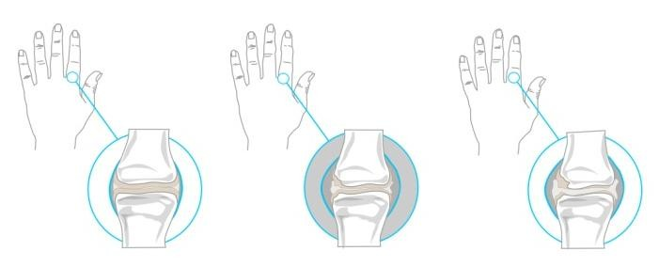

Ilustration 1. Clinical articular

Whereas ulnar deviation of the MCP, is one of the most common joint misalignments (diagnosed in approximately one third of patients) in the period of the AR state, this deformation is resumed joint for Orthopaedic jewelry design

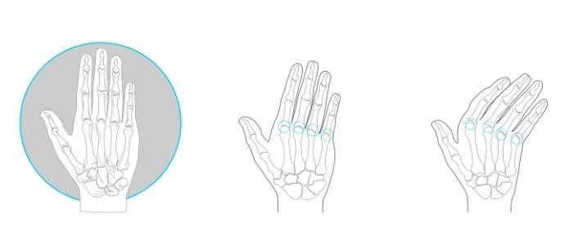

Ilustration 2. Pathological process of ulnar deviation

The ulnar deviation is considered a progressive shift towards the MCP joints cube. Several factors contribute to their progress; anatomical, functional and pathological, some causes for each factor are: the anatomical factor, this asymmetry and ulnar inclination of the metacarpal heads, the thrust direction of the flexor and extensor tendons, in the functional factor is gravity, the opposing force of the thumb with the other fingers and finally the condition factor, a result of chronic inflammation of the joints that cause damage to the joint capsule and ligaments that surround it, causing loss of balance in the early stages of RA.
The arthritic patient with ulnar deviation in initial stage, only a slight decrease functional features of the hand, specifically a limited range of art. MCF, ie the patient can and should continue with the mobility of your joints, so the ideal splint having the characteristics of mobility support and allows the hand is a functional brace.

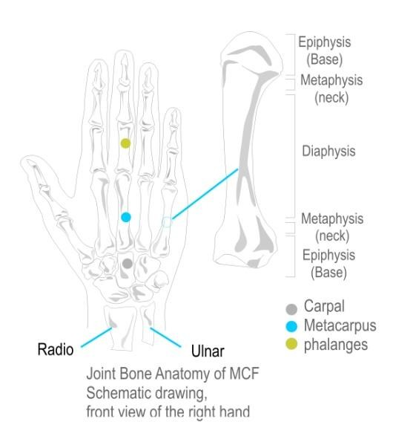

Ilustration 3. Hand anatomy

The biggest challenge in designing such splints is to combine and prioritize the objectives, firstly the splint should provide support and protect joints affected and the other will allow the use and normal function of the hand *.
- There are three periods according to the evolution of RA onset, state and sequels; the second period is characterized by the full affirmation of all clinical and radiological characteristics of the disease.
- The normal hand function refers to the main activities of the hand (grasping and gripping.

Methodology

In designing splints for people with RA, consider four aspects, the disease or condition, pathological mechanics arthritic hand, constraints and functional needs of the patient, and is critical anatomical knowledge no arthritic hand, for establish benchmarks and comparisons.
This last issue was addressed from the internal anatomy (osteoarticular, arches and muscles of the hand) to the external anatomy (skin and palmar creases) and was also considered joint mobility ranges, such research was the basis for determining the requirements and define parameters:

3.1 Requirements and parameters
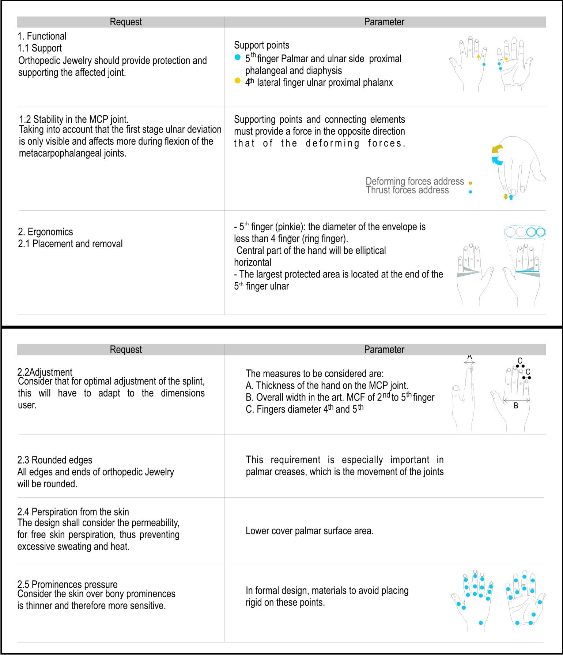

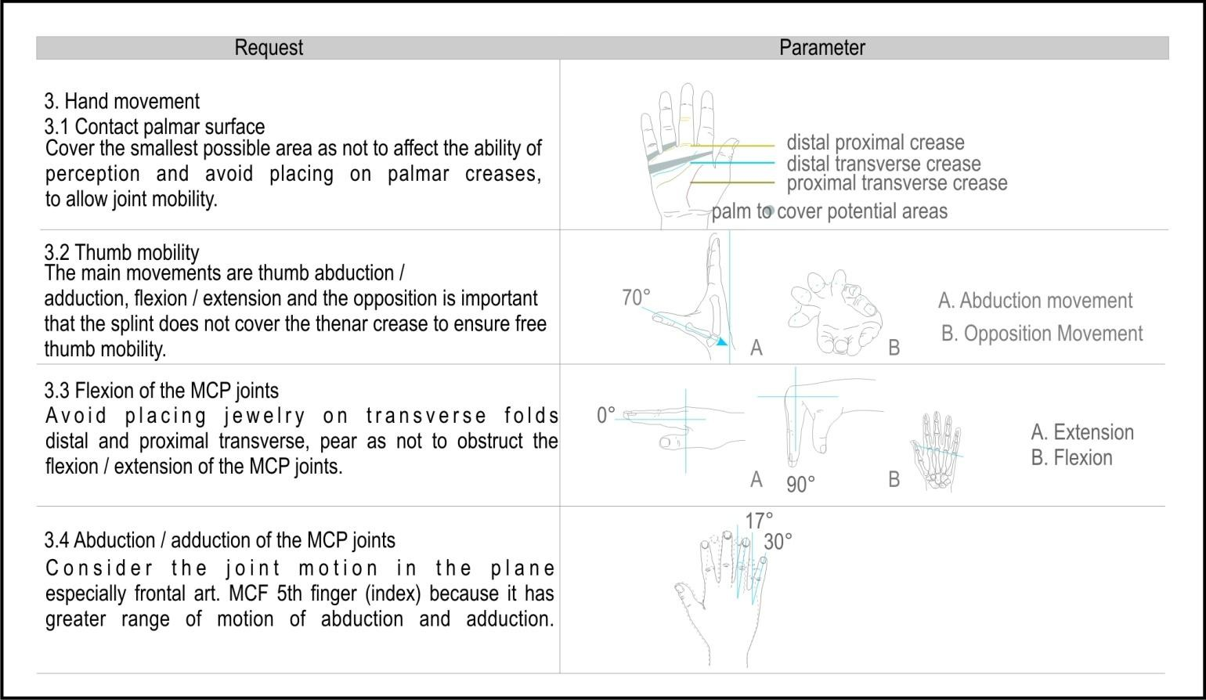

Under these requirements and parameters are designed and developed various models and prototypes, which are outlined below.

Development of models

With distinct morphological proposals in each performance was evaluated on five aspects. Placement and Removal: The model performed better on this criterion, by its simplified form and its enclosures that are easy to locate and place on each finger. In this regard it is suggested that the new proposal delineate the shape of their parts or components according to the part of the hand where they are to be placed.
Setting: In this approach the model A and model B did better, but both are detected the same problem: the parts of the hand that were in direct contact with the elastic tensor, suffered a touch constantly with the motion of the parts therefore determined that the pieces covered the perimeter greater hand parts where possible and avoid direct contact of the skin elastic tensor.
Comfort: The Model A was the best present results, this is because unlike the B and C models, parts are not on any bony prominence or palmar crease.
Support: In all the simulations performed it was observed that an element
necessary to cover the lateral end of the little finger ulnar and radial end cover to the 2nd finger.
Permissibility of hand function: Again, the model has a better performance in this respect, because it allows the movements of flexion / extension and abduction / adduction. This is because the location of the wire (elastic tensor) linking parts and unlike the B and C each piece is located on a finger allowing individual mobility of joints.

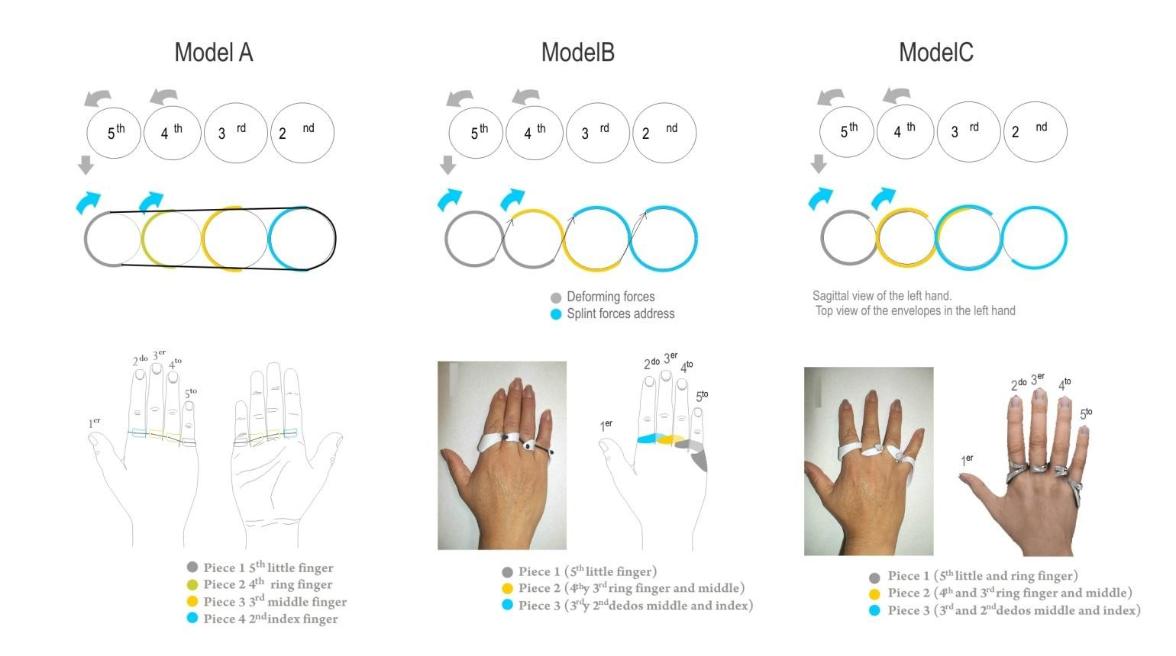
Ilustration 4. Models

Considering the findings obtained in tests on models of phase 1, we developed a series of simulations covering three support points specified in requirement 1.1 * these three points are joined by an elastic tensor quarter point located on the radial side of the metacarpophalangeal joint MCF 2nd (index) finger.
As attachment means is a thread selected elastic tensor of 1 mm diameter by its ability (elongation), when subjected to a force decrease, as generated in the abduction and adduction movements of the art. MCF.

Results

Orthopaedic Jewelry has the function of: stabilize, align and support the affected joints during daily activities or rest, through means that prevent ulnar palmar displacement metacarpofalágicas MCF joint.

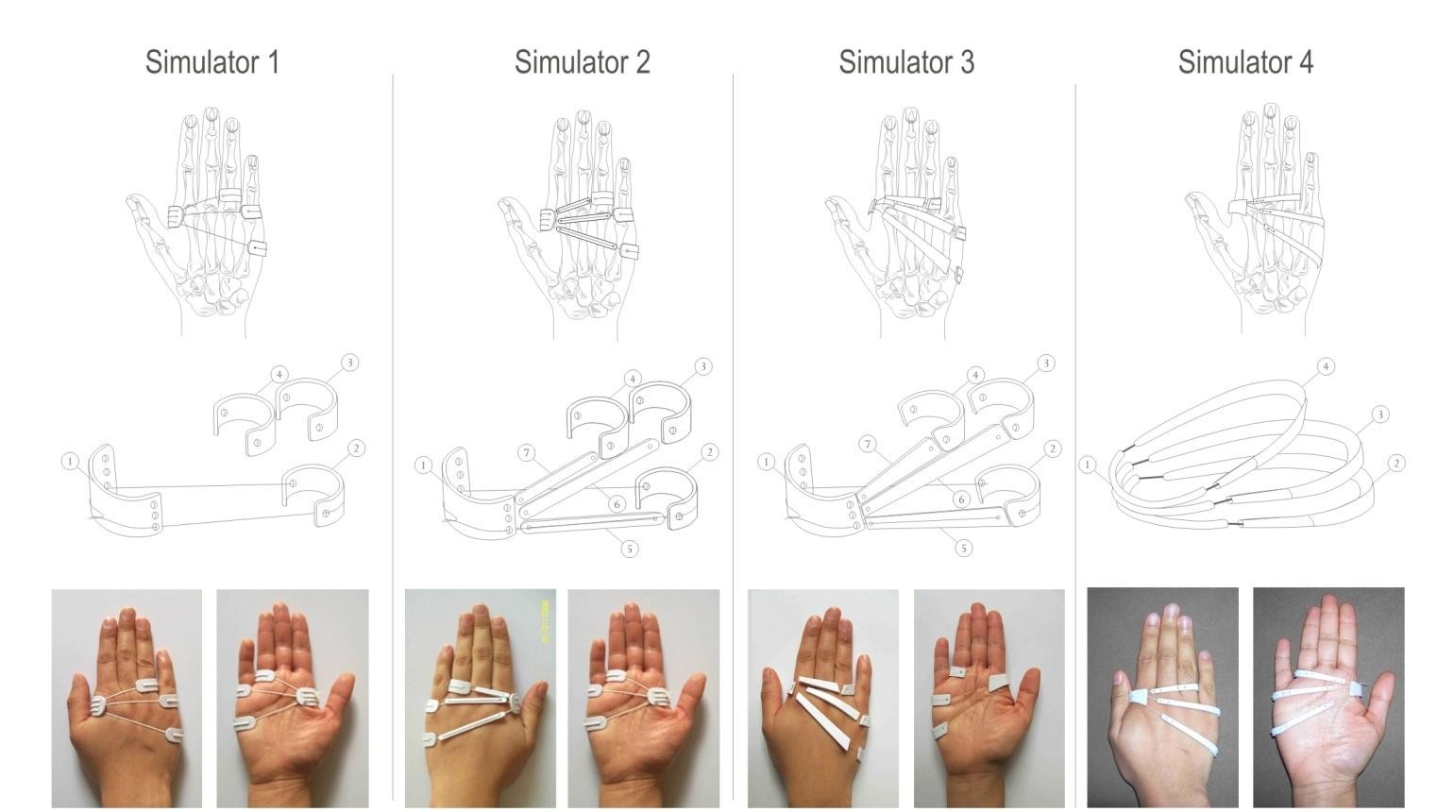
Ilustration 5. Different simulators

Considering the comments in the previous models was proposed as little as possible to cover bony prominences, moving the pieces on the radial side to the shaft of the art. MCF 2nd finger (index), was accentuated horizontal curvature part 3 so that this be placed over the bony prominence of the 4th finger (ring finger) and to pass below the bony prominence of the 3rd finger (middle ), part 2 was placed above the bony prominence of the 5th finger (pinky). These changes allowed the proper flex the metacarpophalangeal (MCP) and hand grasping activities. Was considered a greater thickness on the left side (ulnar) of all the pieces so that there is more support in this area.
Orthopaedic Jewelry, consists of three elliptical rings, which placed in the hand overlap one above the other.
The three pieces are made of sterling silver produced by the process of molding lost wax casting.

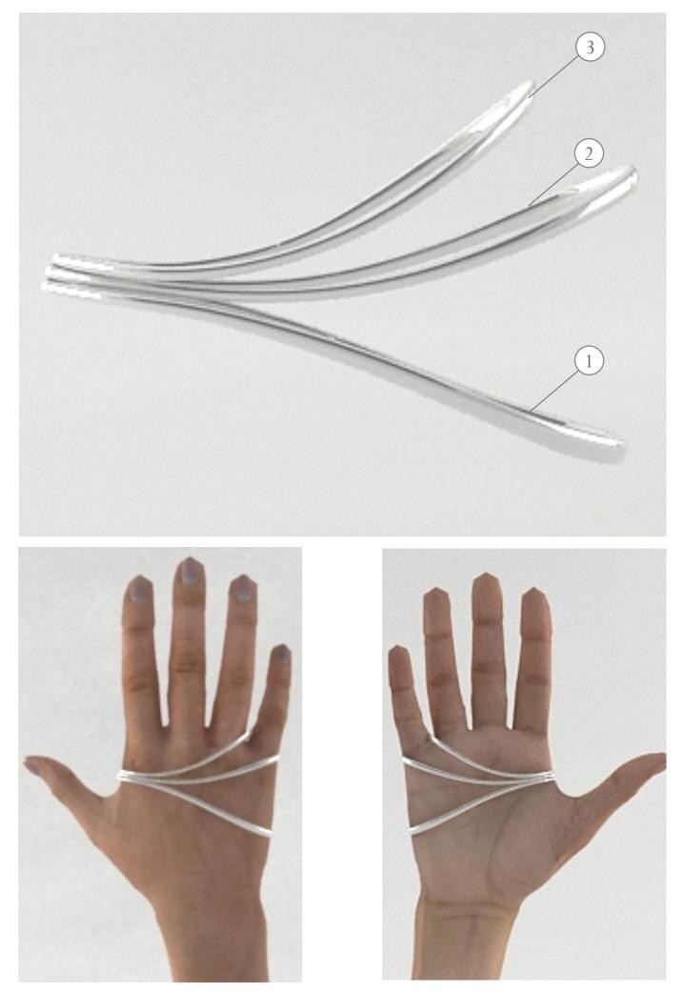

Ilustration 6. Final design palmar and dorsal view

Conclusions
Orthopaedic Jewelry for Ulnar Deviation in stages, provides an aesthetic, comfortable and functional, plus a long life splint for orthopedic treatment. The biggest challenge in this project was undoubtedly combine the objectives of a functional brace or daily use with the qualities of appearance of a jewel. To resolve this issue was necessary to develop and analyze multiple models and simulators, plus two previous proposals made in silver, you past showed that modifications were necessary considering the production process (lost wax casting).
The design covers the deficiencies observed in similar products on the ergonomic aspect: fit, comfort, and the functional aspect: support, protection and stabilization of the affected joints, is to a rapprochement with the National Institute of Rheumatology Rehabilitation Area, for tests in patients with ulnar deviation and observe product functionality, obtaining the parameters necessary changes.

 | 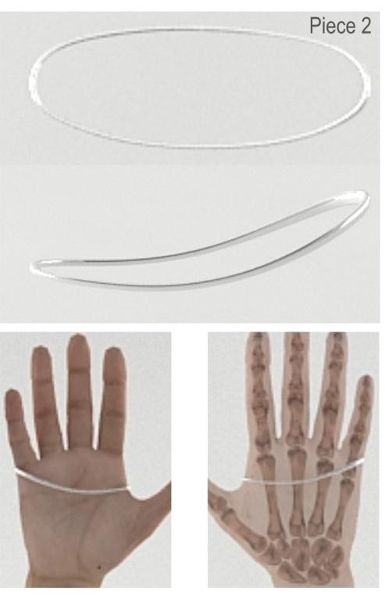 | 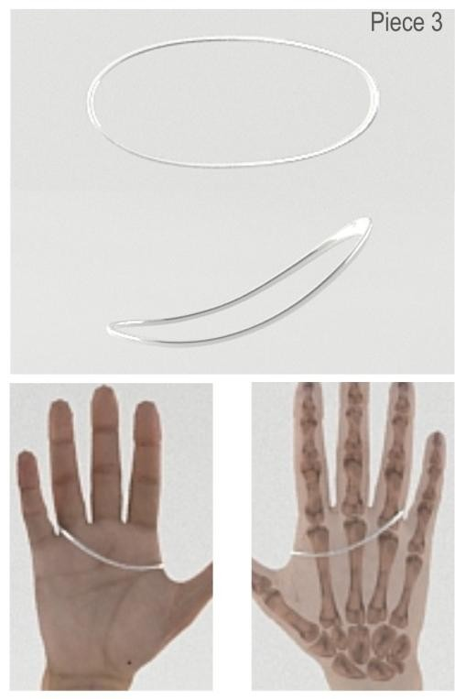

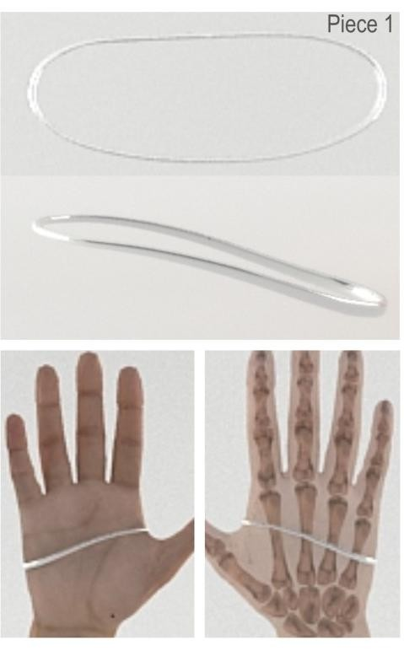
Ilustration 7. Parts of the final design

References

- Clinical Practice Guide for the Management of Rheumatoid Arthritis in Spain (GUIPCAR), Spanish Society of Rheumatology, [Electronic version].
- Cheryl Metcalf, Ring Splints Project "function Three dimensional motion analysis of silver ring splints in Rheumatoid Arthritis". Retrieved March 2010, from
- http://users.ecs.soton.ac.uk
- Hsu, J. D. and Michael, J.W. (2009), Atlas of orthotics and devices Help, Chapter 17 p.227, Spain, Elsevier-Masson.
- MaryLynn and Noelle Jacobs M (2003) Splinting the hand and upper extremity: principles and process, (p. 3), Ed Lippincott Williams & Wilkins, United States.
- De Cillis. V, Peréz Dávila, A (2010). Stabilization splint of the metacarpophalangeal joint in AR: short-term effects. Argentina Journal of Rheumatology, p. 75. [Electronic version].
- Mendez S. Fernando (2002), Rehabilitation in Rheumatic Diseases, Academic Guide (p. 40-47). Faculty of Medicine, National University of Colombia.
- Rodriguez J. Balcazar (2002) Procedural Standards Manual Rheumatoid Arthritis Rehabilitation, thesis for the Title Specialty Rehabilitation Medicine, UNAM Mexico DF

DESIGN OF ERGONOMIC ORTHOPEDIC CRANE FOR PATIENTS WITH IN MOBILITY AND DISPLACEMENT DIFFICULTIES

Gabriel Bermúdez1, Araceli Vázquez, Joel Manríquez, Aurelio Olmedo

Industrial Engeenering
Instituto Tecnológico Superior de Irapuato Carretera Irapuato-Silao Km. 12.5, Irapuato, México, C.P. 36821 gabriel.bermudez@itesi.edu.mx1

RESUMEN
Para alguien que tiene lesiones en la espalda, ¿puede ser tan sencillo entrar en un auto como para otra persona o es necesario una mayor planificación? Hacer este tipo de preguntas, y muchas más, es parte de una nueva dimensión del diseño, que está adquiriendo cada vez más importancia. La tendencia a hacer que la fabricación de productos, así como la correspondiente información, sean más accesibles para quienes tienen cualquier tipo de discapacidad, está abriéndose camino. Y lo que es muy interesante, el hecho de buscar soluciones que se adapten a las necesidades de los discapacitados contribuye a mejorar la concepción de los productos en general, beneficiando tanto a las personas discapacitadas como a los que no tienen discapacidad.
El presente trabajo muestra la aplicación de criterios ergonómicos y antropométricos para el rediseño de equipos ortopédicos, en especial de una grúa ortopédica, con las funciones de una grúa hospitalaria y una grúa bipedestal. Primeramente se encuestaron 120 pacientes con problemas de movilidad y desplazamiento para conocer las necesidades latentes de los usuarios; mediante un QFD se tradujo la voz del cliente en especificaciones de diseño. Se realizó un estudio antropométrico para caracterizar la población de estudio y determinar los criterios de diseño ergonómico en grúa y arnés. Finalmente se realizó el análisis de esfuerzos de los componentes para evaluar su resistencia.

Palabras clave: QFD, Antropometría, grúa terapéutica

ABSTRACT
For someone who has a back injury, Can be as simple as getting into a car for someone else or need more planning?Ask these questions, and many more, is part of a new dimension of design, which is becoming increasingly important. The tendency to make the manufacture of products, and the corresponding information, more accessible for those with any type of disability, is making headway. And that is very interesting, helps to improve the design of products in general, benefiting both people with disabilities and those without disabilities.

The present work shows the application of ergonomic and anthropometric criteria for the redesign of orthopedic equipment, especially orthopedic crane, with the functions of a crane and a crane standing position. First surveyed 120 patients with mobility problems

and displacement to meet the latent needs of users; QFD led by the voice of the customer in the design specifications. Anthropometric study was conducted to characterize the study population and determine the design criteria and harness ergonomic crane. Finally was the stress analysis of components to evaluate their resistance.

Keywords: QFD, Anthropometry, crane therapeutic

INTRODUCTION

Therapists become important in Mexico, due to the increase of aged, diseases associated with loss of limb, disability, or by accidents. This problem causes significant effects in hospitals and rehabilitation, in terms of service delivery.
In some rehabilitation centers throughout the country, it´s common to see the lack of equipment such as cranes, enabling them to develop management activities and transfer of patients, its cost is high in the case of imported products, and do not adhere to national regulations and safety measures. A common countermeasure is to operate with procedures which employ two people, or, articulated beds are used which provide great help to the staff for patient mobilization.
Even with this method, consider that the transfer of a person with disabilities, consider that the transfer of a person with disabilities, is a weight that is carried away; not always the patient has sufficient strength to facilitate their mobility, so that a bad movement, or lack of strength and coordination enter both parties (patient-therapist) can result in a fall or occupational injury. There are patients who work and others do not, either unable or whim. At the time of a patient to mobilize the position you want to have to avoid sudden movements, when the person who is ill collaborates with his transfer, only need one person to help. In the present work situation therapists occupational diseases due everyday tasks of its activity (treat and evacuate disabled patients or amputees from his wheelchair to a hospital area). With the help of a crane orthopedic patient makes no effort, and crane tolerate any weight including obese, s necessary to harness the use of which will be safe during transport movements. Having orthopedic equipment such as a crane, it would be easier and safer patient transfer.
For the design of a product meets customer expectations, is important to have tools to identify and translate the perceptions and customer needs into design criteria and specifications. A suitable tool for the design of new products is the Blitz QFD (Quality Function Deployment). This methodology is the fact that companies do not have unlimited resources. Therefore, we should concentrate resources on what adds more value to the customer (Mazur,2002), quality is restricted by our greatest weakness with respect to what the client requires; that's where we need to improve. The BLITZ QFD 7 comprises steps, which are mentioned below:

- Get the customer's voice.
- Sort verbalizations.
- Structuring Customer Needs.
- Prioritizing customer needs.
- Expand prioritized needs.

- Scan only priority relations in detail.

The Blitz QFD is a very powerful system that invites us to analyze, by going directly to ask the client, whether or not the design of new products meet the latent needs and future customers.

OBJECTIVES.

This paper aims to show ergonomic design of a crane orthopedic maximum load capacity of 120 kg to a height of 70 m. . The lifting mechanism includes patients in a sitting position to a standing position, with support arms and shins.

METHODOLOGY

In the first stage, Blitz QFD lined project resources with the real needs of the client; information provided by disabled patients and users (patient and family therapists) allowed defining spaces, distribution mechanisms and parts that make up the crane; as well as the dimensions and location corresponding harness.

Getting the customer's voice.

For the voice of the customer, a table is first customer segments (TSC) to identify customers of the crane under different scenarios (table 1).

Table1. Customer Segments Prepared

¿Who? | ¿what? | ¿When? | ¿Where? | ¿Why? | ¿How?
therapists | Move to patients more quickly and with less physical wear | When they move them easily and need patients | Rehabilitation centers, hospitals and even in the homes of the same patients | Because this product using the therapist tends to suffer less physical wear | Facilitating the lifting, transfer and patient therapy
disabled | For therapists and doctors move it easily and in a more comfortable it is also | When the patient is in rehab or have the need to go to the bathroom | Rehabilitation centers, hospitals and even in the homes of the same patients. | Because the patient in question is not self- sufficient to | Making minimal effort

 | easier to give the patient the proper rehabilitation. |  |  | perform certain actions
People with diseases temporary disability | For therapists can provide rehabilitation but an easier way. | When you will provide rehabilitation therapy. | Rehabilitation centers, hospitals and even in the homes of the same patients | Because the patient is suffering from a temporary disability that prevents you from being  self- sufficient | Using it for the rehabilitation of it by making minimal effort

Once identified customers or users of the crane, surveyed a group of 120 patients with mobility problems and displacement of CRIS-Irapuato, The survey consisted of 15 open-ended questions to learn the customer's needs. The questions were asked two times to ensure that the patient had clear what is being asked, then the verbalizations were recorded electronically.

Sort verbalizations

At this stage, verbalizations were categorized into the following topics:

- Cost.
- Design.
- Materials.

Note that in these three groups were subdivided to better understand customer needs. Not taken into account the number of each type verbalizations appreciate.

- Cost Availability.
- Innovative Design
Ergonomic Management Facility

Material Properties.
  - Structuring customer needs

At this stage, verbalizations were extracted from the real needs of customers through a second review by a group of therapists CRIS-Irapuato.

Analyze and prioritize customer needs.

Were determined dependency relationships between requirements as shown in Table 2.

Table 2: Relations
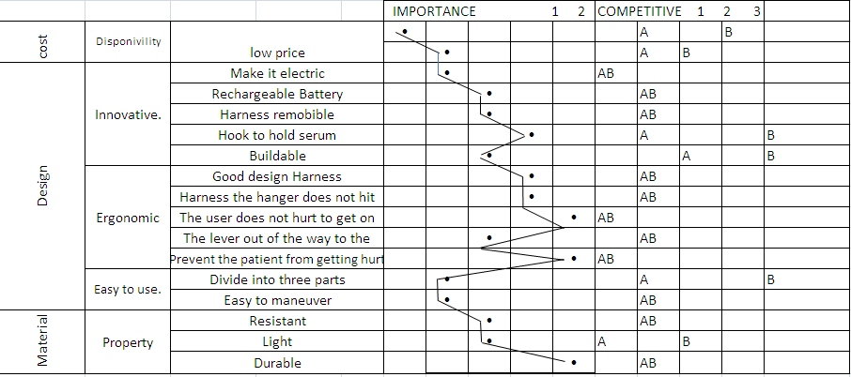

Deployment of prioritized needs

Once identified the priority needs of our customers, we identified the parameters, elements and processes contribute to our processes meet these needs (Figure 1.)

Anthropometric Study

As a second step, we performed anthropometric study in patients with lower limb disabilities, to characterize the study population, age, gender and disease. With this information the crane was designed considering the 90th percentile of the population measure, applicable regulations, as well as security systems for proper operation.
The definition of the dimensions and the method for measuring technique based on anthropometric Standardized Hertzberg, 1968. The sample consisted of examining a total of 90 disabled patients with an age range of 23-63 years. The convenience sample with random selection of subjects.

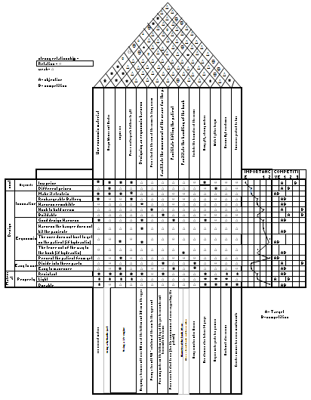

Figure1. House quality orthopedic Crane.

Conditions of measurement

The measurements were performed at the Institute for People with Disabilities (Guanajuato) with adequate security, lighting and cleaning. Patients were measured in two positions: In the lying position, the patients were placed on a flat horizontal bed without shoes head facing forward in the Frankfort plane, shoulders relaxed and both at the same height, arms outstretched to your sides, hands resting on the bed, heels together and toes apart at 45 degrees between them.
In the sitting posture, patients were placed in his wheelchair, with the trunk erect retaining the normal curvature of the spine, head oriented to the Frankfort plane; shoulders relaxed and in a horizontal line, arms limp at his sides and hands resting on the first third of the thighs, the thighs forming an angle with the trunk and the popliteal area separate inches from edge of the seat, legs forming an angle of 90 degrees with

the thighs, adjusting the height of the chair, feet flat on the supports of the chair trying to preserve the alignment of the trunk-thigh-leg and foot.
The measurements were made between 2 people, the therapist assisted in placing the patient in the correct positions for taking measurements.
The 16 anthropometric measure population characteristics are:

Table 3: Anthropometric measures characteristics of disabled patients

 | Measure | Average | P90
1 | Age | 31.3  years | 50.2  years
2 | Weight | 66.8 kg | 90.3 kg
3 | Height | 1644.2 | 1746.1
4 | Height to eye | 1526.8 | 1622.8
5 | Height to chin | 1413 | 1507.8
6 | Height at shoulder | 1359.7 | 1450.9
7 | Height to elbow | 1010.1 | 1092.2
8 | Gripping lower height | 734.1 | 791.4
9 | Height trocantera | 834.1 | 903.7
10 | Maximum vertical reach | 1978.4 | 2118.6
11 | Scope of fine prehension | 766.8 | 827.1
12 | Pressure range of force | 733.2 | 792.3
13 | Maximum depth of the body | 271.7 | 331.5
14 | Width bideltoidea | 445.5 | 492.7
15 | Foot height | 49.4 | 59
16 | Body mass index | 24.4 | 31.7

Subsequently, each designed elements forming orthopedic Soliworks crane. The design was to integrate the functions of a crane with a crane bipedestal hospital; the material used for construction, consisted of a rectangular hollow section (PTR) of 2 "x 2", 14 gauge.

Calculation of the most unfavorable position

The study is performed with a static calculation of the orthopedic crane structure. To find the most unfavorable position was a simplified version of the important parts yielding the forces and moments to which is subject to various arm positions. Was calculated with a standard charge structure was chosen a weight of 120 kg, this is the minimum weight of manufacturing in the market.
Calculation is performed on the force that holds the hanger weight: F weight = (120) (9.8) = 1176 N = 119,919 kg * Strength
This force is supporting the harness and place it on the rack have to split it between the

two clips:

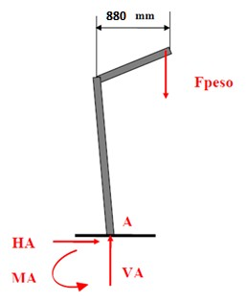
F perch = 1176/2 = 588N = 59.9595 kg * Strength Diagram of the arm body in the highest position.

Realizing the power balance

Σ MA = 0 → - F Weight (880) + MA = 0 Weight MA = F (880) = 1034880 N * mm

Free body diagram horizontally
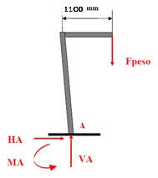

∑ MA=0 → - F Peso (1100)+MA=0 MA=F Peso (1100)= 1,293,600 N*mm

Free body diagram in lowest position

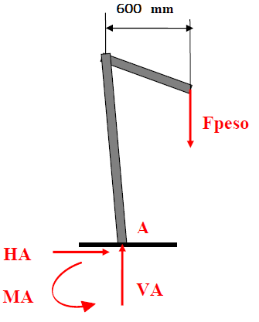
∑ MA=0 → - F Peso (600)+MA=0 MA=F Peso (600)= 660,000N*mm

In view of equations can say that the greater the distance from the Fpeso to underrun, the greater the time at that point. Therefore the horizontal position is the position that has already unfavorable 1,293,600 N * mm.

Diagram 3.9 free solid arm

F peso
RH
78
o
210

Rv

∑ Mrot=0 → Fcil*Sen 78*280 – Fcil *Cos 78*210 – 1176*1100=0 F*230.22-1364160=0 → F=5818.97 N =593.37 Kg*Fuerza

This indicates the need for an actuator with 5818.97 N, which is the force needed to lift 120kg. And the use of a material which in this case is preferred to use a PTR 2x2 "gauge 14 for supporting a load worst 1, 293.600 N * mm.
As a final step, we designed a new harness for patients, with the competitive advantage of having a header, to support the patient's head and neck, as well as new lower-cost materials and the same tensile strength.

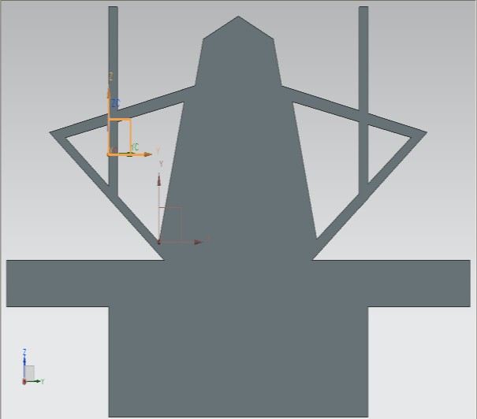

Figure 2. Crane orthopedic Harness

4.- RESULTS AND CONCLUSIONS

Anthropometric helped characterize the disabled population that has limited mobility and displacement in the city of Irapuato, Mexico.
Among the results of the work, must specifications and tolerances of individual components and their therapeutic crane harness, As a result of the translation of the customer's voice when using methodology Blitz QFD.
The material used in the prototype design, is low cost and increased use in industry, making it easy to make or buy spare parts in case of damage.
The prototype design should improve the quality of life for patients with disabilities in community Cuerámaro, Guanajuato.
The stress analysis yielded information on the strength of the material and the critical points of component failure, ensuring product quality, in the interest of safety of the equipment.

CONCLUSIONS / DISCUSSION

The design and manufacture a therapeutic crane meets the latent needs of users, considering ergonomic criteria essential for proper operation, improving the quality of life of the disabled population, It is noteworthy that in some rehabilitation centers in the region, not common to have such equipment necessary for the movement and management of patients with mobility difficulties, so the proposal described above contributes to strengthening these centers with ergonomic equipment commensurate with the population, and provide economical and functional implements this area.
By simulating the operation and assembly of each component with SolidWorks, you can identify ergonomic design errors before manufacturing, contributing to the reduction of time and cost.
The pilot of the prototype in Guanajuato Institute for People with Disabilities, allowed to validate the feasibility of the prototype to commercialization.
Finally the project promotes the training of research and technological development; and strengthens the research projects developed by the ITESI.

REFERENCES

[1]. Beer, Johnston, Mazurek, Esisenber, (2010), Mecánica Vectorial Para Ingenieros Estática, Mc Graw Hill, México.
[2]. Gallego T. (2007.) Bases Teóricas y Fundamentos de la Fisioterapia. Madrid:
Editorial
[3]. Médica Panamericana;
[4]. Glover W, McGregor A, Sullivan C, Hague J. (2005) Work- related musculoskeletal disorders affecting members of the Chartered Society of Physiotherapy. Physiotherapy ;91:138-147.
[5]. González Bosch, Verónica y Tamayo, Francisco, (2012.) "Blitz QFD: Un Vistazo Relámpago al Poder del QFD", Asociación Latinoamericana de QFD.
[6]. Harber P, Billet E, Gutowski M, SooHoo K, Lew M, Roman A. (1985) Occupational low-back pain in hospital nurses. J Occup Med ; 27(7):518-24.
[7]. Hertzberg, H.T.E.( 1968) The conference on standardización of Anthropometric techniques and Terminology. Ameer J Physical Anthropol, 28, 1-15,
[8]. Mazur, Glenn, (2002) "QFD Black Belt Notes", Japan Business Consultants, E.U. [9]. Wilkinson WE, Salazar MK, Uhl JE, Koepsell TD, DeRoos RL, Long RJ.(1992)
Occupational injuries: a study of health care workers at a northwestern health science center and teaching hospital. Aaohn J; 40(6):287-93.
[10]. Yoji Akao et.al.: (199) Quality Function Deployment (QFD); Productivity Press.

Proposal for ergonomic furniture provision and improvement for students handed in DGETI campuses of the State of Chihuahua.

Resumen.
Miguel Francisco Nassri Chávez. Full Time profesor CBTis 128, Ciudad Juárez, Chihuahua mnassri@gmail.com

El presente estudio tiene como objetivo principal el de elaborar un análisis, y de este una propuesta, para que las autoridades de la Subsecretaria de Educación Media Superior –SEMS- y de la Dirección General de Educación Técnica industrial –DGETI- tomen en cuenta las dimensiones y características ergonómicas del equipamiento de mesa bancos o pupitres y que estos sean los adecuados y que cumplan con las normas mínimas ergonómicas-antropométricas. Y está basado en los factores ergonómicos-antropométricos para una población de alumnos-(as) que estudian bachillerato en los planteles de la DGETI en el Estado de Chihuahua. En la elaboración de esta propuesta se fundamentó en algunas teorías, como la teorías de la postura “sentado” Fernández, et al, (2008-133), y por Kroemer, citado por (Fernández), quien refiere, la tarea básica de la Ergonomía es la de diseñar condiciones “Tolerables” que no atenten contra la salud o la vida. También se incluye algunas definiciones de los conceptos principales de este análisis. La metodología utilizada para conocer el número de alumnos, (as) zurdos, se procedió a contabilizarlos salón por salón, turno por turno en dos planteles de la DGETI, en esta ciudad, CBTis 128 y CBTis 114, además se diseñó y aplico un cuestionario de 6 –seis- preguntas, en donde se exterioriza la opinión de los afectados respecto si se le dificulta trabajar en pupitres solo para diestros, además se contó con el consentimiento de los alumnos para obtener las fotografiados in situ.
Palabras clave: Antropometría, postura, ergonomía, sistema musculo esquelético, alumnos(a) zurdos, Lesión.

Abstract.
This study aims to develop a principal of this analysis and a proposal for the authorities of the Sub-secretary of Intermediate Superior Education – (Spanish abbreviation) and the General Direction of industrial technical education -DGETI- (Spanish abbreviation) take into account the size and ergonomics of the equipment table benches or desks and that these are adequate to meet the minimum standards anthropometric, and is based on anthropometric ergonomic factors for a population of students-(as in school studying the DGETI campuses in the state of Chihuahua, also in the development of this proposal was based on some theories, such as theories of posture "sitting" Fernandez, (2008-133), ), and Kroemer, quoted by (Fernandez), who relates the basic task ergonomics is the design conditions "Tolerable" not jeopardize the health or life. Also included are some definitions of the main concepts of this analysis. The methodology used to determine the number of students-(as) proceeded to post them lefties classroom by classroom, turn by turn in the DGETI two campuses, in this city, CBTis 28 and CBTis 114, is also designed and implemented a questionnaire 6 -Six- number of

questions where the view is externalized on affected if it is hard work in single-handed desks, and they had the consent of the students to get photographed in situ.
Keywords: anthropometry, posture, ergonomics, musculoskeletal system, students (a) left-handed, injury.

Introduction.
The need to protect students against the causes of their own schoolwork illnesses, injuries and accidents, is certainly the concern of education authorities, as also is concern students of Occupational Ergonomics and Anthropometry. All sources of schoolwork should these efforts lead to the prevention of occupational hazards, with consequent advantages in the production of scientific knowledge (Knowledge) in educational establishments. Musculoskeletal injuries are disorders characterized by an abnormal condition when purchasing a posture inadequate and poorly designed furniture can cause this injury to the muscles, joints, bones or ligaments, tendons, nerves, vessels, which is an inevitable consequence deteriorating health of the individual. For SEP educational system, SEMS, DGETI, is and will always be health and safety as a primary goal of all students and staff.

Objective.
It is purpose of this analysis is to demonstrate and provide sufficient information to authorities and managers of the Assistant Secretary of School Education (SEMS) and the Directorate General of Education of the urgent need for adequate equipment, suitable for students (as) lefties. Besides the feasible solutions that positively impact performance conditions in the production of scientific knowledge (Knowledge) and improve the teaching learning process of students in upper secondary education in Ciudad Juarez, Chihuahua.

Justification.

In teaching practice there are some who will discuss a history of the events that students spend lefties, when schools do not have these in the appropriate school furniture desks for students handed themselves in a group of 50 if there is an average of 3 to 4 students lefties.
To start this job, I will discuss the following anecdote, which is mentioned in http://www.larednoticias.com/noticias.com/noticias. (July 28, 2008). This apparently happened in the American College of Tuxtla Gutierrez, Chiapas, one of the most expensive city apparently, a teacher corrects each time the notebook position one of his students, as does the small (or ) fits, then the book hits the desk with tape. She is left- handed, and three others of your living room, but in the whole school desks only for right there. In other cases, some teacher’s behaviorists 50s, tied his left hand back to left-handed students.
In the Bachelor of Technology Center, Industrial and Services No. 128 in Ciudad Juarez, Chihuahua (CBTIS No 128), in a morning and evening shift there are 159 students lefties, and not in that squad has sufficient own furniture for students (a) left- handed, if we consider that there are only five CBTis Ciudad Juarez, in the state high school about 16 centers, which means that the number of students increases

significantly, this is a warning to that for authorities take seriously the anomalous situation.

Methodology.

Will consider the position refers to the way it supports the body in space. The position at work is defined as the position of the body when a person performs an activity takes. Next pictures (1, 2, 3, 4, 5, 6) can be clearly seen when a student takes a stand anthropometrically not own, as seen in the photos, the positions taken in the wrist and his body crouched-inclined are associated with an increased risk of injury.

Picture #1and 2
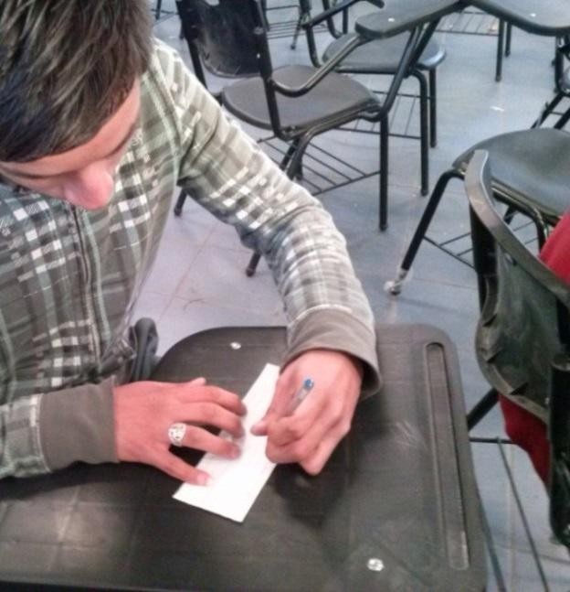

Picture #3 and 4
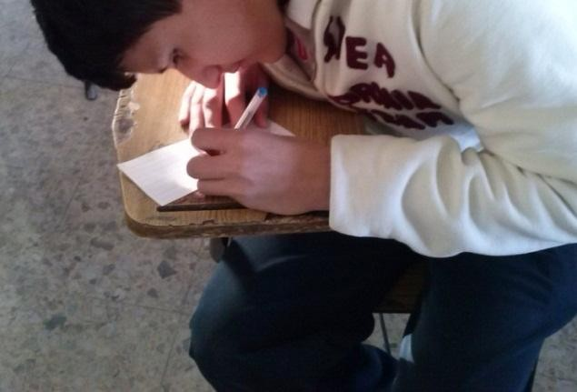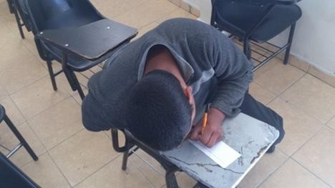

Picture #5 and 6
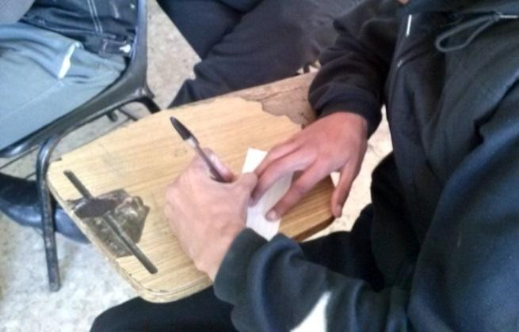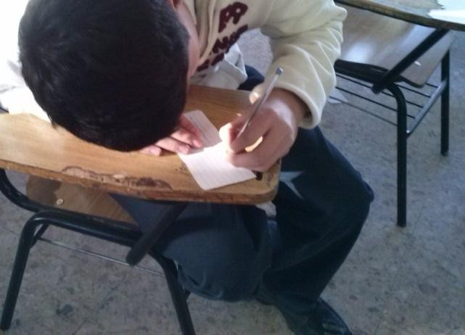
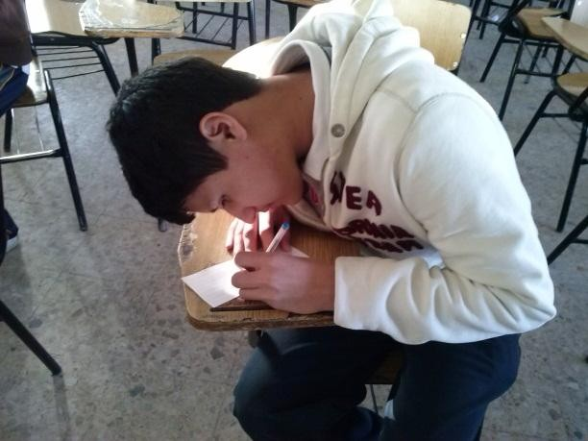Picture 7 the body and neck of the student are perpendicular to the palette of banking

Dir ect ion of the pal let
the angle of inclination is 45 °

Note the position of the student body develops Illustration 6 when school work is not completely neutral posture, flexed, bent. It is generally considered that more than one joint which deviates from the neutral position produces high risk of injury.
We designed a small survey of only 5 questions. Were visited classroom by classroom in two shifts (Cbtis 128), to identify students who are left-handed, and those overweight, thereupon asked to answer the survey.

4.1- Questionnaire

1.-As individual lefty ever received in an assault. Yes No In some

occasions
- - If yes, by whom. Fellow friends classroom Master (o) My parents
- - What kind of aggression. Verbal left hand tied, hand to beat me not to write to her, , other, specifies.
specifies
- - After all this time writing with his left hand, have you had any ailment? Yes No
- - If you answered yes to what part of your body. Doll , Arm, another part Back
- - Is it difficult for you to work at desks for right? Yes No , if you answered that you
specify.

4.2 Proposal for furniture
Desk (Mesa-bank) and proposed ideal classroom for both left and right handed students.
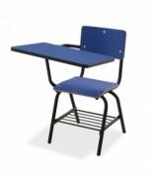
bench or desk wide blade

Results.

CBTis 128 morning shift
Group | Classroom | Number of left handed men | Number of left handed women | of seats left trowel | No of seats with wide blade | Total lefties.
2º A | 1 | 2 | 2 | 0 | 0 | 28
2ºB | 2 | 2 | 1 | 0 | 0 | 28
2ºC | 3 | 3 | 0 | 0 | 0 | 28
2ºD | 4 | 1 | 0 | 0 | 0 | 28
2ºE | 5 | 0 | 2 | 0 | 0 | 28
2ºF | 6 | 2 | 0 | 0 | 0 | 28
2ºG | 20 | 2 | 2 | 0 | 1 | 28
2ºH | 26 | 3 | 1 | 0 | 0 | 28
2ºI | 13 | 2 | 3 | 0 | 4 | 28
Total |  | 17 | 11 | 0 | 5 | 28

CBTis 128 morning shift
Group | Classroom | Number of left handed men | Number of left handed women | of seats left trowel | No of seats with wide blade | Total lefties.
4º A | 15 | 5 | 1 | 0 | 0 | 26
4ºB | 9 | 0 | 1 | 0 | 6 | 26
4ºC | 11 | 2 | 1 | 0 | 7 | 26
4ºD | 17 | 3 | 0 | 0 | 2 | 26
4ºE | 18 | 0 | 4 | 0 | 2 | 26
4ºF | 19 | 0 | 0 | 0 | 1 | 26
4ºG | 10 | 0 | 2 | 0 | 0 | 26
4ºH | 16 | 2 | 3 | 0 | 3 | 26
4ºI | 8 | 0 | 2 | 0 | 1 | 26
Total |  | 12 | 14 | 0 | 22 | 26

CBTis 128 morning shift
Group | Classroom | Number of left handed men | Number of left handed women | of seats left trowel | No of seats with wide blade | Total lefties.
6º A | 27 | 3 | 0 | 0 | 1 | 25
6ºB | 7 | 3 | 0 | 0 | 0 | 25
6ºC | 22 | 3 | 1 | 0 | 0 | 25
6ºD | 28 | 3 | 1 | 0 | 0 | 25
6ºE | 21 | 0 | 2 | 0 | 0 | 25
6ºF | 14 | 0 | 0 | 0 | 0 | 25
6ºG | 25 | 1 | 1 | 0 | 53 | 25
6ºH | 12 | 2 | 0 | 0 | 1 | 25
6ºI | 24 | 2 | 3 | 0 | 1 | 25
Total |  | 17 | 8 | 0 | 56 | 25

CBTis 128 evening shift
Group | Classroom | Number of left handed men | Number of left handed women | of seats left trowel | No of seats with wide blade | Total lefties.
2º J | 5 | 4 | 1 | 0 | 0
2ºK | 2 | 1 | 1 | 0 | 0
2ºL | 3 | 0 | 0 | 0 | 0
2ºM | 4 | 1 | 0 | 0 | 0
2ºN | 1 | 5 | 0 | 0 | 0

2ºO | 6 | 4 | 1 | 0 | 0 | 27
2ºP | 24 | 0 | 1 | 0 | 1 | 27
2ºQ | 26 | 4 | 0 | 0 | 0 | 27
2ºR | 25 | 3 | 1 | 0 | 53 | 27
Total |  | 22 | 5 | 0 | 54 | 27

CBTis 128 evening shift
Group | Classroom | Number of left handed men | Number of left handed women | of seats left trowel | No of seats with wide blade | Total lefties.
4º J | 14 | 2 | 1 | 0 | 0 | 35
4ºK | 7 | 3 | 1 | 0 | 0 | 35
4ºL | 18 | 2 | 1 | 0 | 2 | 35
4ºM | 10 | 5 | 0 | 0 | 0 | 35
4ºN | 17 | 1 | 0 | 0 | 2 | 35
4ºO | 16 | 4 | 1 | 0 | 3 | 35
4ºP | 21 | 3 | 2 | 0 | 0 | 35
4ºQ | 12 | 3 | 2 | 0 | 1 | 35
4ºR | 19 | 2 | 2 | 0 | 1 | 35
Total |  | 25 | 10 | 0 | 9 | 35

CBTis 128 evening shift
Group | Classroom | Number of left handed men | Number of left handed women | of seats left trowel | No of seats with wide blade | Total lefties.
6º J | 27 | 5 | 1 | 0 | 1 | 18
6ºK | 22 | 2 | 1 | 0 | 0 | 18
6ºL | 20 | 1 | 1 | 0 | 1 | 18
6ºM | 8 | 0 | 0 | 0 | 1 | 18
6ºN | 11 | 1 | 0 | 0 | 7 | 18
6ºO | 15 | 0 | 1 | 0 | 0 | 18
6ºP | 9 | 1 | 1 | 0 | 6 | 18
6ºQ | 13 | 1 | 0 | 0 | 4 | 18
6ºR | 28 | 2 | 0 | 0 | 0 | 18
Total |  | 13 | 5 | 0 | 20 | 18

CBTis 128
Total lefties morning shift students | 79 Men and woman
Total lefties evening shift students | 80 Men and woman
Total on campus | 159

CBTis 114 evening shift
Group | Classroom | Number of left handed men | Number of left handed women | of seats left trowel | No of seats with wide blade | Total lefties.
2º C |  | 3 | 2 | 0 | 0
2ºD |  | 1 | 1 | 0 | 0
2ºF |  | 1 | 2 | 0 | 0
2ºH |  | 0 | 1 | 0 | 0
2ºI |  | 4 | 0 | 0 | 0
2ºK |  | 3 | 1 | 0 | 0
2ºO |  | 2 | 1 | 0 | 0
2ºP |  | 3 | 1 | 0 | 0
Total |  | 17 | 9 | 0 | 0 | 26

CBTis 114 evening shift
Group | Classroom | Number of left handed men | Number of left handed women | of seats left trowel | No of seats with wide blade | Total lefties.
4º C |  | 2 | 1 | 0 | 0
4ºD |  | 4 | 1 | 0 | 0
4ºF |  | 3 | 0 | 0 | 0
4ºH |  | 3 | 2 | 0 | 0
4ºI |  | 0 | 3 | 0 | 0
4ºK |  | 2 | 2 | 0 | 0
4ºO |  | 3 | 2 | 0 | 0
4ºP |  | 3 | 0 | 0 | 0
Total |  | 20 | 11 | 0 | 0 | 31

CBTis 114 evening shift
Group | Classroom | Number of left handed men | Number of left handed women | of seats left trowel | No of seats with wide blade | Total lefties.
6º C |  | 0 | 3 | 0 | 0
6ºD |  | 0 | 1 | 0 | 0
6ºF |  | 3 | 2 | 0 | 0
6ºH |  | 1 | 1 | 0 | 0
6ºI |  | 3 | 0 | 0 | 0
6ºK |  | 2 | 2 | 0 | 0
6ºO |  | 0 | 0 | 0 | 0
6ºP |  | 1 | 0 | 0 | 0
Total |  | 10 | 9 | 0 | 0 | 19

CBTis 114 Morning shift
Group | Classroom | Number of left handed men | Number of left handed women | of seats left trowel | No of seats with wide blade | Total lefties.
2º A |  | 3 | 1 | 0 | 0 | 28
2º B |  | 1 | 2 | 0 | 0 | 28
2ºE |  | 2 | 0 | 0 | 0 | 28
2º G |  | 0 | 0 | 0 | 0 | 28
2º J |  | 4 | 1 | 0 | 0 | 28
2º L |  | 3 | 2 | 0 | 0 | 28
2º M |  | 2 | 2 | 0 | 0 | 28
2º N |  | 4 | 1 | 0 | 0 | 28
Total |  | 19 | 9 | 0 | 0 | 28

CBTis 114 Morning shift
Group | Classroom | Number of left handed men | Number of left handed women | of seats left trowel | No of seats with wide blade | Total lefties.
4º |  | 4 | 0 | 0 | 0 | 37
4º |  | 5 | 1 | 0 | 0 | 37
4º |  | 2 | 2 | 0 | 0 | 37
4º |  | 3 | 2 | 0 | 0 | 37
4º |  | 4 | 1 | 0 | 0 | 37
4º |  | 5 | 0 | 0 | 0 | 37
4º |  | 2 | 2 | 0 | 0 | 37
4º |  | 1 | 3 | 0 | 0 | 37
Total |  | 26 | 11 | 0 | 0 | 37

Group | Classroom | Number of left handed men | Number of left handed women | of seats left trowel | No of seats with wide blade | Total lefties.
6º A |  | 4 | 1 |  |  | 31
6ºB |  | 3 | 2 | 0 | 0 | 31
6ºE |  | 1 | 0 | 0 | 0 | 31
6ºG |  | 2 | 3 | 0 | 0 | 31
6ºJ |  | 3 | 3 | 0 | 0 | 31
6ºL |  | 1 | 0 | 0 | 0 | 31
6ºM |  | 2 | 1 | 0 | 0 | 31
6ºN |  | 4 | 1 | 0 | 0 | 31
Total |  | 20 | 11 | 0 | 0 | 31

Total lefties morning shift students | Men | 76
Total lefties evening shift students | Woman | 96
Total on campus | 172

TOTAL PUPILS LEFTHANDERS
CBTis 128 | Men | 159  172
CBTis 114 | Woman | 159  172
TOTAL 331

Brief analysis of the results.

If the campus CBTis 128, has an enrollment of about 1,800 students (+ -) in two shifts and there are only about 83 banks with wide blade table for both shifts, this equates to 4.6% of table banks, on the other hand, if the enrollment is approximately 1,800 students, and 159 are handed in two shifts, then there is a 8.33% of left-handed students, which is very significant that amount, so it is necessary to equip a minimum of a 15 to 20% of banks table wide blade.
Note, not analyzed 114 CBTis campus, enrollment is unknown and the other campuses of the DGETI in Ciudad Juarez, Chihuahua.

Conclusions

-In relation to the results, needless to say that there is a great shortage of desks (4.6%) for students (as) lefties, that they meet the anthropometric dimensions and adequate minimum ergonomic features, only two stocks accounted CBTis CBTis 128 and 114 . Note, in terms of number of students (as) lefties.
- As a result, the fatigue in his school work, can cause serious injury to the student, and this situation is not neutral stance adopted affects poor production quality of schoolwork intellectual (knowledge).
- While not ruling out the possibility that currently have students who are injured or hurt, it should be mentioned that the basic task of ergonomics is to design conditions "Tolerable" not jeopardize the health or life.
- Students interviewed expressed most bodily ailments as you go back the school shift. Respondents attributed these conditions to the positions taken, and say they have to turn the back to work in banks only for right table.

Bibliography.

- Fernández, Jefrfrey E. Marley, Robert J. Noriega M. Salvador, Ibarra M. Gabriel. (2008).. Occupational Ergonomics. International Journal of Industrial Ingineering. printed in México

- López Atondo, José Rénan. (No date of publication) www.monografias.com.
- Occupational Ergonomics. Research and Applications. Vol 3 2010 Ergonomists Society of Mexico,. civil association 151.
- Prado León, Rosalía. Ávila Chaurand, Rosalío. Herrera Lugo, Enrique. Lilia Rosalía. (2005). Anthropometry. Ergonomic factors in. design Center of Arts, Architecture and Design. University of Guadalajara. Mexico.
- Remote Ergonomics Evaluations in the Office . Jeffrey E. Fernández, Gabriel Ibarra- Mejía, and Brandy F. Ware. JFAssociates, Inc Vienna, VA 22181 Corresponding author’s email: jf@jfa-inc.com, University of Texas at El Paso, Department of Public Health Sciences College of Health Sciences
El Paso, TX

Sites web visited
1.-burbujabzo on Diciembre 09, 2012.
2.-http://www.monografias.com/trabajos/ergonomia/ergonomia.shtml#ixzz2MuXPBnTZ 3.-http://www.larednoticias.com/noticias.cfm?n=13180#ixzz2MtCAeHOc,

PROTECTIVE PACKAGING DESIGN, USING ERGONOMIC CRITERIA

Rosa Maria Bernardette Coss y León Perez and Elvia Luz González Muñoz

Centro de Investigaciones en Ergonomía.
Universidad de Guadalajara Calzada Independencia Norte No. 5075,
Huentitán El Bajo S.H. C.P. 44250 Tel. 12023000 Corresponding author’s e-mail:rossy.cossyleon@hotmail.com

Resumen: El objetivo de este estudio es presentar el desarrollo de un proyecto de diseño de empaque en el cual se consideren criterios ergonómicos para su desarrollo, considerando algunos principios básicos, para llevar a cabo una búsqueda y delimitación de aquellos criterios que deban ser considerados durante el proceso de diseño de empaque protectivo, así como una justificación de los mismos, mediante el uso de principios básicos y fundamentos propios de biomecánica, anatomía y antropometría. La metodología para este estudio se basa en la realización de un análisis de tareas durante la manufactura de un empaque por un usuario indirecto, (aquel que se encarga de manufacturar el empaque). Este análisis se llevó a cabo con la intención de hacer una identificación de errores probables en la interacción entre el usuario y el producto, y se reforzó con observación del desempeño del usuario en situaciones reales. Posteriormente, se realizó un prototipo de la propuesta de diseño resultante del análisis, haciendo la aplicación de las adecuaciones ergonómicas, para repetir el análisis de tareas y la observación, incluyendo las nuevas características y poder hacer así un comparativo de los errores cometidos durante la actividad y el tiempo necesario para realizarla, y un análisis de los problemas ergonómicos potenciales que se pudieran generar debido a la manufactura del sistema.
Una vez llevado a cabo el análisis de tareas para el proceso de manufactura del sistema de protección y almacenamiento para la tarjeta electrónica modelo ALN-004, en su etapa de diseño original y en la de propuesta de rediseño, se observaron diferencias significativas en los tiempos utilizados para el armado de la charola, debido principalmente a la dificultad para ubicar las marcas internas en la pieza base del diseño original y al tiempo perdido en asegurarse de la correcta orientación de la misma. Por los errores cometidos en dicha orientación, se observó la posibilidad de generación de una pérdida de materias primas, al inutilizar la pieza principal por hacer el proceso de pegado de las piezas menores por la cara incorrecta.
En cuanto al manejo conjunto del sistema ya ensamblado, se registró también una diferencia en el nivel de comodidad del usuario ocasionado por la existencia o no existencia de los elementos de sujeción en la caja, y al colocarla en la tarima, de manera más marcada al inicio o al final del proceso, cuando la altura del manejo de la caja se daba más debajo del nivel de sus rodillas o más arriba del nivel de sus hombros. Esto se mejoró considerablemente con adecuaciones propuestas, como el

agregar los elementos de sujeción y no estibar más alto de la altura del hombro del percentil 5° del grupo poblacional.

Abstract: The aim of this study is presenting a packaging system design in which ergonomic criteria are considered for development, considering some basic principles, for conducting a search and definition of those criteria that should be taken in account during the protective packaging design process, and justifying it, through the use of biomechanics, anatomy and anthropometry basic principles. The methodology is based on an task analysis during the manufacture of a package system by an indirect user (one who is responsible for manufacturing the packaging). This analysis was carried out with the intention of making an identification of probable errors in the interaction between the user and the product, and was reinforced by observation of user performance in real situations. Later, a prototype of the design proposals resulting from the analysis was created, applying ergonomic criteria, for repeating the task analysis and observation, including the new features and to do so a comparison of the errors made during the activity and the time required to perform it, and to analyze the potential ergonomic problems that may be generated due to the manufacturing system.
Once the task analysis for the manufacturing process and protection system for the electronic storage ALN-004 model was carried out, for the original design and the new one, significant differences in the time used for assembly the tray were found, mainly due to the difficulty in locating internal marks in the basic piece of the original design, and the time the worker lost in making sure on the correct orientation for the pieces. Because of the mistakes made in this stage, we observed the possibility of generating a waste of raw materials, because of disabling the main system piece, for making the process of gluing the smaller pieces on the wrong side on it.
Regarding the overall packing system management, there was also a difference in the comfort level of the worker, caused by the existence or non-existence of the hand holes in the box, and when the worker placed the box on the pallet, especially when i t was at the beginning or end of the process with each pallet; that means when the height of the box management was below the worker knees or above his/her shoulder level. This was significantly better with proposed adjustments, such as adding hand holes and marking a limit for stacking the boxes up to the 5th percentile shoulder height of the population group.

KEYWORDS: ergonomics, protective packaging, design

  - INTRODUCTION

In our current society, characterized by industrialization and high product diversification, large manufacturers and their suppliers have seen the need to change their processes to keep up with the growing demand of its customers, which are arranged daily at waiting for less time for the new products. Therefore, industries such as electronics and automotive manufacturers are increasingly streamlining their production lines and making them foolproof, while trying to avoid the most losses from damage to the components of their products. And recently, industries such as aerospace parts

manufacturers have a momentum in Mexico, presenting new demands on companies for goods and services, since they think our country is a good area for their development.
In this scope, the product packaging is becoming a part of the necessary instruments for the production on the high technology parts, which require special treatment for its management and transfer. This is not only about the envelope for containing the finished product and giving a face for it on the shelf anymore, it is about the protective packaging, used on the production line as a container, transport and storage form for components used as a part of cars, computers or even the plane in which traveling for leisure or work. Now, we can start to consider it as a containing and protecting system for the work in process pieces, for the production line at the electronics, automotive and aerospace industries. An important part for the design of protective packaging for internal use in industries, is the use of ergonomic criteria which are making it easier to the user, plus, of course, to fulfill its basic function of providing the necessary protection to the product.
It is important to say that at the time the engineer and / or buyer request package to the supplier, they use to benefit the criteria focused on the product or on the logistics for it. Most of the times, they forget the needs of the user who will use this package in the production process, when actually the use of those guidelines can be done without impacting the costs, but reflecting a high degree of benefit to reduce the time of manufacture, and the degree of difficulty of some activities for people at the production line.
Packing system characteristics are totally different in each project, because the dimensions and needs of the product to pack vary with each type of component produced, so each product needs a different packing system.
According to Snook, cited by Debb, Drury and McDonell (1986), due to the increasingly amount of problems related to the incorrect manual material handling at the Industries, is now more effective to modify the tasks and the containers used in the production line, than forcing the operator to change the way he/she works.As an example of it, one of the NIOSH research goals has been to improve the operator / container coupling, using handles. In experiments done by those authors, a change was made for adapting the hand hold cut-out, making it curved, with a section close to horizontal and a section close to vertical, so the operator could move the hand according to the situation, considering the box size and weight, minimizing the wrist deviation when handling the box at different height... In some other experiments, cited by Snook y Ciriello (1991), investigators have tried to develop guides for de evaluation and design of the manual material handling tasks, according to the workers capacities and limitations. Those guides pretended to help industry to reduce low back pain problems. The tests demonstrated the maximum accepted weight and required forces were lower when the task was more frequent.
Some different tests analyzed the answers of female users to different kind of material handling, modifying the holding distances and the height of the handling. They found the maximum acceptable weight and the required forces to be significatively lower for females than for males, but they were proportionally similar. They also proved the box size and the required distance for the task had significant variants to be considered for establishing acceptable maximum load guidance.

In the last test from the same series, Snook and Ciriello proved the superiority of a box with hand hold cut outs, over another one with no hand holds cut outs when the worker had to lift, down, push, pull and carry the box. When using boxes with no hand hold cut outs, the worker had consistent decrements in the maximum accepted weight, considering the box size and the task frequency. In a general way, they showed the capability for handling loads should be considered taking out a 15% of the accepted amount when using a box with no hand holds cut outs. And they found it is affected too because of the handling material height, from the knee of the worker to his/her shoulder. For the manufacturing process, one useful element for the assembly process is to integrate visual communication elements. According to Agrawala, Li and Berthouzoz (2011), visual communication via diagrams, sketches and graphic elements, is basic to the information transfer process, capitalizing the human ability for information processing, improving user comprehension, memory and inference. All those elements can be applied on the protective packaging design, integrating an assembly instructive, supported with reference elements, such as marks in the shape of the piece for indicating pieces location or orientation. Those elements can help the worker to process the complex concepts easily and to reduce the chance for generating an useless product due to assembly mistakes.
For the present analysis, a specific packaging model used on the production line in the electronic industry was studied. It was required that the packaging had as a specific characteristic: to be assembled by hand, because it was considered a lot of potential problems can be detected from the manufacturing stage.

OBJECTIVE

The aim of this study is presenting the development of a packaging design project in which ergonomic criteria are considered for development, using some basic principles, to conduct a search and definition of those criteria that should be taken in account during the protective packaging design process, and justifying it, through the use of biomechanics, anatomy and anthropometry basic principles.

METHODOLOGY

  - Procedure

First, a task analysis was developed during the manufacture process of the packaging system and a simulation of the process was done and video recorded, to be analyzed later.
From the obtained data, a new design of the packaging was proposed, applying ergonomic adjustments, and a new prototype was fabricated. Next step, the investigators repeated the simulation and the observation, comparing the results to those obtained at the first stage.

  - Participants

Both simulation exercises were done with the same subject, a 26 year old male, worker from a packaging design and manufacturing company. This Company is actually giving service to the electronics, automotive and aerospace industry in the Guadalajara Metropolitan Area.
The subject accepted to participate in the study, after being informed about the tests to be done, and the video recording.

Instruments

For the tests, the team used a video recorder, pencil and paper for notes and proposals, and the cardboard and polyethylene pieces needed for the prototype manufacturing. For producing the prototypes, the team had access to the CAD table, the software and the material from the packaging Company.

ERGONOMIC ANALYSIS RESULTS
  - System objective

The objective of the system is to hold and to protect the electronic board model A-004, from and during it production process to the end of it, when it is placed in the electronic product. This system should assure the component electrostatic protection, avoiding the static discharges produced when the packaging material moves, reinforcing this way the protection given for the accessories used by the worker at the production line, such as the electrostatic coat.
For this study, the team used the packaging manufacture stage, considering the worker that is making the package as an indirect user, because of the contact he has with the system, even he is not the one that uses it for placing the boards. This part of the process involves in some way the workstation design.

Product characteristics

The system includes ten rectangular trays, fabricated in 1.2 psi pink polyethylene. The trays have antistatic characteristics, and their general dimensions are 19 11/16” x 13 ¼” x 1”; each one has the capacity to hold 4 boards. Each tray has two cut outs for helping on the handling and 24 little polyethylene pieces attached on the bottom, for holding the board placed in the tray below it.
The system also includes another polyethylene piece, with the same characteristics of the trays, but the cavities. This piece is used as a cover for the upper tray.
All the trays and top should be placed in a plastic polyethylene bag, gusseted style, 3 mil, and pink antistatic color. The internal dimensions of the bag are 25” x 16” x 25”.
The trays and top inside the bag are placed in a cardboard box (RSC style, FEFCO 201). The box is made in single wall, C flute, 32 ECT, with antistatic interior finish. Internal dimension of the box is 24 3/16” x 13 3/8” x 13 7/8”. This box does not have hand hold cut outs.

    - User characteristics

The user characteristics are presented on Table.1. Table 1. User characteristic description.
Age: | 18-64 years old
Sex | Male or female, not limitative, but with certain preference for the female.
School degree required: | Secondary school
Social-economic level: | low to medium- low
previous experience with similar products: | from inexpert to expert on similar products manufacture
Special skills: | Basic instructive and sketches reading
Special skills: | Manual skills for manufacturing
Physical limitations: | None
Cognitive limitations: | None
Other: | None

    - Environment characteristics
The assembly stage is done by a packaging design and manufacture company. The production lines are organized in a lineal way, and each operator makes different functions, and gives the product to the next operator for the process continuity.

    - Task description and analysis

The tasks the worker does for this system production can be included in the next way: Selection and placing of the required pieces for each assembly.
Heat sealing of the lower and upper pieces to form the tray. The lower piece is a polyethylene rectangular plank, 0.5 inches thick. It will be the base of the tray. The upper piece is a similar polyethylene plank, but it has the shape for the cavities for containing the boards. The small inserts have to be heat sealed to the lower piece, for holding the board in the tray placed below when they are stacked.
Finished pieces inspection, to check the heat sealing is completed and firm, placing each kit formed by ten trays and one top in the bag and the box.
Stack the finished boxes on the pallet.
A task analysis was done to detect the potential problems for the manufacturing of the system.

Potential ergonomic problems

Complementing the task analysis, we performed a list of potential problems or inadequacies ergonomic on which proposed work:
Lack of clear instructions for quicker review of supporting documents for the manufacture of the product.
Lack of visual communication elements in the design of the piece, which will eliminate the possibility of errors in the orientation of the parts and expedite the understanding of the relationship between the instructions and the product
Lack of fasteners in the box and there fasteners with inadequate anthropometric characteristics in the tray.
Ability to support performance of the operator with simple tools which will facilitate the work, as the assembly of the box, which is done manually and can present any mismatch that impedes the introduction of the remaining assembly at said box, or instruments a more automated automatic wrapper.
Ability to set specific limits on the height of the materials stowed on stage, on efforts to prevent the shoulder and back area for the operator to place the finished boxes.

Characterization and valuation of the ergonomic properties

For the preparation of the proposed redesign of the containment system and protection for ecards model A-004, the following points were considered:
Adequacy anthropometric. Reviewing the dimensions of the piece in the aspects relating to the user, as the lateral holds to take the tray. We found the size of these holds somewhat limited in length. The analysis concluded that, although the formal element was originally designed for use by the end user, who placed the cards in the trays, can also indirectly benefit the user that will manufacture, at the time of introduction into the bag. It was proposed to adjust the size to fit the 95th percentile male population group affected.
Adequacy anthropometric height of the finished product considering stowing shoulder height 5th percentile female population group of industrial workers.
Adequacy biomechanics. Add clamping grips with appropriate characteristics or in the box containing the entire system, to facilitate gripping thereof.
Suitability for Ease of Use instructional generation with clear, specific and quick to identify, based on the principles of visual communication, to capitalize the facility operator to process information, improving their comprehension, memory and inference during assembly of the proposed product.
Suitability for Ease of Use Based on the same principle of visual communication, integrate product design elements for identification and orientation of parts.

    - Proposal of fitness ergonomics

The final proposal adequacy consists of redesigning the tray that is part of the containment system and protection for the electronic card model A-004 and generated drawings and instructions for assembly (see Fig. 1)

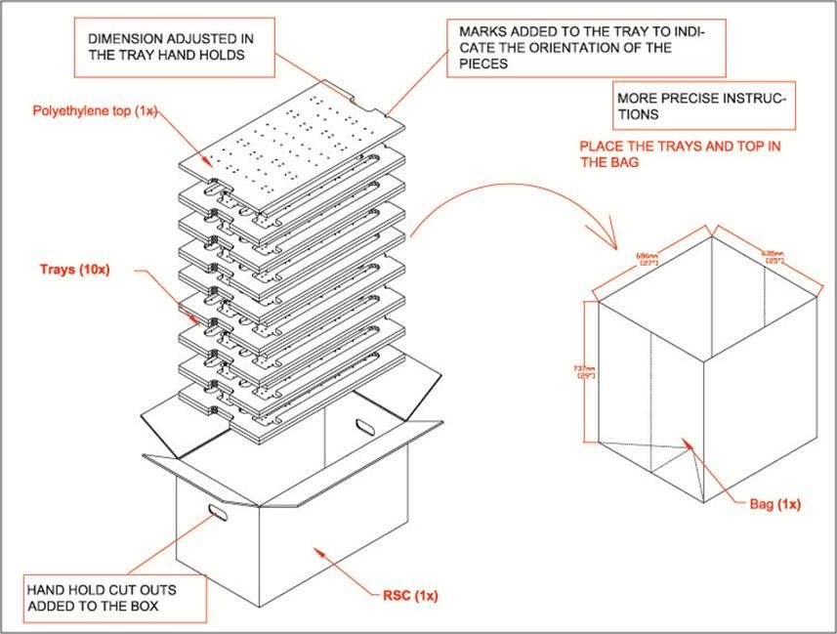
Figure 1. Proposal of containment system.

Once the task analysis for the manufacturing process was carried out, significant differences in the time used for assembly of the tray were found, mainly due to the difficulty in locating internal marks in the lower piece of the original design and the time the worker lost in making sure the correct orientation for the pieces. Because of the mistakes made in this stage, we observed the possibility of generating a waist of raw materials, because of disabling the main system piece, for making the process of heat sealing the smaller pieces on the wrong side. After the analysis of the production timing, the team found the proposed adjustments helped to reduce the cycle time 18%, making the worker activities more efficient. Besides, the worker gets the emotional benefit from the increased usability
Regarding the overall packing system handling, there was also a difference in the comfort level of the user caused by the added hand hold cut outs in the box, and when the operator stacked the box on the pallet, because of the new limit in the stacking height. The new stacking height considers the percentile 5 for female users.

CONCLUSIONS

At the end of the corresponding analysis, we can determine the importance of the application of ergonomic factors in the design of protective packaging components, for making easier the work of the different users, starting from the one manufacturing it. These ergonomic factors are based in manual material handling and tool design criteria, because both topics provide us with guidelines for the development of components that facilitate handling during an activity that can be constant and repetitive.
Anyway, the main objective of the system, to protect and hold the components, should not be lost, so all the extra characteristics we can add to the system will be useful just if they do not affect the primary system function.

REFERENCES

Agrawala, M., Li, W., & Berthouzoz, F. (2011). Design principles for visual communication. Communication for the ACM, 54(4), 60-69. DOI: 10.1145/1924421.1924439
Deeb, J. M., Drury, C. G., & McDonell, B. (1986). Evaluation of a curved handle and handle position for manual materials handling. Ergonomics, 29(12), 1609-1622.
Snook, S. H., & Ciriello, V. M. (1991). The design of manual handling tasks: revised tables of maximum acceptable weights and forces. Ergonomics, 34(9), 1197-1213

APPLICATION OF THE OWAS METHOD FOR EVALUATING RISK FOR A LABORER OF SACKSFLOUR
Villegas Duarte Jesús Efraín2, Quirós Morales, Aarón Fernando1, López Acosta,

Mauricio1, Montiel Rodríguez, Luis Carlos1, Martínez Solano, Gilda María1
,
Varela

Campos Rubén1
1 Industrial Engineering Department, 2Student of Educational Program of Industrial and Systems Engineernig from Instituto Tecnológico de Sonora, unit Navojoa, email: efraiin_82@hotmail.com,aquiros@itson.mx,mauricio.lopez@itson.edu.mx,lmontiel@itso n.mx, gilda.martinez@itson.edu.mx, rvarela@itson.mx

RESUMEN
El propósito de este trabajo es identificar los riesgos ergonómicos se presentan en las estaciones de trabajo área dentro de una empresa de fabricación de harina al momento de levantar los costales. Para eso nos basaremos al método OWAS, con el evaluamos las distintas posturas del trabajador como son posición de espalda, brazos, piernas y la carga al momento de realizar su tarea una vez que los posibles riesgos han sido identificados y analizados en el sitio, se presentarán las mejoras para disminuir y contribuir a una mejor adaptación a los seres humanos en su trabajo, que incluyen el cuidado de la salud, reducción de las cargas y perfección de las condiciones de trabajo, entre otras. El propósito de este trabajo es la seguridad en el lugar de trabajo en el momento de llevar a cabo sus actividades. La necesidad de realizar un análisis ergonómico es esencial para definir los elementos representativos en el desarrollo de los trabajos y recoger la mayor información posible las actividades que se llevan a cabo. Con el desarrollo del análisis ergonómico dentro de la empresa está prevista para conocer los principales peligros ergonómicos asociados con estaciones de trabajo.

Palabras Claves: Ergonomía, Método OWAS, trastornos músculo esquelético

ABSTRACT
The purpose of this work was to identify ergonomic hazards arising in the workstations area of a flour manufacturing company at the moment of lifting the sacks. We used the method OWAS, which assesses the different positions of the worker, such as: position of the back, arms, legs and the load at the time of the task. Once the potential risks have been identified and discussed in the site, we recomended improvements that can reduce risks and contribute to a better adaptation of humans to work. Improvements include health care, the reduction of burdens and the perfection of the working conditions, among others. The purpose of this research is the safety in the workplace at the time to carry out the activities. The need for an ergonomic analysis is essential to define the representative elements in the development of the work, and collect the best possible information of the activities that are carried out. The purpose of the ergonomic analysis in the company is expected to know the main hazards associated with the workstation.

Keywords: Ergonomic, OWAS method, muscle-esqueletic disorder.

INTRODUCTION

The principle of ergonomics is to design work and working conditions to suit the individual characteristics of each worker. The steady increase in the prevalence of back disorders and muscle-skeletal diseases has focused efforts to reduce the harmful load.
According to recent research results reducing the static load caused for working bad position is one of the main measures to correct the situation. There are different methods that can be applied towards the worker this to have a better performance and suffers no injury when performing their jobs these methods are based on a simple and systematic classification of working positions, combined with comments on the tasks are seeking areas of opportunity in which you can perform this was due to today consciousness has created within companies and has attracted interest to promote knowledge, evaluation and application, implementing improvements to workstation through ergonomic designs.

OBJECTIVE

Analyze the workstation in the production area of sacks of flour based on the position of the worker, identify the different position adopted by one worker during development task by observing activity in the work area with the support of the use of the method OWAS and develop an ergonomically design proposal.

METHODOLOGY

The OWAS method (Karhu, 1977), bases its results on the observation of the different positions taken by the employee during the course of the task, allowing to identify 252 different positions as a result of the possible combinations of the position of the back (4 positions), arms (3 positions), legs(7 positions), load lifted (3 interval)
The first part of the method, making location register data or may be performed through observation “in situ” of the worker, analysis of photographs, or viewing videos taken prior activity. Once the observation positions encodes the compiled method. Each position is assigned an identification code. Depending on the risk or discomfort is a stand for the worker, the method distinguishes four levels OWAS list in ascending order, being, therefore, the value 1 the lowest risk and the value 4, the highest risk. For each risk category the method will establish a proposed action, indicating in each case whether or not the redesign of the position and its urgency.
So, on the encoding, the method determines the risk category of each position, reflection of the discomfort involved for the worker. Subsequently, evaluates the risk and discomfort for each body part (back, arms and legs) assigning, depending on the relative frequency of each position, a risk category of each body part. Finally, the analysis of the risk categories for the positions calculated and observed for the different parts of the body, will identify the most critical positions and postures, as well as the corrective actions needed to improve the job, defining in this way, an action guide for redesigning the evaluated task.

The OWAS method has a limitation to point. The method allows identification of a series of basic positions back, arms and legs, encoding in each "code position", however, does not allow a detailed study of the severity of each position. (Karhu, 1977).
The procedure for applying the method is, in summary, as follows:
Observing whether the task should be divided into several phases or stages, in order to facilitate the observation.
Set the total obervation time of the task (20 to 40 minutes).
Determining the duration of the time intervals in which to divide the observation (the method proposed time intervals between 30 and 60 seconds.) identify, during the observation of the task or phase, the different positions adopted by the workers. For each position, determine the position of the back, arms and legs as well as the load being lifted.
Encode observed positions, assigning each load position and the values of the digits that make up your "code position" identifier. Calculate for each "code position", the risk category to which it belongs, in order to identify those critical positions or higher level of risk to the worker.The calculation of the percentage of positions classified in each risk category, may be useful for the determination of these critical positions.
Calculate the percentage of repetitions or relative frequency of each position of the back, arms and legs with respect to other. (The OWAS method doesn’t allow to calculate the risk associated with the relative frequency of the loads lifted, however, its calculation can guide the evaluator on the need for an additional study of lifting).
Determine, based on the relative frequency of each position, the risk category to which belongs each position of the various parts of the body (back; arms and legs), in order to identify those that have a more critical activity.
Determine, based on calculated risks, corrective and redesign needed actions. If you have made changes, evaluate the task with OWAS method to verify the effectiveness of the improvement.
Coding of the observed positions: the method begins with the collection, previous observation, of the different positions taken by the worker during the performance of the task.
The method assigns four digits to each position observed, depending on the position of the back, arms, legs and load supported, thus configuring its identifier code or "Code ofposition".
To those observations divided into stages, the method adds a fifth digit to the "Codeof position", this digit determines the phase in which the encoded position has been observed.

Back position. | Arm position. | Leg position. | Loads.
Figure 1. The observed positions (code of position) coding scheme.

Below is detailed the form of coding and classification of the positions proposed by the method:
Back positions: first digit of "Code ofposition".

The first member to encode will be the back. To set the value of the digit that represents it muste be determined whether the position taken by the back is right, bent, with twist or bent with twist.
The value of the first digit of "Code ofposition" is obtained after consulting the table shown below (Mattila, 1999).

Table 1. Coding of the back positions.
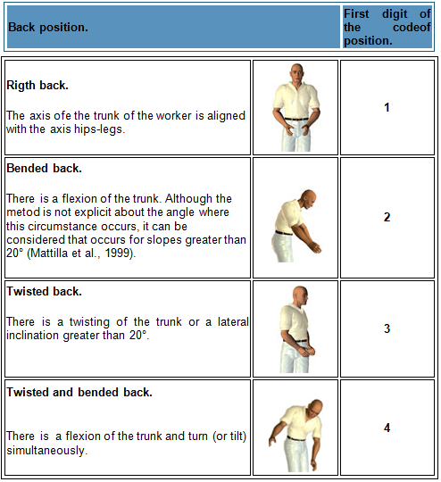

Table 2. Coding of the positions of arms.
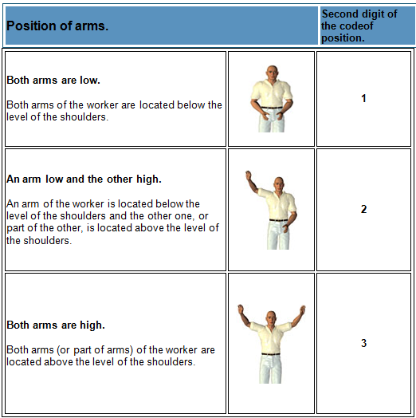

Table 3. Coding of the positions of legs.
Position of legs. |  |  | Third digit of the codeof position.
 | Sitting. | 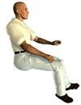 |  | 1
 | Standing with both legs straight with weight balanced between both. | 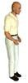 |  | 2
 | Standing with one leg straight and the other bent with the weight unbalanced between both of them. | 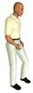 |  | 3

Standing or squatting with both legs and weigth balanced between both of them. Although the method is not explicit about what angle this circumstance occurs, it can be considered that occurs for angles thigh-calf less or equal than 150° (Mattila et al., 1999). Larger angles will be considered straight legs. |  | 4
Standing or squatting with both legs bent and weigth unbalanced between both of them.  It can be considered that occurs for angles thigh- calf less or equal than 150°. Larger angles will be considered straight legs. | 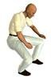 | 5

Table 3. Coding of the positions of legs. (Continuation).
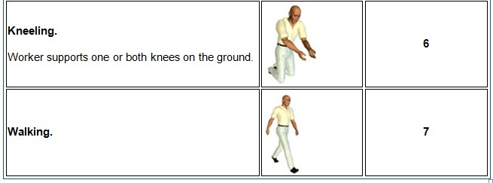

Table 4. Load and forces supported encoding.
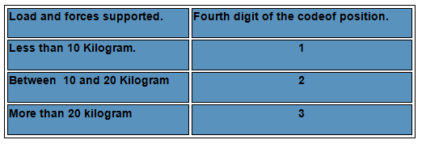

Table 5. Table of categories of risk and corrective actions.
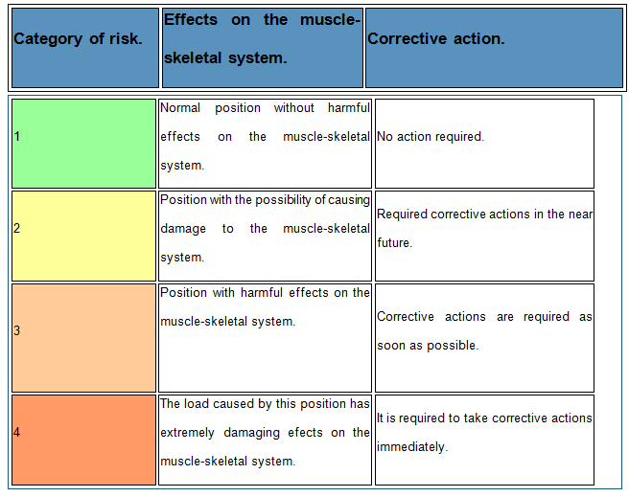

Note: For each category of risk is assigned a color code in order to facilitate its identification in tables.

Table 6. Table of classification of the categories of risk of the “codes of position”.
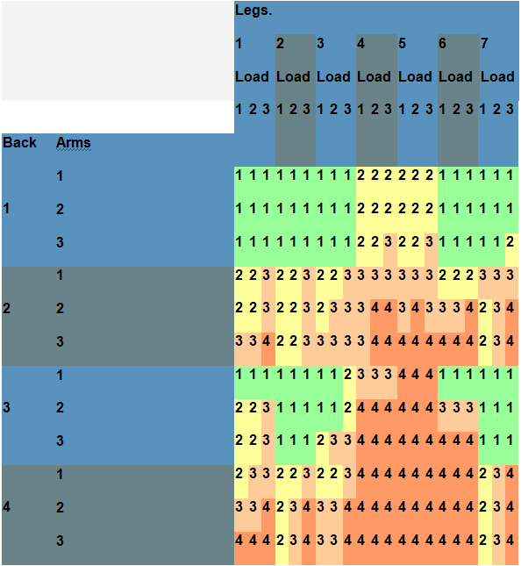

RESULTS AND DISCUSSION

Coding postures observed: The method begins with the collection, after observation of the various positions taken by the worker while performing the task. Note that the larger number of the observed positions will be smaller the possible error introduced by the observer (estimated 100 observations is introduced with an error of 10%, while for the possible error 400 is reduced to approximately half 5%).
The method OWAS assigns four digits each observed position depending on the position of the back, arms, settings so its identification code or "code position". For those observations divided into phases, legs and the load, the method adds a fifth digit to "code position", that digit determines the phase in which it was encoded posture observed.
Application of the OWAS method.

Back Positions: The first member to be encode it will be back. To set the value of the digit that represents what should determine whether the position of the back is right, bent, folded twist or turn.

Positions of the arms: Next, will be analyzed the position of the arms. The value of the second digit of "code position" will be 1 if the two arms are low, 2 if one is low and the other high and finally, 3 if both arms are raised. (Nogareda, 2006).
Leg positions: With the encoding position of the legs, will complete the first three digits of the "code position" to identify body parts analyzed by the method.
Loads and Forces Supported: Finally, we must determine which load range, among the three proposed by the method, which the worker belongs when it takes up the position.
The study was based on the lifting of sacks of flour, scores below:
Folded back: There trunk flexion. Although method doesn’t explicit from which angle this was the case, can be considered to occur for inclinations greater than 20 °, the score is
- As illustrated in Figure 1.
The two arms raised: Both worker arms are located above shoulder level, the score is 3. As illustrated in Figure 2.
Legs position: Stand with both legs straight with the weight balanced between the two. The score is 2. As illustrated in Figure 3
Load and Power Supported: More than 20 kilograms, the score is 3. As illustrated in Figure 4
Final Result: : According to the assigned score on the different positions that were evaluated in the worker, it could be determined that corrective actions are required because they would cause harmful effects on the muscle-skeletal system, and thus avoid unnecessary costs for the company due to work injury.

CONCLUSIONS
Based on the results of the application of the method OWAS, it was possible to demonstrate that workers are on risk if they continue lifting the sacks of flour in the same way they currently do, it is necessary to take corrective action as soon as possible to prevent muscle-skeletal injury to the worker, this with the purpose that the company can reduce expenses. There are different ways to give solution to this: to use equipment like wheelbarrowsto charge and to transport the product, to bring closer the destination of the product and also the support of hoists for thetransport.

REFERENCES.

KARHU, O., KANSI, P., Y KUORINKA, L.(1977).Correcting working postures in industry: A practical method for analysis. Applied Ergonomics, 8, pp. 199-201.
KIVI, P. Y MATTILA, M.(1991). Analysis and improvement of work postures in the building industry: application of the computerized OWAS method. Appl Ergon, 22, pp.43–48.
MATTILA, M. Y VILKKI, P.(1999).OWAS methods. En: W. Karwoswki and W. Marras, Editors, The Occupational Ergonomics Handbook, CRC Press, Boca Raton, pp. 447–459.
NOGAREDA, S.,Y DALMAU I.(2006). Assessment of working conditions: postural load. NTP 452. Instituto National Health and Safety at Work.

STUDY TO DETECT CARPAL SYMPTOMATOLOGY IN DENTISTS

Ruiz Ibarra Jesús Iván1, Ramírez Leyva Alberto1, Castro Estrada Claudia2, Valdez Quintero Arleth1, Mondaca Armenta Jesús1, Salido Valdez Rafael1, León Heras Ileana1, Vega Valenzuela Rosmar1

1 Professor at the Technological Institute of Los Mochis.
2 Professor of Indigenous Autonomous University of Mexico.

Email Authors:jesus_ruizi@hotmail.com, alberto_ramirez_leyva@yahoo.com,klaudy_00@hotmail.com

RESUMEN
El presente estudio se considera como una primera etapa que permitirá detectar la sintomatología carpiana en odontólogos que laboran en Los Mochis, Sinaloa, en el cual se realiza una serie de pruebas que permitirán saber si hay algún indicio de alteraciones conocidas, como lo son los Desorden de Trauma Acumulativos (DTA’s). Lo cual permitirá realizar estudios mas afondo en dado caso que se presentara algún síntoma, ya sea en cuanto al rediseño de la herramienta usada, en cuanto al método utilizado o los tiempos de reposo recomendados para dicha actividad. Para realizar el estudio primeramente contactamos algunos dentistas para realizar un pequeño sondeo, también buscamos las clínicas particulares ubicadas en la ciudad de Los Mochis, visitamos a éstos y les aplicamos la encuesta que nos serviría de base para definir si estaba correctamente realizada. Los dentistas que entrevistamos en el sondeo nos dijeron que colaborarían con la investigación y acordamos solicitar una cita para aplicar la encuesta completa. Al visitar a los dentistas, primeramente explicamos el motivo de nuestra investigación y se les cuestiono si tenían conocimiento sobre el padecimiento del síndrome del túnel carpiano. Se pudo apreciar que el número de odontólogos del género femenino es igual al del género masculino. También se apreció que la antigüedad mínima de años laborados es de 10 años en el género femenino y de 20 años en el masculino. En lo referente a sintomatología se apreció que el 60% de las odontólogas entrevistadas presentaron dolor en la muñeca, palma o antebrazo. Y solo el 20% de los hombres presento estos síntomas. En cuanto a adormecimiento de mano y dedos el 80% de las mujeres lo presentaron, mientras que solo el 20% de los hombres lo padecen.

Palabras claves: DTA, Síndrome del túnel de carpo, Dentistas

ABSTRACT
This study is considered as a first step to allow the detection of symptoms in carpal dentists working in Los Mochis, Sinaloa, in which it performs a series of tests that let you know if there is any indication of known disorders, such as the disorder Cumulative Trauma (DTA's). Which will allow for more in depth studies in such case to be presented any symptoms, either as to the redesign of the tool used, as to the method used or recommended standing times for such activity? For the study first contacted some dentists to perform a small survey, we also seek private clinics located in the city of Los

Mochis, visited them and we apply the survey would inform us to determine whether it was properly done. Dentists who we interviewed in the survey said they would cooperate with the investigation and agreed to make an appointment to apply the full survey. When visiting the dentist, first explained the reason for our research and question whether they were aware of the condition of carpal tunnel syndrome. It was seen that the number of female dentists is equal to the male gender. It was also observed that the minimum period of years worked is 10 years in females and 20 years in males. Regarding symptomatology was observed that 60% of dentists surveyed had pain in the wrist, palm or forearm. And only 20% of men presenting these symptoms. As for hand and finger numbness 80% of the women had, while only 20% of men suffer from it.

Keywords: CDT, carpal tunnel syndrome, Dentists.

INTRODUCTION.

Dentists are at risk of conditions that may limit your job performance, as well as cause damage to your health that impact on their daily activities, these alterations are known as cumulative trauma disorders (CTD).
One of the main problems faced by dentists is known as carpal tunnel syndrome, this as a result of poor posture adopted to work, not ergonomically designed workspace and the use of inadequate equipment and lack of ergonomic techniques when performing their professional activities.
According to a study by the Graduate School of Zaragoza (UNAM) in practice the dentist should take steps where possible and reduce the disease by using bad positions during each treatment to make and reduce unnecessary risk of CTD in some years later by postural control errors that can be easily modified.
In Mexico there are few studies on the condition of carpal tunnel syndrome, for which there is a clear need for research in this way to try to prove the existence of these problem dentists in Mexico, but especially in the city of Los Mochis.
I n carrying out an investigation in the city of Los Mochis will establish the number of dentists who have symptoms that may be associated with carpal tunnel syndrome. There is also little information on this topic so it is necessary to perform retrospective studies, which provide tools for developing and evaluating diagnostic criteria employed therapeutic interventions can help prevent its occurrence and its consequences, as in the early diagnosis is the possibility of faster treatments more effective and less aggressive in younger patients and shorter development . Inform practitioners of these issues, as well as educating students in training in this type of pathology, may be a way to prevent them.
There symptoms of Carpal Tunnel Syndrome in dentists with over 10 years of clinical practice. Pain and numbness are the most characteristic symptoms that can occur for the presence of the syndrome. It depends on each individual's predisposition to the disease due to the techniques that you use their clinical practice and reach the positions taken, or force him to his movements. (Hilda Rojo, FESI, 2006).

OBJECTIVES.

Determine the manifestation of Carpal Tunnel Syndrome in Dental Surgeons who work 44 hours a week with daily 8-hour shift in the city of Los Mochis, Sinaloa surveys.

MATERIALS AND METHODS

When making an inquiry is necessary to follow a suitable methodology to thereby obtain reliable results.
In this chapter we will mention the way we conduct research to achieve the desired objectives, describe the subjects who were under investigation, and the resources that were used and the procedure by which we conduct research.

  - SUBJECTED

After establishing the population of dentists who live in the city of Los Mochis, for the study took a sample of 30, which were subjected to a preliminary survey which were key questions with which we verify that fulfill characteristics we seek as are a minimum age of 15, who work in shifts of 8 hours, plus check showed the characteristic symptoms of the syndrome. Dentists who participated with us are people who work in both the Mexican Social Security Institute (IMSS) and particular.

  - PROCEDURE

For the study first contacted some dentists to perform a small survey, we also seek private clinics located in the city of Los Mochis, visited them and we apply the survey would inform us to determine whether it was properly done. Dentists who we interviewed in the survey said they would cooperate with the investigation and agreed to make an appointment to apply the full survey.
When visiting the dentist, first explained the reason for our research and question whether they were aware of the condition of carpal tunnel syndrome.
Were administered the first survey asking general data such as age and seniority. We also asked about their employment cycle, if they take breaks between patients and how long, as well as which activity is mostly done that.
Then we move to questions regarding symptoms that could give us evidence that the dentist may have the syndrome, another important fact is his health, which is if they have a chronic degenerative disease, which make dentists more likely to have syndrome.
Carpal tunnel syndrome can be identified by some simple tests such as test Durkan (JA Durkan., 1991), Phalen (George S. Phalen) and Tinel (Jules Tinel, 1879- 1952), which will be explained later.
We apply the tests to the dentist to have a diagnosis of possible disease carpal tunnel syndrome.

  - DIAGNOSTIC TESTS

To get a clear diagnosis of the specific symptoms of carpal tunnel syndrome there are several diagnostic tests which are simple and easy to implement, in this study carpal tunnel syndrome will be evaluated with tests Durkan, Phalen and Tinel.
Antonio Jurado in his book Manual of Diagnostic Tests, Orthopaedics (2002), describes the tests:

  - Durkan TEST

Its aim is to highlight the median nerve neuropathy, the patient is positioned sitting with the forearm in supination resting on the couch.
The examiner sits in front of the patient places the thumbs of both hands on the median nerve as it passes through the carpal tunnel. The examiner applies direct pressure on the median nerve for at least 30 seconds.
The finding is considered positive if there is tingling in the thumb, index and middle finger side face.

  - Phalen'sTEST

The objective of this test is to demonstrate the median nerve compression under the carpal tunnel. To perform the test, the patient should be sitting with his elbows on the table and forearms perpendicular to it and supination prone neutral position, the examiner simply sits in front of the patient, and asks him to do one in that position full palmar flexion of both wrists facing the fingers, and hold that position about 1 minute.

  - Tinel test

In the Tinel test, the doctor taps or press the median nerve in the patient's wrist. The test is positive if there is a kind of cramp in the fingers or a sense of shock. (NINDS, 2003).

FORMAT No. Date of issue:

Anthropometric Format

GENERAL DATA
Name:
Age: Gender: Antiqueness :
Birthplace: Father: Mother:

PROFESSIONAL DATA
Breaks: Every half hour: Every hour : An hour half an hour:
Break time: Five minutes: Ten minutes: Half hour:
Work Cycle:How often performed, (list from highest to lowest) Cleanings ( )
Repairs grindstone ( )

Endodontics ( )
Exodontia ( )
SYMPTOMS

Pain in the wrist, palm or forearm: OR Numbness of hand, fingers: OR Tingling: OR
Fractures, injuries, sprains: OR Weakness: OR


Stress Diabetes Thyroid Arthritis Hypertension
MEDICALHISTORY

ANALYSIS

Below are presented in tables and graphs the results of surveys of dentists, is data that helped us identify prone to carpal tunnel syndrome.
Mainly shows a comparison chart that shows the personal details of dentists, variables such as gender, age and seniority.

Table 1: Ratio gender, age, length.
Dentist Age | Gender | Age | (years worked)
1 | Female | 60 | 23
2 | Female | 50 | 30
3 | Female | 36 | 10
4 | Female | 50 | 28
5 | Female | 44 | 20

Table 2:Ratio gender, age, length.
Dentist | Gender | Age | (years worked)
1 | Male | 52 | 29
2 | Male | 45 | 20
3 | Male | 54 | 30
4 | Male | 57 | 34
5 | Male | 55 | 31

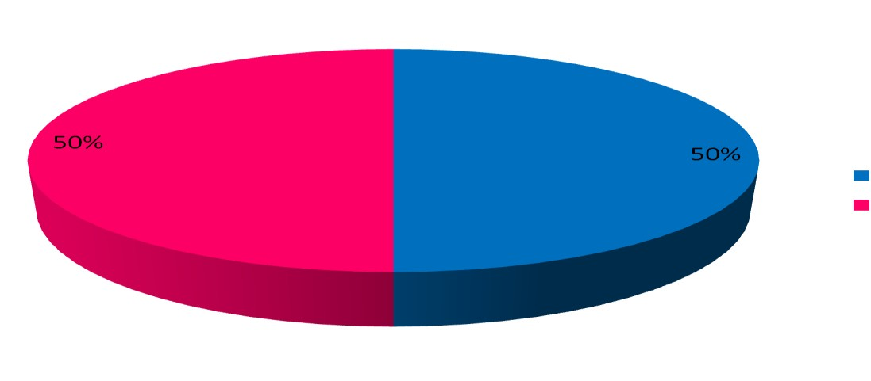In the data collection can be seen that the number of female dentists is equal to the female gender, is each genus equivalent to 50% of the total.
Men
Women
Figure 1: Percentage of men and women.

We can also see that the minimum period of years worked is 10 years in females and 20 years in males. Being an average age of 22.2 and 28.8 for women than men. In terms of age we can see that the majority are on average 50 years, being 36 years younger females and 45 the smaller male. The following charts show the average age- gender relationship, and age-gender of dentists:

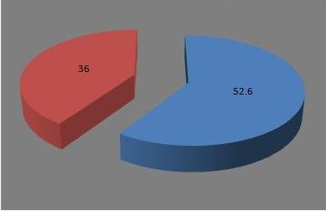
Men
Women

Figure 2: Average age-gender relationship.

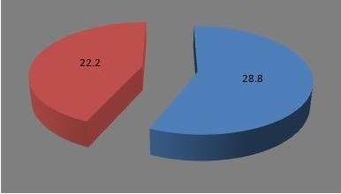
Men
Wome n
Figure 3: Average age-gender relationship.

By the following graphs we can see the results obtained from the surveys, both in symptoms, medical history and test results.

CONCLUSIONS

The dentist working positions, high vibration, repetitions and inadequate tool design, among other factors affecting labor when performing their profession suffering to do it, reducing the quality and accuracy of work, lowering his prestige in his work.

REFERENCES

Antonio Jurado Bueno (2007): Manual de pruebas Diagnosticas: traumatología y ortopedia ISBN: 978-84-8019-593-5
Hortencia Patricia Castillo Castillo (2007): Profesor de la Escuela de Odontología Universidad Anahuac Mayab escuela de odontología Manual: La técnica de odontología a cuatro manos como estrategia para el desarrollo de habilidades clínicas
Mata Amado, Guillermo (1995). Actualización sobre los conceptos de odontología prehispánica en Mesoamérica. En VIII Simposio de Investigaciones Arqueológicas en Guatemala, 1994 (editado por J.P. Laporte y H. Escobedo), pp.129-144. Museo Nacional de Arqueología y Etnología, Guatemala (versión digital)
Rojo Botello, Hilda, Godinez Chávez Azucena Alejandra, Márquez Ramírez Rosa Paola, Martínez Serrano Daniel : Audioterapia en odontología para pacientes de la delegación miguel hidalgo y clínicas odontológicas FESI del 2006
- Cortesi Ardizzone (2008); Manual práctico para el auxiliar de odontología ISBN: 9788445818152

http://www.webodontologica.com/odon_arti_ergonomia.asp http://www.cdc.gov/Spanish/niosh/fact-sheets/Fact-sheet-705001.html http://espanol.ninds.nih.gov/trastornos/tunel_carpiano.htm

http://odontologia.iztacala.unam.mx/instrum_y_lab1/otros/COLOQUIOXIX/conten ido/CARTEL-2008/Sindrome%20del%20Tunel%20del%20Carpo.doc http://www.unimayab.edu.mx/licenciaturas/licenciatura_cirujano_dentista_sureste
_merida_yucatan/docs/reglamentacion/manual_4_manos.pdf http://www.assh.org/PUBLIC/HANDCONDITIONS/Pages/S%C3%AD dromedelT%C3%BAnelCarpiano.aspx http://www.nlm.nih.gov/medlineplus/spanish/ency/article/000433.htm http://www.estrucplan.com.ar/Producciones/entrega.asp?IdEntrega=112 http://www.geodental.net/article-6250.html http://www.webodontologica.com/odon_noti_tunel3.asp http://www.actaodontologica.com/ediciones/2006/3/lesiones_musculo_esqueletic as.asp
http://www.odontomarketing.com/ergonomia/03.htm

APPLICATION OF REBA METHOD FOR RISK ASSESSMENT IN CEMENT BAGS LIFTING.

González Gaxiola Jesús Isaac2, Montiel Rodríguez, Luis Carlos1, Quirós Morales, Aarón Fernando1 & López Acosta, Mauricio1. Sánchez Padilla Jesús Enrique1 Martínez Solano Gilda María1.
1 Industrial Engineering Department, 2Student of Educational Program of Industrial and Systems
Engineering from Instituto Tecnológico de Sonora, unit Navojoa, email: Isaac_sini@hotmail.com, aquiros@itson.mx, mauricio.lopez@itson.edu.mx, lmontiel@itson.mx, esanchez@itson.mx gilda.martinez@itson.edu.mx

RESUMEN: El propósito de este trabajo es identificar los riesgos ergonómicos que se plantean a la hora de levantar un saco de cemento y dejarlo en el camión de carga. Una vez que los riesgos potenciales que se han identificado y discutido en el sitio, las mejoras se presentarán a reducir y contribuir a una mejor adaptación de los seres humanos en el trabajo, incluida la atención de la salud, la reducción de las cargas y la perfección de las condiciones de trabajo, entre otros. El propósito de este trabajo es la seguridad en el trabajo a la hora de llevar a cabo sus actividades. La necesidad de un análisis ergonómico es esencial para definir los elementos representativos de la evolución de los trabajos y recopilar la mejor información posible de las actividades que se llevan a cabo. Palabras clave: método REBA, riesgos ergonómicos

ABSTRACT.
The purpose of this work is to identify ergonomic risks that arise at the moment of lifting a cement sack and to leave it on the cargo truck. Once the potential risks have been identified and discussed in the site, improvements will be presented to reduce and contribute to a better adaptation of human beings at work, including health care, the reduction of burdens and the perfection of the working conditions, among others. The purpose of this work is the safety in the workplace at the time to carry out their activities. The need for an ergonomic analysis is essential to define the representative elements in the development of the work and collect the best possible information of the activities that are carried out.
Keywords: REBA method, ergonomic risk.

INTRODUCTION.
This study is based on the standards set by the work ergonomics, with the aim of promoting the adaptation of work to man, to ensure their well-being during the execution of their job functions. Likewise, it alludes to identify, assess and correct through ergonomic methodologies. At the same time, we do not reject implementing ergonomic improvements to the functions performed, taking necessary measures to ensure accordance with this order. Once the study has finalized training will be applied using notices, warnings and advices that meet the ergonomic standards that has been marked on the evaluated position, so the details will be identified for prompt corrective actions.

OBJECTIVE.

Evaluate the workplace through REBA method when lifting a cement bag and place in it the truck, to get results that indicate if the activity it is ergonomic and favorably performed.

METHODOLOGY.
The method REBA (Rapid Entire Body Assessment) was proposed by Sue Hignett and Lynn M Catamney and published by the journal Applied Ergonomics in 2000. The method is the result of collaboration between a team of ergonomists, physiotherapists, occupational therapists and nurses, they identified about 600 positions in its manufacture. (MCATAMNEY, L. 2000).
The method allows the joint analysis of the positions taken by the upper limbs (arm, forearm, wrist), trunk, neck and legs. It also defines other factors considered decisive for the final assessment of the position, as the load or force handled, the type of grip or muscular activity developed by the worker. (Hignett y Mc Atamney 2000).
This method application prevents the evaluator on the risk of injury associated with a position, primarily musculoskeletal type, indicating in each case the urgency with which corrective actions should be applied. It is therefore a useful tool for the prevention of able to warn of risks of inadequate working conditions. (Kuorinka, 1977).
Features REBA method for the study of certain posts.
It is an especially sensitive to the risks of musculoskeletal type.
Divide the body segments to be coded individually, and evaluates both the upper limbs, as the trunk, neck and legs.
Aloud assessing muscle activity caused by static postures, dynamic, or due to sudden or unexpected changes in posture.
 The result determines the level of risk of injury by establishing the level of action required and the urgency of intervention.
The application of the method REBA.
Group A: trunk neck and legs points. The method begins with the evaluation score of the members of the group A (individually), formed by the trunk, neck and legs. Trunk.
The first member of the group to evaluate is the trunk. Must determine whether the employee performs the task with the trunk erect or not, the latter indicating the degree of flexion or extension observed. Trunk score will increase it´s value if lateral bending or trunk twisting exists. As illustrated in Figure 1 and shown in Table 1.
Rating neck.
The method considers two possible positions of the neck. In the first one, neck is bent between 0 and 20 degrees and in the second there flexion or extension of more than 20 degrees. The score calculated for the neck may be increased if the worker side bending or twisting the neck. According to Figure 2 and Table 2.
Rating legs.
Obtain initial score was assigned to the legs depending on the weight distribution. Legs score will be enhanced if one or bending both knees. The increase may be up to 2 units if flexion of more than 60 °. If the worker is seated, the method considers that there is no bending and thus increases score legs. As illustrated in Figure 3 and is indicated in Table 3.

Group B: Ratting for upper limb (arm, forearm and wrist). After the evaluation of the group members will proceed to the assessment of each member of the group B, formed by the arm, forearm and wrist. Remember that the method analyzes a single part of the body, right or left side, therefore will be assessed a single arm, forearm and wrist, for each position.
Rating arm
Depending on the angle formed by the arm will get your score. To score assigned to the arm can be increased if the worker has rotated arm or shoulder is high. Yet, the method considered a mitigating risk the existence of armrest or to take a position in favor of the gravity, in such cases reducing the initial score arm. The conditions accounted for using as mitigating or aggravating arm position may not occur in certain positions. As seen in Figure 4 and Table 4.
Forearm rating
The score, its function is forearm flexion angle, in this case the method adds no additional conditions for modifying the score assigned. According to Figure 5 and Table 5.
Wrist rating
After studying the bending angle of the wrist will select the corresponding score querying the values provided by the table. Wrist calculated value will be increased by one unit if T his presents torsion or lateral deviation. As seen in Figure 6 and Table 6.

Group A: Scores of the trunk, neck and legs.
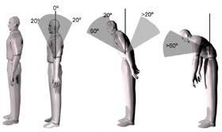
Figure 1. Score of the trunk

Table 1. Coding of the positions of the trunk.

Puntos | Posición
1 | The trunk is erect.
2 | The trunk is between 0 and 20 degrees of flexion or between 0 and 20 degrees of extension.
3 | The trunk is between 20 and 60 degrees of flexion or more than 20 degrees of extension.
4 | The trunk is flexed more than 60 degrees.

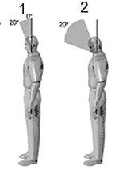
Figure 2. Score of the neck.

Table 2. Coding of the neck positions.

Points | Positions
1 | The neck is between 0 and 20 degrees of flexion.
2 | The neck is flexed or extended more than 20 degrees.
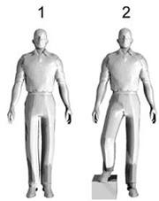

Figure 3. Score of the legs. Table 3. Coding of the legs.
points | positions
1 | Bilateral support, walking or sitting.
2 | Unilateral support, light stand or unstable posture.

Group B: Ratting upper limb (arm, forearm and wrist).

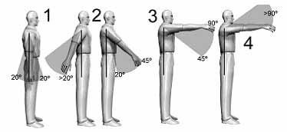
Figure 4. Score of the arm. Table 4. Coding of the arm.

points | positions
1 | The arm is between 0 and 20 degrees of flexion or between 0 and 20 degrees of extension.
2 | The arm is between 21 and 45 degrees flexion or more than 20 degrees of extension.
3 | The arm is from 46 to 90 degrees of flexion.
4 | The arm is bent more than 90 degrees.

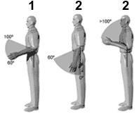

Figure 5. Score of the forearm. Table 5. Coding of the forearm.
points | positions
1 | The forearm is between 60 and 100 degrees of flexion.
2 | The forearm is flexed below 60 degrees or above 100 degrees.

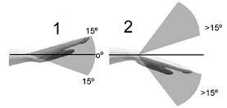

Figure 6. Score of the wrist.

Table 6. Coding of the wrist.

points | positions
1 | The wrist is between 0 and 15 degrees of flexion or extension.
2 | The wrist is flexed or extended more than 15 degrees.

Score of the load or force (Group A).

In this table it is added + 1 point to the results obtained in the parts evaluated in A group, in this table is evaluated the amount of load or force used.

points | positions
+0 | The load or force is less than 5 kg.
+1 | The load or force is between 5 and 10 kg.
+2 | The load or force is greater than 10 kg.

Score for the type of grip (Group B).
In this table it is added + 1 point to the results obtained in the Group B, in this table are evaluated the grip conditions.

Table 7. Final evaluation of the conditions of grip.

+0 | Good grip. The grip is good and the force grip of middle-ranking.
+1 | Regular grip. The gripping hand is acceptable but not ideal or grip is acceptable using other parts of the body.
+2 | Bad grip. The grip is possible but not acceptable.
+3 | Unacceptable grip. Grip is awkward and insecure, it is not possible to hand-hold or grip is unacceptable to using other parts of the body.

RESULTS AND DISCUSSION.

A Group scores

Table 8. Results obtained in the assess of the trunk, neck and legs.

Trunk. | Neck.
Trunk. | 1 |  |  |  | 2 |  |  |  | 3
Trunk. | Legs. |  |  |  | Legs. |  |  |  | Legs.
Trunk. | 1 | 2 | 3 | 4 | 1 | 2 | 3 | 4 | 1 | 2 | 3 | 4
1 | 1 | 2 | 3 | 4 | 1 | 2 | 3 | 4 | 3 | 3 | 5 | 6
2 | 2 | 3 | 4 | 5 | 3 | 4 | 5 | 6 | 4 | 5 | 6 | 7
3 | 2 | 4 | 5 | 6 | 4 | 5 | 6 | 7 | 5 | 6 | 7 | 8
4 | 3 | 5 | 6 | 7 | 5 | 6 | 7 | 8 | 6 | 7 | 8 | 9
5 | 4 | 6 | 7 | 8 | 6 | 7 | 8 | 9 | 7 | 8 | 9 | 9

B Group score.

Table 9. Results obtained in the assess of the arm, forearm and wrist.

Arm. | Forearm.
Arm. | 1 |  |  | 2
Arm. | Wrist. |  |  | Wrist.
Arm. | 1 | 2 | 3 | 1 | 2 | 3
1 | 1 | 2 | 2 | 1 | 2 | 3
2 | 1 | 2 | 3 | 2 | 3 | 4
3 | 3 | 4 | 5 | 4 | 5 | 5
4 | 4 | 5 | 5 | 5 | 6 | 7
5 | 6 | 7 | 8 | 7 | 8 | 8
6 | 7 | 8 | 8 | 8 | 9 | 9

Rating C.

Using the results obtained in group A and B throws us a third result called C.

Table 10. Results in tables A and B.

Rating A. | Rating B.
 | 1 | 2 | 3 | 4 | 5 | 6 | 7 | 8 | 9 | 10 | 11 | 12
1 | 1 | 1 | 1 | 2 | 3 | 3 | 4 | 5 | 6 | 7 | 7 | 7
2 | 1 | 2 | 2 | 3 | 4 | 4 | 5 | 6 | 6 | 7 | 7 | 8
3 | 2 | 3 | 3 | 3 | 4 | 5 | 6 | 7 | 7 | 8 | 8 | 8
4 | 3 | 4 | 4 | 4 | 5 | 6 | 7 | 8 | 8 | 9 | 9 | 9
5 | 4 | 4 | 4 | 5 | 6 | 7 | 8 | 8 | 9 | 9 | 9 | 9
6 | 6 | 6 | 6 | 7 | 8 | 8 | 9 | 9 | 10 | 10 | 10 | 10
7 | 7 | 7 | 7 | 8 | 9 | 9 | 9 | 10 | 10 | 11 | 11 | 11
8 | 8 | 8 | 8 | 9 | 10 | 10 | 10 | 10 | 10 | 11 | 11 | 11
9 | 9 | 9 | 9 | 10 | 10 | 10 | 11 | 11 | 11 | 12 | 12 | 12
10 | 10 | 10 | 10 | 11 | 11 | 11 | 11 | 12 | 12 | 12 | 12 | 12
11 | 11 | 11 | 11 | 11 | 12 | 12 | 12 | 12 | 12 | 12 | 12 | 12
12 | 12 | 12 | 12 | 12 | 12 | 12 | 12 | 12 | 12 | 12 | 12 | 12

Final score.

Table 11. Final score.

Final score. | Level of action. | Level of risk. | Action.
1 | 0 | Negligible. | It is not necessary action.
2-3 | 1 | Low. | It can be necessary action.
4-7 | 2 | Middle. | Action is necessary.
8-10 | 3 | High | Action is necessary as soon as possible.
11-15 | 4 | Very high | Action is necessary immediately.

Group A: Ratings of the trunk neck and legs.

Result: trunk bent over to 60 degrees, the score is 4. Since there is lateral bending sum +1.

Final result: 5.

Result: The neck is flexed more than 20 degrees, the score is 2. As no lateral twisting of the neck does not add any value.

Final result: 2.
Result: Support bilateral, walking or sitting, the score is 1.
If exists bending both knees of one or more than 60 ° is added +2.

Final result: 3
A Group scores
Final score 8. Si la carga es mayor a 10kg se le suma +2 por lo tanto la puntuación final es 2+8=10. If the load is greater than 10kg +2 is added so the final score is 2 +8 = 10.

Group B: Ratting upper limb (arm, forearm and wrist).
Result: arm is between 45 and 90 degrees of flexion so the score is 3. Since the arm is rotated abducted or +1 is added.

Final result: 4.
Final result: E l forearm is between 60 and 100 degrees of flexion, the score is 1.
Result: Wrist is between 0 and 15 degrees of flexion or extension hence the score is 1. Since there is no torsion or lateral deviation of the wrist does not add any value.

Final result: Bottom Line: 1 B Group score.
Final result: 4. As grip is poor +2 is added, so the final score of the group B is 2

+4= 6

Rating C
Using the results obtained in group A and B throws us a third result called C.

Final score: 11.
By the fact that there are significant changes in posture or unstable postures are adopted is added to the final score +1 11 +1 = 12
According to the previous score the task performed has a very high level of risk and action is required immediately.
It is advisable to talk to workers about the positions that must be carried out for the realization of such work, and avoid fractures, sprains, etc. that can seriously damage a worker since giving them the necessary consultants you can avoid these risks, and thus being more efficient, workers increases the productivity of the task without the need for compensation that are expenses that have to cover the company

CONCLUSIONS.

Thanks to the results obtained by the REBA method, it was possible to realize the risk involved d lift the cement bag and deposit it in the truck and has a high level of risk and action is required immediately, as if not, as time passes the worker may suffer irreparable damage or partial body.

REFERENCES
Borg,G.,1985.An Introduction to Borg's RPE-Scale Movement. Publications,Ithaca, NY. Corlett E. N, Bishop, R.P., 1976. A technique for assessing postural discomfort.
Ergonomics 19 (2), pp. 175 -182.
Hignett, S., 1994. Using computerised OWAS for postural analysis of nursing work. In: Robertson,S. (Ed.),Contemporary Ergonomics. Taylor & Francis, London, pp. 253-258.
Hignett, S. y Mcatamney, L., 2000, REBA: Rapid Entire Body Assessment. Applied Ergonomics, 31, pp.201-205.
Mcatamney, L. Y CORLETT, E. N., 1993, RULA: A survey method for the investigation of work-related upper limb disorders. Applied Ergonomics, 24, pp. 91-99.

OCCUPATIONAL RISK ASSESSMENT IN A WINDOW REGULATORS ASSEMBLY COMPANY: A CASE OF L.E.S.T. METHODOLOGY

Amina Marín Martínez1, Martina Elisa Platt Borbón1, Magdalena Romo Ayala1

1Industrial Engineering Department University of Sonora
Blvd. Luis Encinas y Rosales, edificio 5G planta baja Hermosillo, Sonora, México, 83000
Corresponding author´s e-mail: amarin@industrial.uson.mx

Resumen
El presente documento muestra el uso del método de evaluación ergonómica L.E.S.T. para identificar y valorar los factores de riesgo presentes en los puestos de trabajo en el área de producción de una empresa ensambladora de elevalunas automotrices ubicada en la ciudad de Hermosillo Sonora; se evaluaron de forma objetiva la concepción del puesto, los factores ergonómicos, los factores psicológicos y sociológicos y se estableció un perfil analítico que indica para cada uno de los cuatros factores de riesgos evaluados si su condición es satisfactoria, presenta algún grado de molestia o si definitivamente su condición resulta altamente nociva para la salud del trabajador, finalmente se hace referencia a la necesidad de establer alternativas para mejorar las condiciones de los factores de riesgo ergonómicos presentes de manera que se reduzcan los riegos presentes o los ubiquen en niveles en donde el trabajador pueda convivir con ellos con mínimas o nulas consecuencias a su salud.

Palabras claves: L.E.S.T., ergonomía, riesgos laborales, elevalunas.

Abstract
This paper aims at presenting the outcomes of an ergonomic evaluation using L.E.S.T. methodology to identify and assess the risk factors carried out into an auto parts facility located in Hermosillo Sonora in which window regulators are manufactured. Has been objectively evaluated, job design, ergonomic factors and the psychological and sociological factors and has been established an analytical profile indicating for each of the four risk factors evaluated if their condition is satisfactory, have some degree of discomfort or is definitely harmful to workers' health, according to its condition at time study, Finally reference is made to the need for alternatives to improve conditions of ergonomic risk factors, so as to reduce the risks at this factor levels and locate where the worker can live with them with minimal or nothing health consequences.

Key words: L.E.S.T., ergonomic, occupational risk, window regulator.

INTRODUCTION

Mexico is one of the top ten car manufacturing countries worldwide (OICA, 2012), in Sonora state, the auto parts industry, an important element of the automotive industry, supports regional economy and generates a lot of work in the sector, making it also one of the main generators of occupational hazards (Marín et al, 2010 and 2011).
The overall impact of worker health on the health and prosperity of society were recognized in the WHO Ministerial Conference on Health Systems (2008) in Tallinn, Estonia, where the theme "Health Systems, Health and Wealth" was addressed and which also approved the agreement that emphasizes the connection between health and prosperity. The agreement states that "Beyond its intrinsic value, improved health contributes to social welfare through its impact on economic development, competitiveness and productivity. Health systems high performance, contribute to economic development and prosperity, the good health of the worker contributes to high productivity and success of the company, leading to economic prosperity in the country, individual and social welfare and prosperity of workers (WHO, 2010).
Because many of the occupational risk problems are associated with excessive physical work demands caused by poor workstation design, tools, and generally inadequate working methods, occupational safety and health state of art suggests that ergonomic hazards made identify and from that apply ergonomic principles to design job demands and adapt it to the capabilities of the worker.
Ergonomics is one of the most important topics for occupational health. If a workstation or a place where an employee is working it is not ergonomically designed, it can bothersome in the long term, and it will end up causing him some injuries, a syndrome, an illness, and so forth and consequently, the employee’s work absences. For these reasons one of the first activities to be performed in a company that seeks to be competitive must be to get employees to work in healthy work environments and therefore the assessment of the current situation in the field of ergonomic risks in the enterprise, is essential.
L.E.S.T. method was used in these research conducted into an auto parts facility located in the city of Hermosillo Sonora in which window regulators are manufactured aimed to identify whether the jobs will have some degree of discomfort or if its condition is definitely highly detrimental to the health of workers, which could lead to some consequences for competitiveness company.

OBJECTIVES

The main purpose of this research is to identify and assess ergonomic risk factors and their impact on workers’ health present in the production workplace of an auto parts facility where automotive window regulators are manufactured and establish alternatives to improve the conditions of ergonomic risk factors present in the study so as to reduce the risks present this factor levels and locate where the worker can live with them with minimal or no health consequences

METHODOLOGY

This research was conducted in a Tier 1 supplier, located in Hermosillo, Sonora, this factory has 223 employees. A tour for recognition of workstations conditions for the production area in the company was conducted, taking into account the comments made in relation to the symptoms frequency reported by staff, identified the need to carry out the ergonomic study involved for all positions in the window regulators production process.
Involvement of workers in each area was voluntary and participation from a total of
31 workers in the 25 workstation areas studied was obtained, a questionnaire musculoskeletal symptoms were administered and 14 anthropometric parameters was measured, results of this measures were already shown in a previous article in the Occupational Ergonomics. Research and Applications Vol. 4 edited by Ergonomists Society of Mexico in 2011.
For every workstation, tasks and actions have been video recorded to be used in evaluation and to answer the L.E.S.T. method request using the information contained and diagnostic tour of the facilities were used in the L.E.S.T. observation guide to evaluated, in addition to the general conditions work were evaluated the following components: CP Conception of the job; A. Personal safety; B. Environment; C. Physical workload; D. Mental workload; E. Autonomy, F. Relations; G. Repeatability and H. Contents job for each of the 25 analyzed workstation and their specific activities (see table 1-3) (Guelaud et al, 1986)
Several instruments were used in this research but for the purpose of this paper, even though additional data as the results of a questionnaire on musculoskeletal symptoms applied to understand their symptoms and an anthropometric study of workers, already published are mentioned, only the results of L.E.S.T. Method are addressed here in detail.

Table 1. workstations ABC-F area

No. | Area | Number | Workstation Name
1 | ABC-F | 10 | POLEAS
2 | ABC-F | 20D | CARROS D
3 | ABC-F | 20T | CARROS T
4 | ABC-F | 30 | CABLES
5 | ABC-F | 40DI | MONTAJE D I
6 | ABC-F | 40DD | MONTAJE D D
7 | ABC-F | 40 T | MONTAJE T

Table 2. workstations ABC-C area

No. | Area | Number | Workstation Name
8 | ABC-C | 05 CHD | CLINCH
9 | ABC-C | 10 CHD | POLEAS
10 | ABC-C | 20 CHD | CARROS
11 | ABC-C | 30 CHD | CABLES
12 | ABC-C | 40 CHD | MONTAJE D
13 | ABC-C | 50 CHD | MOTOR
14 | ABC-C | 60 CHD | MONTAJE
15 | ABC-C | 70 CHD | CONTROL
16 | ABC-C | INSPECTION D | INSPECCION D

Table 3. workstations ABC-CT area

No. | Area | Number | Workstation Name
17 | ABC-CT | 10 CHT | POLEAS
18 | ABC-CT | 20 CHT | CARROS
19 | ABC-CT | 30 CHT | SOPORTE
20 | ABC-CT | 40 CHT | MONTAJE Y P
21 | ABC-CT | 50 CHT | ATORNILLADO
22 | ABC-CT | 60 CHT | CABLES
23 | ABC-CT | 70 CHT | MONTAJE
24 | ABC-CT | 80 CHT | CONTROL
25 | ABC-CT | INSPECTION T | INSPECCION T

The L.E.S.T. Observation Guide were used to keep track of relevant information and activities where the work is performed and later with this information and the video taken in the area, the analysis was performed with the method L.E.S.T.
The L.E.S.T. method includes evaluation of nine components, grouped into four factors that are rated on a scale from 1 to 5, where any value has a corresponding value on a scale of 1-10 and, in each case, have particular meanings agreeing that positive attributes are the lowest in the scale while the highest negative. So for each scale factor is as follows on table 4 and 5.

Table 4. L.E.S.T. Punctuation system. 1-5 Scale

Label | Name factor | Punctuation system
(CP) | Conception of the job or design dimension, | 1 = very good, 2 = good, 3 = fair, 4 = Poor, and 5 = very poor.
(A) | Personal Safety | 1 = very good, 2 = good, 3 = average,  4 = dangerous, and 5 = very dangerous.
(B) | Environment, hygiene and cleanliness observed workplace | 1 = very good, 2 = good, 3 = average,  4 = dangerous, and 5 = very dangerous.
(C) | Physical workload | 1 = very slight, 2 = slight, 3 = average, 4 = high, 5 = very high.
(D) | Mental workload | 1 = very slight, 2 = slight, 3 = average, 4 = high, 5 = very high.
(E) | Autonomy | 1 = very good, 2 = good, 3 = fair, 4 = poor, and 5 = very poor.
(F) | Relationships | 1 = external relations group 2 = group relationship 3 = easy relationships, 4 = difficult relationships, and 5 = Isolated.
(G) | Repeatability | 1 = very low, 2 = low, 3 = good, 4 = high, and 5 = very high.
(H) | Contents job | 1 = High, 3 = Medium, and 5 = Null.

Table 5. Risk factors and impact on workers’ health

1-5  Scale | 1-10  Scale | Conceptio  n of job | Ergonomics factors |  |  | Psychological and sociological  factors
5 | 10 | Very poor | Very  dangerou s | Very  dangerous | Very high | Very  poor | Isolated | Very  high | Null
4 | 8, 9 | Poor | Dangerou  s | Dangerou  s | High | Poor | Difficult  relationshi ps | High
3 | 6, 7 | Fair | Average |  | Average | Fair | Easy  relationshi ps | Goo  d | Mediu  m
2 | 3, 4, 5 | Good | Good |  | Slight | Good | Group  relationshi p | Low
1 | 0, 1, 2 | Very good | Very good |  | Very slight | Very | External | Very | High

 |  |  |  |  |  |  | good | relations  group | low
 |  | CP | A | B | C | D | E | F | G | H
C.P.→ Conception of the job, A → Personal Safety, B → Environment, C → Physical workload, D → Mental workload, E → Autonomy, F → Relationships, G → Repeatability, H → Contents job

One factor that gets a value greater than three point five (3.5) represents a significant risk that must be addressed.

RESULTS AND DISCUSSION

The assessment of the general conditions of work was done with the L.E.S.T. method, which provides a rating for nine different components: CP Conception of the job; A Personal safety; B Environment; C Physical workload; D Mental workload; E Autonomy, F Relations; G Repeatability and H Contents job on a scale of 1 to 5, as already explained above. The analysis results identified the different degrees of risk for different factors. Below are the results for each element in the L.E.S.T. analysis, for each workstation in the research (table 6-8).

Table 6. ABC-F area workstations risk factors evaluation

No. | Area | CP | A | B | C | D | E | F | G | H
ABC-F
1 | 10 | 2.0 | 4 | 4 | 4 | 3 | 4.3 | 4 | 5 | 3.1
2 | 20D | 2.7 | 3 | 4 | 4 | 3.5 | 4.3 | 4 | 5 | 3.1
3 | 20T | 2.7 | 3 | 4 | 4 | 3.5 | 4.3 | 4 | 5 | 3.1
4 | 30 | 2.3 | 3 | 4.5 | 3.2 | 3 | 4.3 | 4 | 5 | 3.1
5 | 40DI | 2.7 | 2 | 4 | 2.4 | 3 | 4.3 | 4 | 5 | 3.1
6 | 40DD | 2.7 | 2 | 4 | 2.4 | 3 | 4.3 | 4 | 5 | 3.1
7 | 40 T | 2.7 | 2 | 4 | 2.4 | 3 | 4.3 | 4 | 5 | 3.1

Table 7. ABC-C area workstations risk factors evaluation

No. | Area | CP | A | B | C | D | E | F | G | H
ABC-C
8 | 05 CHD | 1.66 | 3 | 4.5 | 4 | 3 | 4.3 | 4 | 5 | 3.1
9 | 10 CHD | 1.7 | 4 | 4.5 | 4 | 3 | 4.3 | 4 | 5 | 3.1
10 | 20 CHD | 1.7 | 3 | 4 | 3 | 3 | 4.3 | 4 | 5 | 3.1
11 | 30 CHD | 2.7 | 3 | 2.4 | 3.2 | 3 | 4.3 | 4 | 5 | 3.1

12 | 40 CHD | 2.1 | 3 | 4 | 3.5 | 3 | 4.3 | 4 | 5 | 3.1
13 | 50 CHD | 3.1 | 3 | 2.4 | 3 | 3 | 4.3 | 4 | 5 | 3.1
14 | 60 CHD | 2.7 | 2 | 2.4 | 3.7 | 3 | 4.3 | 4 | 5 | 3.1
15 | 70 CHD | 3.2 | 2 | 4 | 3.7 | 3 | 4.3 | 4 | 5 | 3.1
16 | INSPECTION D | 3.4 | 2 | 2.41 | 5 | 3.5 | 4.3 | 4 | 5 | 3.1

Table 8. ABC-CT area workstations risk factors evaluation

No. | Area | CP | A | B | C | D | E | F | G | H
ABC-CT
17 | 10 CHT | 1.7 | 4 | 4 | 4 | 3 | 4.3 | 4 | 5 | 3.1
18 | 20 CHT | 1.7 | 3 | 2.4 | 3 | 3 | 4.3 | 4 | 5 | 3.1
19 | 30 CHT | 1.7 | 3 | 4 | 3.5 | 3 | 4.3 | 4 | 5 | 3.1
20 | 40 CHT | 2.1 | 3 | 2.4 | 3.5 | 3 | 4.3 | 4 | 5 | 3.1
21 | 50 CHT | 2.5 | 3 | 2.4 | 3 | 3 | 4.3 | 4 | 5 | 3.1
22 | 60 CHT | 2.2 | 3 | 2.4 | 3 | 3 | 4.3 | 4 | 5 | 3.1
23 | 70 CHT | 1.7 | 2 | 2.4 | 3.7 | 3 | 4.3 | 4 | 5 | 3.1
24 | 80 CHT | 1.7 | 3 | 2.4 | 3.7 | 3 | 4.3 | 4 | 5 | 3.1
25 | INSPECTION T | 3.4 | 2 | 2.4 | 5 | 3.5 | 4.3 | 4 | 5 | 3.1

For all components measured with L.E.S.T. methodology, we took into account only those who obtained a value greater than 3.5 because represents a significant risk that must be addressed. forward we are showing the factors A, B, C, D, E, F and G (Personal safety; environment, Physical workload, mental workload, autonomy, relationships and repeatability) in which the risks are present as shown and described below (see table 9-11).

Table 9. ABC-F area workstations risk factors greater than 3.5

No. | Area | CP | A | B | C | D | E | F | G | H
ABC-F
1 | 10 | - | 4 | 4 | 4 | - | 4.3 | 4 | 5 | -
2 | 20D | - | - | 4 | 4 | 3.5 | 4.3 | 4 | 5 | -
3 | 20T | - | - | 4 | 4 | 3.5 | 4.3 | 4 | 5 | -
4 | 30 | - | - | 4.5 | - | - | 4.3 | 4 | 5 | -
5 | 40DI | - | - | 4 | - | - | 4.3 | 4 | 5 | -

6 | 40DD | - | - | 4 | - | - | 4.3 | 4 | 5 | -
7 | 40 T | - | - | 4 | - | - | 4.3 | 4 | 5 | -

Table 10. ABC-C area workstations risk factors greater than 3.5

No. | Area | CP | A | B | C | D | E | F | G | H
ABC-C
8 | 05 CHD | - | - | 4.5 | 4 | - | 4.3 | 4 | 5 | -
9 | 10 CHD | - | 4 | 4.5 | 4 | - | 4.3 | 4 | 5 | -
10 | 20 CHD | - | - | 4 | - | - | 4.3 | 4 | 5 | -
11 | 30 CHD | - | - | - | - | - | 4.3 | 4 | 5 | -
12 | 40 CHD | - | - | 4 | 3.5 | - | 4.3 | 4 | 5 | -
13 | 50 CHD | - | - | - | - | - | 4.3 | 4 | 5 | -
14 | 60 CHD | - | - | - | 3.7 | - | 4.3 | 4 | 5 | -
15 | 70 CHD | - | - | 4 | 3.7 | - | 4.3 | 4 | 5 | -
16 | INSPECTION D | - | - | - | 5 | 3.5 | 4.3 | 4 | 5 | -

Table 11. ABC-CT area workstations risk factors greater than 3.5

No. | Area | CP | A | B | C | D | E | F | G | H
ABC-CT
17 | 10 CHT | - | 4 | 4 | 4 | - | 4.3 | 4 | 5 | -
18 | 20 CHT | - | - | - | - | - | 4.3 | 4 | 5 | -
19 | 30 CHT | - | - | 4 | 3.5 | - | 4.3 | 4 | 5
20 | 40 CHT | - | - | - | 3.5 | - | 4.3 | 4 | 5 | -
21 | 50 CHT | - | - | - | - | - | 4.3 | 4 | 5 | -
22 | 60 CHT | - | - | - | - | - | 4.3 | 4 | 5 | -
23 | 70 CHT | - | - | - | 3.7 | - | 4.3 | 4 | 5 | -
24 | 80 CHT | - | - | - | 3.7 | - | 4.3 | 4 | 5 | -
25 | INSPECTION T | - | - | - | 5 | 3.5 | 4.3 | 4 | 5 | -

Described below are the positions in each of risky factors evaluated for any one that means a high degree of discomfort or those who definitely can be harmful to the worker:

(CP)Conception of the job. This component refers to the physical location with the instruments of labor within the space as well as the ratio between workstation and employees. Although all positions with an assessment were less than 3.5 in this area, in some places, find items and temporary circumstances that cause the worker carry out their activities with poor posture, generating actions at or above shoulders or inclinations and turns in the main body of worker, the risky positions in this area are: 20D, 20T, 40DI, 40DD and 40T for ABC-F area, 10CHD, 50CHD, 60CHD, 70CHD and
inspeccion D at ABC-C area and 40CHT and inspeccion T at ABC-CT area.

(A)Personal safety. This aspect measures the security conditions that exist in the workplace and that maintain the integrity of workers. In this section are three jobs with value above 3.5, because of the risks associated with worker's hands bruise, they are positions 10 at ABC-F area and 10 CHD at ABC-C area and 10 CHT at ABC-CT area.
(B)Environment. This point relates to the physical environment conditions and includes thermal environment, environmental sound, atmospheric lighting and hygiene at workplace; here most of the jobs were rated higher than 3.5 because of the lighting levels and noise in the environment.

(C)Physical workload. This component takes into account core posture and posture worst performed by a worker on the job and considers postural loads of work and effort made by the worker in their activity, in this area most of the job should reconsider the lifting height and weight of the work objects that use.

(D)Metal workload. This component assesses the mental operations performed on the job and levels required to carry them out. Here the worth more than three point five jobs were 20D 20T inspection D and inspection T.

(E)Autonomy. This point relates to the conditions of individual autonomy with workers in their jobs, in terms of their influence on the pace of work and possible stops in its activities. Here all the positions were valued above 3.5.

(F)Relations. This factor relates to interpersonal relationships dependent and independent work. In this component, all posts were with values above 3.5.

(G) Repeatability. This aspect reflected the cycle of actions within the task, according to the time it is repeated the same type of movement. It refers to the sequence of positions efforts or sustained over a given period of time which may cause physical stress. Here the total positions was evaluated with values above 3.5 as it has a short cycle, with no change in the task, so it become monotonous activities.
Finally relating to ergonomic factors, following is a chart for jobs where at least one of the risks means a high degree of discomfort or those who definitely can be harmful to the worker (see figure 1).

Figure 1. Job condition for ergonomics risk factors greater than 3.5
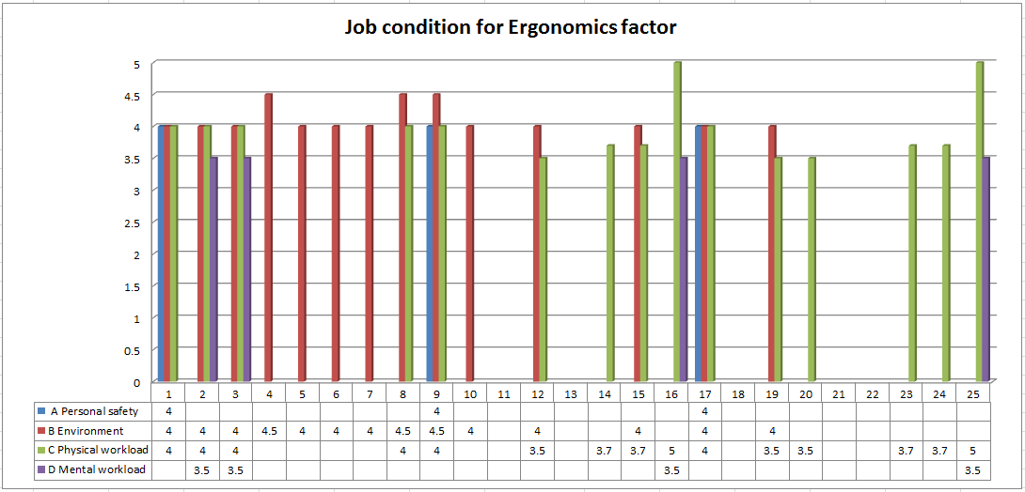

CONCLUSIONS

In summary after analyzing the L.E.S.T Method results, ergonomic hazards affecting the workers´ good performance were identified and its potential impact on workers´ health assessed.
We found that 84% evaluated positions (21) has at least one risk condition which means a high degree of discomfort or definitely can be detrimental to the worker and the subject of ergonomic factors by the method evaluated, in this study the B physical environment and C physical workload are the most often risk occur, standing at 66% and 72% respectively of jobs at risk.
Given the above it is concluded that for the company to improve its competitiveness by employees occupational health status must implement consistently improvements on this issue, such as redesign or improve workstation and jobs designs where a greater number of risks are present, in positions where physical workload its involved do a fatigue assessments, improve the physical work environment, and lead human resource management focus on job rotation and occupational health programs among others.

REFERENCES

Guelaud, F., Roustang G., Beauchessne M. y Gautrat J. et al. (1986). Por un Análisis de las Condiciones del Trabajo Obrero en la Empresa. LEST. Laboratorio de Economía y Sociología del Trabajo del C.N.R.S. Aix Provence, Francia.

Marín Martínez, Amina, María Magdalena Romo Ayala, Martina Elisa Platt Borbón, Zaira Linnethe Sandoval Moreno (2011). Identification of ergonomic risk factors In manufacturing automotive window regulators. Ergonomía ocupacional investigaciones y aplicaciones Vol 4, Sociedad de Ergonomistas de México A.C. (SEMAC) 2011.

Marín Martínez, Amina. (2010). Producción sustentable: un enfoque de salud ocupacional para la productividad en la industria de autopartes en la ciudad de Hermosillo, Sonora. Tesis de doctorado. Universidad Autónoma de Baja California.

OICA International Organization of Motor Vehicle Manufacturers (2012), production statistics, http://oica.net/category/production-statistics/.

WHO Ministerial Conference on Health Systems: “Health Systems, Health and Wealth”, Tallinn, Estonia, 27 June 2008 http://www.euro.who.int/en/who-we-are/policy- documents/tallinn-charter-health-systems-for-health-and-wealth accessed january 20013.

World Health Organization, 2010 WHO healthy workplace framework and model: background and supporting literature and practices http://www.who.int/occupational_health/healthy_ workplaces/en/ index.html accessed 17 january 20013.

WAYS TO APPLY OWAS METHOD TO EVALUATE THE POSITIONS TAKEN BY A CHARGER IN A SUPERMARKET STORAGE AREA

Zubirán Hurtado, Gabriel Tadeo1, Martínez Solano, Gilda María2 & Varela Campos, Rubén2 López Acosta, Mauricio2
1Alumno del Programa Educativo de Ingeniería Industrial y de Sistemas. 2Departamento de Ingeniería Industrial del Instituto Tecnológico de Sonora, unidad Navojoa, email: @hotmail.com, gmmartinez@itson.mx, rvarela@itson.mx. mauricio.lopez@itson.edu.mx

RESUMEN
El propósito de este estudio es identificar las distintas posturas ergonómicas que presenta un cargador en la estación de trabajo en el área de almacén de un supermercado para eso nos basaremos con el método OWAS que nos servirá para evaluar las distintas posturas del trabajador como son posición de la espalda, posición de piernas, posición de los brazos, y levantamiento de carga, al momento de estar trabajando, una vez identificados los riesgos de las posturas, se presentarán alternativas para disminuir los riesgos de que el trabajador sufra un accidente y pueda realizar dicho trabajo de la mejor manera posible. Este estudio nos orientara para plantear acciones correctivas hacia las malas posturas de los trabajadores y se les podrá orientar de cuáles son las posturas correctas. Que deben adoptar en dicha área, este estudio se practicara de una manera visual.

Palabras Claves: Ergonomía, Método OWAS, trastornos músculo esquelético.

INTRODUCTION

Ergonomics is the technological discipline that deals with the design of workplaces, tools and tasks that match the worker´s physiological, anatomical, and psychological skills. Looks for the optimization in the three system elements (human, machine, environment), which develops methods to study the person, technology and organization. Now at days there are several methods that can be applied towards the worker this is for the worker to have a better performance and for “him” not to suffer any injuries when performing the job, must take into concern that the human body is capable of producing movements due to a complex system muscle and bone, called muscular skeletal system. There are three types of muscles in the human body: skeletal or striated muscle, attached to the bone, heart muscle, which is located in the heart and smooth muscle, and the internal organs and the walls of the capillaries. It is a need to know the muscular skeletal system´s shape to get inside the analysis of manual labor and develop applications to reduce ergonomic hazards in the workplace. In this document is shown a project´s summary developed in the operator load and unloads using the method for valuing OWAS their ergonomic hazards.

OBJECTIVE

To analyze the workstation at the storage area based on the worker´s positions, identify the various positions taken by the same during the task course by observing activity on

the cargo supported by the use of OWAS method and develop a proposal and ergonomic design.

METHODOLOGY

The method according OWAS (Karhu, 1977), is based on the observation results of the various positions taken by the employee during the course of the task, allowing to identify up to 252 different positions as a result for the possible combinations in the back´s position (4 positions), arms (3 positions), legs (7 positions) and load lifted (3 intervals).
The first part at the method, data collection or location register, done through the observation the workers "in situ" , doing an analysis of photographs, or watching videos taken prior activity.
Once the method observation is done this encodes the compiled postures. Each position is assigned an identification code.
Depending on the risk or discomfort a posture represents for the worker, OWAS method distinguishes four levels listed on ascending order, being, therefore, the value of 1 the lowest risk and the value four the highest risk. For each category risk the method will establish an action propose, indicating in each case whether to or not to redesign position and its urgency.
So, once the encoding is done, the method determines each position´s risk category, showing the discomfort worker has to deal with., Subsequently, evaluates the risk and discomfort for each body part (back, arms and legs) assigning, according to the function on the relative frequency, A risk category for each part of the body
Finally, the risk categories analysis for the positions calculated and observed for the different parts of the body, will allow to identify the most critical postures and positions, this way as well as the corrective actions needed to improve the position, defining in this way, an action guide for redesign for the evaluated task.
The OWAS method presents a limitation to show. The method allows identification of a series of basic positions back, arms and legs, encoding in each "code position", however, does not allow a detailed study of the severity of each position. (Karhu, 1977).
The procedure for applying the method is, in summary, as follows:

- Observing whether the task should be divided into several phases or stages, in order to facilitate the observation.
- Set the total observation time of the task (20 to 40 minutes).
- Determining the duration of the time intervals in which to divide the observation (the method proposed time intervals between 30 and 60 seconds.)
- Identify, during the observation of the task or phase, the different positions adopted by the workers. For each position, determine the position of the back, arms and legs as well as the load being lifted.
- Encode observed positions, assigning each load position and the values of the digits that make up your "code position" identifier.
- Calculate for each "code position", the risk category to which it belongs, in order to identify those critical positions or higher level of risk to the worker. The calculation

of the percentage of positions classified in each risk category, may be useful for the determination of these critical positions.
- Calculate the percentage of repetitions or relative frequency of each position of the back, arms and legs with respect to other. (The OWAS method doesn’t allow to calculate the risk associated with the relative frequency of the loads lifted, however, its calculation can guide the evaluator on the need for an additional study of lifting).
- Determine, based on the relative frequency of each position, the risk category to which belongs each position of the various parts of the body (back; arms and legs), in order to identify those that have a more critical activity.
- Determine, based on calculated risks, corrective and redesign needed actions.
- If you have made changes, evaluate the task with OWAS method to verify the effectiveness of the improvement.
Coding of the observed positions: the method begins with the collection, previous observation, of the different positions taken by the worker during the performance of the task.
The method assigns four digits to each position observed, depending on the position of the back, arms, legs and load supported, thus configuring its identifier code or "Code of position".

To those observations divided into stages, the method adds a fifth digit to the "Code of position", this digit determines the phase in which the encoded position has been observed.

Back position | Arm position | Leg position | Loads
Figure 1.The observed positions (code of position) coding scheme.

Below is detailed the form of coding and classification of the positions proposed by the method:
Back positions: first digit of "Code of position".
The first member to encode will be the back. To set the value of the digit that represents it must be determined whether the position taken by the back is right, bent, with twist or bent with twist. The value of the first digit of "Code of position" is obtained after consulting the table shown below (Mattila, 1999).

Table 1. Coding of the back positions.

Back position |  | First digit posture Code
Right back  The worker trunk axis is aligned with the hip-leg axis. |  | 1
Folded back  There trunk flexion. Although no explicit method from which angle this was the case, may be considered to occur for inclinations greater than 20 ° (Mattila et al., 1999). | 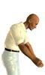 | 2
Back Swivel  There trunk twist or lateral inclination greater than 20 °. |  | 3
Swivel back bent  There trunk flexion and rotation (or angle) simultaneously. |  | 4

Arm positions: second digit of "code position"
This body part will be the second to evaluate it will give the correct value for the work being performed, when the arms are located under the shoulder level is 1, another movement is when a worker's arm is located below the the shoulders and the other not, or another part is situated above the level of the shoulders is 2, finally serious Both arms (arms or part of) the worker are placed above the shoulder level would be 3 the number of evaluation. (Nogareda, 2006).

Table 2. Coding of the positions of arms.

Arm position |  | Second digit position code
The two lower arms  Both arms of the worker are located under the shoulder level. |  | 1
One arm low and the other high  A working arm is located under the level of the shoulders and the other or another part is situated above the level of the shoulders. |  | 2
The two arms raised  Both arms (arms or part of) the worker are placed above the shoulder level. | 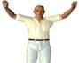 | 3

Leg positions: third digit of "code position"
It would be the third digit of the position of the legs and the completion of the first three digits of body postures analyzed by this method. Where (Sitting posture your code would be one, standing with both legs straight with the weight balanced between the two would be 2, Standing with one leg straight and the other bent with the weight balance between the two would be 3, standing or squatting with both legs bent and the weight balanced between the two would be four, standing or squatting with both legs bent and the weight balance between both is 5, Kneeling is 6, walking your code is 7).

Table 3.Coding of the positions of legs.

Leg Position |  | Third digit position code
Sitting. | 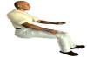 | 1
Stand with both legs straight with the weight balanced between both. |  | 2
Standing with one leg straight and the other bent with the weight balance between both. |  | 3
Standing or squatting with both legs bent and the weight balanced between both  Although no explicit method from which angle this was the case, may be considered to occur for thigh-calf angles less than or equal to 150 ° (Mattila et al., 1999). Angles greater are considered straight legs. |  | 4
Standing or squatting with both legs bent and the weight balance between the two.  Can be considered to occur calf thigh angles less than or equal to 150 ° (Mattila et al., 1999). Angles greater are considered straight legs. |  | 5
Kneeling  The worker supports one or both knees on the ground. | 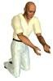 | 6
Walking | 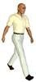 | 7

Loads and forces supported: fourth digit of "code position"

Finally we must evaluate the limit load lifting between the three proposed by the method, which the worker belongs when it takes up the position. Would be: Less than 10 Kilograms serious posture code 1, between 10 and 20 Kilograms your code would be 2, and more than 20 kilograms would your code 3.

Table 4. Load and forces supported encoding.

Loads and forces supported | Fourth digit of the code position.
Less than 10 kg. | 1
Between 10 and 20 kilograms | 2
More than 20 kilograms | 3

The following table shows the index used to measure the risk associated with the task, indicating for each value of the risk, its color code, type of posture and corrective action is necessary. The color code will be used in the list of "codes stance" and frequency charts positions and loads carried.

Table 5. Table of categories of risk and corrective actions.

Categoría de Riesgo | Efectos sobre el sistema músculo- esquelético | Acción correctiva
1 | Postura normal sin efectos dañinos en el sistema músculo- esquelético. | No requiere acción
2 | Postura con posibilidad de causar daño al sistema músculo- esquelético. | Se requieren acciones correctivas en un futuro cercano.
3 | Postura con efectos dañinos sobre el sistema músculo-esquelético. | Se requieren acciones correctivas lo antes posible.
4 | La carga causada por esta postura tiene efectos sumamente dañinos  sobre el sistema músculo-esquelético. | Se requiere tomar acciones correctivas inmediatamente.

Note: For each category of risk is assigned a color code in order to facilitate its identification in tables.

Table 6. Table of classification of the categories of risk of the “codes of position”

 |  | Legs
 |  | 1 |  |  | 2 |  |  | 3 |  |  | 4 |  |  | 5 |  |  | 6 |  |  | 7
 |  | Load |  |  | Load |  |  | Load |  |  | Load |  |  | Load |  |  | Load |  |  | Load
 |  | 1 | 2 | 3 | 1 | 2 | 3 | 1 | 2 | 3 | 1 | 2 | 3 | 1 | 2 | 3 | 1 | 2 | 3 | 1 | 2 | 3
Back | Arms | 1 |  | 3
 | 1 | 1 | 1 | 1 | 1 | 1 | 1 | 1 | 1 | 1 | 2 | 2 | 2 | 2 | 2 | 2 | 1 | 1 | 1 | 1 | 1 | 1
1 | 2 | 1 | 1 | 1 | 1 | 1 | 1 | 1 | 1 | 1 | 2 | 2 | 2 | 2 | 2 | 2 | 1 | 1 | 1 | 1 | 1 | 1
 | 3 | 1 | 1 | 1 | 1 | 1 | 1 | 1 | 1 | 1 | 2 | 2 | 3 | 2 | 2 | 3 | 1 | 1 | 1 | 1 | 1 | 2
 | 1 | 2 | 2 | 3 | 2 | 2 | 3 | 2 | 2 | 3 | 3 | 3 | 3 | 3 | 3 | 3 | 2 | 2 | 2 | 3 | 3 | 3
2 | 2 | 2 | 2 | 3 | 2 | 2 | 3 | 2 | 3 | 3 | 3 | 4 | 4 | 3 | 4 | 3 | 3 | 3 | 4 | 2 | 3 | 4
 | 3 | 3 | 3 | 4 | 2 | 2 | 3 | 3 | 3 | 3 | 3 | 4 | 4 | 4 | 4 | 4 | 4 | 4 | 4 | 2 | 3 | 4
 | 1 | 1 | 1 | 1 | 1 | 1 | 1 | 1 | 1 | 2 | 3 | 3 | 3 | 4 | 4 | 4 | 1 | 1 | 1 | 1 | 1 | 1
3 | 2 | 2 | 2 | 3 | 1 | 1 | 1 | 1 | 1 | 2 | 4 | 4 | 4 | 4 | 4 | 4 | 3 | 3 | 3 | 1 | 1 | 1
 | 3 | 2 | 2 | 3 | 1 | 1 | 1 | 2 | 3 | 3 | 4 | 4 | 4 | 4 | 4 | 4 | 4 | 4 | 4 | 1 | 1 | 1
 | 1 | 2 | 3 | 3 | 2 | 2 | 3 | 2 | 2 | 3 | 4 | 4 | 4 | 4 | 4 | 4 | 4 | 4 | 4 | 2 | 3 | 4
4 | 2 | 3 | 3 | 4 | 2 | 3 | 4 | 3 | 3 | 4 | 4 | 4 | 4 | 4 | 4 | 4 | 4 | 4 | 4 | 2 | 3 | 4
 | 3 | 4 | 4 | 4 | 2 | 3 | 4 | 3 | 3 | 4 | 4 | 4 | 4 | 4 | 4 | 4 | 4 | 4 | 4 | 2 | 3 | 4

RESULTS AND DISCUSSION

The study was basen on evaluate a charger person’s (someome who operates a porder at a supermarket storage area) scores are shown below:

Back ben.
There is trunk flexion. Al thougt the method does nor explicit from and angle this case happened it can be considered to occur fon greafer than 20° bentavers (inclinatrons) the score is 2

Two arms raised.
The employee’s arms must be located below the shoulders, the score is 3

Leg Position.
Stand with both legs straight with the weight balanced between the two. The score is 2.

Supported loads an forces.
More than 20 kilograms, the score is 3.

Final Result: 3
According to task´s previous scores, task has high level risk, which requires corrective actions soon as possible before an accident happens to the operator.

The following table shows the study's evaluation what be led just to the conclution that the posture with on muscle-skeletal system harmful effects and requires corrective actions as soon as possible.
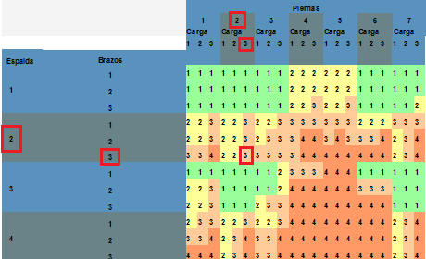

CONCLUTION

According to the results obtained by OWAS method, it was possible to identify the employee works risk was rated as high risk level, that is why immediate action its need with measures that allow to safeguard the under study operators integrity.
Proposals:
Make a more thorough study that helps improve the working environment and conditions.
Design tools and equipment to help improve the workers physical and mental heath( forklifts, etc.)
Provide training on ergonomic position that must be used in the different tasks.

REFERENCES

KARHU, O., KANSI, P., Y KUORINKA, L. (1977). Correcting working postures in industry: A practical method for analysis. Applied Ergonomics, 8, pp. 199- 201.
KIVI, P. Y MATTILA, M. (1991). Analysis and improvement of work postures in the building industry: application of the computerized OWAS method. Appl Ergon, 22, pp.43–48.

MATTILA, M. Y VILKKI, P. (1999). OWAS methods. En: W. Karwoswki and W. Marras, Editors, The Occupational Ergonomics Handbook, CRC Press, Boca Raton, pp. 447–459.
NOGAREDA, S.,Y DALMAU I. (2006). Evaluación de las condiciones de trabajo: carga postural. NTP 452. Instituto nacional de Seguridad e Higiene en el trabajo.

Ergonomic Evaluation in an auto shop using the REBA method

Sepúlveda Losoya, Diego Moisés1, López Acosta, Mauricio2, Martínez Solano, Gilda María2 & Montiel Rodríguez, Luis Carlos2
1Alumno del Programa Educativo de Ingeniería Industrial y de Sistemas.
2Departamento de Ingeniería Industrial del Instituto Tecnológico de Sonora, unidad Navojoa, email: diego.sepulveda13 @hotmail.com, mauricio.lopez@itson.edu.mx, gmmartinez@itson.mx, lmontiel@itson.mx.

Resumen. La finalidad de este trabajo es identificar los riesgos ergonómicos que se presentan en las estaciones de trabajo dentro del área de vulcanizado de llantas para automóviles y tractores. Para eso se basarán al método REBA, con el cual evaluarán las distintas posturas del trabajador como son posición de tronco, cuello y piernas así como brazo, antebrazo y muñeca, al momento de realizar su trabajo. Una vez que los riesgos han sido detectados y analizados, se presentarán las alternativas de mejora para reducir riesgos y contribuir a obtener mejores posturas de trabajo, que incluyen el reducción de las cargas, cuidado de la salud y perfección de las condiciones de trabajo, entre otras. La necesidad de realizar un análisis orientará al evaluador sobre la necesidad o no de plantear acciones correctivas sobre determinadas posturas. Por otra parte, las puntuaciones individuales obtenidas para los segmentos corporales, la carga, el agarre y la actividad, podrán guiar al evaluador sobre los aspectos con mayores problemas ergonómicos y dirigir así sus esfuerzos preventivos convenientemente.

Palabras Claves: Ergonomía, Método REBA, Trastornos Músculo Esqueléticos.

Summary. The purpose of this paper is to identify ergonomic hazards that occur in the workstations within the area of vulcanized tire for cars and tractors. That will build the REBA method, with which evaluate the different positions of workers such as position of trunk, neck and legs and arm, forearm and wrist when performing their work. Once risks have been identified and analyzed, will present the improvement alternatives to reduce risks and contribute to better working postures, including burden reduction, health care and perfection of the working conditions, among other. The need for guidance to the evaluator analysis on whether or not to propose corrective actions on certain positions. Moreover, the scores obtained for individual body segments, the load, grip and activity may lead the evaluator on the most problematic aspects ergonomic and handle so conveniently preventive efforts.

Keywords: Ergonomics, REBA Method, muscle-skeletic disorders

1.- INTRODUCTION.

Ergonomics is a body of knowledge that tray to adapt products, tasks, tools, spaces and the wider environment, to the capacity and needs of people. The main goal of

ergonomics is to improve efficiency, safety and welfare of workers. Prevents the evaluator on the risk of injury associated with a position, mainly the ones of the muscle- skeleton, indicating in each case the urgency with which corrective actions should be applied. This paper summarizes an ergonomic study on a company-made auto shop. change in the activity of the tire, where it was used REBA method.

2.- OBJECTIVE

Evaluate the positions that adopts tire assemblage operator using the REBA Method, to identify ergonomic hazards in the activity.

3.- METHODOLOGY

REBA method assesses the risk of specific postures independently. Therefore, to evaluate a position should select their most representative positions, either by repetition over time or by its precariousness. The correct selection of the positions to assess the results will determine the results provided by the method and future actions. As previous steps to actual implementation of the method should be:
Determining the period of observation considering the position, if necessary, the work cycle time.
Realize, if necessary due to the excessive length of the task to evaluate, the decomposition of this elementary operations or subtasks for detailed analysis.
Record the different positions taken by the employee during the course of the task, well by capturing video, either through photographs or by entry in real time if it were possible.
Identify all positions from those considered most significant recorded or "dangerous" for evaluation with the REBA method.
The REBA method is applied separately to the right and left side of the body. Therefore, the evaluator at their discretion and experience, must determine, for each selected position, the side of the body that "a priori" carries a greater position load. If there is doubt about recommends evaluating both sides separately.
The application of the method can be summarized in the following steps:
Division of the body into two groups: group A for the trunk, neck and legs and Group B consists of the upper limb (arm, forearm and wrist). Individual rating of each group members from their respective boards.
See Table A for obtaining the initial score of the group A from the individual scores of the trunk, neck and legs.
Group B rating from scores arm, forearm and wrist using Table B.
Modification of the score assigned to group A (trunk, neck and legs) as a function of applied load or force, hereinafter "Rating A".
Correcting the score assigned to the area of the upper body (arm, forearm and wrist) or group B according to the type of cargo handled grip, hereafter "Score B".
From the "Score A" and "Score B" and by consulting Table C gives a new rating called "Score C".
Changing the "Score C" depending on muscle activity developed to obtain the final score of the method.

Check the level of action, risk and urgency of action for the value calculated.

After the application of the REBA method is advised:
The comprehensive review of individual scores obtained for the different parts of the body, as well as strength, grip, and activities, to guide the evaluator on where corrections are needed.
Redesign of the post or making changes to improve certain critical positions if the results recommend.
Redesign of the job or making changes to improve certain critical positions if the results obtained recommended changes.
In case of changes, re-evaluation of the new conditions of the job with the REBA method for testing the effectiveness of the improvement.

Group A: Scores of the trunk, neck and legs.

Figure 1. Score trunk.

Table 1. Coding of the positions of the trunk.
Points | Position
1 | The trunk is erect.
2 | The trunk is between 0 and 20 degrees of flexion or between 0 and 20 degrees of extension.
3 | The trunk is between 20 and 60 degrees of flexion or more than 20 degrees of extension.
4 | The trunk is flexed more than 60 degrees.

Figure 2. Score of the neck.
Table 2. Coding of the neck positions.

Points | Position
1 | The neck is between 0 and 20 degrees of flexion.
2 | The neck is flexed or extended more than 20 degrees.
Figure 3. Score of the legs.
Table 3. Coding of the legs.

Points | Positions
1 | Bilateral support, walking or sitting
2 | Unilateral support, light stand or unstable posture.

 Group B rating from scores arm, forearm and wrist using Table B.

Group B: Scores of upper limb (arm, forearm and

wrist).
Figure 4. Score of the arm.

Table 4. Coding of the arm.
Points | Positions
1 | The arm is between 0 and 20 degrees of flexion or between 0 and 20 degrees of extension.
2 | The arm is between 21 and 45 degrees flexion or more than 20 degrees of extension.
3 | The arm is from 46 to 90 degrees of flexion.
4 | The arm is bent more than 90 degrees.

Figure 5. Score of the forearm. Table 5. Coding of the forearm.
Points | Positions
1 | The forearm is between 60 and 100 degrees of flexion.
2 | The forearm is flexed below 60 degrees or above 100 degrees

Figure 6. Score of the wrist. Table 6. Coding of the wrist.
Points | Positions
1 | The wrist is between 0 and 15 degrees of flexion or extension.
2 | The wrist is flexed or extended more than 15 degrees.

Modification of the score assigned to group A (trunk, neck and legs) as a function of applied load or force, hereinafter "Rating A".

points | positions
+0 | The load or force is less than 5 kg.
+1 | The load or force is between 5 and 10 kg.
+2 | The load or force is greater than 10 kg.

Correcting the score assigned to the area of the upper body (arm, forearm and wrist) or group B according to the type of cargo handled grip, hereinafter "Rating B"
Tabla 7. Final evaluation of the conditions of grip
+0 | Good grip. The grip is good and the force grip of middle-ranking.
+1 | Regular grip. The gripping hand is acceptable but not ideal or grip is acceptable using other parts of the body
+2 | Bad grip. The grip is possible but not acceptable.
+3 | Unacceptable grip. Grip is awkward and insecure, it is not possible to hand- hold or grip is unacceptable to using other parts of the body.

From the "Score A" and "B rating" and by consulting Table C gives a new rating called "Rating C". see Table 10.

Table 8. Results in Table A and B
Rating A | Rating B
 | 1 | 2 | 3 | 4 | 5 | 6 | 7 | 8 | 9 | 10 | 11 | 12
1 | 1 | 1 | 1 | 2 | 3 | 3 | 4 | 5 | 6 | 7 | 7 | 7
2 | 1 | 2 | 2 | 3 | 4 | 4 | 5 | 6 | 6 | 7 | 7 | 8
3 | 2 | 3 | 3 | 3 | 4 | 5 | 6 | 7 | 7 | 8 | 8 | 8
4 | 3 | 4 | 4 | 4 | 5 | 6 | 7 | 8 | 8 | 9 | 9 | 9
5 | 4 | 4 | 4 | 5 | 6 | 7 | 8 | 8 | 9 | 9 | 9 | 9
6 | 6 | 6 | 6 | 7 | 8 | 8 | 9 | 9 | 10 | 10 | 10 | 10
7 | 7 | 7 | 7 | 8 | 9 | 9 | 9 | 10 | 10 | 11 | 11 | 11
8 | 8 | 8 | 8 | 9 | 10 | 10 | 10 | 10 | 10 | 11 | 11 | 11
9 | 9 | 9 | 9 | 10 | 10 | 10 | 11 | 11 | 11 | 12 | 12 | 12
10 | 10 | 10 | 10 | 11 | 11 | 11 | 11 | 12 | 12 | 12 | 12 | 12
11 | 11 | 11 | 11 | 11 | 12 | 12 | 12 | 12 | 12 | 12 | 12 | 12
12 | 12 | 12 | 12 | 12 | 12 | 12 | 12 | 12 | 12 | 12 | 12 | 12

Changing the "Rating C" depending on muscle activity developed to obtain the final score of the method.
Check the level of action, risk and urgency of action for the value calculated, see Table 9.

Tabla 9. Final score.

Final score. | Level of action. | Level of risk. | Action.
1 | 0 | Negligible. | It is not necessary action.
2-3 | 1 | Low. | It can be necessary action.
4-7 | 2 | Middle. | Action is necessary.
8-10 | 3 | High | Action is necessary as soon as possible.
11-15 | 4 | Very high | Action is necessary immediately.

After the application of the method is advised REBA:

- The comprehensive review of individual scores obtained for the different parts of the body as well as strength, grip, and activities, in order to guide the evaluator on where corrections are needed.
- Redesign of the post or making changes to improve certain critical positions if the results obtained so recommended
- In case of changes, re-evaluation of the new conditions of the post with the REBA method for testing the effectiveness of the improvement.

4.- RESULTS

REBA analysis results show the positions observed: Group A
Position trunk: is between 20 and 60 degrees of flexion or more than 20 degrees of extension is 3 and the trunk score increase its value there is lateral bending or twisting of the trunk +1. Rating 4.

Position of the neck: when evaluating is flexed or extended more than 20 degrees. Score 2

Position legs: to be evaluated leading to unilateral support, light support or unstable position. Score 2

A group scores are shown in Table 10.

Table 10. Results obtained in the assess of the trunk, neck and legs.

Trunk | Neck
Trunk | 1 |  |  |  | 2 |  |  |  | 3
Trunk | Legs |  |  |  | Legs |  |  |  | Legs
Trunk | 1 | 2 | 3 | 4 | 1 | 2 | 3 | 4 | 1 | 2 | 3 | 4
1 | 1 | 2 | 3 | 4 | 1 | 2 | 3 | 4 | 3 | 3 | 5 | 6
2 | 2 | 3 | 4 | 5 | 3 | 4 | 5 | 6 | 4 | 5 | 6 | 7
3 | 2 | 4 | 5 | 6 | 4 | 5 | 6 | 7 | 5 | 6 | 7 | 8
4 | 3 | 5 | 6 | 7 | 5 | 6 | 7 | 8 | 6 | 7 | 8 | 9
5 | 4 | 6 | 7 | 8 | 6 | 7 | 8 | 9 | 7 | 8 | 9 | 9

Group B

Positions of the arms is between 21 and 45 degrees of flexion or more than 20 degrees of extension is 2 and the score increases by arm be abducted or rotated +1. Score 3
Position of the forearms is flexed being valued below 60 degrees or above 100 degrees. Score 2
Position of the wrists to be evaluated is flexed or extended more than 15 degrees and the wrist score is 2 increased because there is torsion or lateral deviation of the wrist +
- Score 3

B. Group score.
Table 11. Results obtained in the assess of the arm, forearm and wrist.
Brazo | Antebrazo
Brazo | 1 |  |  | 2
Brazo | Muñeca |  |  | Muñeca
Brazo | 1 | 2 | 3 | 1 | 2 | 3
1 | 1 | 2 | 2 | 1 | 2 | 3
2 | 1 | 2 | 3 | 2 | 3 | 4
3 | 3 | 4 | 5 | 4 | 5 | 5
4 | 4 | 5 | 5 | 5 | 6 | 7
5 | 6 | 7 | 8 | 7 | 8 | 8
6 | 7 | 8 | 8 | 8 | 9

Table C final results:

This table shows the results obtained in Table A and B which throws us a third final results.
Therefore the result of Table A is 6, so that if the load or force is greater than 10 Kg +2 increases, and if the force is abruptly applied increases +1. Score 9

Table B the result is 5, but if the grip is possible but not acceptable increases +2. Score 7
Tabla 12. Results in Table A and B
Rating A | Rating B
 | 1 | 2 | 3 | 4 | 5 | 6 | 7 | 8 | 9 | 10 | 11 | 12
1 | 1 | 1 | 1 | 2 | 3 | 3 | 4 | 5 | 6 | 7 | 7 | 7
2 | 1 | 2 | 2 | 3 | 4 | 4 | 5 | 6 | 6 | 7 | 7 | 8
3 | 2 | 3 | 3 | 3 | 4 | 5 | 6 | 7 | 7 | 8 | 8 | 8
4 | 3 | 4 | 4 | 4 | 5 | 6 | 7 | 8 | 8 | 9 | 9 | 9
5 | 4 | 4 | 4 | 5 | 6 | 7 | 8 | 8 | 9 | 9 | 9 | 9
6 | 6 | 6 | 6 | 7 | 8 | 8 | 9 | 9 | 10 | 10 | 10 | 10
7 | 7 | 7 | 7 | 8 | 9 | 9 | 9 | 10 | 10 | 11 | 11 | 11
8 | 8 | 8 | 8 | 9 | 10 | 10 | 10 | 10 | 10 | 11 | 11 | 11
9 | 9 | 9 | 9 | 10 | 10 | 10 | 11 | 11 | 11 | 12 | 12 | 12
10 | 10 | 10 | 10 | 11 | 11 | 11 | 11 | 12 | 12 | 12 | 12 | 12
11 | 11 | 11 | 11 | 11 | 12 | 12 | 12 | 12 | 12 | 12 | 12 | 12
12 | 12 | 12 | 12 | 12 | 12 | 12 | 12 | 12 | 12 | 12 | 12 | 12

Final score.
Tabla 13. Final score.

Final score. | Level of action. | Level of risk. | Action.
1 | 0 | Negligible. | It is not necessary action.
2-3 | 1 | Low. | It can be necessary action.
4-7 | 2 | Middle. | Action is necessary.
8-10 | 3 | High | Action is necessary as soon as possible.
11-15 | 4 | Very high | Action is necessary immediately.

The final assessment of the method is a value of 11, which indicates that the task performed has a very high level of risk and action is required immediately.

5.- CONCLUSIONS
According to the results obtained by the REBA method, we identified that the risk of work to remove the tire to the car and vulcanized has a high level of risk, so it is necessary to act immediately with measures to safeguard the integrity of the operator under study.

6.- REFERENCES.

Borg,g.,1985. An Introduction to Borg's RPE-scale. Movement Publications, Ithaca, NY. Corlett, E. N, Bishop, R.P., 1976. A Technique for Assessing Postural Discomfort.
Ergonomics 19 (2), pp. 175 -182.

Evaluación de las posturas de trabajo como riesgo de carga física en el sector marítimo-pesquero. revista del INSHT. Artículo de la sección técnica 2 del pts número 28.
Hignett, S., 1994. Using Computerized OWAS for Postural Analysis of Nursing Work. in: Robertson SA. (ed.), Contemporary Ergonomics. Taylor & Francis, London, UK. pp. 253-258.
Hignett, S. y Mcatamney, L., 2000, REBA: Rapid Entire Body Assessment. Applied Ergonomics, 31, pp.201-205.
Karhu, O., Kansi, P., y Kuorinka, L., 1977, Correcting Working Postures in Industry: a Practical Method for Analysis. Applied Ergonomics, 8, pp. 199-201.
Mcatamney, l. y Corlett, E. N., 1993, RULA: A Survey Method for the Investigation of Work-Related Upper Limb Disorders. Applied Ergonomics, 24, pp. 91-99.
NTP 601: Evaluación de las condiciones de trabajo: carga postural. Método REBA (Rapid Entire Body Assessment). INSHT.
Waters, T.R., Putz-Anderson, V., Gard, A.,Fine,L.J., 1993. Revised Niosh Equation for the Design and Evaluation of Manual Lifting Tasks. Ergonomics 36 (7).

STOVE CHINANTLA

Efren Toledo Toledo¹, Dr. Ed. Raymundo Ocaña Delgado², Mtro. Francisco Platas López², Mtro. Jorge E. Zarur Cortes² y Mtro. Santiago Osnaya Baltierra².

¹ Fellow of the Academic Industrial Design
² Full Time Professor University Center UAEM Zumpango,
Autonomous University of Mexico State Camino Viejo a Jilotzingo s/n
Valle Hermoso Zumpango, Mexico State

e-mail: nefrett.02@gmail.com; rocanad@uaemex.mx; fplatasl@uaemex.mx; jezarurc@uaemex.mx; sosnayab@uaemex.mx

Resumen: Durante la cocción de cualquier alimento se generan un sinnúmero de emisiones contaminantes, que gracias a las ventajas de los muebles utilizados actualmente en las cocinas, la caridad encuentra una salida para la gente. Sin embargo, en México, como en muchos otros países de América Latina y del mundo, donde la situación económica es precaria, el proceso de cocción resulta ser una importante fuente de contaminación, ya que las características de los edificios, el mobiliario y los combustibles utilizados, las emisiones se mantienen dentro espacios, de ocasionar daños a la salud de los habitantes. Un claro ejemplo de esto es la comunidad de San Juan Petlapa Chinantla que forma parte de la región Chinanteca, ubicada a unos 100 km de la ciudad de Oaxaca, una situación que cuando se analiza detenidamente, se ha puesto de manifiesto la necesidad de diseñar una cocina que va a mejorar las condiciones ambientales, y lógicamente, la salud de las familias de la comunidad de que se trate.

Palabras clave: Diseño, Estufa, Contaminación

ABSTRACT: During cooking of any food are generated countless pollutant emissions, which thanks to the advantages of the furniture currently used in kitchens, charity finds an outlet for people. However, in Mexico as in many other parts of Latin America and the world, where economic status is precarious, the cooking process turns out to be a major source of pollution, since the characteristics of buildings, furniture and fuels used, the emissions remain within spaces, creating damage to the health of the inhabitants. A clear example of this is San Juan Petlapa Chinantla community that is part of the region Chinanteca, located about 100 km from the city of Oaxaca, a situation that when analyzed carefully, has highlighted the need to design a stove that will improve environmental conditions, and logically, the health of the families of the community in question.

Keywords: Design, Stove, Pollution.

INTRODUCTION
As a matter of Yassi (2002), speaking of pollution is address any undesirable modification of the environment, caused by the interaction of physical, chemical or biological with it in quantities greater than natural, and which together are harmful to human health .
Today, air pollution is one of the most serious environmental problems and global concern. This is present in all walks of life, regardless of the level of socioeconomic development, geography or culture. Derivative of this pollution, every year the number of people suffering from respiratory diseases and others associated with the emission of pollutants, both indoors and outdoors goes on increasing.
Around this condition, in Mexico, as in many more populations of Latin America and the world, there are communities exposed to stationary sources of air pollutants, which in many cases all stems from the precarious situation in which they find or, to the neglect of abandoning traditions. Such is the case of San Juan Petlapa Chinantla community located about 100km from the city of Oaxaca, where the process of cooking food inside their homes has become a source of contamination, affecting both infants, youth and adults.
In this regard, according to studies by K. R. Smith to the FAO, in stoves and furnaces suitable and good combustion practices, you may clean consumption of firewood and charcoal, and other biomass, resulting mainly carbon dioxide and water. Corroborating such conditions are difficult to achieve in rural and urban poor in small used cheap fed with wood stove. For the wood that does not burn properly and becomes carbon dioxide results in incomplete combustion products such as: carbon monoxide, benzene, butadiene, formaldehyde, polyaromatic hydrocarbons and many other compounds hazardous to health.
Added to this must be the problem increases if the stove has not picked up chimneys or hoods to expel smoke outside. And although there have been no large- scale surveys statistically representative, hundreds of small studies worldwide in typical local situations have revealed that there are significant concentrations of small particles in the interior of the house, which can reach levels of long-term 10-100 times higher than those recommended by the World Health Organization (2005) in its revised guidelines on air quality to protect public health.
Significantly, despite the imprecision of measurements have been repeatedly detected various health effects in homes using biomass fuels, in most cases all or part wood. And among them are: acute infections of the lower respiratory tract (pneumonia) in young children, the leading cause of child mortality worldwide and the disease responsible for the loss of more years of life also globally, as well as chronic obstructive pulmonary disease, including chronic bronchitis and emphysema, in adult women who have been cooking for many years with solid fuels without adequate ventilation. Worrying and in relation to which through a paper published in the journal "Proceedings of the American Thoracic Society", experts have recommended the introduction of measures to reduce this type of indoor pollution, including lifestyle changes, improved ventilation and heating systems of homes (Torres-Duque, 2008).

OBJECTIVE

Designing a stove for families in the community of San Juan Petlapa Chinantla, Oaxaca, which allows cooking food safely, reducing the pollution levels indoors.

METHODOLOGY

The methodology used to address the problems identified is the design method called "transparent box", whose author responds to Christopher Jones and is configured specifically for three stages (Objective, Problem Analysis and Evaluation), although some were broken giving as resulting in a total of six steps. Significantly for Jones, is transcending design, using creativity, rationality and control organized to come up with something coherent and conscious.
Now, to be clear about the purpose, it was necessary to make a visit to San Juan Petlapa, a small village that belongs to Chinanteca, and which extends along the northeastern part of the state, adjoining the Veracruz north, northwest with the Mazatec region, with Cuicateca west and south-east with the Zapotec region. In this community, the residence is patrilocal basically. In the upper area of the region is the traditional adobe house with tile roof. While in the transition region is common to find wooden houses with thatched roofs or shingles, and at the bottom are constructions of roundwood or jonote thatched roof. In all cases the roofs have two outstanding and existing buildings in uptown tile is being replaced by leaf, and in the lowlands the jonote by wooden boards.

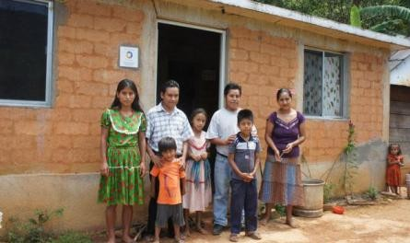
Figure 2. House uptown

Figure 1. House transition region

Now located in the community, the task was to gain access to the interior of the houses, to thereby observe the conditions in which the housewives cook at par, corroborate the data on the high levels of pollution generated. In relation to this activity, we identified three situations of concern, the first is that in an area no greater than 40m², is both kitchen, bedroom and area of coexistence, where in the best case there are divisions based fabric. The second is that in many of the small houses used for cooking food or leftover stones adobe blocks as support containers (pots), using wood as the main fuel. Exist at all times by the structure, the risk of an accident or spill hot liquids.

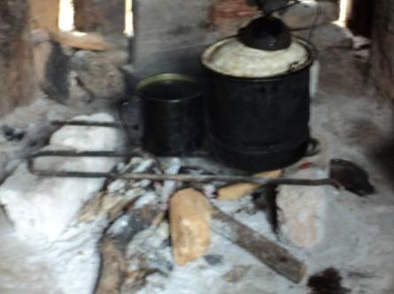

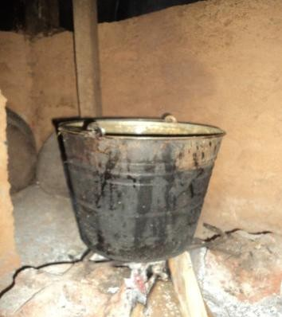
Figure 3. Stove with stones and wood
Figure 4. Based Fogón adobe blocks, sticks and firewood

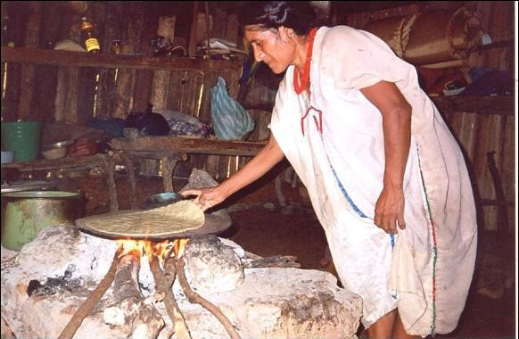
Figure 5. Tortilla cooking stove with stones

Meanwhile, the third position also evident that in a large number of housing exists a stove made by the inhabitants themselves with adobe blocks, mud and a stones griddle as support, which on average have a length of 1.70m, with 0.50 m deep and 0.80m high. In it, there are three areas, intended for the preparation of food, one for cooking thereof and, perhaps most importantly, the area to take "tortillas".
Relevant is that during the stay in the community of San Juan Petlapa, and after application of the residents interviewed, information was obtained regarding cooking times, drawing attention only on normal days, Monday to Saturday the housewives spend between 4-5 hours making tortillas, initiating activity of preparing food at 4 in the morning. Time in which the fire is kept constant, and whose periods are increased twice during local festivals.

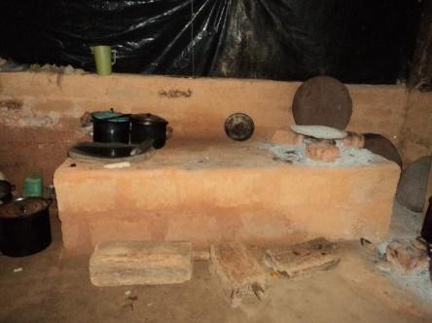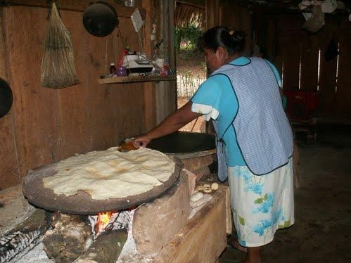

Figure 6. Solid foundation stove (3 areas)
Figure 7. Cooking tortillas in oven solid foundation

Stoves analyzing, both the base as the base stone solid was observed that in both cases there is a lack of an element able to avoid contaminating the smoke generated inside the house. Since the fire is fed below the griddle for wood, without a fuel containment area, allowing the smoke particles and those resulting from the processing of wood (ash) to spread freely.
Similarly, that existed comments regarding the conditions that the stove and the characteristics of the construction, the room gets too hot, the food usually presents ashes, comal constantly slipping from its supports, it becomes difficult intake process and is a frequent irritation in the eyes of both babies and adults.
Already with the previous body of information, it was determined that the problem was setting the fires or stoves used so far. So it was necessary to design an item that would reduce risks and damages to the residents of San Juan Petlapa during cooking.
After the stay in the community of San Juan, we proceeded to generate various proposed solutions, initially through sketches, which were improved by software doomed the representation of objects and atmosphere, as in the case of Solid Work, Rhinoceros and 3D Studio.

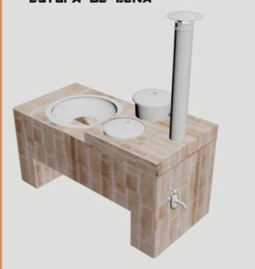
Figure. 8 Stove Chinantla

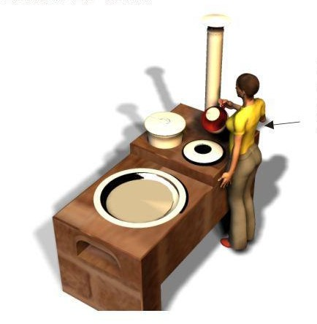
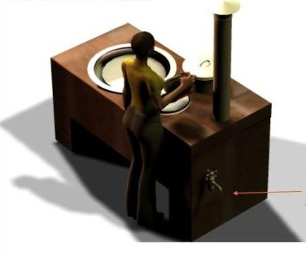
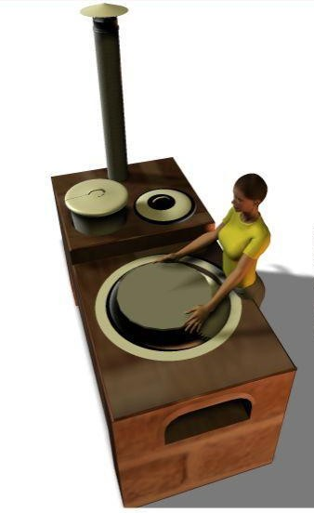
Figure. 9 Atmosphere of Stove Chinantla

RESULTS

Having determined the alternative specifications, we proceeded to generate a first prototype, which was tested. After verifying its functionality and make small adjustments, the team moved back to the community of San Juan Petlapa, making a family permit to build a stove inside your property, noting that issues of mistrust of the inhabitants, it was not possible it inside the house.
However, the design in question was built using materials that community might have on hand, as in the case of mud, clay and cement and readily available supplies despite the characteristics of the area. Comment is so two-dimensional that they did see two possible bases to work, a fully closed and the other hollow, where the latter had the advantage of having a space to store firewood and thus avoid leaving the house to get more fuel steadily. Of course, the decision would be subject to the economic status of each family.
Moreover, the stove Chinantla is a project that reduces fuel consumption, saves time and money, reducing eye irritation and respiratory diseases. Besides conserving, part of the culture of the community. Its features include, the ring having a curved metal, allowing griddle accommodate any size, also presents a liquid container capable of heating them through the radiation generated by the flame which assists the griddle, whereas in much help people in cold season will not be affected during the washing of utensils. Finally shows a key for the water outlet, allowing access to the vital liquid with ease.

CONCLUSIONS

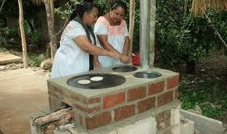
Figure. 10 Chinantla stove use in the community of San Juan Petlapa

Even when it seems that in the XXI century man has managed to solve most of their needs through a simple or complex object, that's not entirely true. For as been allowed to see the work done in relation to the problems presented within a large number of dwellings in the community of San Juan Petlapa Oaxaca, the solution that the inhabitants had been generated in relation to cooking their food, despite the best intentions, in attachment to traditions and of course, based on its economy, has resulted in prejudice to his health.
Therefore, the stove Chinantla is a viable proposition, since it is created from readily available materials that do not affect the area or the environment. Besides allowing to maintain their traditions, and not meant to be a place to install another fire with the intention of "tortillas", but rather, seeks to be an element that preserves the sense of common identity as part of the community and the instead of the possibility of having a better quality of life.
Finally we comment that, to solve this project was quite difficult as sharing the lifestyle of a remote community such as San Juan Petlapa, reveals that there is much to be done for the benefit of society through design of new objects, it is believed that when we all live in similar conditions do not, so it will turn more frequently valuable eyes to communities rather than seeking to improve their economic reach, have elements required to ensure their health.

REFERENCES

Organización Mundial de la Salud (OMS). 2005. WHO air quality guidelines global update 2005. Copenhague, Dinamarca, Oficina Regional de la OMS para Europa. Disponible en: www.euro.who.int/Document/E87950.pdf
TORRES-DUQUE C, Maldonado D, Pérez-Padilla R, Ezzati M, Viegi G; On behalf of the Forum of International Respiratory Studies (FIRS) Task Force on Health Effects of Biomass Exposure. Biomass Fuels and Respiratory Diseases: A Review of the Evidence. "Proc Am Thorac Soc." 2008; 5: 577-590.
VILCHIS, Luz del Carmen (2000). Metodología del diseño. Centro Juan Acha A.C. UNAM. México. 107-111.
YASSI A, Kjellstrom T, de Kok T, Guidotti. Salud Ambiental Básica (versión al español realizada en el INHEM). México DF. PNUMA. 2002.

http://www.fao.org/docrep/009/a0789s/a0789s09.htm http://www.ine.gob.mx/ueajei/publicaciones/libros/363/cap20.html#top

IMPLEMENTATION OF SOME PRINCIPLES OF LEAN MANUFACTURING WITH ERGONOMIC SUPPORT ANALYSIS
MC. Rigoberto Zamora Alarcón1, L.D.I. Tania Castañeda Madrid2,
Ing. Ariel Rubio Villegas3, Jesús Edgardo Figueroa Lizarraga4, Alan de Jesús Córdoba Pacheco5
1Facultad de ingeniería-Mecánica-Industrial Universidad Autónoma de Baja California-Instituto Tecnológico de Mexicali
Blvd. Benito Juárez S/N Mexicali, Baja California 21280 mczamora02@yahoo.com.mx

2Facultad de arquitectura y Diseño Mexicali, Baja California 21280

3Facultad de arquitectura y Diseño Universidad Autónoma de Baja California Mexicali, Baja California 21280

4Estudiante Ingeniería Mecánica Universidad Autónoma de Baja California Mexicali, Baja California 21280 5Estudiante Ingeniería Mecánica
Universidad Autónoma de Baja California Mexicali, Baja California 21280

Resumen: Proyecto de estudio desarrollado a partir del análisis de riesgo ergonómico utilizando el método RULA (Rapid Upper Limb Assessment) y BRIEF. El análisis arrojo información para mejorar el ambiente de del laboratorio de Diseño Industrial en área de Maderas. Se desarrollo el Proyecto de evaluación ergonómica en estaciones de laboratorio de diseño industrial, en taller de maderas, con el propósito de enfocar esfuerzos en la prevención de riesgos.
El proyecto se realizo a partir de evidentes condiciones de trabajo en el laboratorio que indicaban condiciones y ambiente incomodo, para el desarrollo óptimo de las labores de un taller.
Las posturas de los alumnos al trabajar en las maquinas fueron determinantes para establecer la aplicación de evaluación ergonómica para mejorar posturas confortables de trabajo, aplicando principios de 5 s y SMED

Objetivo: Evaluar y controlar los riesgos en estación de laboratorio por actividades repetitivas, posturas, y agentes del medio que por sus características puedan causar daños a la salud, considerado el análisis ergonómico aplicado al concepto de estaciones de trabajo

Metodología empleada: Normas oficiales Mexicanas de STPS (Secretaria de Trabajo y Previsión Social) vigentes, Evaluación RULA/BRIEF, Mediciones antropométricas, Principios de aplicables a estaciones de trabajo con 5 s, SMED

Resultados
Mejora en Índice de frecuencia
Mejora en posturas en un 50%
Beneficio Área de confort 40% Operatividad 20%
Optimización de espacio 20% Productividad 30%

Condiciones ambientales
Iluminación 20%
Ruido 30%
Conclusiones: Con base a los datos obtenidos:
- Disminuyo partículas en ambiente
- Mejoro la iluminación
- Se considerarán para el diseño de las estaciones de trabajo, la media poblacional del estudio antropométrico
- Se comprobó que el costo beneficio de la aplicación de la ergonomía generó mejoras significativas en las condiciones laborales beneficiando a 50 alumno
Palabras Clave: Manufactura Esbelta, RULA, BRIEF, Análisis Ergonómico

Abstract: Study project developed from the ergonomic risk analysis using the RULA (Rapid Upper Limb Assessment) and BRIEF method. The analysis threw information to improve the environment of Industrial Design Laboratory in Woods area. Ergonomic assessment project was developed in stations of the laboratory of industrial design, workshop of wood, in order to focus efforts on the prevention of risks. Project was conducted from apparent working conditions in the laboratory that indicated conditions and atmosphere uncomfortable, for the optimal development of the work of a workshop. Students working postures in the machines were decisive for establishing the application of ergonomic evaluation to improve comfortable positions of work, applying principles of 5s, SMED
Objective: To evaluate and control the risks in station's laboratory by repetitive activities, positions, and agents of the medium that by its characteristics may cause damage to health, considered the ergonomic analysis applied to the concept of workstations Methodology: Official Mexican standards of STPS (Secretaría de Trabajo y Previsión Social) current evaluation RULA/BRIEF, anthropometric measurements, principles applicable to workstations with 5 s, SMED

Results
Project results:

Improved Frequency index
positions in a 50% improvement

Benefits

Area of comfort 40% operation 20% optimization of space 20% productivity 30%

Environmental conditions
Ilumination 30%
Noise 30%

Conclusions:
Based on the data obtained:
� decreased particles in atmosphere
� improved the lighting
� will be considered for the design of workstations, the population mean of the anthropometric study
� it was found that the cost-benefit of the application of ergonomics generated significant improvements in working conditions benefiting 50 student

key words: Lean manufacturing, RULA, BRIEF, ergonomic analysis

1.- INTRODUCTION

Ergonomic assessment project was developed in stations of the laboratory of industrial design, workshop of wood, in order to focus efforts on the prevention of risks.
The project took place from to identify working conditions in the laboratory and the environment uncomfortable, for the optimal development of the work of a workshop.
The positions of students working in the machines were decisive to establish the application of ergonomic evaluation to improve comfortable positions of work, applying principles of 5s and SMED as complementary to scheduled improvement analysis elements.

- OBJECTIVE

Evaluate and control risks in laboratory station by repetitive activities, positions, and agents of the medium that by its characteristics may cause damage to health, considered the ergonomic analysis applied to the concept of workstations

- METHODOLOGY

Mexican Official Standards of STPS (Secretary of Labor and Social Welfare) in force Federal
Labor Law art. 132 Obligations of Employers Cap. X, Ergonomics art. 102. (Federal Regulation on Safety, Hygiene and Working Environment 1997)
The official Mexican standards determined by the Secretary of Labor and Social Welfare in effect allowed us to measure each of the parameters set by physical and chemical conditions, however, to labor issues in the area we focus on physics
    - Physics, Lighting (NOM-025-STPS-1999)

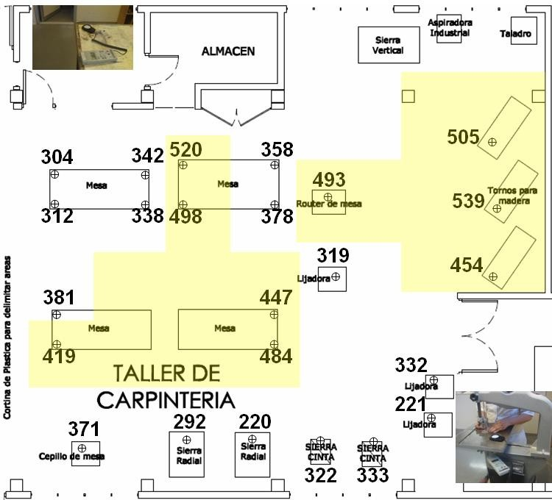

Figure 1. Location of adequate lighting in each of the workstations

We detected problems in the lighting in most of the stations, according to Marcombo, lighting for normal workshop facilities should be 400 to 800 Lux (Chiner 2004)
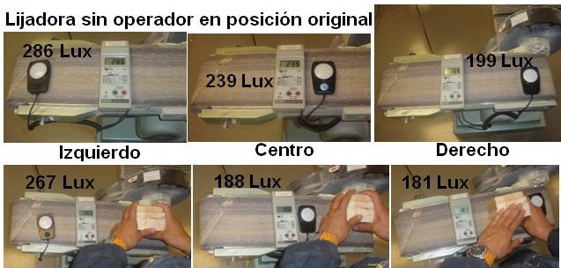

Figure 2. Lighting in Belt/Disc Sander, with operator and without

As shown in Figure 2, regardless of that there was nothing to obstruct the light to the Belt/Disc Sander, does not comply with the lighting required to perform operations efficiently, therefore is try comply with better lighting, placing it closest of the lamps, achieving the values that are shown in Figure 3, however the objective was not

achieved, since only improve 33% and sometimes in up to 65% being in conditions below 400 to 800 lux.
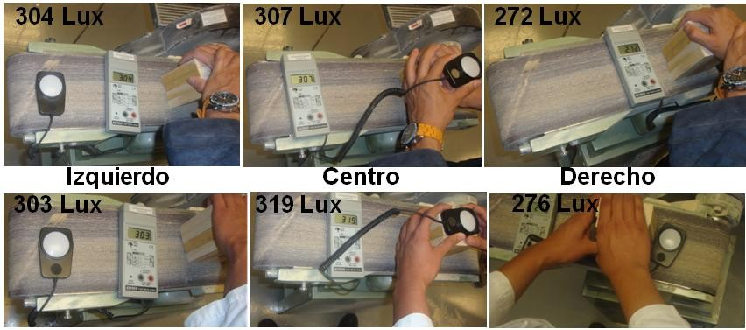

Figure 3. Lighting in new position, with dark and clear coat

    - Physical, Noise (NOM-011-STPS-2001).
OSHA uses the concept of noise dose, where exposure to any greater than 80 dBA sound level, causes a partial dose, who listen to it.
Less than 85 dB noise levels may hinder significantly, personal and telephone communication (Niebel, 2009)
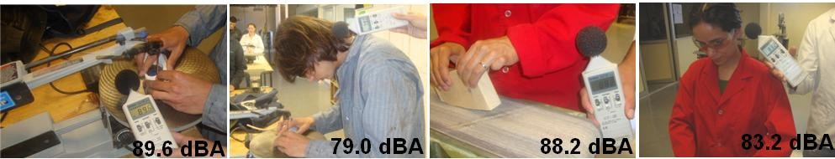

Figure 4. Some levels of noise measurements in machine and operator

As shown in Figure 4, the decibels of the sanding machines are in the allowed limit. Recommended 90dBA maximum sound level, for a day of 8 hours of work, but any more sound level requires protection (Niebel, 2009).
Meets the decibels below the maximum level, Earplugs and earmuffs are used . A 34 per cent improvement in levels of noise as a temporary solution was obtained. Less than 85dB noise levels do not cause hearing loss, but contribute to the distraction and bother, resulting in a poor performance of the worker. (Niebel, 2009)
OSHA requires, a mandatory conservation program of the hearing, with supervision, hearing tests, tests hearing tests and training for workers exposed to occupational noise greater or equal to a PPT 85 DB.

    - Air-conditioning ventilation
- Is recommended a system of ventilation and general workshop of wood extraction, to keep staff, safety and comfort by gases, vapours or sawdust generated by processes.
- VentDepot recommended 15 renewals per hour of air.
- The laboratory of wood we consider a height of 5 meters, 10330 CFM and 2 fans placed in windows.
- Selects a fan type exhaust GreenHeck, models S1/S2/SC3/SB/SBC with capacities from 100 to 87000 CFM.
- The vacuum cleaner was cover with sawdust, every half hour, wasn't practice and took lot of time for maintenance.
- Students designed as separate the sawdust from each of the machines.
- Comfort for operators was appreciated immediately, the results are very tangible. Figure 5 shows the proposed placement of fans and a separator type cyclone proof.
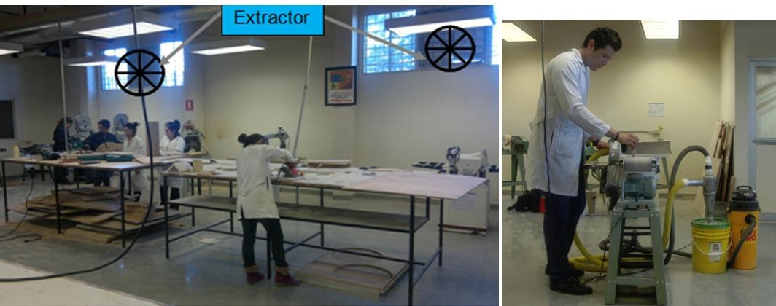

Figure 5. General and localized, ventilation to improve air and provide comfort in laboratory

RULA EVALUATION

RULA in Figure 6 requires new dimensions of machine design and research needed. Figure 7. It shows the RULA analysis in preparation for the Router. The result RULA was redesign the method of changing the Router
Students outside the percentile have problems to meet Wood projects, because they don't have enough comfort to operate the machines.

3.4 Principles applicable to workstations with 5 S - SMED

3.4.1 Implementation of 5 S

3.4.1.1 Order application in storage templates, tools and tooling
- Locating elements, often used, in the workstation.
  - About machine place frequently used items.
  - Outside of the place of use store elements of infrequent use.
- Elements that are used together to store them in sequence of use.
- Spaces must be larger, to place and remove items easily.
  - Store elements with similar functions.
  - Store together, elements that are used in similar products.

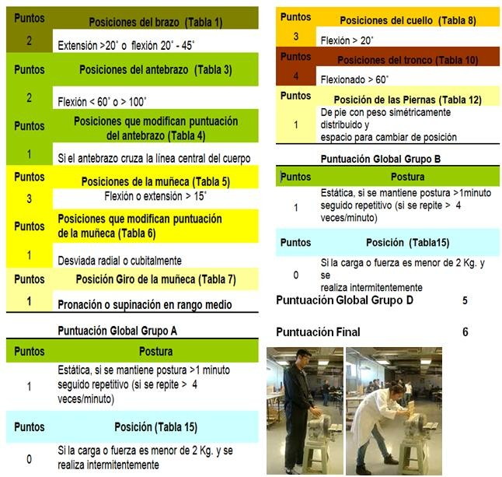

Figure 6. RULA to some students, who were left out of the original design of the Belt/Disc Sander

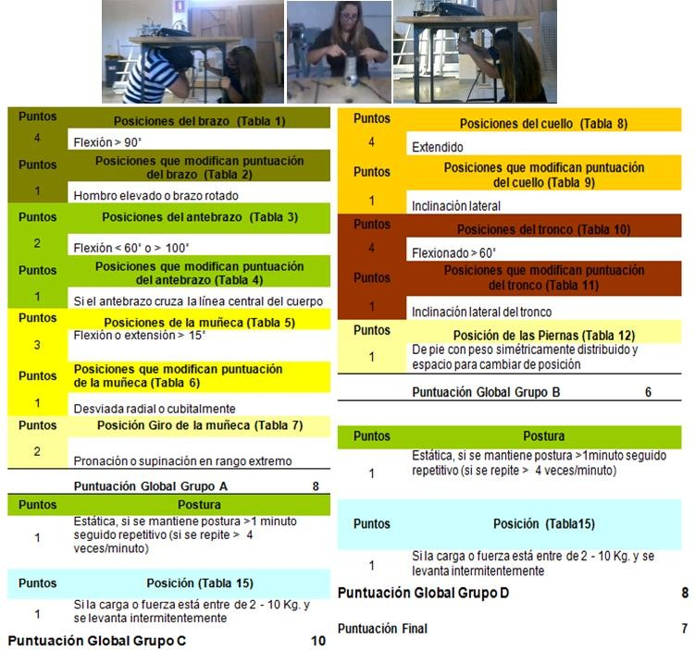

Figure 7. RULA analysis to change Router in 5 minutes

3.3 Anthropometric measurements
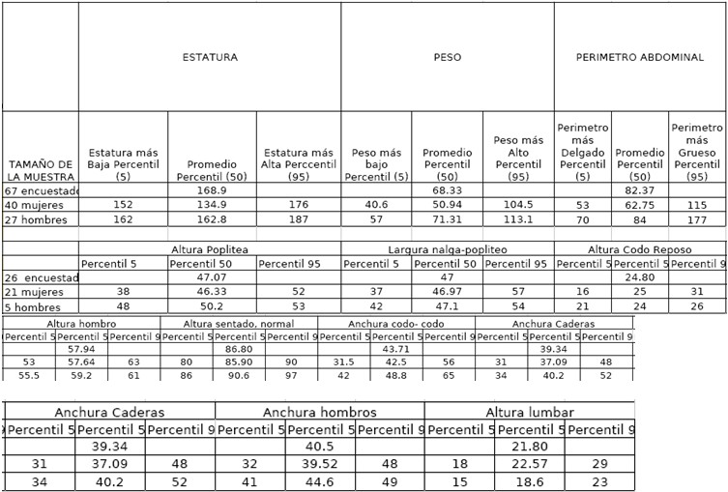
Figure 8. Measures anthropometric Faculty of architecture and design

      - Economy of movements to eliminate disorder

Can be eliminated, the disorder of movements, placing parts, machinery, tools and templates in the best locations
        - Decide, best locations, for machinery, equipment, tool and useful.
        - Delete disorder of movements of people, time, energy and effort in motion of feet, hands, arms or trunk, moving only what is necessary.
Principles to reduce or eliminate movements making operators (Hiroyuki 1990)
- Begin and end each movement, with both hands moving
- Trunk movements kept in minimum
- Using the force of gravity, rather than the muscular
- Avoid zigzag movements and sudden changes of direction
- Movement with stable rhythm
- Maintain posture and comfortable movements
- Use feet, to press the switches of the machines (position "on" and "off") where it is practical
- Keep materials and tools front
- Organizing materials and tools in order to use
- Use simple methods to supply and to remove materials 11.keep operators at a height appropriate for the work to be done

- Made that materials and parts may be clinging easily
- Design forms and positions of grips and handles for easy and efficient use

      - Identify locations and use map 5s to decide

Strategies for identify each element in each place.
Signs and cards to identify
- Names of areas of work
- Locations inventory
- Situations of storage equipment
- Standard procedures
- Machines disposal
- Identify stored on shelves of store inventory, which can be identified by a card
- Strategy of painting system, is used to create dividing lines between step and areas of work (areas of operation).
- Corridors should facilitate a fluid and step safe articles, having sufficient width and avoiding turns and abrupt changes.

      - Strategy of coding in colors
- Encoding colors to mark parts, tools, templates and tools to be used for each purpose
- Outlines strategy

    - SMED preparation of tools and templates as external preparation

      - Procedure before the improvement
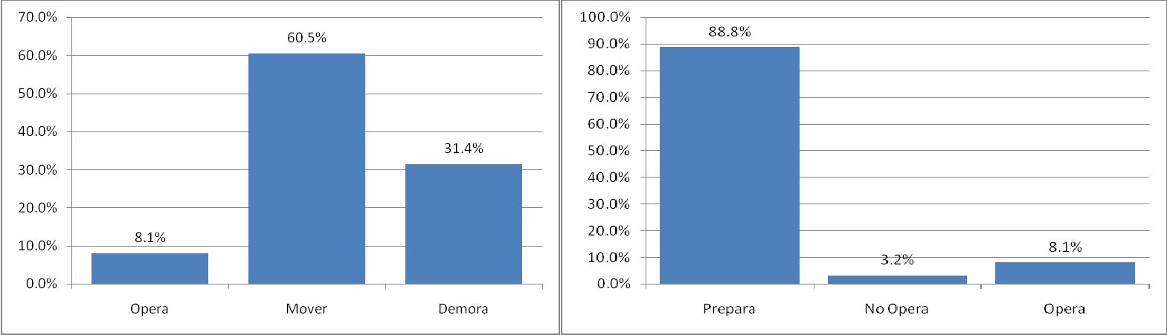
Figure 9. Results of change in Router before applying SMED, 5s, and ergonomics The results observed by the team's improvement, in videos of change Router are
displayed in Figure 9.
        - Change of Cutter of machine in 300 seconds,
        - Machining 1 router average 8 seconds
        - Machining 2 router average 6seconds
        - Search material, for machining, add time lost to process.

3.4.2.1 Procedure after improvement
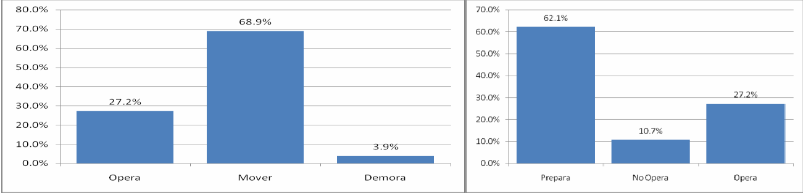

Figure 10. Results of the analysis after application of improvement with SMED phase 2, 5 S, and ergonomics

Phase 3. SMED
Refinement of external preparation

Improve external preparation, includes refining storage, transportation of parts and useful
methods to improve the organization of all elements
Keep everything in perfect condition and ready for the next operation Elements that should be as a reserve
SMED improves storage and transport

RESULTS

  - Results of the environmental project STPS
- noise decreased on average 34%, protecting the ears of each operator as a workaround.
- The lighting improved on average 33% (from 15% to 70%), not reached the required standards for ideal operation.
- Suspended particles decreased by 40%, the clothes already will not be so dirty. Traders are uncomfortable

Project results SMED, 5S and ergonomic improvement

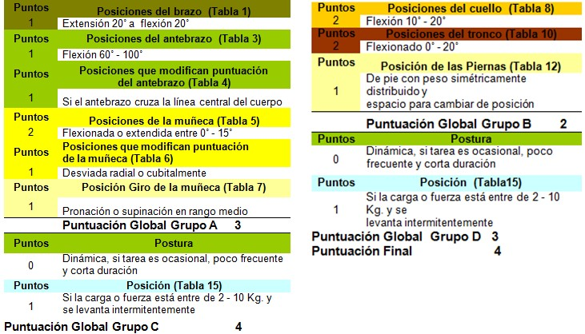

Figure 11. RULA analysis for improvement in setup Router proposal

- Requires changes in methods of operation, it is necessary to deepen
- Improves ergonomics in 42.9%, by RULA analysis in setup,
- Dropped to 78.7% in preparation of setup times
  - Preparation time, by ergonomic postures, fell 58.3%
  - Preparation time, by application of SMED and 5s, lean manufacturing reduced 20.4%
- SMED and ergonomic improvement up to 400% increased operation of machining
  - 2.3% increase to a 10.1% machining 1
  - 1.8% increase to 7.8% machining 2

CONCLUSION

- Decreased noise level in students by solution temporary using ear protection
- Improved the lighting in general
- Decreased particles in atmosphere
- Sawdust Separators are designed, to avoid problems in vacuum cleaners
- Redesign the workstation height, the population percentile of the anthropometric study served to buy existing equipment. Adjusted machines for students that do not come in percentile

- Decreased time of preparation, with tools SMED, 5S and improvement of ergonomic postures, assembly and disassembly of tools and templates

6. REFERENCES

Chiner Dasi Mercedes, Diego Mas J.Antonio, y Alcaide Marzal Jorge, (2004)
Universidad Politécnica de Valencia, Laboratorio de ergonomía, Alfaomega
(Hiroyuki, Hirano) Equipo de desarrollo de Productivity Press (1999). 5 S para todos, 5 pilares de la fabrica visual, Productivity Press
“Ley Federal del Trabajo y Leyes de Seguridad Social” (2009) Tax Editores unidos, S.A de C.V. México, D.F.
Mondelo, Pedro R, Gregori, Enrique, Blasco, Joan, Barran, Pedro, (2004) “Ergonomía 3 Diseño de puestos de Trabajo”, Ed. Alfaomega
Niebel/Frievalds, (2009) “Ingeniería Industrial, Métodos, Estándares y Diseño del Trabajo”, 12ª Edición.
(Shingo, Shigeo) Equipo de desarrollo de Productivity Press (1997). Preparaciones Rápidas de maquinas, El sistema SMED, Productivity Press
Villaseñor, Contreras Alberto, (2009) “Lean Manufacturing” ed. Limusa México, D.F. Zandin, “Manual del Ingeniero Industrial” quinta edición, ed. McGraw-Hill









