Chapter 11

Gamma Radiation as a Recycling Tool for Waste Materials Used in Concrete

Gonzalo Martínez-Barrera, Liliana Ivette Ávila-Córdoba, Miguel Martínez-López, Eduardo Sadot Herrera-Sosa, Enrique Vigueras-Santiago, Carlos Eduardo Barrera-Díaz, Fernando Ureña-Nuñez and Nelly González-Rivas

Additional information is available at the end of the chapter http://dx.doi.org/10.5772/60435

Abstract

Over the course of the last 50 years, a large number of major technological advances have contributed to the development of higher-strength, high-performance materials that provide excellent benefits. Nevertheless, in most cases, after a very short useful life, these products become waste material and contribute to environmental degra‐ dation. This situation has created an environmental crisis that has reached global proportions. In efforts to combat this issue and to promote sustainable development and reduce environmental pollution, some investigations have focused on recycling using innovative and clean technologies, such as gamma radiation, as an alternative to conventional mechanical and chemical recycling procedures. In this context, the reuse and recycling of waste materials and the use of gamma radiation are useful tools for improving the mechanical properties of concrete; for example, the compressive strength and modulus of elasticity are improved by the addition of waste particles and application of gamma radiation. In this chapter, we propose the use of gamma radiation as a method for modifying waste materials; for instance, polyethylene terephthalate plastic bottles, automotive tire rubber, and the cellulose in Tetra Pak containers, and their reuse to enhance the properties of concrete.

Keywords: Recycling, Waste materials, Gamma radiation, Concrete, Mechanical properties


© 2015 The Author(s). Licensee InTech. This chapter is distributed under the terms of the Creative Commons Attribution License (http://creativecommons.org/licenses/by/3.0), which permits unrestricted use, distribution, and reproduction in any medium, provided the original work is properly cited.

Introduction

Concrete is the most widely used structural material in the world, due to its easy preparation and low cost. Nevertheless, it has some disadvantages: a) pores, which can become entrance points for water, water vapor, gases and chemical substances that might damage concrete; b) the rapid deterioration in roughness of the concrete surface because of its high abrasion; c) poor resistance to aggressive substances and salty water; and d) low resistance to heating. One alternative for remediating these problems is the incorporation of polymeric materials, which bind well with mineral aggregates that are the main components of concrete.
Currently, because of the more stringent legislation regarding the environment and the market demand for environmentally friendly products, manufacturers are interested in developing approaches aimed at reducing the environmental impact of industrial processes through reductions in the amount of residues produced or by treating those that are inevitably generated. The environmental damage caused during the extraction of raw materials, as well as the high cost of extraction methods, provides good motivation for the use of industrial and domestic residues as substitutes or complements of fresh materials in several areas of manu‐ facturing. The depletion of reliable, secure raw material reserves and conservation of non- renewable sources are also incentives to develop ways to reuse waste materials.
In recent years, various tools and strategies have been proposed to meet environmental challenges within the building industry, including a) increasing the use of waste materials, especially those that are by-products of industrial processes; b) using recycled materials instead of natural resources, which will make the industry more sustainable; and c) improving durability as well as mechanical and other properties, thus reducing the volume of construc‐ tion replacement materials for structures that are damaged or destroyed.
In principle, the molecular structure of composite materials can be modified using gamma radiation. Cross-linking and polymer degradation (by chain scission) can occur with radiation; the chemical composition of the polymer is the key factor determining the extent to which these processes occur. Materials with superior properties can be obtained from recovered scrap polymer cross-linked by gamma radiation. The application of radiation technology in the recycling of polymers is a good option from both an economic and ecological point of view.
The purpose of this chapter is to show how the combination of gamma radiation with waste and recycling materials can provide alternative tools for improving the physical and chemical properties of concrete. Waste materials such as polyethylene terephthalate (PET) bottles, tire rubber, and cellulose in Tetra Pak containers are discussed in terms of their physicochemical modification by radiation and their use in enhancing the properties of concrete. Such infor‐ mation is focused on contributions to improving the care of the environment.

Recycled and waste materials used in concrete

In light of the growing awareness of environmental concerns, the use of waste materials in industrial processes is an attractive area of opportunity. The recovery and recycling of solid

waste has long been the subject of research. Its use in building, road construction and paving materials is beneficial in helping to reduce environmental pollution and as a solution to waste disposal issues [1, 2].
Solid waste is classified by its chemical nature as organic and inorganic. Glass, ceramics and metals such as aluminum used in packaging materials are the main components of inorganic solid waste; others include zinc, copper and iron [3]. In the case of organic solid waste, one of the most representative components is polyethylene terephthalate (PET). In 2007, the world’s annual PET consumption comprised 250,000 million bottles (10 million tons of waste). In the United States 50,000 million bottles are discarded in landfills each year. Since PET waste is not biodegradable, it can remain in the environment for hundreds of years. PET waste can be used to produce an unsaturated polyester resin (UPR) in the presence of glycols and dibasic acid. This material can serve as a binder to produce polymer concrete (PC) with high compressive strength. With a PET/glycol ratio of 2:1, higher compressive strength of polymer concrete can be obtained [4].
Due to the increasing number of cars worldwide, the accumulation of huge volumes of discarded tires has become a major waste management problem. In 2002, approximately 275 million of scrap tires were generated in the U.S., 110 million in Japan, and 37 million in the UK. Over 100,000 tons of waste tires are generated annually in Taiwan. The final disposal of used tires is a major environmental concern; landfills where tires are discarded represent a severe fire and health hazard. Burning tire scrap to provide energy for the production of vapor or electricity is one of the most common methods for eliminating tire waste [5]. The use of waste tires as alternative fuel in cement furnaces has been established across the U.S. and Europe. Applications utilizing waste tires include the bituminous hot mixing of pneumatic dust for agglutinative modification in asphalt pavement [6, 7]. Another alternative is its use as a substitute of fine or coarse aggregates in concrete. Its characteristics can improve the mechan‐ ical properties of concrete such as strength and modulus of elasticity over those achieved by sand or stone.
Recycling of waste tires in the construction industry can aid in preventing environmental pollution and in the design of more economically efficient buildings. In this respect, the use of waste tire rubber in ready-mixed concrete has become increasingly popular globally, gener‐ ating significant research interest in the last two decades. A modest quantity of unprocessed scrap tires is used to provide shock protection for marine platforms against the impact of waves or ships. In some regions of the world, people still resort to burning tires, which produces unacceptable levels of pollution. As such, new and innovative techniques to promote recycling are important. Many countries avoid/forbid the stockpiling or landfill of waste tires, providing a significant incentive for investigating recycling strategies. One of such strategies involves the transformation of scrap tires into alternative aggregates, generating increased economic value while reducing aggregate consumption [8].
Materials from tires are used in a variety of elastomers and plastic products, as well as for asphalt rubber (AR) pavement. Oxychloride cement is a binder for rubberized concrete mixtures. In a recent study, asphalt rubber was prepared in two ways, one with a gap-graded design and the other using open gradation. The results showed satisfactory performance and

the potential for household use. The wet process is the most suitable for normal asphalt mixtures with ground tire rubber (GTR). It is worth mentioning that rubber asphalt mixtures meet ASTM International specifications. Through the use of different concentrations of AR and GTR, modified asphalt can represent a superior alternative to conventional mixtures for use of local materials and paving techniques [7].
In a study,, the mechanical properties of polymer concrete made from reinforced epoxy powder tire rubber were studied. Mixtures were optimized using direct neural modeling and reverse neuronal modeling at minimal cost; in this case, the most important cost variable is resin content. Direct neural modeling gave the optimum composition for obtaining maximum values of compressive, flexural and tensile strength. Reverse neural modeling was used to analyze the maximum values of mechanical properties obtained with varying concentrations of the epoxy resin powder. The results show a high resistance to compression for composition of 0.215 (weight fraction) for epoxy resin and 0.3 (weight fraction) of tire powder. The maxi‐ mum flexural strength of 0.23 was obtained with 0.17 resin tire powder epoxy, and maximum tensile strength for the 0.24 and 0.17 resin [9].
The use of tire rubber as aggregate reduces the compressive strength of the concrete, which may limit its usefulness in some structural applications. Nevertheless, it has desirable charac‐ teristics including lower density, higher impact resistance and toughness, higher ductility, and better sound insulation properties. These features may be advantageous for a variety of construction applications, such as access roads. A significant reduction in used tire waste could be accomplished by using scrap tires for concrete-coated tire rubber particles. The use of magnesium oxychloride makes it possible to produce high-strength concrete with better elastomer adhesion characteristics and with significantly improved performance. Moreover, the adhesion between tire rubber particles and other constituent concrete materials may be improved by pretreatment of the aggregates of magnesium oxychloride tire rubber. Adhesion depends on several factors, including size and concentration of tire particles, type of cement, the use of chemical and mineral additives, and methods of pretreating tire rubber particles. In terms of size, it is possible to use tire powder in both mortars and concrete [10]. Additionally, higher amounts of textile fibers (from used tires in plasters and plasterboards of pressed gypsum) cause less resistance reduction compared to plaster without additives.
Composites incorporate various waste materials, including granulated cork, cellulose fibers from waste paper, and fibers from the recycling of used tires. Several studies have concentrated on developing new composite materials through the use of different processes for composite production, including simple molding or pressing.
The main components of natural fibers are cellulose, hemi-cellulose and lignin, with minor concentrations of pectin, waxes and water-soluble substances. Linear cellulose molecules are linked laterally by hydrogen bonds to form linear bundles, giving rise to a crystalline structure. The degree of crystallinity is one of the most important structural parameters of cellulose. The rigidity of cellulose fibers increases, while flexibility decreases, with an increasing ratio of crystalline to amorphous regions. Moreover, the addition of cellulose fibers improves the bending behavior of the composites [11].

Some of the most important waste materials are those containing cellulose, for example, Tetra Pak containers. Such packaging is made from three raw materials: paper (about 75
%), low-density polyethylene (about 20 %) and aluminum (about 5 %). Discarded contain‐ ers are recycled through a simple, well-established process called hydropulping. In this process, the cellulosic fibers are separated from thin layers of polyethylene and alumi‐ num. Most of the waste from the paper industry is known as paper sludge (PS), which is burnt and becomes PS ash. It is used as a soil improvement material and raw material for cement. PS ash increases the strength of extremely stiff concrete with its high water absorption capacity. It can be added to concrete, and undergoes a pozzolan reaction with calcium hydroxide due to the hydration of cement, resulting in an obtained material with increased compressive strength relative to concrete without PS ash. The material contains
38.1 % silica (SiO2), 21.4 % alumina (Al2O3) and 28.9 % CaO [11]. SEM images of PS ash show particles with a rough shape, but no spherical particles are present. Typical concen‐ trations are 200 kg/m3 of cement and between 100 and 300 kg/m3 of PS ash. Plant fibers and ‘‘man-made’’ cellulose fibers are used as substitutes for asbestos fibers in cement matrices; they show comparable properties at lower cost, with values essentially depend‐ ent on the properties of the fiber and the adhesion between fiber and matrix [12].
For the preparation of composites, paper recovered from packaging has been utilized, with the pulped fibers composed of 40 % resinous wood, 35 % Alfa grass (Stipa tenacissima L.) and 25 % leafy wood. The fiber sizes are classified as fine for values < 1.25 mm and coarse for values of > 1.25 mm to < 5 mm. The results show that compressive strength decreases as pulped fiber content increases, largely due to the fact that increasing fiber content induces more voids that reduce weight and weaken the composite. When waste fibers are added to cement, the amount of water for the preparation increases to compensate for the water absorbed by the fibers; thus it is necessary to calculate the water/cement ratio (W/C). For a composite with 10 % fibers (W/ C = 0.56), SEM microscopy images show agglomerations of fibers in non-homogeneous dispersion. When an additional water quantity is added (W/C = 0.64), better dispersion of fibers is observed, but strength decreases because of the voids formed by the added water.
Thermal conductivity, κ, is a measure of thermal insulating efficiency of materials; when cellulose fibers are added to composites (2–16 % by weight), thermal conductivity values diminish, and consequently energy is saved. The fibers are thus used as cement replacement. This behavior is due to the porosity that occurs in the packing of fibers that is induced by bubbles of air formed during the mixing operation, and to the insulation properties of the fibers themselves. When more voids are in the mix, a lighter composite specimen is obtained and its thermal conductivity is diminished.
Cellulose fibers have been used as cement replacement in lightweight concrete; the fibers were recycled from packages and mixed at concentrations up to 16 % by weight. Results of studies showed that an increase in the fiber content led to a reduction in the compressive strength of concrete and an improvement in thermal insulation properties, along with a homogeneous distribution of fibers in the matrix, when an appropriate water−cement ratio was used. Better thermal insulation of the cement matrix and low density provide for a lightweight construction

material. This type of lightweight concrete is used for the construction of partition walls (compressive strength 8.6 MPa), partitions, ceilings and roofs [13].
One important alternative for recycling PET materials is their use as concrete aggregate substitutes. Given the technological demands in the construction area, studies are explor‐ ing the possibility of generating alternative materials with increasing functionality, lower cost, and better physical, chemical and mechanical properties than those of conventional materials [14, 15].
In the last two decades, virgin polymers used in road surfaces have shown advantages by virtue of certain improved characteristics of these materials. Researchers have used different polymers which, when properly mixed with asphalt, have resulted in improved road surface yield and lifespan. However, waste polymers can be dangerous and remain in the environ‐ ment; and thus it is important that they would be recycled or reused effectively.
Road surface yield can be improved through modification of the asphalt with various sub‐ stances, most of which are virgin materials that are scarce and costly. An alternative is the use of waste materials, such as plastic bottles, which can help reduce waste material and potentially improve its yield [16]. To improve concrete ductility, PET fibers from plastic bottles have been used. Results show that the addition of only a few fibers has a considerable influence on the concrete post-cracking. Both type lamellar and type O fibers improve concrete hardness. The latter helps to join together the concrete of each cracked section side [17].
Various studies have predicted the long-term creep of polymer concrete containing CaCO3 and fly ash particles, as well as recycled PET resin, through short-term creep experiments. Results have shown more rapid creep deformation of early-age concrete with PET in comparison to ordinary concrete deformation. More than 20 % of the long-term creep occurs during the first two days, and 50 % during the first 20 days. Furthermore, creep deformation of polymer concrete without reinforcement is greater than that for concrete with CaCO3, due to the higher surface area of CaCO3 particles. Reinforcement plays an important role in reducing polymeric concrete deformation. Creep values increase with an increase in applied effort, although the increases are not proportional, due to the viscoelastic, non-linear behavior of polymeric concrete with recycled PET [18].
Concrete has been manufactured with up to 3 % recycled PET bottle fibers. The main concern in the development of PET fiber is its alkali strength; however, research has found that this is not an issue for fiber used in concrete. PET fiber has been used for tunnel pulverization and covering, including motorbike tunnels. Future applications include underground structures found in hostile environments, for example, near the coast or in the sea. Moreover, it can be considered use as pavement in narrow, winding and steep roads. In a comparison study of PET with other fibers, moisture levels of PET fibers were found to be lower than those of polyvinyl alcohol (PVA) fibers but higher than polypropylene (PP) fibers [19].
To reduce cracks in concrete, PET particles obtained from recycled bottles, with lengths of 10, 15 and 20 mm and concentrations of 0.05, 0.18 and 0.30 % by volume, were added. Bending and impact tests were carried out at 28 and 150 days. Significant effects on compression strength values were observed with the addition of fiber. Moreover, Young modulus values

were reduced with higher fiber content, where surface changes occurred according to the increment of the fiber concentration.
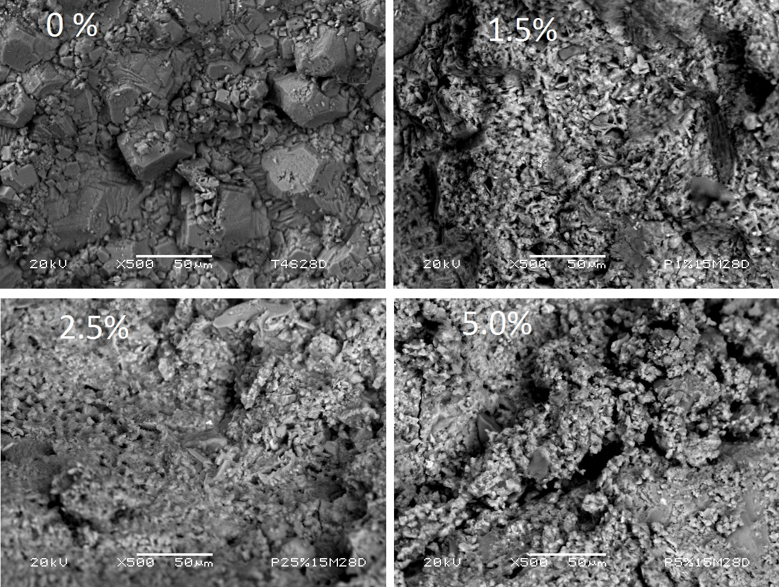Compressive strength of concrete is dependent on PET concentrations. Such behavior can be explained in terms of the surface characteristics of concrete with PET particles (Figure 1). For concrete without PET particles, dispersed particles of mineral aggregates (sand and gravel) show rough surfaces (0 % PET). At lower concentrations, PET particles cover the mineral aggregates, and more rough surfaces are detected (1.5 % PET). Concrete surface morphology changes with increased concentration of PET particles, and the mixture produces a more homogeneous surface, with some compact regions (2.5 % PET). However, when PET particle concentration is further increased (5.0 % PET), regions with some cracks are observed.

Figure 1. Concrete with different concentrations of PET particles

In another study investigating curing time, it was observed that, at 28 days, the flexural, impact and tensile strength were increased with the presence of fibers. However, at 150 days, this improvement was no longer present, as a result of fiber fragilization and degradation in the alkaline concrete environment. After a year, porosity was increased in concrete with fibers. In view of the important aspects of sustainability, such as the use of

recycled materials in construction, fibers obtained from recycled PET bottles are an alternative in reinforced concrete [14].

Structural modification of waste materials using gamma radiation

Gamma rays are produced in the disintegration of radioactive atomic nuclei and in the decay of certain subatomic particles. The commonly accepted definitions of the gamma ray region in the electromagnetic spectrum include some wavelength overlap. Gamma ray radiation has wavelengths that are generally shorter than a few tenths of an angstrom, and gamma ray photons having energies greater than tens of thousands of electron volts [20].
The effects of gamma radiation on polymers are usually evaluated through changes in their chemical structure and mechanical behavior. These modifications occur as a result of reor‐ ganization of chemical bonds, which allows an increase in the degree of polymerization or structural reticulation. Polymers have been modified with the purpose of optimizing proper‐ ties and increasing their compatibility in composite materials [21].
Gamma radiation is being used successfully today for post-consumer plastics recycling. Such technology is feasible from both an ecologic and economic point of view. Among the most important benefits of this application are the following: a) improvement in mechanical properties and performance of recovering polymers or polymer mixtures, mainly through cross-linking or modification of several combined-phase surfaces; b) more rapid polymer decomposition, particularly by chain scission, which produces low molecular masses that can be used as additives or raw materials in several processes; and c) advanced polymeric materials production, designed specifically to be environmentally compatible [22].
The effects of gamma radiation on PET have been evaluated in several studies. For example, the processes involved in PET degradation induced by radiation were assessed through the use of electron spin resonance (ESR) and optical absorption spectroscopy. PET films were irradiated at a temperature of −196 °C in darkness. Upon irradiation, the film changed to reddish purple in color, which enabled the detection of PET radical ionic species by ESR [23]. In another work, a photosensitization process through gamma radiation was carried out; changes were followed by infrared spectroscopy and reversed-phase high-performance liquid chromatography. PET break zones were observed as well as the formation of terephthalic acid as a result of radiolysis [24].
Results of studies on the effects of gamma radiation on packaging PET films in the 0–200 kGy dose range demonstrate that diethylene glycol content increases at low doses (5–10 kGy) but decreases at high doses (30–200 kGy). While molecular mass, intrinsic viscosity and terminal carboxyl groups decrease slightly at doses greater than 60 kGy, permeability, thermal prop‐ erties, color, and surface resistivity are not significantly affected at any dose [25].
The morphology of the surfaces of recycled PET particles were evaluated by scanning electron microscopy (SEM); particles varied in size from 0.5 to 3.0 mm and were obtained following a

cutting process of PET bottles. After irradiation, several changes on the surfaces were observed, as shown in Figure 2.

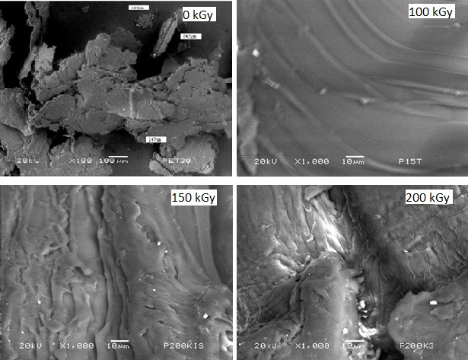DSC, X-ray photoelectron spectroscopy, SEM, and molecular mass determination were used to evaluate the effects of gamma radiation on PET in varying doses up to 15 MGy at a ratio of

Figure 2. SEM images of non-irradiated and irradiated recycled PET particles

The thermal behavior of gamma-irradiated amorphous PET films under environmental conditions was studied for doses up to 3.5 MGy at a rate of 28 kGy/h. Differential scanning calorimetry (DSC) was used to determine the glass transition temperatures (Tg) and degrees of crystallinity. The results showed that both Tg and heat capacity decreased as the dose was increased, which was due to the breaking processes in polymeric chains. It is possible to conclude that Tg could be used as an indicator of dose absorption ratios in PET [26].
1.65 MGy/h. A decrease in molecular mass was observed at a dose of 5 MGy, which was attributed to polymer chain scission; however, molar mass increased at doses greater than 5 MGy, due mainly to recombination and branch formation [27].
X-ray diffraction and UV spectroscopy were used to evaluate the optical and structural properties of irradiated PET in the 0–2 MGy dose range. The diffraction pattern revealed the

PET semicrystalline nature, with crystallinity increased as the radiation dose increases. UV analysis revealed an increment in both activation and absorption energies, but the forbidden band decreased at a higher applied dose [28]. Another study in which PET bottles were irradiated at doses from 0 to 670 kGy, the results showed an increase in both crystallinity and crystal size in the formed particles after irradiation [29].
The effects of gamma radiation on the mechanical and thermal properties of recycled PET mixtures with low-density polyethylene (LDPE) and ethylene vinyl acetate (EVA) were studied using applied doses of 25, 50, and 100 kGy. The results showed maximum cross-linking chains for 10 % of recycled PET irradiated at 100 kGy [30].
An ethylene–methyl acrylate–glycidyl methacrylate monomer was grafted into PET through gamma radiation. The formed elastomer shown a 30 % increase in impact strength, with only
0.1 % terpolymer mass, compared with the non-irradiated mixture. From these observations it can be concluded that gamma radiation is a very adequate technique (on-site) for improving the compatibility of polymers in composites [31].
A study of thermoplastic aromatic polyesters (used for their electrical insulating capacity) showed stable polymeric chains due to the presence of benzene rings upon irradiation with doses up to 1 MGy. For higher doses (5 MGy), irradiated PET samples showed diminution of molecular mass due to chain scissions [13].
Some investigations focusing on the effects of gamma radiation on the physicochemical properties of cellulose have been described; the results show that an increase of 25 kGy (on average) caused a loss of 1 % in cellulose crystallinity in a dose range of 0–1 MGy. Cellulose shows degradation (from 6 to 12 %) at up to 31.6 kGy, and the degree of crystallinity is unchanged up to 300 kGy. The degree of polymerization (DP) is obtained up to 1 kGy; this decreases above 10 kGy. Moreover, changes in specific gravity and lattice constant are observed up to 1 MGy, with complete degradation of cellulose at 6.55 MGy.
In cellulose, there are amorphous zones along the microfibril length in which the crystallinity is interrupted. These zones allow the penetration of chemicals into the microfibrils. Further‐ more, gamma radiation causes the breakdown of cellulose into shorter chains, which are water- soluble, and also leads to an "opening of additional micro-cracks” that are easily penetrable by water molecules.
Figure 3 shows SEM images of irradiated recycled cellulose. For non-irradiated cellulose, smooth and homogeneous surfaces are observed, and some particles are present. When the radiation dose is increased to 50 kGy, more dispersed particles and some cracks are observed; for higher doses, more space between cellulose surfaces appears, together with small voids. Such modifications can be attributed to the main effects produced by gamma radiation: scission and cross-linking of molecular chains in cellulose.
In Figure 4, the surface characteristics of the recycled tire particles are shown. Non-irradiated particles show a homogenous surface, while particles irradiated at 200 kGy show roughness and voids on the fiber surfaces. Incremental doses of gamma radiation provoke more damage to the surface, and voids are formed (greater than 100 μm). Finally, with irradiation at 300 kGy,

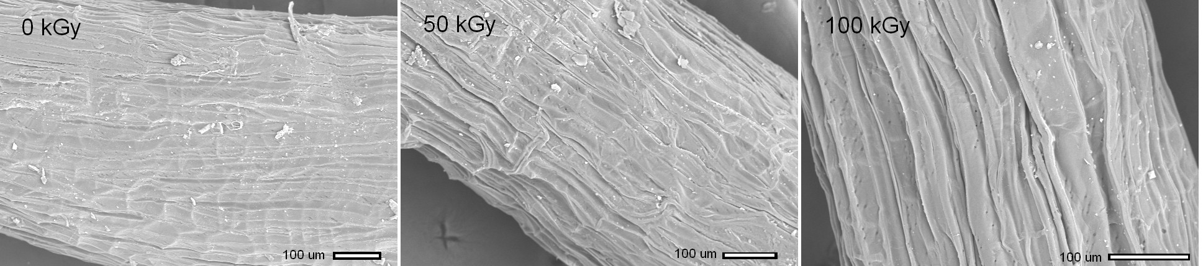
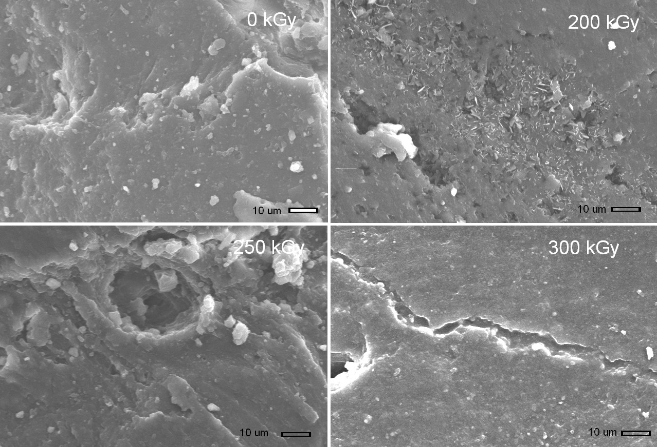
Figure 3. SEM images of non-irradiated and irradiated cellulose fibers

the surface damage is more prominent, showing large cracks as a consequence of gamma radiation.
Figure 4. SEM images of non- irradiated and irradiated tire rubber particles

Concrete with waste and recycled materials: Effects of gamma irradiation

The use of gamma radiation presents significant advantages for PET recycling and for improving the mechanical properties of concrete, which can be explained by changes in the chemical structure of the surface. Gamma radiation accelerates the initiation of polymerization

of a monomer into the ceramic matrix, and can provide considerable benefits, the most important of which is better adhesion between the fibers and matrix [32]. The main mechanical properties analyzed in concrete are strain, compression, and impact strength, deformation in the yield point and breakdown, as well as deformation values and elasticity modulus.
Some studies have investigated the effects of ionizing radiation on polymer–ceramic composite materials. For example, in gypsum/poly(methyl acrylate) composites, polymerization yield increased with increasing radiation dose. A yield of 87-88 % was obtained at doses of 3–4 kGy. Since this process is carried out at room temperature, there is substantial economy of heat energy in addition to reduction in cost of keeping the composite under pressure. The pressure allows much of the monomer (usually with high volatility) to fill the interstices of the ceramic matrix during the conversion to ceramic–polymer composite.
There are a few studies on the effects of gamma radiation on concrete [33–35]. The effects produced can be controlled through the use of appropriate radiation doses. For instance, it is possible to modify the surface to obtain a rougher and more cracked material, allowing for greater compatibility with the cementitious material [34].
For concrete with irradiated waste tire particles, compressive strength values followed similar patterns. The values decreased as particle concentration increased, with values ranging from
7.4 to 17.5 MPa. The highest value was for concrete with 10 % of particles 2.8 mm in size; this value was 27 % lower relative to that of the control concrete. Concretes with particles 2.8 mm in size had larger values than those with 0.85 mm particles. The concretes with 20 or 30 % of particles had higher values in comparison to concrete with non-irradiated particles. Thus, the use of larger particle sizes is more efficient than using smaller particles.
The mechanical properties of concrete are dependent on the size and concentration of the waste tire particles. Compressive and tensile strength values are reduced by the presence of these particles, as they promote stress concentration zones and introduce tensile stresses into concrete, resulting in rapid cracking and concrete failure. Nevertheless, in some cases, improvement in mechanical properties is observed when gamma radiation is applied to the waste tire particles. It appears that the best results are obtained in concrete with 10 % irradiated particles 2.8 mm in size. Concrete with irradiated particles can receive up to 30 % of tire particles, helping to reduce the final cost of the concrete.
Changes in mechanical properties may be related to morphological changes that occur in the fracture zones of concrete specimens, as illustrated in Figure 5. For non-irradiated concrete, a rough surface can be seen (0 kGy); when a radiation dose of 200 kGy is applied, the dispersed particles are covered with irradiated tire fibers as a consequence of the scission of the polymer chains. At a higher dose, 250 kGy, the tire rubber fibers continue to cover the hydrated cement particles, as evidenced by the presence of cross-linked regions accompanied by larger quan‐ tities of ceramic particles. Strong bonds are progressively developed between tire particles and cement matrix with incremental irradiation.
Concrete acting as a binder mixed with crumb rubber can produce more flexible concrete blocks, thus providing a softer surface. The crumb rubber block produced for pedestrian pavement also performs quite well in terms of both skid and abrasion resistance. One of the

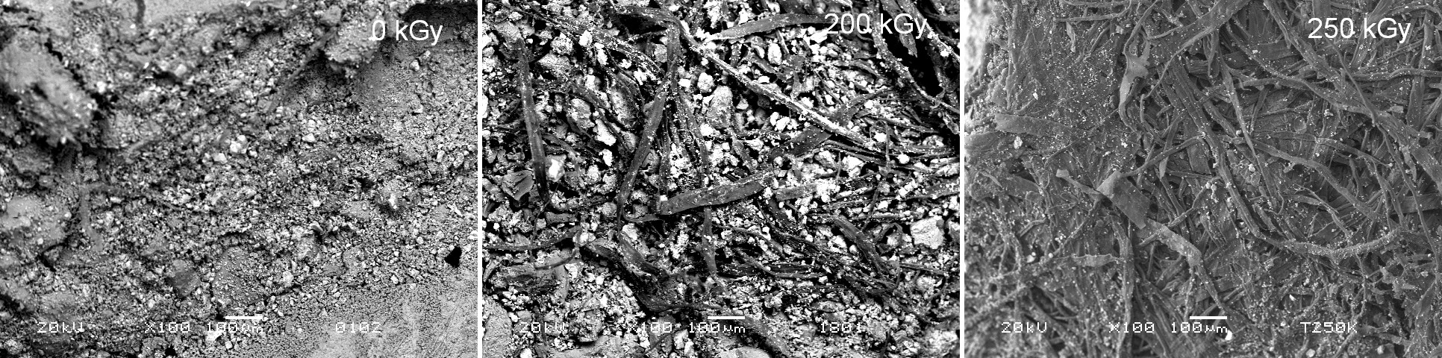

Figure 5. SEM images of gamma-irradiated concrete with tire rubber fibers

clearest effects of irradiation of thermoplastic/elastomer blends is the change in tensile strength due to their cross-linking and degradation. These values increase with doses up to 150 kGy and then decrease as the dose is increased to 250 kGy. At any dose, however, tensile strength values decrease as the ratio of ground tire rubber (GTR) into the blend increases. The GTR particles separate the molecules of ethylene propylene diene monomer (EPDM) and high- density polyethylene (HDPE), and hence retard the formation of cross-linking. Moreover, a higher ratio of GTR indicates the presence of more spaces in the polymeric network due to the incomplete cross-linking of GTR. Therefore, it may be concluded that the presence of GTR reduces the cross-linking of EPDM and HDPE and cannot protect the blend from deterioration, particularly at higher doses, thus acting only as filler [36].
Waste tire rubber has been used to produce a composite used in a multilayer plate subjected to the direct impact of a bullet, in which a sandwich of soft and hard materials is used to stop the ballistic force. The role of the soft layer, which is rubberized concrete, is to act as a cushion to absorb some of the total energy, thus reducing the impact force reaching the hard layer. This results in a delayed response time at the beginning of the impact event, decreasing the acceleration peak and lowering the vertical displacement of the center of mass [36].
The elongation of blends with different composition decreases when the dose is increased. With a larger dose, more cross-linking is produced in the sample, which prevents structural reorganization during drawing and reduces internal chain mobility and elongation [37].
In real applications under practical or engineering conditions, polymer-based materials such as blends are not stretched until they undergo rupture. Therefore, despite the improved mechanical properties, the tensile strength measurements are not adequate. The property that measures the resistance to a limited strain deformation of polymeric materials under practical applications is the tensile modulus at 100 % elongation. Radiation-induced cross-linking in polymer materials should be reflected by an increase in hardness. The hardness values of all blends increase slightly with doses up to 250 kGy, and hardness values decrease with increas‐ ing GTR content. The high degree of crystallinity of HDPE has a significant effect on hardness. Temperatures of the maximum rate of reaction (Tmax) taken from the thermogravimetric analysis, thermogram show an increase with an increasing ratio of GTR up to 33 %, and then a decrease at higher ratios.

In general, the higher thermal stability of the composition containing GTR compared to the EPDM/HDPE blend is due to the oxidative degradation of the GTR and the formation of carbonyl groups with higher dissociation energy than that of CH groups. SEM images of blends with different composition show that EPDM and HDPE are non-compatible polymers. However, upon irradiation, the surface is homogeneous and smooth, and exhibits no indica‐ tion of phase separation, due to the occurrence of cross-linking between the incompatible polymers. The appearance of white particles across the SEMs indicates the non-compatibility among EPDM, HDPE and GTR. Meanwhile, the presence of GTR does not affect the cross- linked polymer matrix. These features increase with the ratio of GTR, which may explain the decrease in tensile and hardness properties associated with the introduction of GTR [38].
Compressive strength values of concrete with waste cellulose were obtained. Concrete without waste cellulose at 28 days of curing had the highest compressive strength value, 21.7 MPa. Some general patterns were observed. The values gradually decreased as cellulose concentra‐ tion was increased. Concrete with 3 wt% of waste cellulose had a minimal difference (5 %) relative to control concrete (without cellulose). This did not occur for concrete with 7 wt% of waste cellulose, as it had a 47 % reduction. The compressive strength values increased with longer curing time, no matter of the percentage of cellulose.
Such reductions in values can be explained in terms of waste cellulose added. The strength is dependent on the amount of waste cellulose and water cement ratio (w/c). Cellulose, which is hydrophobic in nature, can be substitute for up to 7 wt% of sand in the mixture, and thus a greater amount of water is available to interact with the surface of non-hydrated grains of cement particles. As a result, weak interfacial adhesion between cellulose and hydrated cement particles is obtained, and consequently, a reduction in compressive strength values is ob‐ served.
Recovery of these materials has long been the subject of research. Other characteristics, such as electric properties, have been studied for irradiated PET covering a dose range from 100 kGy to 2 MGy; both \conductivity and electric constant values increase with the increment of irradiation dose. This raises the possibility of using PET films in electronic components such as capacitors and resistors. With irradiation at low doses (8, 10 and 15 kGy), two types of laminated PET films showed improved physical and mechanical properties at 15 kGy [3].
A study of concrete reinforced with waste PET particles found that non-irradiated concrete followed typical behavioral patterns for compressive strain, increasing progressively with incremental PET particle concentration, but no such pattern was observed for compressive strength or elasticity modulus. Minimal value is obtained for compressive strength and maximal value for elasticity modulus when adding 2.5 wt% of PET. Both compressive strength and elasticity modulus values are maximal when adding 0.5 mm PET particles to concrete.
Different behaviors can be observed with irradiated versus non-irradiated concrete. When PET concentration is increased, the compressive strength values diminish, and a notable reduction in compressive strain is obtained. However, elasticity modulus exhibits the opposite behavior with non-irradiated concrete. In this study, at 2.5 % PET, a minimal value was observed. With regard to PET particle size, a similar behavior for non-irradiated concrete was observed:

maximal values for both compressive strength and elasticity modulus are obtained by adding a 0.5-mm particle. In general, irradiated concrete containing PET particles had similar elasticity modulus, higher compressive strength, and lower compressive strain values compared to non- irradiated concrete.
Since compressive strength of concrete is one of the key structural design parameters used by engineers, waste PET particles can provide suitable material for construction. A small amount of PET (5.0 %) substituted for fine aggregates in the mix design can increase strength as much as 23 % and diminish strain up to 26 %. Thus irradiation represents a useful tool and suitable method for recycling waste PET.
In one study, recycled PET was incorporated into hydraulic concrete as a substitute for sand, and the effects on mechanical properties (compressive strength, elasticity modulus and unitary deformation) were evaluated. The considered variables were particle size (0.5, 1.0 and 3.0 mm), volume PET concentration (1.0, 2.5 and 5.0 %) and gamma radiation dose (100, 150, and 200 kGy). Results showed that samples irradiated at a dose of 100 kGy exhibited greater compres‐ sion strength (between 15 and 35 %) than non-irradiated specimens. In addition, compression strength decreased with increasing PET particle size, regardless of the percentage used [39].
In the case of samples irradiated at 150 and 200 kGy, a 50 % increase in mechanical strength was observed in comparison to samples irradiated at 100 kGy. However, no difference in strength was obtained for samples irradiated to 150 and 200 kGy with PET at any size or concentration. With regard to elasticity modulus, values were similar for both types of specimens, with an inverse relationship existing between mechanical property and PET particle size: the smaller the size, the greater the elasticity modulus. Finally, with respect to unitary deformation, the values obtained from irradiated specimens were between 20 and 70
% less than those of non-irradiated samples, as shown in Figure 6.
Reductions in compressive strain values are due to irradiation effects in both cement paste and PET particles. Irradiation causes chain scission and generation of free radicals, which can cause bonds to form in hydrated cement paste, and consequently produces a hard rather than ductile material. A SEM image of irradiated concrete with 1.0 % PET 0.5 mm in size shows a homo‐ geneous distribution of PET particles; when PET particles are added (2.5 %), morphological changes in the homogeneous regions of hydrated cement with irradiated PET particles can be observed. With higher PET particle concentration, inhomogeneous surface areas with fewer hydrated regions are detected. These morphological changes are not enough to cause a significant difference in compressive strain values, as minimal differences are observed among them, independently of PET size and concentration.
In a current study, gamma radiation and waste cellulose were investigated as tools for improving the mechanical properties of cement concrete. Waste cellulose was obtained from Tetra Pak packages. A simple and inexpensive process was sought, as well as a contribution to environmental care. Prior to the preparation of concrete specimens, one set of waste cellulose particles with an average size of 0.5 mm was obtained from Tetra Pak containers, and was used in concentrations of 3, 5, and 7 wt%; these values were selected in order to avoid problems related to homogeneity and workability.

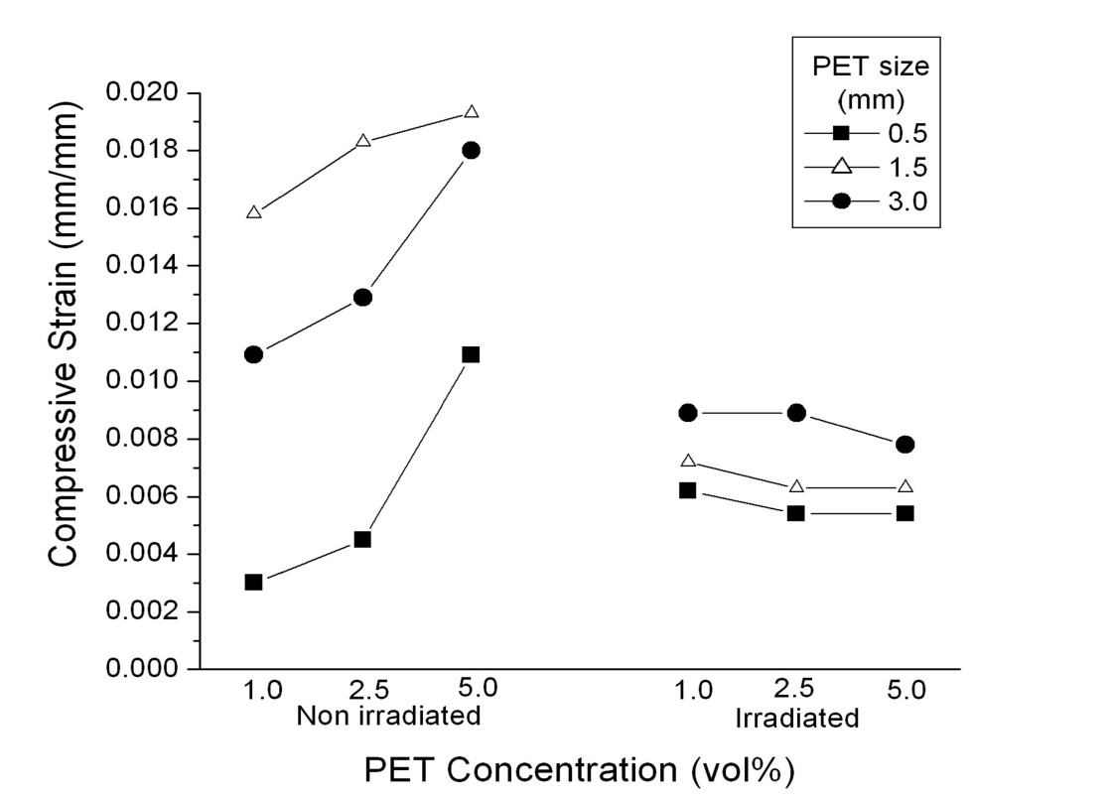Figure 6. Compressive strain of non-irradiated and irradiated concrete with PET particles

Compressive strength values of non-irradiated concrete with waste cellulose demonstrated that concrete without waste cellulose after 28 days of curing had the highest compressive strength value. Some characteristic patterns were observed. The values gradually decreased as cellulose concentration was increased. Concrete with 3 wt% of waste cellulose had a minimal difference (5 %) relative to control concrete (without cellulose). This did not occur for concrete with 7 wt% of waste cellulose, as it had a 47 % reduction. Independent of cellulose percentage, the compressive strength values increased with longer curing time.
In the case of irradiated concrete, different behavior was observed. The values increased as the waste cellulose concentration increased. The highest value was observed for concrete after 28 days of curing and irradiated at 300 kGy, which was 47 % higher relative to control concrete. For each radiation dose, the values increased with longer curing time. In general terms, irradiated cellulose covered the sand particles, and thus the zone around them was affected by stress concentration. Therefore, if the distance between particles is sufficiently small, these zones intersect and form a percolation network, which generates good adhesion between cement matrix and cellulose, and thus an increment in the modulus of elasticity is obtained. The results can be attributed to the effects of gamma irradiation on the waste cellulose. Improvement in the modulus of elasticity values indicates a predominant domain of cross- linking of polymer chains in cellulose. However, some shorter chains are produced, which are water-soluble, and as a consequence, a solubility increment is reached.
Improvements in compressive strength can be explained in terms of the effects of gamma radiation on the concrete components and waste cellulose. As we know, many types of

chemical reactions take place during gamma irradiation of polymeric materials —cross-linking and degradation by chain scission, among others— but one or the other of these effects may be predominant in some materials.
The formation of cross-linking of the polymeric chains in the cellulose under the effects of the irradiation dose is highly significant, with impacts on the cement and water molecules. Cross- linking is the most important effect of polymer irradiation, as it generally improves the mechanical, thermal and chemical properties of concrete. Moreover, application of high- energy irradiation to cellulose creates free radicals by the scission of the weakest bonds; such radicals can react with certain molecules in the cement matrix. The interaction between calcium silicate hydrate (formed during the hydration process) and the cellulose present in the pores during irradiation polymerization enhances the interphase bonding, resulting in improved mechanical strength.

Conclusions

Waste or recycled materials and gamma radiation are both useful tools for improving the mechanical properties of concrete, where waste materials are substitute for gravel or sand. In particular, the compressive strength and modulus of elasticity values exhibit improvement with the addition of certain concentrations of waste materials and the application of a specific gamma radiation dose. In contrast, non-irradiated concrete possesses poor mechanical properties.
As concrete compressive strength is a key structural design parameter used by engineers, waste materials of different shapes (particles or fibers) may be suitable as construction material. A small amount of waste materials can be substitute for fine aggregates in the mix design to enhance the mechanical properties. In addition, gamma radiation can be a useful tool and suitable method for recycling waste materials. Properties of flexural and compressive strength are dependent upon waste concentrations. In general, mechanical properties are improved when the waste concentration is sufficient to decrease the negative effect of poor particle– matrix adherence. A more ductile material is obtained at the expense of flexural and compres‐ sive strength.
In the case of concrete with PET particles, for non-irradiated samples, compressive strain typically increases progressively as PET particle concentration increases, while compressive strength and elasticity modulus are not affected by changes in concentration. With regard to PET particle size, maximal values of both compressive strength and modulus of elasticity are dependent upon PET particle size. Different behaviors are observed for irradiated versus non- irradiated concrete. When PET concentration is increased, compressive strength values are reduced. More notable is the reduction in compressive strain. However, the elasticity modulus exhibits opposite behavior to that shown for non-irradiated concrete. Lastly, with SEM images, the influence of gamma radiation on waste materials and its effect on the mechanical properties of concrete is corroborated.

Acknowledgements

Financial support of the Autonomous University of the State of Mexico (UAEM), Toluca, by grant UAEM 2015/3223FS is acknowledged.

Author details

Gonzalo Martínez-Barrera1*, Liliana Ivette Ávila-Córdoba2, Miguel Martínez-López1, Eduardo Sadot Herrera-Sosa3, Enrique Vigueras-Santiago1, Carlos Eduardo Barrera-Díaz3, Fernando Ureña-Nuñez4 and Nelly González-Rivas3

*Address all correspondence to: gonzomartinez02@yahoo.com.mx

  - Laboratorio de Investigación y Desarrollo de Materiales Avanzados (LIDMA), Facultad de Química, Universidad Autónoma del Estado de México, San Cayetano, México

  - Unidad Académica Profesional Tianguistenco, Universidad Autónoma del Estado de México, Tianguistenco, Estado de México, México

  - Centro Conjunto de Investigación en Química Sustentable, Universidad Autónoma del Estado de México – Universidad Nacional Autónoma de México (UAEM-UNAM), Carretera Toluca-Atlacomulco, Unidad El Rosedal, Toluca, Estado de México, México

  - InstitutoNacional de Investigaciones Nucleares, Carretera México-Toluca S/N, La Marquesa Ocoyoacac, México

References

[1] Meyer C. The economics of recycling in the US construction industry. In: Chun Y.-M., Claisse P., Naik T.R., Ganjian E. (eds.) Sustainable construction materials and tech‐ nologies. London: Taylor and Francis Group; 2007, p. 509–513.
[2] Meyer C. Recycled materials in concrete. In: Mindess S. (ed.) Developments in the formulation and reinforcement of concrete. Cambridge: Woodhead Publishing Limit‐ ed; 2009, p. 208–230.
[3] Murathan A., Murathan A.S., Guru M., Balbas M. Manufacturing low density boards from waste cardboards containing aluminum. Materials & Design 2007; 28: 2215– 2217.

[4] Pacheco-Torgal F., Ding Y., Jalali S. Properties and durability of concrete containing polymeric wastes (tyre rubber and polyethylene terephthalate bottles): an overview. Construction and Building Materials 2012; 30: 714–724.
[5] Brown K.M., Cumming R., Morzek J.R., Terrebonno P. Scrap tire disposal: three prin‐ ciples for policy of choice. Natural Resources Journal 2001; 41: 9–22.
[6] Navarro F.J., Partal P., Martinez-Boza F., Gallegos C. Influence of crumb rubber con‐ centration on the rheological behavior of crumb rubber modified bitumen. Energy and Fuels 2005; 19: 1984–1990.
[7] Chiu C.-T. Use of ground tire rubber in asphalt pavements: field trial and evaluation in Taiwan. Resources, Conservation and Recycling 2008; 52: 522–532.
[8] Sukontasukkul P., Chaikaew C. Properties of concrete pedestrian block mixed with crumb rubber. Construction and Building Materials 2006; 20: 450–457.
[9] Diaconescua R.M., Barbutab M., Harja M. Prediction of properties of polymer con‐ crete composite with tire rubber using neural networks. Materials Science and Engi‐ neering: B 2013; 178: 1259–1267.
[10] Siddique R., Naik T.R. Properties of concrete containing scrap-tire rubber—an over‐ view. Waste Management 2004; 24: 563–569.
[11] Paranhos Gazineu M.H., dos Santos W.A., Hazin C.A., de Vasconcelos W.E., Dantas
C.C. Production of polymer–plaster composite by gamma irradiation. Progress in Nuclear Energy 2011; 53: 1140–1144.
[12] Fujiwara H., Maruoka M., Koibuchi K., Fujita K. The application of paper sludge ash to extremely stiff consistency concrete product. In: Chun Y.-M., Claisse P., Naik T.R., Ganjian E. (eds.) Sustainable construction materials and technologies. London: Tay‐ lor and Francis Group; 2007, p. 303–311.
[13] Bentchikou M., Guidoum A., Scrivener K., Silhadi K., Hanini S. Effect of recycled cel‐ lulose fibres on the properties of lightweight cement composite matrix. Construction and Building Materials 2012; 34: 451–456.
[14] Pelisser F., Montedo O.R.K., Gleize P.J.P., Ramos Roman H. Mechanical properties of recycled PET fibers in concrete. Materials Research 2012; 15 (4): 679–686.
[15] Israngkura B., Ungkoon Y. Bond performance of fiber reinforced polymer (FRP) bars in autoclaved aerated concrete. Journal of Civil Engineering and Architecture 2010; 4: 41–44.
[16] Kalantar Z.N., Karim M.R., Mahrez A. A review of using waste and virgin polymer in pavement. Construction and Building Materials 2012; 33: 55–62.
[17] Foti D. Preliminary analysis of concrete reinforced with waste bottles PET fibers.
Construction and Building Materials, 2011; 25: 1906–1915.

[18] Jo B.-W., Tae G.-H., Kim Ch.-H. Uniaxial creep behavior and prediction of recycled- PET polymer concrete. Construction and Building Materials 2007; 21: 1552–1559.
[19] Ochi T., Okubo S., Fukui K. Development of recycled PET fiber and its application as concrete-reinforcing fiber. Cement and Concrete Composites 2007; 29: 448–455.
[20] Bagher, A.M. Advantages of gamma radiation in science and industry. Journal of Advanced Physics 2014; 3 (2): 97–103.
[21] Martínez-Barrera G., Menchaca-Campos C., Barrera-Díaz C., Ávila-Córdoba L. Re‐ cent developments in polymer recycling. In: Bikit I. (ed.) Gamma rays: technology, applications, and health implications. New York: Nova Science Publishers, Inc.; 2013, p. 237–255.
[22] Burillo G., Clough R. L., Czvikovszky T., Guven O., Le Moel A., Liu W., Singh A., Yang J., Zaharescu T. Polymer recycling: potential application of radiation technolo‐ gy. Radiation Physics and Chemistry 2002; 6 (1): 41–51.
[23] Torikai A., Fueki K. Elementary processes in the radiation-induced degradation of poly(ethylene terephthalate)—a note. Polymer Degradation and Stability 1985; 13 (2): 183–189.
[24] Vilensky A.I., Zagorski D.L., Kabanov V.Y., Mchedlishvili B.V. UV- and γ-sensitiza‐ tion of latent tracks in polyethylene terephthalate. Radiation Measurements 2003; 36 (1–6): 131–135.
[25] Jeon D.H., Lee H.K., Park H.J. The effects of irradiation on physicochemical charac‐ teristics of PET packaging film. Radiation Physics and Chemistry 2004; 71: 1059–1064.
[26] Kattan, M. Thermal behavior of gamma-irradiated amorphous poly (ethylene tereph‐ thalate) films. Polymer Engineering and Science 2006; 46 (10): 1374–1377.
[27] Burillo G., Tenorio L., Bucio E., Adem E., Lopez G.P. Electron beam irradiation ef‐ fects on poly(ethylene terephthalate). Radiation Physics and Chemistry 2007; 76 (11– 12): 1728–1731.
[28] Siddhartha S.A., Kapil D., Suresh-Kumar R., Krishna J.B., Wahab M.A. Effect of gam‐ ma radiation on the structural and optical properties of polyethyleneterephthalate (PET) polymer. Radiation Physics and Chemistry 2012; 81(4): 458–462.
[29] Kumar V., Ali Y., Sonkawade R., Dhaliwal A. Effect of gamma irradiation on the properties of plastic bottle sheet. Nuclear Instruments and Methods in Physics Re‐ search Section B: Beam Interactions with Materials and Atoms 2012; 287: 10–14.
[30] Abdel-Tawab K., Ibrahim S., Magida M. The effect of gamma irradiation on mechani‐ cal, and thermal properties of recycling polyethylene terephthalate and low density polyethylene (R-PET/LDPE) blend compatibilized by ethylene vinyl acetate (EVA). Journal of Radioanalytical and Nuclear Chemistry 2012; 295 (2): 1313–1317.
[31] Liang, M., Mozhen, W., Xuewu G. Surface treatment of poly(ethylene terephthalate) by gamma-ray induced graft copolymerization of methyl acrylate and its toughening

effect on poly(ethylene terephthalate)/elastomer blend. Radiation Physics and Chem‐ istry 2003; 90: 92–97.
[32] Patel M., Morrell P.R., Murphy J.J., Skinner A., Maxwell R.S. Gamma radiation in‐ duced effects on silica and on silica-polymer interfacial interactions in filled polysi‐ loxane rubber. Polymer Degradation and Stability 2006; (91): 406–413.
[33] Vodák F., Trtík K.V., Sopko O., Kapickova P. Effect of γ-irradiation on strength of concrete for nuclear-safety structures. Cement and Concrete Research 2005; 35: 1447– 1451.
[34] Martínez-Barrera G., Brostow, W. Fiber-reinforced polymer concrete: property im‐ provement by gamma irradiation. In: Barrera-Díaz C, Martínez-Barrera G (eds.) Gamma radiation effects on polymeric materials and its applications. Kerala: Re‐ search Signpost; 2009, p. 27–44.
[35] Stankovic S.J., Ilic R.D., Jankovic Bojovic K.D., Loncar B. Gamma radiation absorp‐ tion characteristics of concrete with components of different type materials. Acta Physica Polonica A. 2010; 117 (5): 812–816.
[36] Sukontasukkul P., Jamnam S., Rodsin K., Banthia N. Use of rubberized concrete as a cushion layer in bulletproof fiber reinforced concrete panels. Construction and Build‐ ing Materials 2013; 41: 801–811.
[37] Najim K.B., Hall M.R. A review of the fresh/hardened properties and applications for plain- (PRC) and self-compacting rubberised concrete (SCRC). Construction and Building Materials 2010; 24: 2043–2051.
[38] Yung W.H., Yung L.C., Hua L.H. A study of the durability properties of waste tire rubber applied to self-compacting concrete. Construction and Building Materials 2013; 41: 665–672.
[39] Ávila-Córdoba L., Martínez-Barrera G., Barrera-Díaz C., Ureña-Núñez F., Loza-Yá‐ ñez A. Effects on mechanical properties of recycled PET in cement-based composites. International Journal of Polymer Science 2013; 1: 1–6.

