Classification of Mexican Paper Currency Denomination by Extracting Their Discriminative Colors

Farid García-Lamont1, Jair Cervantes1, Asdrúbal López2, and Lisbeth Rodríguez1
1 Universidad Autónoma del Estado de México, Av. Jardín Zumpango s/n, Fraccionamiento El Tejocote, CP 56259, Texcoco-Estado de México, México
2 Universidad Autónoma del Estado de México, Camino viejo a Jilotzingo Continuación Calle
Rayón, CP 55600, Zumpango-Estado de México, México
{fgarcial,alchau}@uaemex.mx, {chazarra17,lisbethr08}@gmail.com

Abstract. In this paper we describe a machine vision approach to recognize the denomination classes of the Mexican paper currency by extracting their color features. A banknote’s color is characterized by summing all the color vectors of the image’s pixels to obtain a resultant vector, the banknote’s denomination is classified by knowing the orientation of the resulting vector within the RGB space. In order to obtain a more precise characterization of paper currency, the less discriminative colors of each denomination are eliminated from the images; the color selection is applied in the RGB and HSV spaces, separately. Experi- mental results with the current Mexican banknotes are presented.

Keywords: Banknotes recognition, color classification, image processing.

Introduction

Nowadays, more and more money transactions are performed using automated ma- chines; for example, payment of services, parking, bank operations, among others. Currently in Mexico, many money transaction processes are still in the transition to be automated, but several others have not been automated.
Automated money transactions in Mexico are necessary not only to give comfort to people, but also to speed up and increase the number of transactions, since a huge amount of monetary transactions are performed with Mexican Pesos [1]. The current technology employed is bought to foreign companies, but this technology is expen- sive and the recognition algorithms are not revealed due to patent rights [2], [3].
Related works on paper currency recognition have focused on the classification of Euros [4], [5] and US Dollars [6], [7]. Other related works address the recognition of the paper currency of specific countries [8]-[12], in these papers the banknotes of each country are modeled by extracting their very particular features; so, the recogni- tion methods are customized depending on the nationality of the paper currency.
The most employed banknotes’ features for recognition in related works are the texture [6], [9], [10] or both texture and size [4], [5], [11]. The disadvantages with these features are, in one hand, the banknotes with different denominations may have

F. Castro, A. Gelbukh, M.G. Mendoza (Eds.): MICAI 2013, Part II, LNAI 8266, pp. 403–412, 2013.
© Springer-Verlag Berlin Heidelberg 2013

the same size; on the other hand, usually the banknotes are mistreated because they may have hand written notes or they may be worn and torn due to daily use, so, the texture pattern of mistreated banknotes is altered, leading to inaccurate recognition [11]. Hence, it must be selected a feature to characterize the denomination of the pa- per currency without being affected by the size or the mistreat level of the banknotes.
Like in many other countries, in Mexico there are used different colors to distin- guish the denomination classes of the banknotes easily. The advantages of using the color features are: 1) the chromaticity of the colors does not change before mistreated banknotes; 2) the colors of the banknotes are not affected by the banknotes’ size.
Hence, in this paper we extract the color features, under the RGB space, of the Mexican paper currency to classify their denominations classes. In order to obtain accurate models, there are selected the discriminative colors by applying a color se- lection approach, separately, in two different color spaces. The banknotes’ images are acquired by scanning the banknotes under the same illumination conditions.
The rest of the article is organized as follows: Section 2 presents how the color fea- tures of the banknotes are extracted. Section 3 shows the color selection approaches; Section 4 describes the tests and experimental results. Discussion in Section 5 and the paper ends with conclusions in Section 6.

Color Extraction

Currently the Mexican paper currency has six denomination classes: 20, 50, 100, 200, 500 and 1000 Pesos. We focus on the recognition of the first five denomination classes because they are employed for common daily transactions, see Table 1.
The banknotes have different colors distributed throughout their surfaces; the color with more occurrences is defined as the “dominant” color, which is the main feature to recognize the denomination. The dominant colors of the 20, 50, 100, 200 and 500 denominations are blue, pink, yellow, green and brown, respectively.
But the dominant color may not be the only one that characterizes the banknote’s denomination, because there may be two or more colors with a similar number of occurrences that contribute with significant data about the banknote. For instance, the dominant color of the 100 Pesos banknote is yellow; however, the color of a consider- able amount of the banknote’s area is red. Therefore, red is also a significant color feature of this denomination that must be included for the banknote’s characterization. To model colors we use the RGB space, which is accepted by most of the image processing community to represent colors [13], it is based in a Cartesian coordinate system where colors are points defined by vectors that extend from the origin [14], where black is located in the origin and white in the opposite corner to the origin, see Fig. 1. The color vector of a pixel p is a linear combination of the basis vectors red,
green and blue, written as:
$p = rpŝ + gpŷ + bpkˆ (1)
Where the scalars r, g and b are the red, green and blue, respectively, compo- nents of the color vector.

Table 1. Images of the Mexican banknotes denominations used for common daily transactions

Denomination Front face Back face
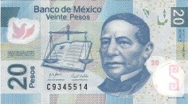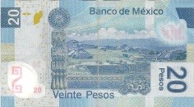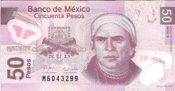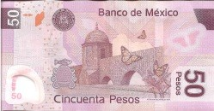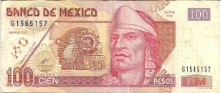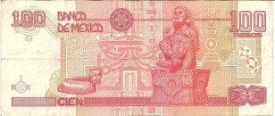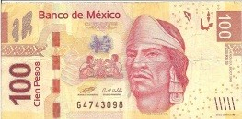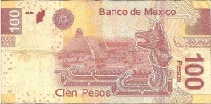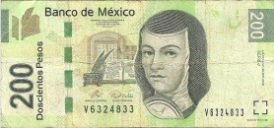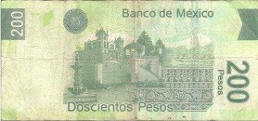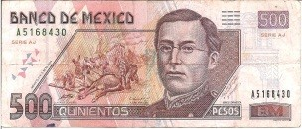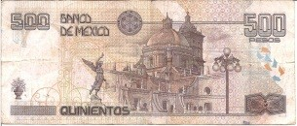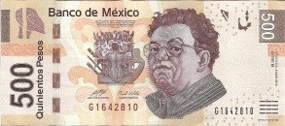
20
50
100 (old)
100 (new)
200 (old)
200 (new)
500 (old)
500 (new)
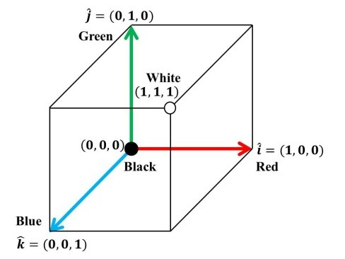
Fig. 1. RGB color space

The orientation and magnitude of a color vector defines the chromaticity and the intensity of the color, respectively [14]. If we sum two color vectors with the same orientation, then, the result is a vector with the same orientation of the two previous and its magnitude will be larger than the previous ones, that is, the resulting color has the same chromaticity but brighter. On the other hand, if two color vectors with different chromaticity are sum the resultant will have different orientation, and also larger; that is, the resulting chromaticity is a combination of the chromaticity of the previous vectors.
The addition of the color vectors of all the pixels of the image gives the resultant vector R, whose orientation may be similar to the color vector’s orientation of the dominant color, where R contains data of all the color features of the banknote. Thus, a banknote can be characterized by computing R as follows.
Let {$1,…, $N} < %3 the set of the pixels’ color vectors of a given image, where
N is the number of pixels of the image; the resultant vector R is computed with:
N

R = ) $p
p=1
(2)

Due to what it is relevant is the orientation of the vector, not its magnitude, the re- sultant vector is normalized:
R
uR = "R" = ruŝ + guŷ + bukˆ (3)
The vector uR characterizes the color feature; later this vector is fed to a classifier for banknote recognition. Observe that the direction cosines of uR are cos αR = ru/"uR" , cos þR = gu/"uR" and cos 8R = bu/"uR" . Moreover "uR" = 1 , there- fore, the components of the vector uR are the cosines of the angles between the vec- tor and the basis vectors. So, the orientation of R is implicit in uR.

Selection of Discriminative Colors

The resulting vector includes colors that may not provide relevant data of the bank- note that may alter the accuracy of the characterization; hence, there are eliminated these colors of the paper currency’s image. Thus, the colors with high variance are eliminated because they are considered as not important data.
Despite we assume the illumination conditions do not vary during the image acqui- sition, the colors printed on the paper currency may lose their intensities because the banknotes may be worn-out or they may have dirt. Due to the RGB space is sensible to color intensity, several color preprocessing applications are performed in the Hue, Saturation and Value (HSV) color space [13], [15] because the Value component, also known as intensity, is decoupled from the chromaticity of the color. So, we apply, separately, the color selection in the RGB space and in the HSV space. This lets us compare which space is convenient to perform the color selection.

Preliminaries
Computing the mean and variance of vectors involves the following mathematical operations. Let {$1,…, $m} < %n a set of vectors, the mean of the vectors is com- puted with:
m
1

µ$ = m ) $p
p=1
(4)

The covariance matrix fi is built:

1
fi=
m

00T (5)

Where 0 = [$1 — µ$,… , $m — µ$]; the variance value is obtained by computing
the norm of the covariance matrix, that is o2 = "fi". The norm of the matrix is com- puted with [16]:
$
"fi" = ƒß(fiT fi) (6)
Where ß is the largest eigenvalue of the matrix obtained with fiTfi.

Color Selection in the RGB Space
Before the vectors R and uR are computed, the image is preprocessed by setting to zero the color vectors with high variance. Due to the colors in this space depend on their intensities, the color vectors are normalized and then the color vector selection is performed. Let {$1,…, $N} < %3 the set of the color vectors of an image, by norma-
lizing the color vectors with $˜p = $p/"$p" we obtain the set {$˜1,… , $˜N} < %3 .
The color vectors with high variance are set to zero; that is:

$˜ $˜p, "$˜p — µ$˜ " $˜
p = {
€ o
2
2

(7)

0, otherwise
2

Where 0 = [0,0,0], the mean µ$˜ and the variance o$˜
are computed as mentioned

in Section 3.1. After the color selection, the vectors are processed with equations (2) and (3).

Color Selection in the HSV Space
The HSV space is cone shaped, see Fig. 2, where the hue or chromaticity is in the range [0,2n] < %; the saturation is the distance to the glow axis of black-white, the value is the height in the white-black axis. Both saturation and value are in the inter- val [0,1] < %. Computing the mean and variance of the hue as a scalar value cannot be precise, because the hue data near 0 are different from the hue data near 2n, but the chromaticity in both cases is very similar. So, the hue of a pixel is represented as a two-element unit vector whose orientation is the pixel’s hue data.

Let {$1,…, $N} < %3 the set of color vectors of an image in the RGB space, these vectors are mapped to the HSV space to form the set {߮1,…, ߮N} < %3. Each vector
߮p has the elements hue (h), saturation (s) and value (r); i.e., ߮p = [hp, sp, rp].
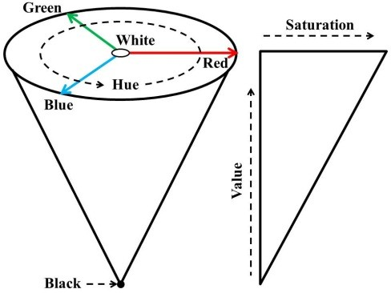
Fig. 2. HSV color space

We obtain the set {ƒ1,… , ƒN} < %2 , where ƒp = [cos hp , sin hp]. Therefore, a pixel’s color vector is set to zero if the hue component of its corresponding vector ߮ has high variance. That is:

2
$p $p, "ƒp — µƒ"
= {
ƒ
€ o2

(8)

0, otherwise
Where the mean µƒ and the variance o2 are computed as mentioned in Section
ƒ
3.1. Once the color vector selection is finished, the selected vectors are normalized and processed with equations (2) and (3). Fig. 3 (a) and (b) show the images obtained after preprocessing in the RGB and HSV spaces, respectively, of the same 20 Pesos banknote. The black pixels are the ones whose color vectors have high variance.
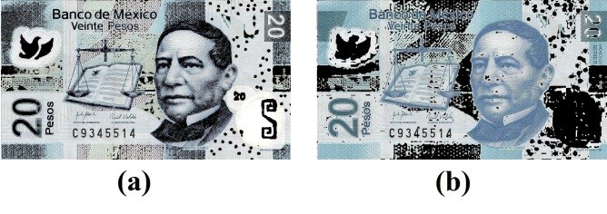
Fig. 3. Images (a) and (b) obtained after preprocessing in the RGB and HSV spaces, respective- ly, of the same 20 Pesos banknote

Experiments and Results
The experimental stage consists on classifying a set of 1600 banknotes, 320 banknotes per denomination class. In this set 400 images are acquired from severely mistreat banknotes and/or with handwritten notes, 80 images per denomination class; the rest of the images are obtained from banknotes with the usual mistreat level. The training set contains 16 images, for each denomination class there are employed one image of

the front face and one image of the back face of the banknote. The training set is slightly imbalanced because there are two kinds of banknotes for the 100, 200 and 500 Pesos denominations; therefore, for these denominations there are employed 4 training images per class while for the 20 and 50 Pesos denominations there are em- ployed 2 training images per class.
For classification, the Learning Vector Quantization (LVQ) networks are suitable for this purpose. A LVQ network is a supervised version of vector quantization, simi- lar to self-organizing maps; usually, it is applied for pattern recognition or multi-class classification [17]. The employed LVQ networks have 32 neurons, the learning rate value is 0.01; the networks are trained with the Kohonen rule [17].
Note that the banknotes are characterized with three different feature vectors: uM is obtained without image preprocessing; uRGB and uKSV are obtained by applying the image preprocessing in the RGB and HSV spaces, respectively. Moreover, it is possible to build “new” characterizations of the banknotes by combining, concatenat- ing, these feature vectors.
Table 2 shows the results obtained by modeling the banknotes’ colors with the fea- ture vectors and their combinations. The rows “W”, “RGB” and “HSV” show the results using the feature vectors uM, uRGB and uKSV , respectively. The rows “W- RGB”, “W-HSV” and “RGB-HSV” shows the results by combining the vectors uM and uRGB , uM and uKSV, uRGB and uKSV, respectively. Finally, the row “W-RGB- HSV” shows the results by combining the three feature vectors.

Table 2. Recognition rates (%) obtained by combining the feature vectors
 | 20 | 50 | 100 | 200 | 500 | rate
W | 100 | 87.50 | 96.67 | 100 | 82.50 | 93.34
RGB | 100 | 97.50 | 100 | 86.16 | 86.25 | 93.98
HSV | 100 | 95 | 100 | 97.44 | 92.50 | 96.98
W-RGB | 100 | 97.50 | 100 | 98.07 | 83.75 | 95.86
W-HSV | 100 | 97.50 | 100 | 98.07 | 93.12 | 97.73
RGB-HSV | 100 | 97.50 | 100 | 97.87 | 93.12 | 97.70
W-RGB-HSV | 100 | 97.50 | 100 | 97.43 | 90 | 96.98

Feature vector Denomination class Average

Regardless the feature vector combinations, the 20 Pesos denomination is the best classified. The recognition rate of the 100 Pesos denomination remains at 100% when at least a color selection approach is applied.
With the feature vector uM all the 200 Pesos banknotes are successfully classified and 96.67% of the 100 Pesos banknotes are correctly identified. While the recognition rates for the 50 and 500 Pesos denominations are low, 87.50% and 82.50%, respec- tively. Using the feature vector uRGB the recognition rates of the 50, 100 and 500 Pesos denominations are improved up to 97.50%, 100% and 86.25%, respectively. The recognition rate of the 200 Pesos denomination falls at 86.16%.
Moreover, with the feature vector uKSV all the 100 Pesos banknotes are properly identified. The recognition rates of the 200 and 500 Pesos banknotes are higher than the obtained using the feature vector uRGB , but the recognition rate of the 200 Pesos denomination is lower than using the feature vector uM. Although the recognition

rate of the 50 Pesos denomination is higher with respect the obtained using uM, it is lower that the obtained using uRGB .
With the combination W-RGB the recognition rates remain almost the same using the feature vector uRGB ; except for the 200 and 500 Pesos banknotes where the rec- ognition rates are higher and slightly lower, respectively.
The recognition rates obtained with the combination W-HSV are slightly higher than employing the feature vector uKSV; from 95% to 97.44% and 92.50% to 97.50%,
98.07 and 93.12% for the 50, 200 and 500 Pesos denominations, respectively.
The combination RGB-HSV gives almost the same recognition rates to the ob- tained with the combination W-HSV; except for the 200 Pesos denomination, where its recognition rate falls from 98.07% to 97.87%.
With the combination of the three feature vectors, the recognition rates are very similar to the obtained with the combination RGB-HSV, where the recognition rate of the 500 Pesos denomination is notably lower, reaching 90%.

Discussion
Without using color selection, most of the 50 Pesos banknotes misclassifications are recognized as 500 Pesos and viceversa. This happens because both denominations have colors in common, although such colors may not be characteristic of these de- nominations, therefore the feature vectors of these denominations become similar.
With the image preprocessing in the RGB space the recognition of the 50 Pesos banknotes is improved, because the non-discriminative colors of this denomination are eliminated. However, for the 500 Pesos denomination the discriminative colors cannot be selected such that to avoid being misclassified as 50 Pesos. The recognition of the 200 Pesos denomination becomes less precise because several green tonalities are eliminated; in consequence, the yellow tonalities predominate. Thus, several 200 Pesos banknotes are misclassified as 100 Pesos.
The color selection in the HSV space improved the recognition rates. The most notable result is the recognition of the 500 Pesos denomination; the colors of the 500 Pesos denomination in common with the 50 Pesos denomination are eliminated in the image preprocessing, due to these colors are not characteristic of this denomination. But the recognition rate of the 50 Pesos denomination is lower than the obtained with the RGB color selection, because the feature vector’s orientation is similar to the brown hue; therefore, the 50 Pesos banknotes are misclassified as 500 Pesos.
In general, the recognition rates using any combination of feature vectors are high- er than employing the feature vectors separately. The combination of the feature vec- tors lets to build a feature vector containing the attributes of the feature vectors that give shape. The highest rates are obtained with the combinations where the color selection is performed in the HSV space. The color selection is more precise in the HSV space because the chromatic hue is an attribute that describes a pure color; while the colors in the RGB space is represented on the spectral components of the basis colors. Besides, despite the color vectors are normalized in the color selection in the RGB space, the influence of the intensity is not totally eliminated.
In order to improve the recognition rate, it may be useful to employ other banknote’s feature; for instance, the texture feature, although this feature has the drawbacks

mentioned before. Another possibility is to use a fuzzy logic-based classifier, due to the fuzzy nature of the color chromaticity.
The average recognition rate of Mexican paper currency reported in [18] is 96%, us- ing only color features, without color selection and by processing only images of banknotes with the usual mistreat level; while we obtain 97.73% without discarding any image from the image database, which contains images of severely damaged banknotes. Though none of the reviewed papers mention their processing times, it is useful to know that because we can decide on which kind of applications the proposed ap- proach is adequate to be employed. The processing time depends not only on the kind of mathematical operations, but also the resolution of the images and the hardware used. In this paper, the average resolution of the images of the 20, 500, 100, 200 and 500 Pesos denominations are 524×951, 522×1002, 518×1140, 518×1665 and 523×1201 pixels, respectively; the microprocessor employed is a Core i5-3310 at 2.90GHz and 4GB RAM, the algorithms are implemented in Matlab R2009a. Table 3 shows the average processing time of one image of any of the five denomination
classes; from the image preprocessing up to the classification.

Table 3. Average processing time, in seconds units

Feature vector | Processing time
W | 0.0656
RGB | 1.6012
HSV | 0.7485

It takes longer to classify a banknote when its image is preprocessed in the RGB space than on the HSV space, because the dimensions of the vectors in the RGB and HSV spaces are 3 and 2, respectively. Without color selection the processing is fast because there are performed essentially arithmetic sums. The processing time of the combinations can be computed by adding the processing times of the feature vectors that model the combinations. Given the processing times and recognition rates, this approach can be used in applications that do not require a very fast recognition; for instance, automatic vending machines. The processing time can be reduced by using either a more powerful processor or images at lower resolution.
In many other countries, as in Mexico, there are employed different colors to iden- tify their paper currency’s denominations; for instance, Euros and Pound Sterling. Our approach can also be used to classify the paper currency of countries that use colors to recognize their paper currency’s denominations. Note that our proposal does not rec- ognize counterfeits; it is beyond the scope of this paper due to counterfeit detection is country-dependable [19].

Conclusions
We have proposed a computer vision approach for the recognition on Mexican paper currency. The denomination classes are recognized by extracting and selecting dis- criminative color features of the paper currency. The banknote’s color is modeled by summing all the color vectors of the image’s pixels, and it is classified by knowing the location of the resulting vector within the RGB space. The recognition becomes

more accurate by using the combination W-HSV; although the combination of the feature vectors RGB-HSV gives almost the same recognition rate, the processing time is larger. Severely damaged banknotes, which are difficult to find in real life, can be accurately classified.

Acknowledgments. This work was sponsored by Secretaría de Educación Pública: convenio PROMEP/103.5/13/6535.

References

- Bank for International Settlements: Monetary and Economic Department, “Triennial cen- tral bank survey for foreign exchange and derivatives market activity in December 2010: Preliminary global results” (2010)
- Tecnocont, http://www.tecnocont.es
- Galantz, http://www.galantz.com.ar
- Jae-Kang, L., Il-Hwan, L.: New recognition algorithm for various kinds of Euro banknotes. In: Conf. of the IEEE Industrial Electronics Society (IECON), pp. 2266–2270 (2003)
- Lee, J.K., Jeon, S.G., Kim, I.H.: Distinctive Point Extraction and Recognition Algorithm for Various Kinds of Euro Banknotes. Int. J. Control Autom. Syst. 2(2), 201–206 (2004)
- Hasanuzzaman, F., Yang, X., Tian, Y.: Robust and effective component-based banknote recognition for the blind. IEEE Trans. Syst. Man Cybern. Part C: Appl. Rev. 42(6), 1021– 1030 (2012)
- Kagehiro, T., Nagayoshi, H., Sako, H.: A Hierarchical Classification Method for US Bank Notes. Trans. Inf. Syst. E89D(7), 2061–2067 (2006)
- Sajal, R., Kamruzzaman, M., Jewel, F.: A machine vision based automatic system for real time recognition and sorting of Bangladesh bank notes. In: Int. Conf. Computer and In- formation Technology (ICCIT), pp. 560–567 (2008)
- Poorrahangaryan, F., Mohammadpour, T., Kianisarkaleh, A.: A Persian banknote recogni- tion using wavelet and neural network. In: Int. Conf. Computer Science and Electronics Engineering (ICCSEE), vol. 3, pp. 679–684 (2012)
- Guo, J., Zhao, Y., Cai, A.: A reliable method for paper currency recognition based on LBP. In: IEEE Int. Conf. Network Infrastructure and Digital Content, pp. 359–363 (2010)
- Hassanpour, H., Farahabadi, P.M.: Using Hidden Markov Models for Paper Currency
Recognition. Expert Syst. Appl. 36(6), 10105–10111 (2009)
- Takeda, F., Sakoobunthu, L., Satou, H.: Thai banknote recognition using neural network and continues learning by DSP unit. In: Palade, V., Howlett, R.J., Jain, L. (eds.) KES 2003. LNCS (LNAI), vol. 2773, pp. 1169–1177. Springer, Heidelberg (2003)
- Paschos, G.: Perceptually Uniform Color Spaces for Color Texture Analysis: An Empirical Evaluation. IEEE Trans. Image Process 10(6), 932–937 (2001)
- Gonzalez, R.C., Woods, R.E.: Digital Image Processing, 2nd edn. Prentice Hall (2002)
- Wang, F., Man, L., Wang, B., Xiao, Y., Pan, W., Lu, X.: Fuzzy-based Algorithm for Color Recognition of License Plates. Pattern Recognit. Lett. 29(7), 1007–1020 (2008)
- Bronshtein, I., Semendyayev, K., Musiol, G., Muehlig, H.: Handbook of Mathematics. Springer, Heidelberg (2007)
- Hagan, H.: Neural Network Design. PWS Publishing Company (1996)
- García-Lamont, F., Cervantes, J., López, A.: Recognition of Mexican banknotes via their color and texture features. Expert Syst. Appl. 39(10), 9651–9660 (2012)
- Lee, K.H., Park, T.H.: Image segmentation of UV for automatic paper-money inspection.
In: Int. Conf. Control, Automation, Robotics and Vision, pp. 1175–1180 (2010)

