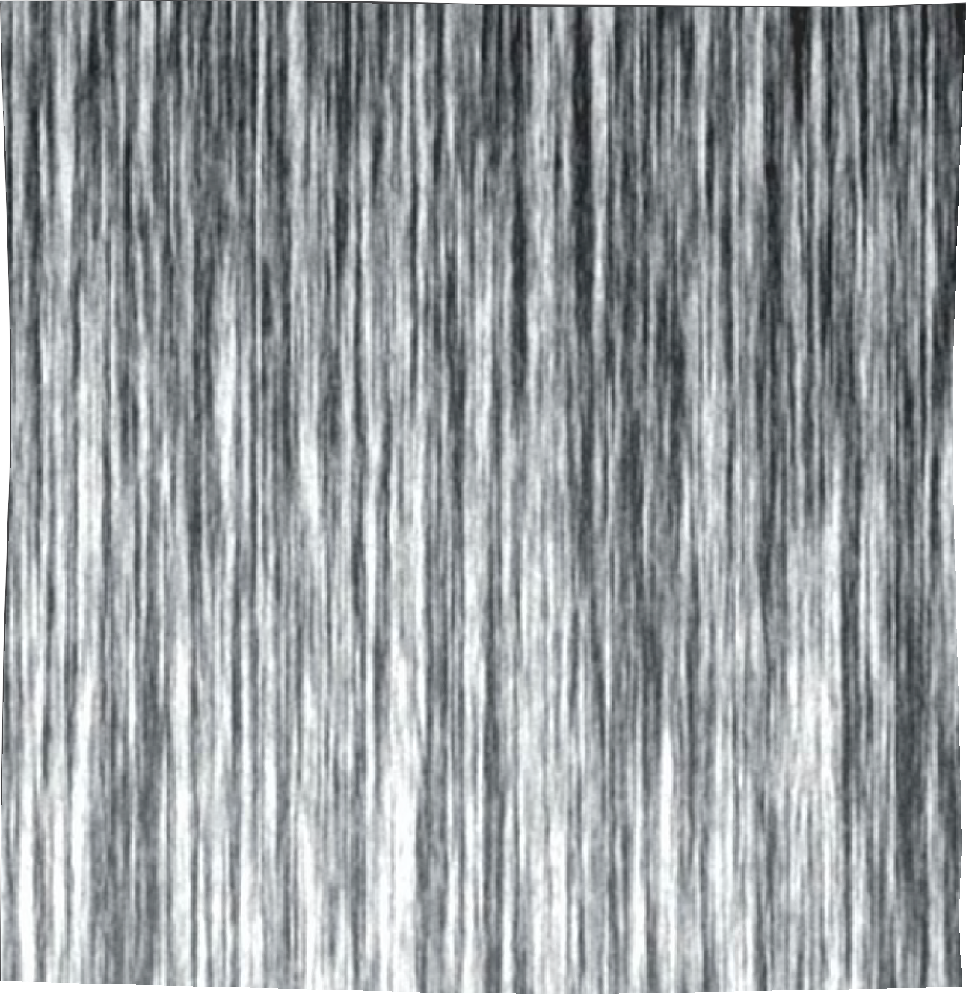

Contents

Introduction
Much more than Bodies 3
Juan Rey

Cultural Bodies
- Mythical Bodies: Masculine Archetypes
of Classical Mythology in Advertising 13
MaRía del MaR Rubio-HeRnández and JavieR lozano delMaR
- Naked Bodies, Clothed Bodies: Images of the Representation
of the Other in the Context of the American Continent 23
MaRía del MaR RaMíRez alvaRado
- Dominant (and Dominated) Bodies: The Corporal Representation
of Masculine Domination in Advertising 31
Manuel GaRRido-loRa

Beautiful Bodies
- Body and Beauty: The Cult of the Male Body in the Printed Press 43
MaRía victoRia caRRillo duRán
- Obsessed Bodies: Influence of Advertising Male Models on Bigorexia 53
caRlos FanJul PeyRó and cRistina González oñate
- Consumption Bodies: Cult and Virtual Representation
of Male Identity in Chile 63
saloMé sola-MoRales

vi
contents

- Body of Desire: Homoerotic Representation
in Mexican Cable Television 75
luis alFonso GuadaRRaMa and Jannet s. valeRo

Political Bodies
- Combat Bodies: The Male Body in the Republican Posters
of the Spanish Civil War 89
Juan Rey
- Body and Dictatorship: Masculinity in Post-War Spanish
Cinema as Expression of Francoism 101
FRancisco PeRales bazo
- Bodies to Vote: The Representation of the Political
Candidate in the Election Campaigns 113
víctoR HeRnández-santaolalla

Spectacular Bodies
- Body Ch-Ch-Ch-Ch-Changes: Body, Identity and Stardom
in David Bowie 127
david selva Ruiz
- Translated Bodies: The Hyper-Ritualization in the Representation of the Male Body among Spanish Youth
in Social Networking Sites 139
lucía caRo castaño

Conclusion
Different Bodies, Different Men 151
víctoR HeRnández-santaolalla
Notes on Contributors 155

2

Body of Desire: Homoerotic Representation in Mexican Cable Television

Luis Alfonso Guadarrama and Jannet S. Valero

Autonomous University of the State of Mexico

In most Western countries, sexual orientation has followed an unsound path. It has gone through different phases and has been considered in several ways: as a heinous sin, as an unnatural behavior, sometimes as a reversible condition, and other times, as an irreversible disease. In one case prosecutors were churchmen, in another, men of science. Finally, it has escaped from the consideration of anomaly, exiting the dialogue of pathologies in which it had been detained, for centuries, by clergy, doctors, psychiatrists, and conservative groups.

Library of Congress Cataloging-in-Publication Data

The male body as advertisement: masculinities in Hispanic media edited by Juan Rey; translated by Francisco Uceda.

pages cm. (Masculinity studies: literary .and cultural representations; vol. 5). Includes bibliographical references. 1. Sex role in advertising Spain. 2. Sex role in advertising Latin America. 3. Men in advertising Spain. 4. Men in advertising Latin America. 5. Masculinity · Spain. 6. Masculinity Latin America. 7. Hispanic American mass media. l. Rey, Juan.

HF5827.85.M35 659. · ‘0455211 dc23 2015003312
ISBN 978-1-4331-2837·-0 (hardcover) ISB,N 978-1-4539-1442-7 (e-book)
ISSN 2161-2692

Bibliographic information published by Die· Deutsche Nationalbibliothek. Die Deutsche Nationalbibliothek lists this publication in the ‘’Deutsche Nationalbibliografie; detailed bibliographic data are available
on the Internet at http:/ /dnb.d-nb.de/.

© 2015 Peter Lang Publishing, Inc., New York 29 Broadway, 18th floor, New York, NY 10006
www.peterlang.com All rights reserved.
At present, homosexuality as a loving sex-erotic lifestyle has been slowly gaining ground in the process of emancipation, social expression, and representation in the media. At each stage, there have been advances, setbacks, deep stagnation, and renewed impulses, which have led to gay liberation, although much remains to be done.

The world of homosexuality, like other areas of life, is dominated by archetypes. In this sense, one of the ideas that has thrived in the social imagination is that a male homosexual is always effeminate, scandalous, prone to gossip, with a sharp voice, a lilting gait, one who carries colorful attire, based on the color choice associated with garments for women; an individual who constantly wants attention and sexual encounters with any heterosexual man.

Among his archetypal features, it also appears that in every sexual encounter, he wants to be penetrated by a heterosexualmale. Thus, thepassivityof thefemininetakes hold, and is reproduced and recreated. These elements, which constitute the collective image of the effeminate gay, are fireproof materials. In many countries, they feed and help to fuel jokes based on mockery, sarcasm...

Para seguir leyendo visite:
www.peterlang.com

