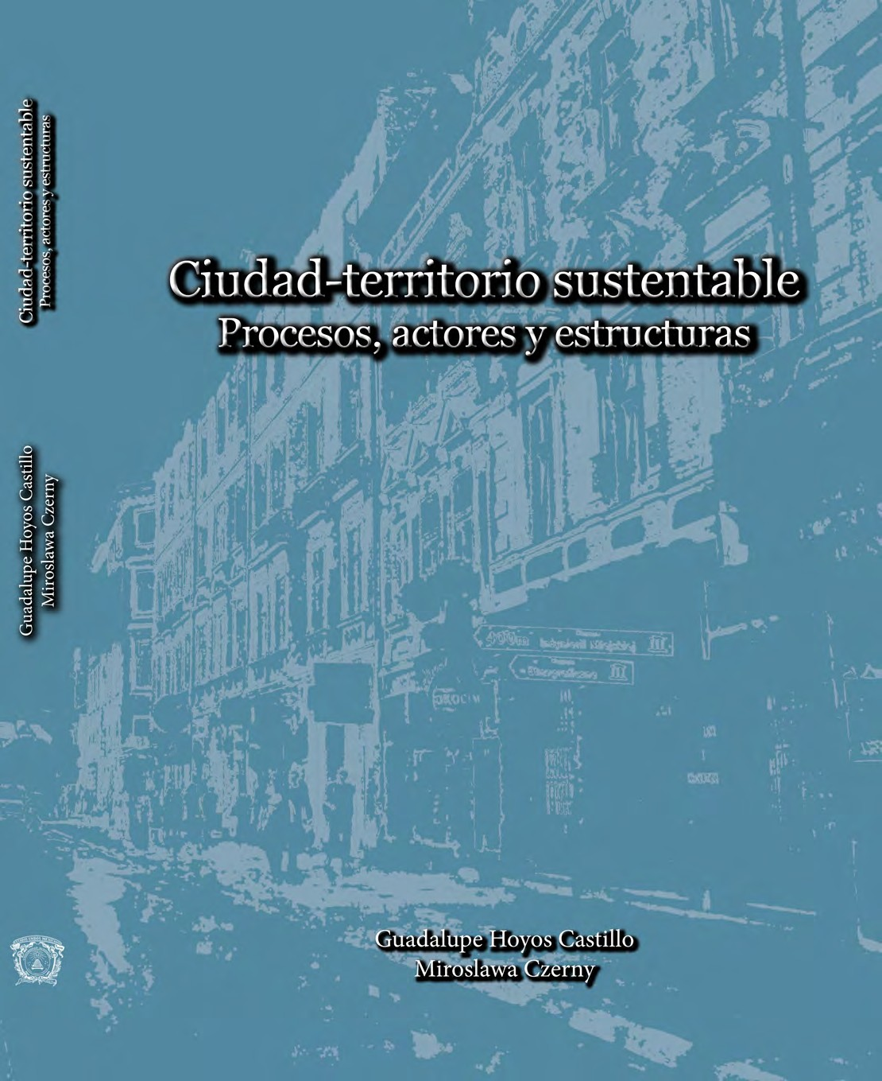

Ciudad - territorio sustentable Procesos, actores y estructuras

Ciudad-territorio sustentable
Procesos, actores y estructuras

Guadalupe Hoyos Castillo Miroslawa Czerny
(Coordinadoras)

Centro de Investigación y Estudios Avanzados en Planeación Territorial de la Facultad de Planeación Urbana y Regional

Facultad de Geografía y Estudios Regionales

Universidad Autónoma del Estado de México Universidad de Varsovia, Polonia

2014

© Derechos reservados 1ª edición 2014
Universidad Autónoma del Estado de México

ISBN 978-607-422-543-3
Impreso y hecho en México
Printed and made in Mexico

Contenido

Introducción

Guadalupe Hoyos Castillo y Miroslawa Czerny
Descentralización urbana en América Latina y México. ¿Es posible 11
arribar a la ciudad-territorio?
Parte I. Procesos y territorios
Barbara Jaczewska
Emergence of local immigrants integration as a European Union 33
policy issue
Rodrigo Pimienta Lastra, Martha Vera Bolaños, Michael Shea y Elena M. Gutiérrez Cárdenas
An analysis of the internal migratory flows which transformed 51
Mexico State
Piotr Raźniak and Anna Winiarczyk-Raźniak
Social security of cities and surrounding areas 71
Parte II. Estructuras ambientales sustentables
Joanna Miętkiewska-Brynda and Jerzy Makowski
Ciudad versus medio ambiente. Reflexión sobre las relaciones 87
Dawid Soszyński and Ewelina Anaszewska
Functioning of rural public spaces in the community of Dębowa 99
Kłoda, in eastern Poland

Wioletta Kałamucka, Krzysztof Kałamucki and Anna Kamińska
The analysis of the route changes of pedestrian tourists trails in the
area of Roztoczański National Park

115

Rosa María Sánchez Nájera y José Alfonso Martínez Sánchez
Características de la innovación en el sistema productivo local de
San Mateo Atenco, Estado de México

131

Salvador Adame Martínez, Edel Cadena Vargas y Miguel Acevedo
Producción florícola y calidad de vida en la cuenca del río
Tenancingo, México

145

Parte III. Actores y planeación urbana

Maciej Lasocki
Development of a contemporary city as an offspring of the political culture in spatial planning

169

Yadira Contreras Juárez, José Juan Méndez Ramírez y Brenda Valdés Flores
La perspectiva de género como herramienta para la planeación territorial

181

Jorge Tapia Quevedo, María Estela Orozco Hernández y Martha Vera Bolaños
La urbanización de la zona poniente del Distrito Federal. Una interpretación sobre la formación de áreas de proximidad residencial entre grupos de altos y bajos ingresos

199

Jacek Kwiatkowski and Angelika Kowalczyk
Public spaces-urban places of the two great metropolis: Moscow and Mexico City

215

José Juan Méndez Ramírez, Alberto Javier Villar Calvo y Juan
José Gutiérrez Chaparro
Nuevas formas de gestión social del espacio urbano: Privatopía
versus gobierno local

239

Juan Roberto Calderón Maya, Verónica Miranda Rosales y Teresa Becerril Sánchez
La instalación de comités municipales de prevención y control del crecimiento urbano, estrategia de regulación territorial en el Estado de México

253

An analysis of the internal migratory
flows which transformed Mexico State

Rodrigo Pimienta Lastra1, Martha Vera Bolaños2, Michael Shea3 y Elena M.Gutiérrez Cárdenas4
Universidad Autónoma Metropolitana y Universidad
Autónoma del Estado de México

Resumen

Los movimientos de población de un país a la ciudad son característicos de los países del tercer mundo en la segunda mitad del siglo XX. El Estado de México -en el centro de la república- es un ejemplo agudo de este fenómeno. El objetivo de este estudio es analizar el flujo de migrantes permanentes dentro y fuera del estado y seleccionar determinadas cohortes para el análisis de variables particulares. La metodología consiste en analizar el los datos originales que se toman del XII Censo General (INEGI 2000), incluyendo los factores de expansión para las variables da- das. Los resultados indican que son más las mujeres que migran que los hombres. La idea establecida de la migración de los jóvenes se cuestiona, el Estado de Méxi- co está disfrutando de un bono demográfico de los inmigrantes en edad de trabajar desde el resto de la república. A diferencia del período hasta la década de 1980, los inmigrantes ahora elegir entre las grandes ciudades o pequeñas localidades, evitando las ciudades de tamaño medio.
Palabras clave: migración interna, población, movimientos.

- Profesor titular e investigador, Universidad Autónoma Metropolitana – Xochimilco Departamento Política y Cultura. Correo: plrd6334@correo.xoc.uam.mx
- Universidad Autónoma del Estado de México. Correo: vera@alestra.net.mx
- Profesor titular e investigador, Universidad Autónoma Metropolitana – Xochimilco, Departamento Educa- ción y Comunicación. Correo: quill24@hotmail.com
- Profesor titular e investigador, Universidad Autónoma Metropolitana – Xochimilco Departamento Política y Cultura. Correo: emcard@correo.xoc.uam.mx

Abstract

Movements of population from country to town are characteristic of third world coun- tries in the second half of the twentieth century. Mexico State–in the centre of the re- public- is an acute example of this phenomenon. The aim of this study is to analyze the flow of permanent migrants into and out of the state and to select certain cohorts for the analysis of particular variables. The methodology consists of analyzing the source material which is taken from the XIIth General Census (INEGI 2000) including expansion factors for given variables. Results, more females than males migrate. Established ideas of the migration of the young are questioned. Mexico State is en- joying a demographic bonus of migrants of working age from the rest of the republic. Unlike the period up to the 1980s, migrants now choose either large cities or small localities, avoiding medium sized cities.
Key words: migration internal, population, movements.

Introduction
n the 1970s, while nations such as Great Britain and Japan increased their populations at an annual rate of 1%, most African countries grew at bet- ween 6% and 7% and those of Latin America at between 4% and 6% (Toda-
I
ro, 1976). In the case of Mexico, these tendencies were particularly pronoun- ced. Between 1930 and 1940, its population had an average annual growth rate of 1.7%. In the following two decades, this rate was maintained with an- nual averages of 2.7% and 3.1% respectively. This process reached its highest point between 1970 and 1980 with a rate of 3.4%. These increases, together with the great economic, social and geographic imbalances in the country, swelled the major urban zones. In 1960, 36.6% of the population lived in loca- lities of 15,000 or more inhabitants. In 1970, this figure was 44.9%, in 1990 it was 57.4% and in 2000 it was 61 %. (These are the authors’ own calculations based on the data of INEGI – the National Institute of Statistics and Geogra- phy.) (INEGI 1990, 2000).
The state of Mexico was not exempt from this process. It lies in the centre of the republic and surrounds the capital, Mexico City. While its average an- nual growth rate between 1930 and 1940 was only 1.5%, between 1950 and 1960 it reached 3.2% and in the following decade it peaked at 7.4 %. If this rate had been maintained, the population of the state would have doubled in only
  - years. The following three decades saw annual growth rates of 6.7%, 2.7% and 2.9% respectively. A significant part of this increase is the result of social growth i.e. migration.

Justification
In Mexico, as in the rest of Latin America, population movements have been widely related to urbanization, the job market and the infrastructure of communication. This, together with the decapitalization of the countrysi- de, propitiated, in the 1970s, great movements of population from country to town and this resulted in enormous concentrations of people and resources in a few areas of the republic. (Unikel 1976:64-67; CONAPO 1994:47-58; 1994b:i- iv,3)

The aim
The objective of this study is to analyze the flows of permanent migrants who have settled in the state of Mexico in the last decade of the 20th century. The population analyzed here consists of those people who have immigrated to the state together with those members of the state’s native population who have emigrated to other places in the republic. In addition, certain cohorts have been selected from both populations in order to examine particular va- riables: age group, gender, size of locality of origin and size of locality of des- tination.

Source material and methodology
The XIIth General Census was carried out by the INEGI between the 7th and 18th of February, 2000; the 14th was established as the official date. Together with the census, another questionnaire was applied to a sample of 2.2 million dwellings. The aim was to collect more information about a series of socio- demographic variables which it was not possible to include directly in the census.
This data has been put at the disposition of the public in the form of a compact disc so that any interested party can generate his own tables using the computer programmes he prefers. The data base consists of 3 archives:
    - dwellings and homes; this includes such data as place of origin, characte- ristics of the dwelling, number of residents and families, together with those residents involved in international migration and the number of migrants in each family (b) characteristics of the people; this includes such variables as place of residence, kinship, sex, age, date of birth, whether or not registered in the social services, place of birth, disabilities, health services, place of resi- dence in 1995, speaker or not of an indigenous language, level of education, religion, ethnic group, marital status, economic characteristics, place of work, other sources of income, and number of children. (c) International migration; every emigrant was registered, together with their place of origin.

In this study the data were used in the following way. To analyze the total
population of the state by age and sex, the information was taken directly from the census. For the remaining tables and graphs, the sample material was used together with its expansion factors in order to obtain estimations of the totals. In the case of the latter, two archives were used: those of dwellings and families. These were unified into a single archive so that they could be calculated simultaneously: that is, the socioeconomic characteristics of each person were integrated with the characteristics of his dwelling. In addition, using the methodology described, another archive was constructed in which emigrants from the state were localized in their places of destination in the republic, with the aim of obtaining the age and gender structure of this group.

Background
At the beginning of the twentieth century, the state of the republic with most inhabitants was Jalisco (1,153,891), followed by Guanajuato (1,061,724), Puebla (1,021,183) Veracruz (981,030) and Michoacan (935,808). With a po- pulation of 934,463, the second census (1900) placed the state of Mexico in sixth place by population. The census showed 49.3% men and 50.7% women (Dirección General de Estadística; 1903). Immigrants only represented 1.6% of the population while emigration was running at 14.1%. The state was losing population at that time.
Seventy years later the state had risen to second place (with 3,833,185 inhabitants) surpassed only by Mexico City itself (6,874,165). This situation was maintained until 1980. In that year, the census registered a population of 7,564,335 in Mexico State, of which 38.4% were immigrants. By 1990, this enti- ty had become the most populated in the republic with 9,815,795 inhabitants. (19.2% more than Mexico City, which had fallen into second place). Of these, 39.6% were immigrants. It seems unlikely that this situation of primacy will change, at any rate in the short or medium term. The census of 2000 gave a po- pulation of 13,096, 686 inhabitants with an annual growth rate for the decade of 2.95% More than two thirds of the population consists of immigrants from other states of the republic. That is, the state acts as a magnet for immigrants.

Analysis of the census material

Characteristics of the populations: total population, immigrants and emigrants
The census of 2000 reports Mexico State as having 13,096,686 inhabitants. This makes it the largest entity by population (13.4%) in the republic. This despite having lost 721,921 citizens (8.6%) to other parts of the country. On

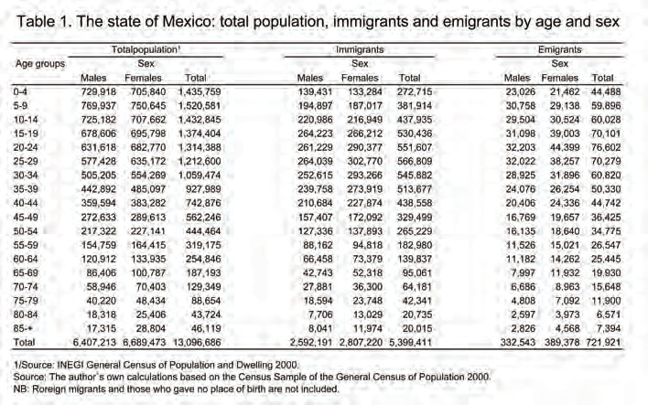
the other hand, 5,394,411 immigrants have settled in the state from the rest of the republic (an extraordinary 41.2% of the present population). See Table 1 and Graph 1.

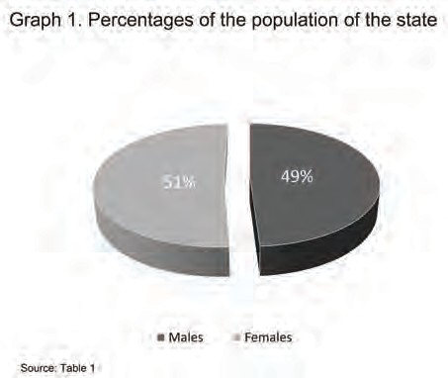

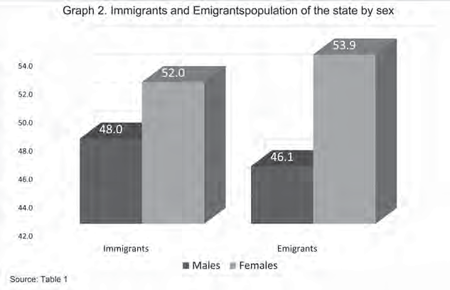
Of the present population, 48% are male and 51.1% female. The corres- ponding figures for immigrants are 48% and 52% and for emigrants 46.1% and 53.9%. Within these figures it is possible to isolate cohorts which are par- ticularly interesting. For example, 60% of the state’s inhabitants are over 18 (58.8% of males, 61.1% of females). Of these, 51.6% were born elsewhere in the republic (47.2% males and 52.8% females). If the population is divided by age, it is found that: those under 14 make up 33.5%, those from 15 to 64 cons- titute 62.7%, and those over 65 are 3.8%. Immigrants under 14 number 4.5%, those from 14 to 65 constitute 75.3% (the amphora) and those over 65 make up 20.2%. Emigrants under 14 number 8.5%, those from 14 to 65, 68.7% and those over 65, 22.8%. (These figures are based on data from Table 1).
Age group pyramids and profiles of these three populations can be found in graphs 3 to 5. The first shows the age groups of the immigrant population. It can be seen that the baseline which represents the generations born in the first five years of the 1990s is slightly narrower than that which represents the generations from 1995 to 2000. This may indicate one of two things: either an increase in births or the arrival of a large number of immigrant families with small children. Starting with the 5-9 age group, the pyramid becomes less irregular. This may also be the result of immigration. That is, the reductions in fecundity which occurred in the whole republic after the middle of the 1970s are not to be observed.
In Graph 4, the age group pyramid for immigrants can be seen. It has the shape of an amphora, narrow at the base and wide when it reaches the cen- tral ages –mostly women- and narrowing again for the older ages. Something which seems to support an idea suggested in the previous paragraph is that 13.2% of the migrants are under 9 years of age. This seems to confirm that a number of families moved into Mexico State permanently.

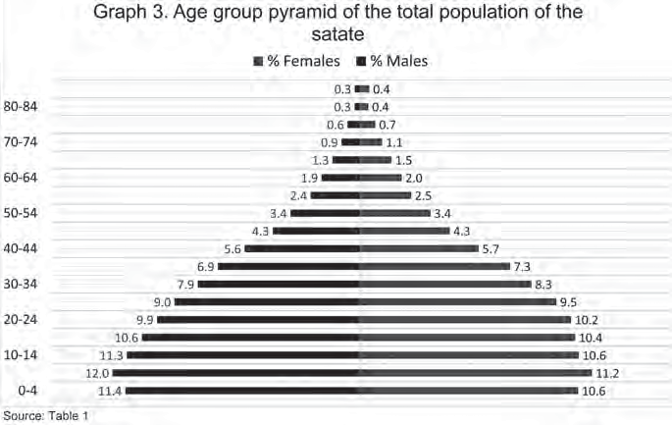

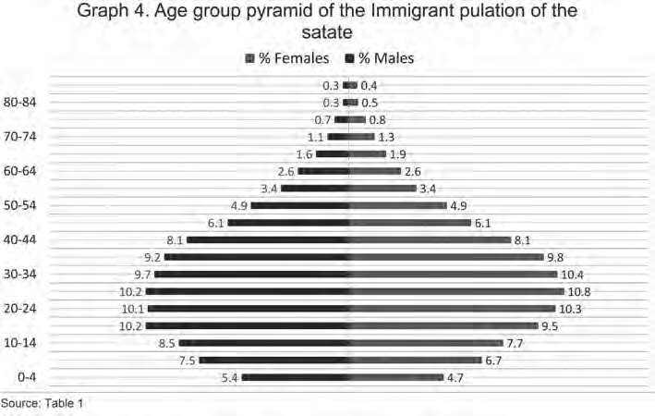

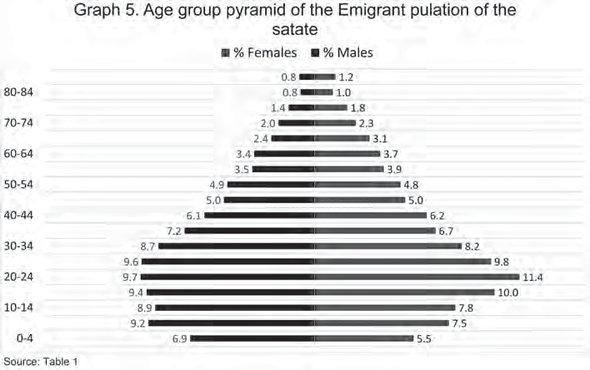
Graph 5 (emigrants) has a similar shape to graph 4, although is more irre- gular. Women represent 11.2% of the under 9 age group, 37.6% of those bet- ween 15 and 64 and 5.1% of those over 65. The corresponding figures for men are 11.5%, 31.1% and 3.5% respectively. There is more work to be done on these statistics because it is almost certain that many of these emigrants went to live in Mexico City.
Table 1 shows the average ages of the 3 populations. For the population as a whole it is 25.5 years, 26 for the women and 25 for the men. In the case of the immigrants the corresponding figures are: 30.6 (total population), 31.1 (women) and 30.1 (men). In the case of emigrants, the figures are: 31.6, 32.5 and 30.7. It is interesting to contrast these figures with the median ages of these populations. These are 23 (total population), 23 (women) and 22 (men.) For immigrants they are: 29 (total population) 30 (women) and 28 (men).For emigrants they are: 28, 28 and 27 respectively.
Some tentative conclusions may be drawn from these figures. First, the groups of immigrants and emigrants have similar characteristics and show important differences from the population of the state as a whole. The latter may be characterized as young: 50% are under 23 and the average age is
25.5. On the other hand, the former may be characterized as young adults: 50% of the immigrants are under 29 and 50% of the emigrants under 28.Their corresponding average ages are 30.6 and 31.6. In the republic as a whole, the average age is 25.6 years with that of men 21.1 and that of women 26. The median ages are: 22 (total population), 22 (men) and 23 (women). It can be seen immediately, therefore, that the statistics for the general population of the state reflect the national statistics but that the figures for immigrants and

emigrants do not. The number of immigrants arriving and staying in Mexico State is particularly interesting. It suggests the state may be enjoying a popu- lation bonus similar to that which the republic is often accused of exporting to the United States.

Interstate migratory flows
Graphs 6 and 7 present interstate migrations. In the first it can be appre- ciated that Mexico City provides 60.7% of the immigrant population of the state. However, in addition, there are three clearly differentiated immigrant blocks. The first consists of those states which contribute a large number of immigrants: Puebla (5.7%), Hidalgo (5.1%), Oaxaca (4.8%). Veracruz (4.8%), Michoacan (4.4%), Guanajuato (3.3%) and Guerrero (2.4%). The total number is 1,648,123 people or 30.5% of the immigrant population. The second block consists of states which contribute a moderate number of immigrants: Jalis- co, Tlaxcala, Querétaro, Chiapas, San Luis Potosí, Morelos and Zacatecas. To- gether these total 352,208 people (6.5%). Finally, the third block consists of the rest of the states which contribute a low number of immigrants: 119,839 people (2.3%).
Graph 7 shows emigration from the state of Mexico. Mexico City receives most: 321,319 people (44.5%). This is followed by Morelos (7.8%) and Hidalgo (6.8%).After these come a block of 10 states: Michoacan, Puebla, Guanajuato, Veracruz, Querétaro, Guerrero, Jalisco, Baja California, Oaxaca and Tlaxcala. These receive 30.6% of emigrants (220,557 people.). The remaining states of the Republic contribute the other 10.3%.

Migratory flows by size of locality
In table 2 the migratory flows by size of locality for two cohorts can be found: localities with a population greater than 15,000 inhabitants and those smaller than 15,000. Also included are immigrants from Guatemala, the Uni- ted States and other countries, in addition to countries which have not been specified (these represent few migrants).
Most internal immigrants (5,003,890 or 92.7% of this group) settle in loca- lities of more than 15,000 inhabitants. Only 7.3% (391,521 people) settle in the smaller localities. As might be expected virtually all immigrants from other
states settle in the larger localities.
When emigrants from the state are considered, the above situation is, in general terms, repeated. 78.7% settle in localities of more than 15,000 inha- bitants and only 21.3% in those of less than 15,000. However, in Michoacan and Puebla the emigrants settle in the larger and smaller localities in almost equal numbers. These findings are perhaps rather surprising. In the 1980s the medium sized cities were identified as the favourite destinations of migrants.

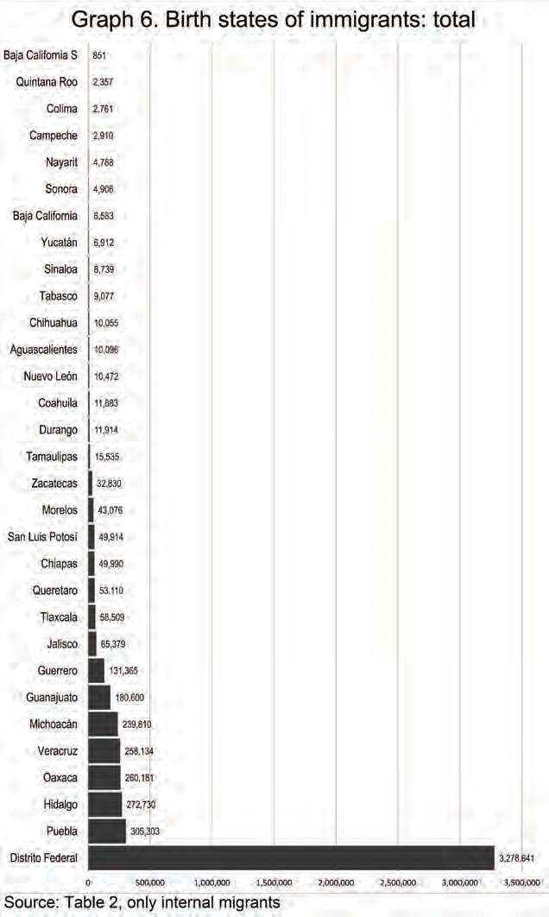

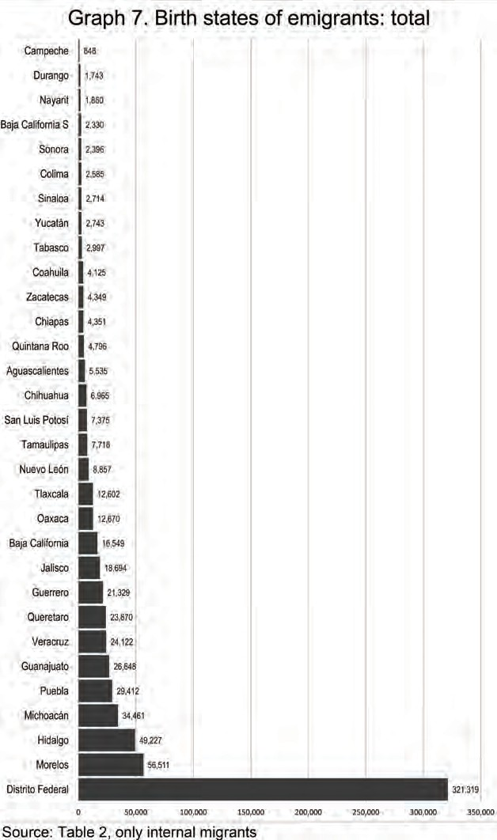

However, this study shows that they now seek to settle either in larger popu-
lation units or, to a lesser degree, in small ones: a polarity of settlement has occurred. Something which may explain this development is the decline of the medium sized cities as industrial centres following the implementation of NAFTA during the Salinas administration. Small local industries have not survived.

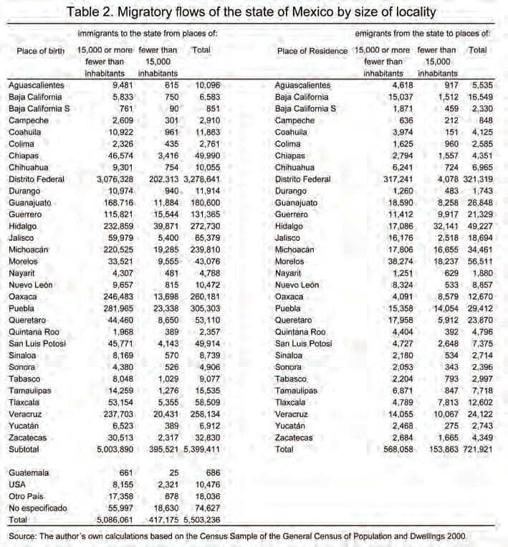

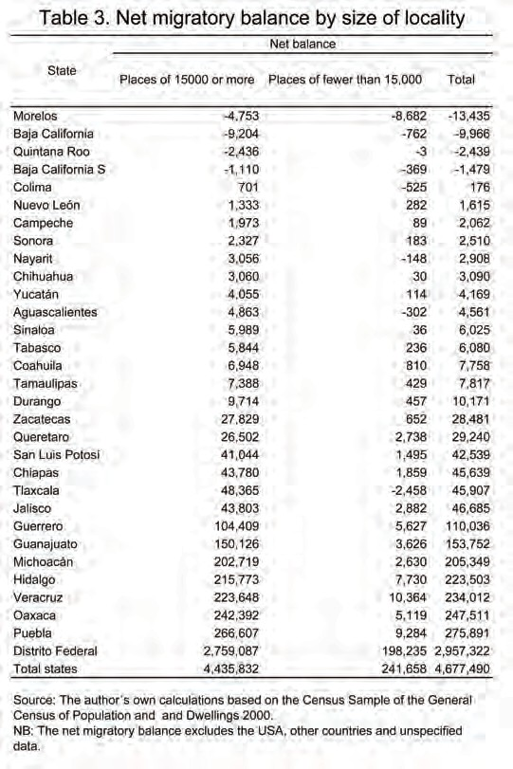
Table 3 and Graph 8 complement Table 2 and Graphs 6 and 7 because they contain the net migratory balances by size of locality together with the total net balance. As will be appreciated, in both kinds of locality Mexico State shows negative net migratory balances1.with Morelos, Baja California, Quin- tana Roo and Baja California Sur. These last two may be considered cases of equilibrium. In the remaining states-except Colima and Nayarit, which may also be considered to be in equilibrium -the net migratory balances are posi- tive. Mexico City is the outstanding example, followed at a great distance, by Guerrero, Guanajuato, Michoacan, Hidalgo,Veracruz and Oaxaca.

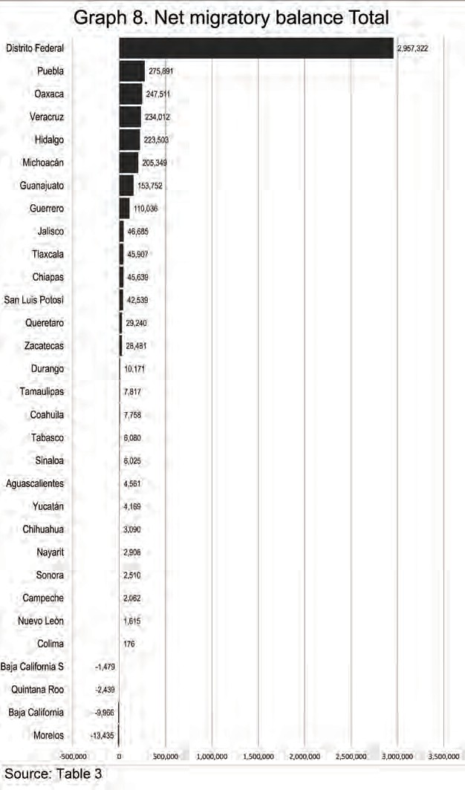

Patterns of places of origin and places of destination of migration by age group, gender and size of locality
Table 4 and Graphs 9 and 10 shows the structures of the migrant popula- tion by age group and gender together with two cohorts of localities where they settle. As can be seen, this, apart from being an explanation of Graph 4, is another form of representation of the same phenomena: the migratory pat- tern of the state in the graphs can be seen reflected in the movements of the cohorts to the localities.
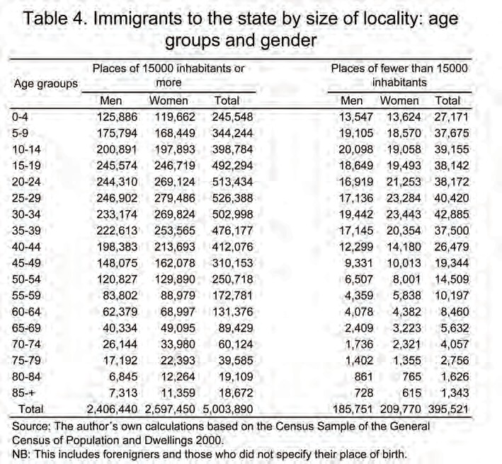

Perfectly defined tendencies can be seen in both graphs, although that which corresponds to localities of 15,000 or more inhabitants is clearer.

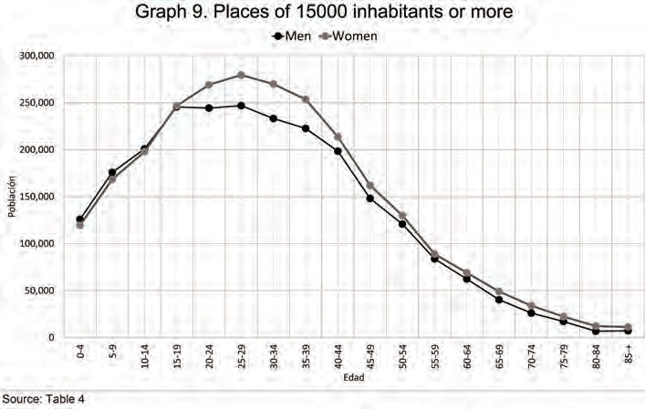

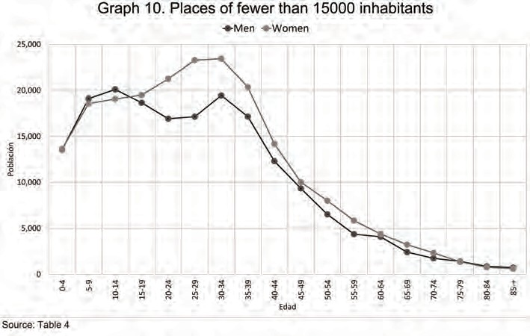

Conclusion and discussion
The data presented here, from the Census of 2000 or from its data base, have been used to examine the characteristics of the demography of the state of Mexico which is, at present, the zone which is, at present, the zone of grea- test attraction of population in the republic. (There are, of course other such zones which will in the future be important: Baja California and Quintana Roo are two examples.)

This investigation casts new light on four aspects of Mexican migration studies
First, it demonstrates the existence of gender selection (which goes against received opinion). Male migration is surpassed by that of females in almost all age groups. Second, it makes a reappraisal of the migration of the young in Mexico State. This does not follow the pattern suggested by demographers who have studied the phenomenon in the developed world and tried to gene- ralize their conclusions. The general model of migratory behaviour for each age group established by (Rogers 1975: 146-147) and cited by (Pimienta 1999: 29-32) states that: “The regularities observed in the pattern of migration are unsurprising: young adults show the highest rates of migration because they have fewer ties to their community, their children are not normally at school and they are not, generally, the owners of the places where they live. Rather, they tend to be renting their dwellings and as they have not acquired seniority in their workplace, this is not yet an important consideration for them. Given that children move as part of the family, their migratory pattern is a reflec- tion of their parents´pattern. Consequently, as younger parents have smaller children, the geographical mobility of these children is greater than that of adolescents. Finally, the small bump which appears between the ages of 62 and 65 shows migration after retirement”.
According to this view, migration in early childhood should be greater than that later in childhood. However, Table 4 and Graphs 9 and 10 show a completely different situation. In these, migration can be seen as a curve which grows from left to right in childhood, exactly the opposite of the idea suggested in the model. There are three possible explanations of this pheno- menon. One is that what is happening here is permanent migration in which the child migrates with the whole family during the early years of his life. Another is that one of the parents or both migrate without small children as a strategy to ensure the survival of the family. Still another is that children in their later childhood (probably from the age of 12 onwards) migrate on their own in order to help their parents with the economy of the family. (Pimienta, 2001)

Third, it has been shown that most migrants are of working age, both wo-
men and men. The former are both more numerous and slightly older than the latter. Many immigrants to the state are in the over-18 age group and this has contributed to a relative but slight ageing of the population. For example, the over 65 age group comprises 3.8% of the total population, 4.5% of immi- grants and 8.5 of emigrants.
Graphs 9 and 10 show a very clear pattern of migration which, although comparable in general terms to the theoretical models, does not reproduce them. Some parts of the curves do not display the tendencies the theory pre- dicts. Moreover, the behaviour of the over-65 age group also differs from the expected pattern.
Fourth, for some time the idea of a demographic bonus has been under discussion i.e. that the form of the population pyramid follows that of an am- phora. This means that most of the population is of working age and there are only a small number of people in the ages of economic dependence i.e. small children and those of retirement age. It could be said that the state of Mexico (and its neighbour Mexico City) were early beneficiaries of this bonus because most of the migrants to these entities are of working age. It would be well worth examining, on another occasion, the demographic symbiosis bet- ween Mexico City and Mexico State. 16 municipalities of Mexico State have such a close relationship to the city that they are considered part of the urban zone (esp. “conurbado” ) and the governments of the two adjoining political units collaborate to finance and built infrastructure (e.g. the new railway line) which will serve the citizens of both.
The social, economic and public policy implications of this investigation are important. That 41.2% of the present population of Mexico State are im- migrants who have settled in the state from the rest of the republic gives pau- se for thought. It is of great importance to analyze these population flows which have immense consequences for planning, allocation of resources and the welfare.
In demography a net migratory balance is defined as the difference, in a given area, between the number of immigrants and the number of emigrants. This may be positive or negative. If the number of emigrants is greater than that of immigrants (a positive difference) it is considered a zone of expulsion. If the balance is zero. It is considered to be in equilibrium.

Bibliography

CONAPO, 1994 a: Evolución de las ciudades de México, México: Consejo Nacional de Población.
CONAPO, 1994b. La población de los municipios de México: 1950-1990. México: Consejo Nacional de Población.

Secretaría de Fomento y Antonio Peñafiel Editores México; 1903: Censo General de la República Mexicana verificado el 28 de Octubre de 1900. Dirección General de Estadística.
INEGI, 2002: Base de datos de la muestra censal del XII Censo General de Población y Vivienda 2000. México: Instituto Nacional de Estadística Geografía e Informática.
INEGI, 1930-2000: Censos Generales de Población y Vivienda, México: Dirección Ge- neral de Estadística.
Pimienta Lastra Rodrigo (2000). Dinámica Migratoria Interestatal en la República Mexicana, El Colegio Mexiquense Editores, Toluca, México.
Pimienta L., Rodrigo, 1999: “Análisis multirregional de los patrones por edad y sexo de la migración interna: El Caso de México”, Tesis de Doctorado en Estudios de Población, El Colegio de México, México.
Pimienta L., Rodrigo, 2001: “Migración interna infantil en México” en Sociológica, Mé- xico: División de Ciencias Sociales y Humanidades de la UAM-Azcapotzalco, pp. 121-146.
Rogers, Andrei, 1975: Spatial Migration Expectancies, Laxenburg, Austria: Interna- tional Institute for Applied Systems Analysis Editors.
Castro Luis and Andrei Rogers, 1984: “What the Age Composition of Migrants can Tell Us”, Laxenburg, Austria: International Institute for Applied Systems Analysis, Editors.
Rogers, Andrei et al., 1978: “Model Migration Schedules and Their Applications”. Lax- enburg, Austria: Migration and Settlement: Selected Essays, Andrei Rogers Editor.
Todaro, Michael P., 1976: “Internal Migration in Developing Countries”, Geneva, Swit-
zerland: International Labour Office Editor.
Unikel, S. Luís, 1976: El desarrollo urbano de México: Diagnóstico e implicaciones futuras, México: Centro de Estudios Económicos y Demográficos de El Colegio de México.

Juan Roberto Calderón Maya, Verónica Miranda Rosales y Teresa Becerril Sánchez

264

