Scanning Electron Microscopy and Energy Dispersive Spectroscopy microanalysis applied to human dental specimens under laser irradiation for caries prevention
- Olea-Mejia1, R. Contreras-Bulnes2, C.M. Zamudio-Ortega2, R. A. Morales-Luckie1, O. Olea- Cardoso3 and R. López-Castañares3
1 Centro Conjunto de Investigación en Química Sustentable UAEM-UNAM. Facultad de Química. Universidad Autónoma del Estado de México. km 14.5 Carretera Toluca-Atlacomulco, San Cayetano 50200, Mexico
2 Facultad de Odontología, Centro de Investigación y Estudios Avanzados en Odontología (CIEAO), Universidad Autónoma del Estado de México, Jesús Carranza Esq. Paseo Tollocan, Col. Universidad, 50130, Mexico
3 Facultad de Química. Universidad Autónoma del Estado de Mexico. Tollocan s/n esq. Paseo Colón, Toluca 50120, Mexico

Scanning Electron Microscopy (SEM) coupled with Energy Dispersive Sperctroscopy (EDS) are two analysis techniques that are widely used to study all kinds of solid samples, from inorganic to biological. They are used to determine morphological features of interest at a micron and sub-micron level as well as to study the chemical composition of the samples in terms of the amount of each element present. Although these analytical techniques are “routine work” in many research areas, it is not the case of the dental area, mainly because the lack of this equipment in the dental research institutes and in dental schools. Therefore, in this chapter we show the SEM/EDS techniques applied to human dental samples when irradiated with a laser Er:YAG to prevent caries. The intention of this work is to show step by step this analysis showing the key variables to consider when working with this type of biological samples. We explain the SEM conditions to obtain satisfactory images especially when it is important to follow a sequence of steps of a treatment in-vitro that changes the morphological structure of the teeth surface. Also, we discuss the EDS analysis to semiquantitatively determine the elements and their abundance in the dental samples.

Keywords: SEM; EDS; human dental samples

Introduction
The study of caries and its prevention is one of the most important topics in dental research since it affects many people around the world [1-3]. One of the proposed treatments for caries prevention is the irradiation of the enamel surface with a pulsed laser [4, 5]. This process could lead to morphological and chemical changes of the teeth surface to be more resistant to caries [6-8]. Therefore, it is necessary to be able to study the enamel surface in terms of its morphology and its chemical composition with suitable, accurate and reproducible techniques when treated with laser light. Therefore, in this chapter we show the use of Scanning Electron Microscopy (SEM) and Energy Dispersive Spectroscopy (EDS) to study the irradiation-induced morphological changes with SEM and chemical modifications with EDS.
SEM is a characterization technique that is used widely for all types of samples, from hard materials such as metals and ceramics to soft materials such as polymers and biological tissues. The basic principle is that an electron beam is finely focused and scanned over the analysis area and signals are produced due to the electron-matter interactions on the surface of the specimen. Such signals include secondary and backscattered electrons for the image formation and characteristic x-ray from the elements present in the sample for composition studies. The SEM can give information regarding the morphology of the surface of the samples at the sub-micrometric level since a point-to-point resolution of
~50 nm is achievable for many common microscopes. The final micrographs look like black and white photographs and therefore it is very easy for the human eye to understand these images [9].
EDS is a spectroscopic technique that allows the user to determine the presence and relative abundance of the elements that compose the surface of the specimen under study. The X-ray photons that are produced when an energetic electron beam reaches the surface are detected and their energy depends on which atom they came from. We can detect X-rays coming from atoms with atomic numbers higher than 4. Consequently, H, He and Ba are not detected by EDS, while all other elements of the periodic table can be studied by this technique. However, not only the presence of the elements can be studied, the composition of the sample can also be determined in a semi-quantitatively way. Although EDS is more accurate for higher atomic numbers with percent errors of around 0.1%, low atomic numbers (C, N, O) can also be suitable studied whit percentage errors of ~1-5% depending on the sample preparation and a suitable calibration for the quantitative calculations [9].
Every type of specimen has to be correctly prepared to obtain satisfactory images and compositions with these techniques. In this chapter, we explain the sample preparation of human dental samples in order to be analyzed by SEM and EDS and successfully obtain good-quality images and chemical composition analyses.

Conditions inside the microscope that affect the analysis of human teeth
Samples inside the microscope are subjected to an environment very different from the ambient and will dictate the sample preparation that is needed depending on the type of material to be studied. We will quickly review the most important conditions inside the microscope to study human teeth, how they can affect the specimens and what to do in order to overcome possible problems during the analysis. We also will review the most important parameters of the microscope and how to optimize them to perform a good analysis.

    - High vacuum
All electron microscopes work under low pressure, some with ultra high vacuum, some with lower vacuum. Vacuum is necessary to ensure that the electrons will travel from the source to the sample without any collision with the gas molecules inside the chamber and is not a problem with dry solids. However, for biological samples high vacuum is very destructive since the water inside the tissue quickly evaporates at room temperature due to its vapor pressure collapsing the specimen inside the chamber. Several methods exist to overcome this problem such as critical-point- drying, etc. Fortunately, human teeth are almost completely dry and they can withstand medium to high vacuum levels (10 Pa or higher) without fracturing. Ultra high vacuum causes fractures to appear on the surface and should be avoided. Therefore, a SEM with the option of low vacuum or an Environmental SEM that works with even higher pressures is desired.

    - Charging due to the electron beam
When a specimen is bombarded with electrons it will negatively charge. If the sample is electrically conductive such as a metal the electrons quickly dissipate to the ground and there is no effective charge of the sample. On the other hand, biological samples including human teeth are not electrically conductive and their surface readily charges upon electron exposure. A very effective way to avoid charging is to coat the sample with a very thin layer (few tens of nanometers thick) of a conductive material, typically gold or carbon. This layer is mostly produced by ion sputtering.
However, in our case we want to analyze chemically and morphologically the samples during several stages, namely before and after irradiation, therefore having a pristine surface throughout the whole study is mandatory. To be able to analyze the samples during all stages without coating the surface we adjusted two variables on the microscope.
The first variable is the electron signal used. There are two types of electron signals that can be detected in a SEM, the signal from secondary electrons and the signal from backscattered electrons. Secondary electrons are electrons that have been “ripped out” from the atoms of the sample; these electrons have low energies (lower than 10 eV), they are collected with a positive electric field and charging of the sample affect heavily the signal coming from these electrons making very difficult (in some cases impossible) to obtain a good image. Backscattered electrons are electrons that come from the electron gun and are backscattered by the nucleus of the sample without any inelastic interaction directly to the detector. They are high energy electrons and the advantage is that charging does not affect as much the signal as for secondary electrons. For many biological samples using the signal from the backscattered electrons is not enough to correctly analyze them and other variables have to be controlled.
The second variable we controlled was the vacuum level inside the chamber. We already noted how the pressure affects biological samples in section 3.1. However we did not mention that at higher pressures there are more gas molecules per unit volume inside the chamber that can be in contact with the surface of the sample. If this surface is charged, the negative charge can be transmitted to the gas molecule. This is also a way to dissipate charges from the surface. Therefore we set the vacuum to the low vacuum mode (30Pa) to help the dissipation of the charges. For soft biological samples using the signal from the backscattered electrons is not enough to correctly analyze them, however, for human teeth together with a low vacuum mode it is possible to obtain good quality images with this electron signal.

SEM and EDS analysis parameters
In the last section we reviewed the two most important conditions that affect the analysis of human teeth samples inside an electron microscope. In this section we will review the most important parameters of the microscope during the analysis and how to optimize them to obtain better results.

    - Accelerating voltage
One of the most important parameters in SEM and EDS is the Accelerating Voltage (AV) in the source of the electron beam. If an AV of 10 kV is used it means that the electrons reaching the surface will have a kinetic energy of 10 keV, 20 kV will produce electrons with an energy of 20 keV and so on. The electron energy determines several important aspects to be taken into account. At higher energy, the number of x-rays generated per electron inside the sample will be higher; however, the sample is also more prone to be damaged and for biological samples a low AV is usually used. Also, electrons with higher energy are capable to penetrate more deeply inside the specimen (several micrometers

depending on the elements present); this is not desired when superficial analysis is being carried. The resolution is also affected by the AV, the higher the AV the better resolution achievable.
Again increasing or decreasing the AV leads to several advantages and disadvantages and the analyst has to find the optimum AV for each type of sample and analysis.

    - Angle of the teeth surface with respect to the ground
The angle between the surface of the specimen and the ground is important for both the chemical composition studies with EDS and the images obtained with the SEM. Ideally the surface of the sample has to be completely parallel to the ground to obtain focused images and reliable EDS analysis. In the next paragraphs we explain the reason of this requirement.
First we will explain the importance of this angle for the SEM studies.
Since the electron beam is focused on the sample surface there is a Plane of Optimum Focus (POF) as seen in Fig. 1. All the features of the sample that fall inside this plane will appear well focused in the final micrograph, however if there are features (such as asperities, holes, etc.) that fall out of this plane they will appear blurry in the micrograph. Also, if the surface of the sample is at a steep angle only one portion of the image will be well focused while the rest will be out of focus.
For EDS analysis, the importance of this angle lies in the arrangement of the detector inside the microscope. As seen in Fig. 2 the X-ray detector is at a specific angle with respect to the electron beam and the generated X-ray have to travel from the surface of the sample to the detector without any obstacle in between. If the sample is not flat, the X-ray trajectory to the detector can be hindered by other features of the sample (Fig. 2a). Moreover, new X-ray can be generated from these features that are not the ones we are interested in. Again the best sample will be the flattest and the one without asperities as depicted in Fig. 2b.
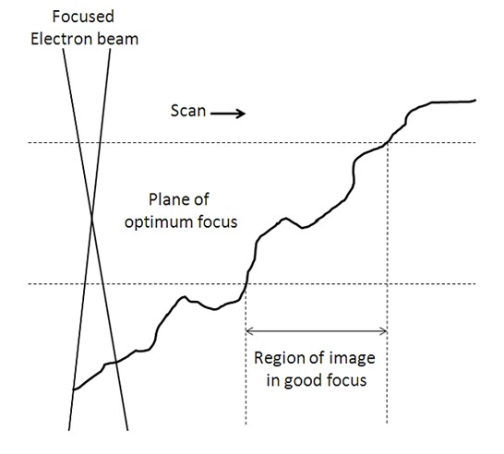
Fig. 1 Diagram showing the Plane of Optimum focus related to the topography and angle of the sample.
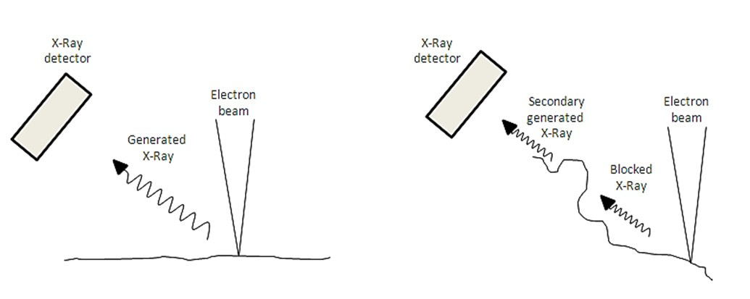
Fig. 2 Diagram showing the topography and angle of the sample affecting the X-ray generation and detection.

    - Spot size of the electron beam
The spot size is a term used by many microscopists to define the cross sectional area of the electron beam that reaches the specimen surface. Since the image in SEM is formed point by point as the sample is being scanned a smaller spot size allows achieving a better resolution. This is especially important when a high magnification (~10000X) is required. However, when we reduce the spot size, the number of electrons reaching the sample is also reduced. This is undesired in the case of EDS analysis because we want as much electrons as possible to generate the highest number of X-rays to have a good composition analysis. Therefore, when taking high magnification images it is advised to work with low spot sizes and when taking EDS spectra it is better to work with higher spot sizes. This is a parameter that can be easily changed during the session without having to turn off the equipment.

    - Working distance
The Working Distance (WD) is the distance between the exit of the electron beam from the beam column to the surface of the sample. It is a very important parameter that allows controlling several characteristics of the analysis. First, a high WD gives a larger POF but the resolution is reduced. On the contrary, smaller WD yield to smaller POF but the resolution is higher. Therefore the analyst must find the optimum WD depending on the necessities of each specific analysis.
In the case of EDS analysis the WD is also very important since the position of the X-ray detector is optimized for a specific WD. In our case the SEM that we used has the optimum WD set to 10 mm. Other equipments may have different optimum WD for EDS studies.

    - Calibration of the EDS spectra
The composition obtained with an EDS analysis is always a semi-quantitative one when there are no composition standards and the surface is not completely flat and well-polished. This is the case for human teeth and many other biological materials since there are no “standard human teeth” and the teeth are not usually polished before the analysis. What we can actually do it to measure the appropriate X-ray intensities for the analysis. The appropriate X-ray will depend on the type of samples we will study. In our case we chose the signal from Ca because it is the largest signal from all the signals of our interest. This is necessary because the quantitative analysis makes the assumption that all measurements for every element in the specimen and the standard are done with identical spectrometer conditions.

Experimental procedure

    - Sample preparation
Deciduous molars without obvious decay or evidence of fluorosis, fractures or fillings were obtained under informed consent. Immediately after exfoliation or extraction, they were collected in a 0.2% thymol solution and transported to the laboratory. The specimens were cleaned with deionized water, traces of soft tissue were removed with a scalpel and roots were cut when necessary using a carbide disc. They were gently brushed with a soft brush and finally rinsed with water. The storage was carried out at 4 °C in 0.2% thymol solution before all analysis.
Afterwards, each tooth was rinsed with deionized water and air-dried. Thirty four molars were selected for the study after showing values between 0 and 13 (healthy tooth) when scanned with a DIAGNOdent® pen (KaVo, Biderach, Germany). The dental organs were cut to obtain blocks with an enamel analysis square area of 3x3 mm and 2x5 mm from either the buccal or the lingual surface of the tooth. For this purpose, each crown was fixed with a thermoplastic epoxy resin to a glass slide placed on a hot plate. The slide was then put on a cutter make a mesiodistal central cut using a diamond wheel under constant deionized water irrigation. The other cuts were made perpendicular to the buccal or lingual surfaces, obtaining one or two blocks from each side. Subsequently, the samples were cleaned for 5 minutes in ultrasonic bath containing deionized water and they were air-dried. Ten specimens were produced for each Group.
In order to analyze the same exact area in each stage of the study a reference point was made on the enamel with a number 1/4 round carbide bur (Fig. 3). Other strategies can be applied, for example, drawing two lines from the corners of the specimen and analyze the intersection, etc.

    - Laser irradiation
The irradiation of the specimens was performed using an Er:YAG laser system (OpusDuo AquaLite EC, Lumenis, Yokneam, Israel) in the non-contact mode at a pulse repetition of 7Hz and a pulse duration of 400 µsec. The surface was scanned once by hand with the sapphire tip of the laser perpendicular to it, at a working distance of 1 mm and with deionized water irrigation (13 mL/min). Pulse energy, sapphire tip diameter and energy fluence for each group were as follows: Group 1 was irradiated at 100 mJ with a sapphire tip of 1.3 mm in diameter (7.5 J/cm2); for Group 2 irradiation was performed at 100 mJ with a sapphire tip of 1.0 mm in diameter (12.7 J/cm2); and finally Group 3 was irradiated at 200 mJ with a sapphire tip of 0.8 mm in diameter (39.8 J/cm2). Ten specimens for a Control Group were also prepared.

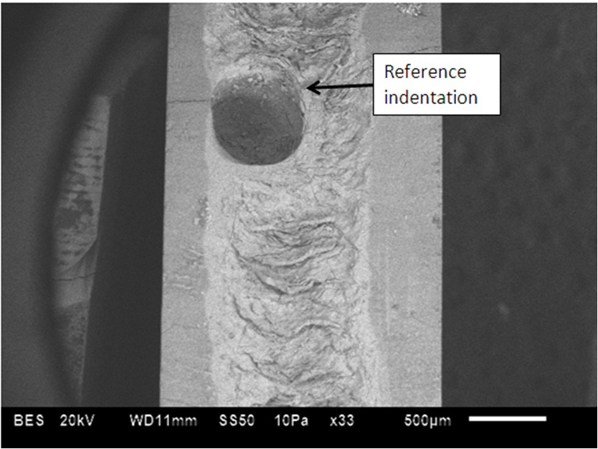
Fig. 3 Sample with a reference indentation for location of the area of analysis

    - SEM and EDS analysis
The blocks were fixed to aluminum stubs with double-sided adhesive carbon tape (SPI Supplies, USA). Since we performed the analysis in the Low Vacuum Mode (10Pa of chamber pressure), a conducting coating was not needed. We made sure every time that the surface of the specimen was parallel to the ground. The morphology of the teeth surface was observed in a scanning electron microscope (JEOL, JSM-6510LV, Japan) at two different magnifications (100x and 400x). The following values were used: Accelerating Voltage 20-25 keV, Working Distance 10 mm, Spot Size (as a percentage given by the equipment) was 60%. As already mentioned, the quantitative calibration for the EDS analysis was done using the signal from Ca.

Results

    - SEM
Fig. 4 shows the micrographs of two Group 1 samples before and after laser irradiation at different magnifications (fluence 7.5 J/cm2). It is clearly shown that the area of analysis is the exact same one in the two stages of the study by observing original features such as microcracks present before the treatment exposed prisms, etc. When the teeth surface is exposed to laser irradiation, removal of some parts of the material can be seen due to the high laser energy density.
Fig. 5 shows the micrographs of Group 2 samples before and after irradiation using a fluence of 12.7 J/cm2. As in the
previous case we observed the exact same area each time. However, the effects of using a more energetic laser light are more pronounced and the surface is more damaged as seen with the formation of more craters and fractures.
Finally, Fig. 6 shows the micrographs of Group 3 samples before and after irradiation using a fluence of 39.8 J/cm2.
This case is different from the last two; the laser energy used was sufficiently high to remove a substantial amount of material from the surface making it impossible to recognize the irradiated and the non-irradiated area. The real importance of having a method of locating the same area in every stage of the study is evidenced in the analysis of this group. Although we cannot recognize any features before and after treatment we are certain that the area of analysis is the same because of the procedure already explained in section 4.1.

    - EDS analysis
Table 1 shows the chemical composition for all Groups. Each reported value is the average value of all 10 specimens for each group and the standard deviation is included. The analysis was taken from the whole area of the micrographs at a magnification of 100X. Therefore the area of the analysis was roughly 1 mm2.
As seen, at higher laser energy, more pronounced changes in chemical composition are produced. In general, the Ca atomic percentage increases with increasing laser fluence. On the other hand, the content of carbon is drastically lower at higher irradiation energies; this effect can be explained because laser irradiation provokes extremely high local

temperatures (thousands of Celcius degrees) and CO2 can be formed with oxygen from the environment. Also, oxygen percentage changes with laser irradiation while the values for phosphorus remain practically constant.
The main goal of this chapter is to show the procedure to obtain god SEM images as well as reliable EDS microanalysis. If interested in a more complete work regarding Laser Er:YAG irradiation of teeth, the reader is referenced to published articles from our group [10, 11].
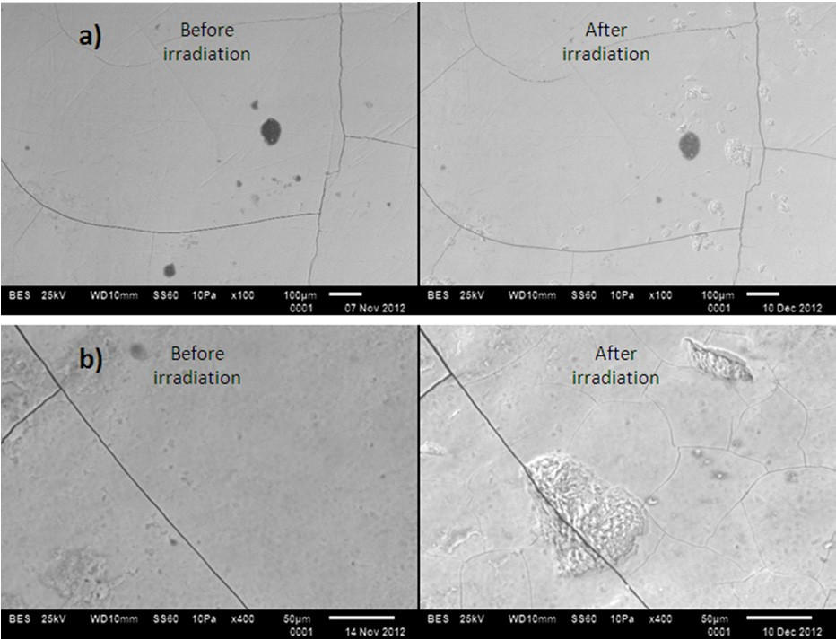
Fig. 4 Micrographs of teeth specimens of Group 1 (7.5 J/cm2) before and after irradiation. a) 100X magnification and b) 400X magnification

Table 1 Atomic percentages obtained with EDS of the teeth surface before laser irradiation BI and after irradiation AI (mean ±
standard deviation).

at% |  | Control | Group 1 | Group 2 | Group 3
Ca | BI AI | 15.2 ± 2.7 | 15.6 ± 2.5  14.0 ± 2.1 | 15.6 ± 2.8  17.3 ± 1.43 | 12.9 ± 3.3  19.9 ± 2.5
P | BI AI | 10.2 ± 1.4 | 10.5 ± 1.4  9.4 ± 1.5 | 10.6 ± 1.4  11.5 ± 0.9 | 8.8 ± 1.9  11.9 ± 1.5
O | BI AI | 58.0 ± 6.8 | 54.7 ± 6.6  62.1 ± 3.5 | 56.6 ± 5.9  60.9 ± 2.4 | 60.9 ± 5.3  65.7 ± 3.9
C | BI AI | 15.7 ± 7.7 | 18.3 ± 8.4  13.1 ± 3.3 | 16.4 ± 8.9  9.4 ± 3.0 | 16.7 ± 3.8  1.5 ± 2.2
Trace elements | BI AI | 0.9 ± 0.4 | 0.9 ± 0.1  1.4 ± 0.2 | 0.8 ± 0.1  0.9 ± 0.1 | 0.7 ± 0.2  1.0 ± 0.1

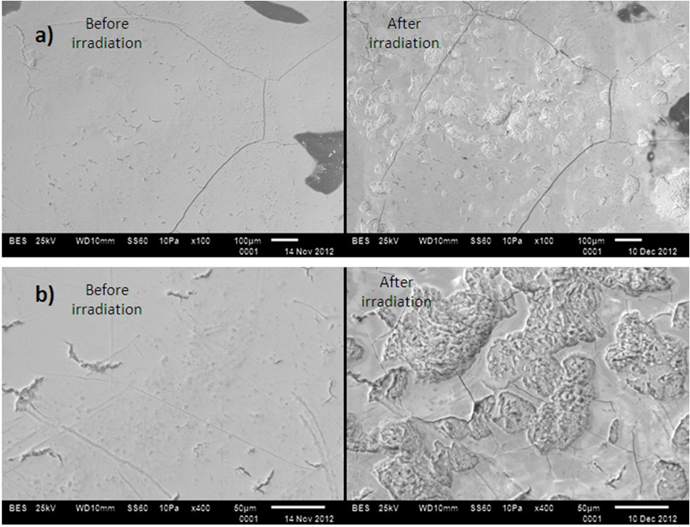
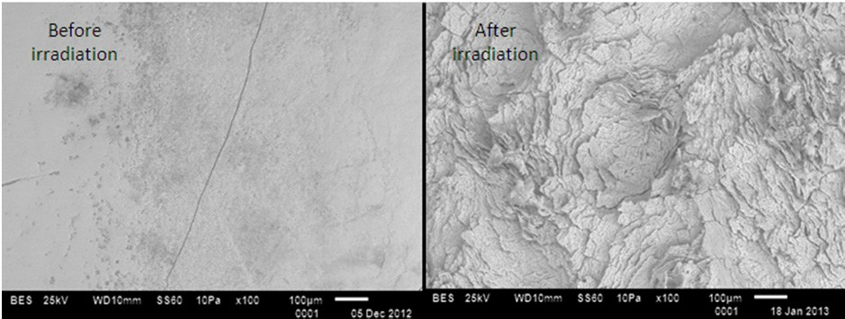
Fig. 5 Micrographs of teeth specimens of Group 2 (12.7 J/cm2) before and after irradiation. a) 100X magnification and b) 400X magnification
Fig. 6 Micrographs of teeth specimens of Group 3 (39.8 J/cm2) before and after irradiation.

Concluding Remarks
In this chapter we have explained briefly the most important aspects of SEM and EDS analysis to be considered when studying human dental samples. We discussed the sample preparation, as well as some equipment conditions and parameters that must be optimized in order to obtain good quality images as well as well as reliable chemical compositions by EDS, including the Accelerating Voltage, Working Distance, Spot Size, calibration of the EDS spectrum and the angle of the sample surface with respect to the ground.
We have also shown two different strategies to be able to locate the same exact area when the same specimen is subjected to different stages during the whole experiment and we need to analyze this area in each stage. We have shown representative micrographs of each group irradiated with different laser energies and the morphological changes that are produced; at higher energy of the laser, the damage taken by the teeth in terms of crack formation, exposed prisms and removal of dental material is higher.
Finally, we have obtained the chemical composition of each specimen and the mean average was reported for each group. Because of the analysis procedure, the composition changes observed are solely related to the effect of the laser irradiation on the surface teeth and not caused by errors occurring during the EDS analysis.

References
[1] Higashida B. Odontología preventiva. México: McGraw Hill; 2000. (Spanish)
[2] Hollister MC, Weintraub JA. The association of oral status with systemic health, quality of life, and economic productivity.
Journal of Dental Education. 1993; 57(12):901-12.
[3] Petersen PE. The World Oral Health Report 2003: continuous improvement of oral health in the 21st century--the approach of the WHO Global Oral Health Programme. Geneva: World Health Organization; 2003.
[4] Dederich DN, Bushick RD. Lasers in dentistry: separating science from hype. J Am Dent Assoc. 2004;135(2):204-12; quiz 29. [5] Walsh LJ. The current status of laser applications in dentistry. Aust Dent J. 2003;48(3):146-55; quiz 98.
[6] Castellan CS, Luiz AC, Bezinelli LM, Lopes RM, Mendes FM, De PEC et al. In vitro evaluation of enamel demineralization after Er:YAG and Nd:YAG laser irradiation on primary teeth. Photomed Laser Surg. 2007;25(2):85-90.
[7] Liu JF, Liu Y, Stephen HC. Optimal Er:YAG laser energy for preventing enamel demineralization. J Dent. 2006;34(1):62-6.
[8] Bevilacqua FM, Zezell DM, Magnani R, da Ana PA, Eduardo Cde P. Fluoride uptake and acid resistance of enamel irradiated with Er:YAG laser. Lasers Med Sci. 2008;23(2):141-7.
[9] Goldstein J, Newbury D, Joy D, Lyman Ch, Echlin P, Lifshin E, Sawyer L, Michael J. Scanning Electron Microscopy and X- Ray Microanalysis. Unated States: Springer; 2003.
[10] Zamudio-Ortega CM, Contreras-Bulnes R, Scougall-Vilchis R, Morales-Luckie R, Olea-Mejia O, Rodriguez-Vilchis LE, Garcia Fabila MM. Morphological and Chemical Changes of Deciduous Enamel Produced by Er:YAG Laser, Fluoride and Combined Treatment. Photomed Laser Surg. 2014; In press.
[11] Díaz-Monroy JM, Contreras-Bulnes R, Olea-Mejía OF, García-Fabila MM, Rodríguez-Vilchis LE, Sánchez-Flores I, Centeno- Pedraza C. Chemical changes associated with increased acid resistance of Er:YAG laser irradiated enamel. Scientific Wolrd Journal. 2014;501357

